Appendix 1: Drill-site geological work

In this appendix details is given for:
- Pre-drilling work
- The drill-sites LHKB-1 and LHKB-2
- Onsite geological core-logging and other work.

Pre-drilling work

The idea of the long-core drilling project started as a spin-off from the project “new geological map of the Fen Complex” initiated in 2015. In the period 2015-2017 the geological advisor and NGU performed several preparatory actions for the eventual case of drilling long cores. It was evident that it was the REE’s that should be in focus, and thus the drilling should be performed within the Fe-dolomite carbonatites. The location of the two drill-sites were selected after considerable pre-drilling work and planning including:
- New geological mapping.
- New gravity measurements.
- Shallow core-drilling through clay cover
- Under-ground geological mapping in old mine workings
- Inspection of old drill-cores available.
- Seismic and resistivity studies of the depth to bedrock under clay cover

Selection of the two drill-sites:

If we should drill long drill-cores within the Fen complex we had to ensure that we at least started in the correct rocks, i.e. Fe-dolomite carbonatites. We especially had to avoid drilling directly into damtjernites, which are younger than the Fe-dolomite carbonatites, and which have intruded from the mantle. If we hit a damtjernite, the worst-case scenario would be that we drilled for 1 km down within a fairly small, vertical damtjernite body which is of no interest for REE mineralizations. Secondly, we used seismic and resistivity studies to avoid eventual large fracture-zones which certainly would be problematic for the drilling operation and for the recovery of cores. Thirdly, we performed shallow reconnaissance core-drilling at several sites surrounding the likely drill-sites to ensure that we would start the drilling within the Fe-dolomite carbonatites.

The LHKB-1 site

This site is located near the peak of the very pronounced gravity high covering the Fen Complex (Ramberg, 1973). Additional reconnaissance gravity profiling confirmed that the crest of the gravity peak is situated near the abandoned Fen old school. Additionally, a few shallow drill-cores proved that Fe-dolomite carbonatite was present under the clay cover.
According to gravity modelling (Ramberg, 1973) the Fen carbonatite could be confined to the uppermost 500 meters, or possibly to 1000 meters, whereas denser rocks are found at deeper levels to explain the large gravity anomaly. Consequently, the best place to test whether the carbonatites continue down to 1000 meters, or not, would be at the peak of the gravity high. We could expect to drill into damtjernite or other dense rocks at a relatively shallow level at this site.

The LHKB-2 site

This site is located relatively close to the boundary between fenite and søvite, exposed north. It would test whether the Fe-dolomite carbonatites have a vertical distribution below the drill-site, or whether the boundary to the host rocks was inclined towards the south, i.e. whether fenites and søvites would appear in the drill-core at depth. Southeast and west of the LHKB-2 drill-site there are also several exposures of damtjernite which we wanted to avoid. Shallow core-drilling at a few sites near the chosen LHKB-2 site proved that there were Fe-dolomite carbonatite at the starting-location of the long drilling.

Backup-sites

In the eventual case we drilled into technically problematic zones (fracture zones), or “unwanted” rocks, that proved that further drilling would be of no interest (i.e. into fenites and søvite at LHKB-2), two backup drill-sites were selected. As the two chosen sites worked well for the purpose, the backup-sites were not tested.

The drill-sites LHKB-1 and LHKB-2

The precise drill-locations and core-data is presented in maps 1-3, photos 1-2 and the two tables below.
Figure 1: Topography map showing the two drill-sites.

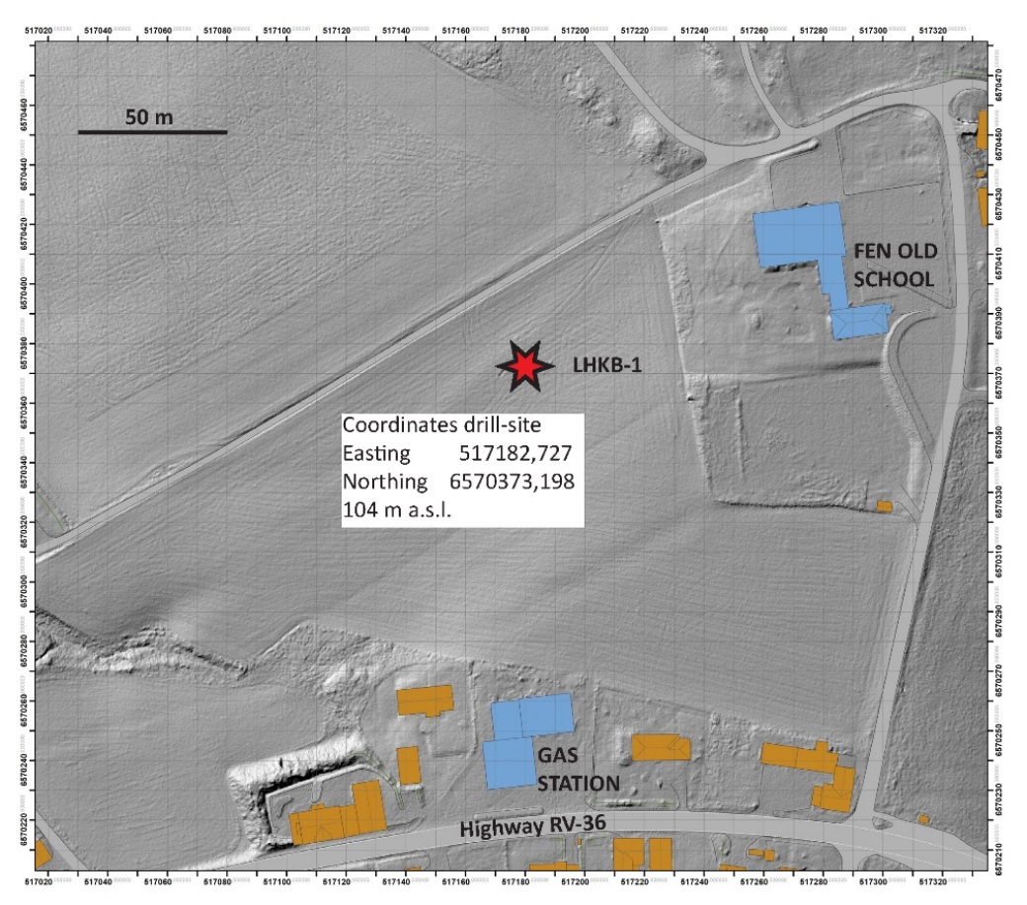
Figure 2: Detailed lidar-scan showing the location of drill-site LHKB-1. This drilling was performed on a grain-field operated by Kåre and Svein Vibeto and owned by Telemark County Municipality. The excellent cooperation during the planning and drilling process is very much appreciated.

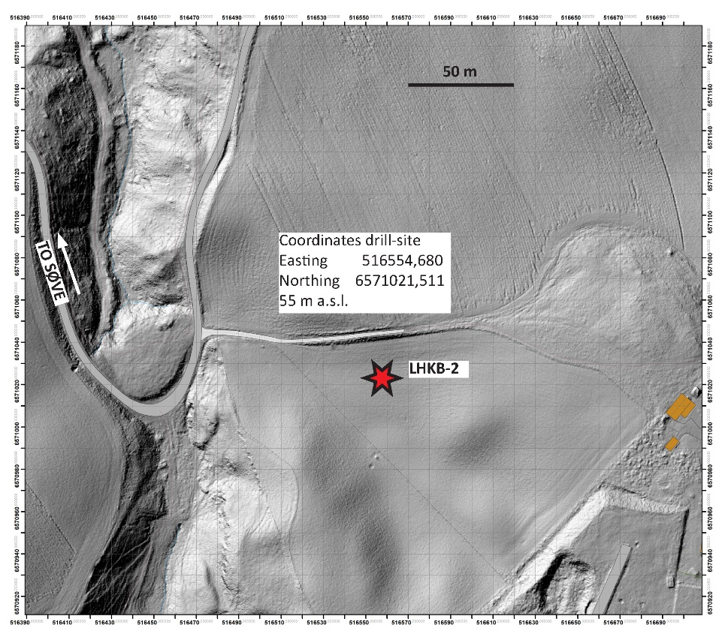
Figure 3: Detailed lidar-scan showing the location of drill-site LHKB-2. This drilling was performed in a cattle-field owned by Telemark County Municipality and operated by the Søve Agricultural School. The excellent cooperation during the planning and drilling process is very much appreciated.

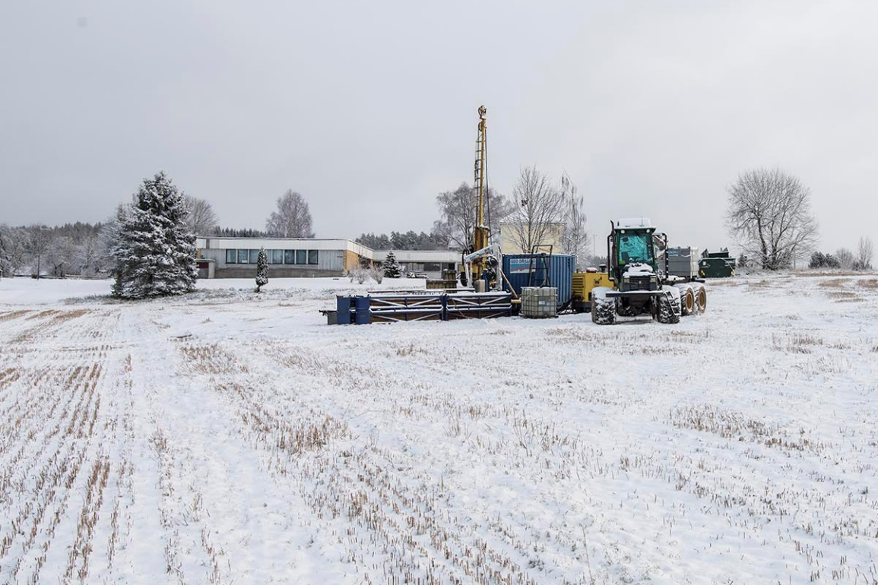
Figure 4: The LHKB-1 drill-site west of the abandoned Fen school.
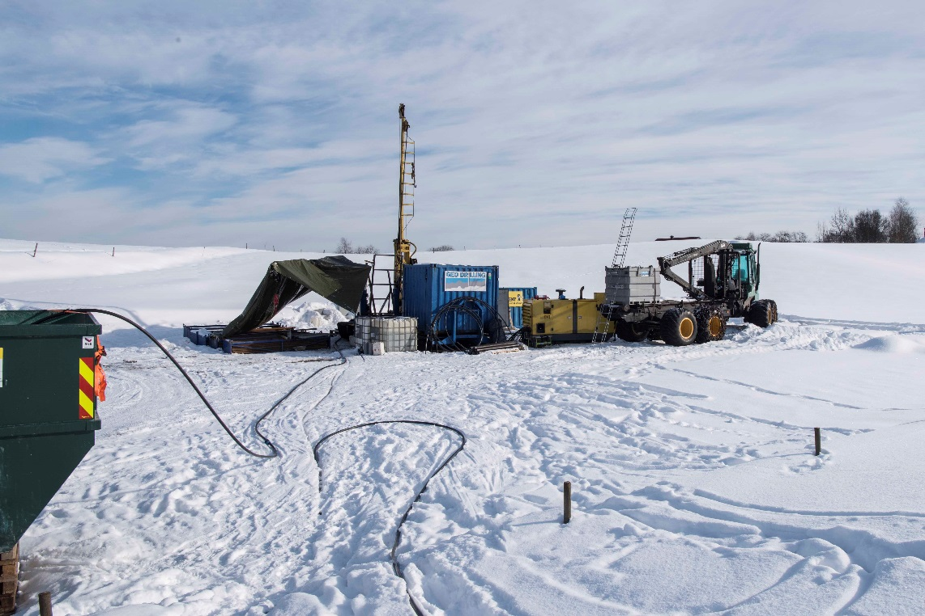
Figure 5: The LHKB-2 drill-site east of Søve agricultural school.
Table A1.1
Table showing the coordinates and elevation for LHKB-1 and LHKB-2. Coordinates were precisely measured in the middle of the holes after drilling with an Altus CPOS-GPS. Datum: Euref 89; UTM-coordinates.

 | Easting | Northing | Elevation (m a.s.l.)
LHKB-1 | 517182,727 | 6570373,198 | 104
LHKB-2 | 516554,680 | 6571021,511 | 55
The horizontal distance between the LHKB-1 and LHKB-2 drill-sites is ca. 903 meters.

Table A1.2
Table showing the total drill-lengths to “end of hole” (EOH), the depths to solid rock surface and the total core-lengths for LHKB-1 and LHKB-2
 | LHKB-1 | LHKB-2
EOH, m | 1001,30 | 716,40
Overburden, m | 13,24 | 4,90
Core length, m | 988,06 | 711,50

Onsite geological core-logging and other work

The onsite core-logging

The cores were inspected and logged nearly on a daily basis from the start of the drilling on November 15th 2017 until the end of April 2018. Logging was performed by the geological advisor Sven Dahlgren.

Bjørn Strømberg and Håvard Grønnevik assisted during the logging by carrying a tremendous number of core-boxes. Furthermore they cleaned all cores, and assisted using the handheld XRF, UV-light, Geiger-counter and during core-photo sessions. Also, Torbjørn Nilssen was hired in for a few days for the same purposes.

The logging was done at the old Fen school in warm rooms. The daylight was generally poor during the winter and most of the core-logging had to be performed using artificial lighting. This hampered observations to a certain extent. During logging we used a Niton handheld XRF, an Automess Geiger counter and a UV light (combined long and short wave).

Core-cleaning
After drilling the cores were generally covered with drill-mud. Thus, all cores had to be carefully cleaned (by hand) before logging and photographing the cores. During parts of the drilling the drilling-company used grease containing Zn and Mo. Therefore great care should be taken to interpret chemical analyses of these two elements.

Core photography
All core-boxes were photographed by S. Dahlgren in a “photo studio” at the Fen school. However, the core-boxes were also photographed as a part of the hyperspectral scanning, and it is those photos that are provided in appendix 2.
Macro photos of selected details was also performed on saw-cut, planar core surfaces. Those photos were taken in the geological advisor’s photo-studio at Barkåker near Tønsberg.

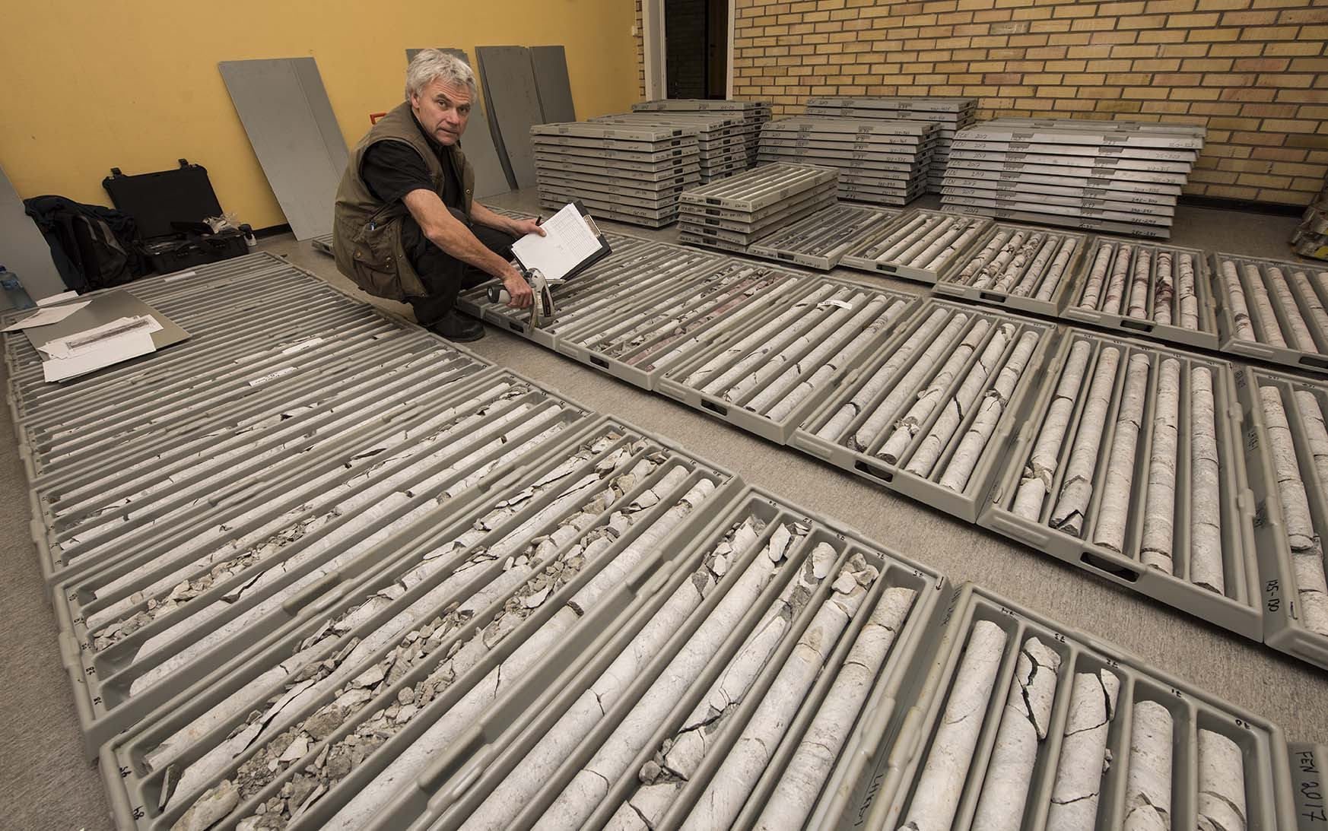
Figure 6: Core-logging at the Fen old school.
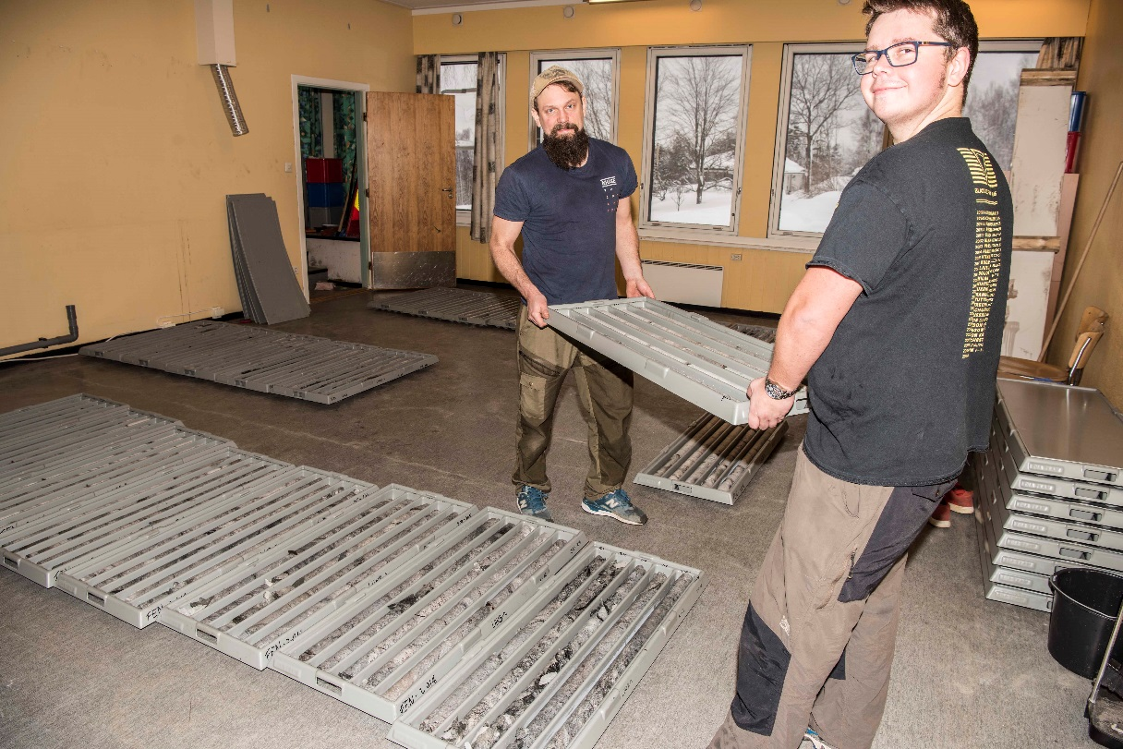
Figure 7: Carrying core-boxes numerous times.
Reference
Ramberg, I. B. (1973). Gravity studies of the Fen Complex, Norway, and their petrological significance. Contributions to Mineralogy and Petrology 38, 135-146.

