NGU Report 2013.027

Helicopter-borne magnetic, electromagnetic and radiometric geophysical survey in the
Repparfjord area, Alta and Kvalsund, Finnmark

REPORT

Geological Survey of Norway  Postboks 6315 Sluppen  NO-7491 Trondheim, Norway  Tel.: 47 73 90 40 00  Telefax 47 73 92 16 20  Report no.: 2013.027 |  |  | ISSN 0800-3416 |  | Grading: Open
Title:

Helicopter-borne magnetic, electromagnetic and radiometric geophysical survey in Repparfjord area, Alta and Kvalsund, Finnmark

Authors:  Frode Ofstad, Vikas Baranwal, Janusz Koziel, Rolf Lynum & Alexei Rodionov |  |  |  | Client:  NGU
County:  Finnmark |  |  |  | Municipalities:  Alta and Kvalsund
Map-sheet name (M=1:250.000)  HAMMERFEST |  |  |  | Map-sheet no. and -name (M=1:50.000)  1835-I & II, 1935-I, II, III & IV
Deposit name and grid-reference:  Repparfjord UTM 34W 600000 – 7800000 |  |  |  | Number of pages: 25 Price (NOK): 120,-  Map enclosures:
Fieldwork carried out:  August-September 2011 | Date of report:  April 30 2013 |  |  | Project no.:  342900 |  |  | Person responsible:
Summary:
NGU conducted an airborne geophysical survey in Repparfjord area in September - October 2011 as a part of the MINN project. This report describes and documents the acquisition, processing and visualization of recorded datasets. The geophysical survey results reported herein are 6000 line km, covering an area of 1200 km².

The NGU modified Geotech Ltd. Hummingbird frequency domain system supplemented by optically pumped Cesium magnetometer and 1024 channels RSX-5 spectrometer was used for data acquisition.

The survey was flown with 200 m line spacing, line direction 146º (North-West to South-East), and average speed 110 km/h. The average terrain clearance of the bird was 58 m.

Collected data were processed at NGU using Geosoft Oasis Montaj software. Raw total magnetic field data were corrected for diurnal variation and levelled using standard micro levelling algorithm.

EM data were filtered and levelled using both automated and manual levelling procedure. Apparent resistivity was calculated from in-phase and quadrature data for each of the five frequencies separately using a homogeneous half space model. Apparent resistivity dataset was filtered and levelled.

Radiometric data were processed using standard procedures recommended by International Atomic Energy Association.

All data were gridded with the cell size of 50 x 50 m and presented as a shaded relief maps at the scale of 1:50 000.

Keywords: Geophysics |  | Airborne |  |  |  | Magnetic
Electromagnetic |  | Gamma spectrometry |  |  |  | Radiometric
 |  |  |  |  |  | Technical report

Table of Contents
1. INTRODUCTION 4
2. LOCATION AND ACCESS 4
3. SURVEY SPECIFICATIONS 5
3.1 Airborne Survey Parameters 5
3.2 Airborne Survey Instrumentation 6
3.3 Airborne Survey Logistics Summary 6
4. DATA PROCESSING AND PRESENTATION 7
4.1 Total Field Magnetic Data 7
4.2 Electromagnetic Data 8
4.3 Radiometric data 9
5. PRODUCTS 10
6. REFERENCES 10
Appendix A1: Flow chart of magnetic processing 11
Appendix A2: Flow chart of EM processing 11
Appendix A3: Flow chart of radiometry processing 11

FIGURES

Figure 1: Repparfjord survey area. 4
Figure 2: Hummingbird system in air 7
Figure 3. Repparfjord survey area with flight path 13
Figure 4: Total Magnetic Anomaly 14
Figure 5: Magnetic Vertical Derivative 15
Figure 6: Magnetic Tilt Derivative 16
Figure 7: Apparent resistivity. Frequency 34000 Hz, Coplanar coils 17
Figure 8: Apparent resistivity. Frequency 880 Hz, Coplanar coils 18
Figure 9:. Apparent resistivity. Frequency 7000 Hz, Coaxial coils 19
Figure 10: Apparent resistivity. Frequency 6600 Hz, Coplanar coils 20
Figure 11: Radiometric Ternary Map 21
Figure 12: Uranium ground concentration 22
Figure 13: Thorium ground concentration 23
Figure 14: Potassium ground concentration 24
Figure 15: Radiometric Total Count 25

TABLES

Table 1. Instrument Specifications 6
Table 2. Hummingbird electromagnetic system, frequency and coil configurations 6
Table 3. Maps in scale 1:50000 available from NGU on request. 10

INTRODUCTION
Recognising the impact that investment in mineral exploration and mining can have on the socio-economic situation of a region, the government of Norway initiated the MINN program (Mineral resources in North Norway). The goal of this program is to enhance the geological information that is relevant to an assessment of the mineral potential of the three northernmost counties. The airborne geophysical surveys - helicopter borne and fixed wing- are important integral part of MINN program. The airborne survey results reported herein amount to 6000 line-km flown (1200 km²) over the Repparfjord survey area, as shown in Figure 1.

The objective of the airborne geophysical survey was to obtain a dense high-resolution aero-magnetic, electromagnetic and radiometric data over the survey area. This data is required for the enhancement of a general understanding of the regional geology of the area. In this regard, the data can also be used to map contacts and structural features within the property. It also improves defining the potential of known zones of mineralization, their geological settings, and identifying new areas of interest.

The survey incorporated the use of a Hummingbird™ five-frequency electromagnetic system supplemented by a high-sensitivity caesium magnetometer, spectrometer and radar altimeter. A GPS navigation computer system with flight path indicators ensured accurate positioning of the geophysical data with respect to the World Geodetic System 1984 geodetic datum (WGS-84).

LOCATION AND ACCESS
Repparfjord survey area is situated in the Alta and Kvalsund municipalities, Finnmark County in Norway. The area is northeast of the city of Alta. The area is accessible by car on E6 road, or by air; Alta Airport is located just outside of the city centre.

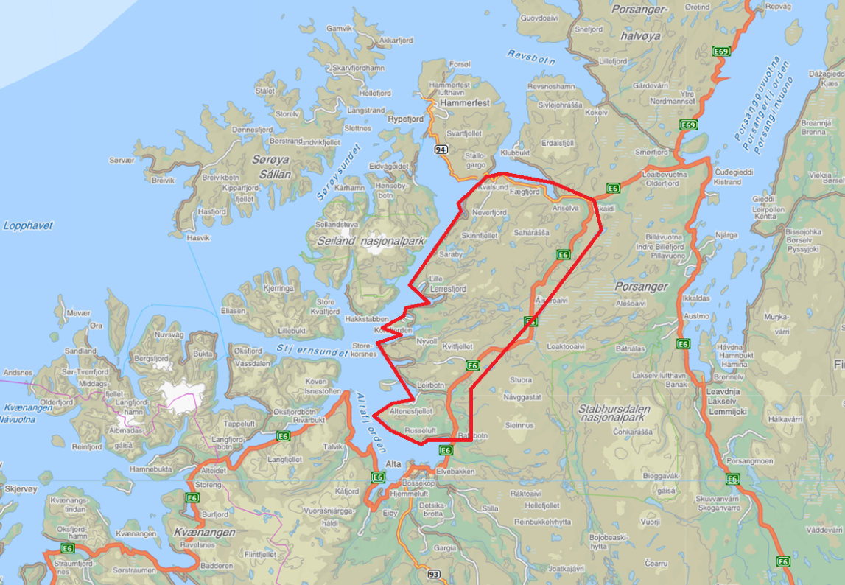
Figure 1: Repparfjord survey area.

SURVEY SPECIFICATIONS

Airborne Survey Parameters

NGU used a Hummingbird™ electromagnetic and magnetic helicopter survey system designed to obtain low level, slow speed, detailed airborne magnetic and electromagnetic data (Geotech 1997). In addition a 1024 channel gamma-ray spectrometer was used to map ground concentrations of U, Th and K.

The airborne survey began on September 20th and ended on October 18th, 2011. A Eurocopter AS350-B2 helicopter from helicopter company HeliScan AS was used to tow the bird. The survey lines were spaced 200 m apart and oriented at a 146° azimuth in UTM zone 34W coordinates. This line direction was selected to match the lines of this survey to the lines of the Nussir and Ulveryggen survey, performed in autumn 2008, which was done at 150° azimuth in UTM zone 35W (Heincke et al. 2008).

The data from the Repparfjord survey was merged with data from the 2008 Nussir and Ulveryggen surveys to produce the complete data set and maps for Repparfjord area.

The magnetic and electromagnetic sensors are housed in a single 7.5 m long bird, which was maintained at an average of 58 m above the topographic surface. Gamma spectrometer installed under the belly of the helicopter registered natural gamma ray radiation simultaneously with the acquisition of magnetic/EM data.

Rugged terrain and abrupt changes in topography may affect the aircraft pilot’s ability to ‘drape’the terrain; therefore there are positive and negative variations in sensor height with respect to the estimated range, which is higher than the standard height of 30 m.

The ground speed of the aircraft varied from 30 – 120 km/h depending on topography, wind direction and its magnitude. On average the ground speed during measurements is calculated to 110 km/h. Magnetic data were recorded at 0.2 second intervals resulting in approximately 6 m point spacing. EM data were recorded at 0.1 second intervals resulting in data with a sample increment of 3 m along the ground in average. Spectrometry data were recorded every 1 second giving a point spacing of approximately 30 meter. The above parameters were designed to allow for sufficient detail in the data to detect subtle anomalies that may represent mineralization and/or rocks of different lithological and petrophysical composition.

A base magnetometer to monitor diurnal variations in the magnetic field was located at Alta Airport a few kilometres southwest of the measured area for the southern part of the survey and at Skaidi just inside the survey area for the nortern part of the survey. Base station magnetometer data were recorded once every 3 second. The CPU clock of the base magnetometer computer was synchronized to the CPU clock of the DAS on a daily basis.

Navigation system uses GPS/GLONASS satellite tracking systems to provide real-time WGS-84 coordinate locations for every second. The accuracy achieved with no differential corrections is reported to be ± 5 m in the horizontal directions. The GPS receiver antenna was mounted externally to the tail tip of the helicopter.

For quality control, the electromagnetic, magnetic and radiometric, altitude and navigation data were monitored on four separate windows in the operator's display during flight while they were recorded in three data ASCII streams to the DAS hard disk drive.

Airborne Survey Instrumentation

Instrument specification is given in table 1. Frequencies and coil configuration for the Hummingbird EM system is given in table 2.

Table 1. Instrument Specifications
Instrument | Producer/Model | Accuracy | Sampling frequency
Magnetometer | Scintrex Cs-2 | 0,002 nT | 5 Hz
Base magnetometer | Scintrex EnviMag | 0,1 nT | 3,3 Hz
Electromagnetic | Geotech Hummingbird | 1 – 2 ppm | 10 Hz
Gammaspectrometer | Radiation Solutions RSX-5 | 1024 ch’s, 16 liters down, 4 liters up | 1 Hz
Radar altimeter | Bendix/King KRA 405B | ± 3 % 0 – 500 fot  ± 5 % 500 – 2500 fot | 1 Hz
Pressure/temperature | Honeywell PPT | ± 0,03 % FS | 1 Hz
Navigation | Topcon GPS-receiver | ± 5 meter | 1 Hz
Acquisition system | Geotech Ltd

Table 2. Hummingbird electromagnetic system, frequency and coil configurations
Coils: | Frequency | Orientation | Separation
A | 7700 Hz | Coaxial | 6.20 m
B | 6600 Hz | Coplanar | 6.20 m
C | 980 Hz | Coaxial | 6.025 m
D | 880 Hz | Coplanar | 6.025 m
E | 34000 Hz | Coplanar | 4.87 m

The electromagnetic, magnetic and radiometric, altitude and navigation data were monitored on the operator's displays during flight while they were recorded to the PC hard disk drive. Spectrometry data were also recorded to internal hard drive of the spectrometer. The data files were transferred to the field workstation via USB flash drive. The raw data files were backed up onto USB flash drive in the field.

Airborne Survey Logistics Summary

Traverse (survey) line spacing: 200 metres
Traverse line direction: 146° NW-SE
Nominal aircraft ground speed: 30 - 120 km/h
Average sensor terrain clearance EM+Mag: 58 metres
Average sensor terrain clearance Rad: 88 metres
Sampling rates: 0.2 seconds - magnetometer
0.1 seconds - electromagnetics
1.0 second - spectrometer, GPS, altimeter

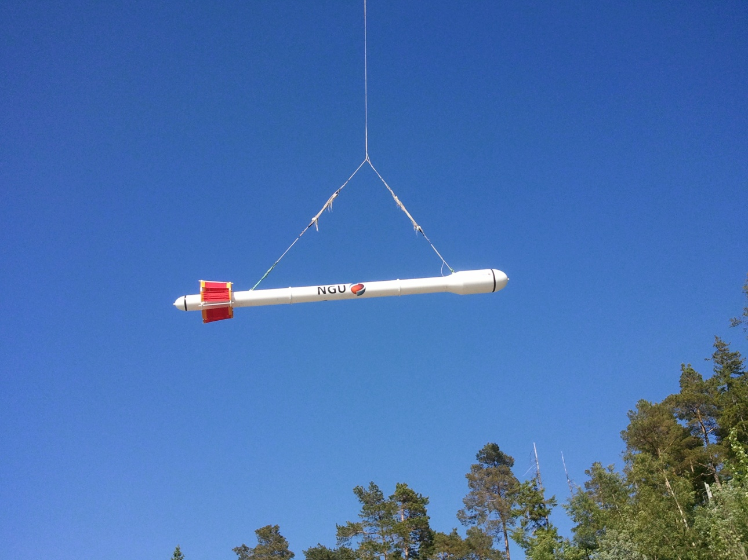
Figure 2: Hummingbird system in air

DATA PROCESSING AND PRESENTATION
Magnetic and radiometric data were processed at the Geological Survey of Norway office in Trondheim. Electromagnetic data were processed by Alexei Rodionov (AR Geoconsulting Ltd., Canada). The ASCII data files were loaded into three separate Oasis Montaj databases. All three datasets were processed consequently according to processing flow charts shown in Appendix A1, A2 and A3.

Total Field Magnetic Data
At the first stage the magnetic data were visually inspected and spikes were removed manually. Then the data from basemag station were imported in magnetic database using the standard Oasis magbase.gx module. Diurnal variation channel was also inspected for spikes and spikes were removed manually if necessary. Since the data from both - airborne and magbase magnetometers- were smooth and contained no significant cultural noise filtering of the raw data was not necessary. Typically, several corrections have to be applied to magnetic data before gridding - heading correction, lag correction and diurnal correction.

Diurnal Corrections
The temporal fluctuations in the magnetic field of the earth affect the total magnetic field readings recorded during the airborne survey. This is commonly referred to as the magnetic diurnal variation. These fluctuations can be effectively removed from the airborne magnetic data set by using a stationary reference magnetometer that records the magnetic field of the earth simultaneously with the airborne sensor. Magnetic diurnals were within the standard NGU specifications during the entire survey (Rønning 2011).

The base magnetometer was located at the Alta Airport for the southern part, then at Skaidi for the northern part of the survey. The average total field value for Alta was 53446 nT, and for Skaidi 53654 nT. The base station computer clock was synchronized with the DAS clock on a daily basis. The recorded data are merged with the airborne data and the diurnal correction is applied according to equation (1).
, (1)
Where:

Corrections for Lag and heading
Neither a lag nor cloverleaf tests were performed before the survey. According to previous reports the lag between logged magnetic data and the corresponding navigational data was 1-2 fids. Translated to a distance it would be no more than 10 m - the value comparable with the precision of GPS. A heading error for a towed system is usually either very small or non-existent. So no lag and heading corrections were applied.

Magnetic data gridding and presentation
Before gridding, flight data were split by lines. For the purposes of data presentation and interpretation the total field magnetic data are gridded with a cell size of 50 m, which represents one quarter of the 200 m average line spacing. A micro levelling technique was applied to the magnetic data to remove small line-to-line levelling errors and a 5 x 5 convolution filter was passed over the final grid to smooth the grid image.

The Vertical Gradient and the Tilt Derivative of the total magnetic field was calculated from the resulting total magnetic field map. These signals transforms the shape of the magnetic anomaly from any magnetic inclination to positive body-centred anomaly and it's widely utilized for mapping of structures.

Electromagnetic Data
The DAS computer records both an in-phase and a quadrature value for each of the five coil sets of the electromagnetic system. Instrumental noise and drift should be removed before computation of an apparent resistivity.

Instrumental noise
In-phase and quadrature data were filtered with 3 fids non-linear filter to eliminate spheric spikes which were represented as irregular spikes of large amplitude in records. Simultaneously, the 30 fids low-pass filter was also applied to suppress high frequency components of instrumental and cultural noise.

Instrument Drift
In order to remove the effects of instrument drift caused by gradual temperature variations in the transmitting and receiving circuits, background responses are recorded during each flight. To obtain a background level the bird is raised to an altitude of approximately 1000 ft above the topographic surface so that no electromagnetic responses from the ground are present in the recorded traces. The EM traces observed at this altitude correspond to a background (zero) level of the system. If these background levels are recorded at 20-30 minute intervals, then the drift of the system (assumed to be linear) can be removed from the data by resetting these points to the initial zero level of the system. The drift must be removed on a flight-by-flight basis, one frequency at a time, before any further processing is carried out. Geosoft HEM module was used for applying drift correction. Residual instrumental drift, often non-linear, was manually removed on line-to-line basis. The same manual removal of instrumental drift was performed on the Nussir dataset from 2008.

Apparent resistivity calculation and presentation
When levelling of the EM data was complete, apparent resistivity was calculated from in-phase and quadrature EM components using a half space homogeneous model of the Earth (Geosoft HEM module) for all five frequencies separately. Threshold of 2 ppm was set for inversion 34 kHz and 1 ppm for all other frequencies.

Secondary electromagnetic field decays rapidly with the distance (height of the sensors) – as z⁻² – z⁻⁵ depending on the shape of the conductors and, at certain height, signals from the ground sources become comparable with instrumental noise. Levelling errors or precision of levelling can lead sometimes to appearance of artificial resistivity anomalies when data were collected at high instrumental altitude. Application of threshold allows excluding such data from an apparent resistivity calculation, though not completely. It’s particularly noticeable in low frequencies datasets. Resistivity data were visually inspected; artificial anomalies associated with high altitude measurements were manually removed and then levelled. Revised resistivity data were gridded with a cell size 50 m and convolution filter was applied to smooth the grids.

Temperature drift of the EM-frequencies were partly above standard NGU specifications during the 2011 survey (Rønning 2012). Due to this, the apparent resistivity for 980 Hz coaxial coils was not calculated. As a result of different quality of the data from 2008 and 2011, the knitting of two datasets presented a problem. While a resistivity of conductors is comparable, the resolution in areas of high resistivity rocks was much better for Nussir survey. None of knitting algorithms offered by Geosoft Oasis Monaj produced satisfactory results and final maps were presented as grid mosaics.

Radiometric data
In processing of the airborne gamma ray spectrometry data, live time corrected U, Th and K were corrected for the aircraft and cosmic background (e.g. Grasty et al. 1991; IAEA 2003). The upward detector method, as discussed in IAEA (2003), was applied to remove the effects of radon in the air below and around the helicopter. Window stripping was used to isolate count rates from the individual radio-nuclides K, U and Th (IAEA, 2003). The topography in the region was rough, and the sensor was not always at a constant altitude. Stripped window counts were therefore corrected for variations in flying height to a constant height of 60 m. Finally, count rates were converted to effective ground element concentrations using calibration values derived from calibration pads at the Geological Survey of Norway in Trondheim. A list of the parameters used in the processing scheme is given in Appendix A3. For further reading regarding standard processing of airborne radiometric data, we recommend the publication from Minty et al. (1997).

Quality of the radiometric data were within standard NGU specifications (Rønning 2012) except for a few short line segments where data were lost due to lack of GPS-signal.

PRODUCTS
Processed digital data from the survey are presented as:
- Three Geosoft XYZ files:
RepparfjordMag.xyz, RepparfjordEM.xyz, RepparfjordSpectrometry.xyz,
- Coloured maps at the scale 1:50000 available from NGU on request.

Table 3: Maps in scale 1:50000 available from NGU on request.
Map # | Name
2013.027-01 | Total magnetic field
2013.027-02 | Magnetic Vertical Derivative
2013.027-03 | Magnetic Tilt Derivative
2013.027-04 | Apparent resistivity, Frequency 34000 Hz, coplanar coils
2013.027-05 | Apparent resistivity, Frequency 880 Hz, coplanar coils
2013.027-06 | Apparent resistivity, Frequency 7000 Hz, coaxial coils
2013.027-07 | Apparent resistivity, Frequency 6600 Hz, coplanar coils
2013.027-08 | Radiometric Ternary Map
2013.027-09 | Uranium ground concentration
2013.027-10 | Thorium ground concentration
2013.027-11 | Potassium ground concentration
2013.027-12 | Radiometric Total count
Downscaled images of the maps are shown on figures 4 to 14.

REFERENCES
Geotech 1997: Hummingbird Electromagnetic System. Users manual. Geotech Ltd. October 1997

Grasty, R.L., Holman, P.B. & Blanchard 1991: Transportable Calibration pads for ground and airborne Gamma-ray Spectrometers. Geological Survey of Canada. Paper 90-23. 62 pp.

Heincke, B., Koziel, J., Walker, P. & Lynum, R.: Helicopter-borne geophysical measurements for mineral exploration at Nussir- 2008. NGU Report 2008.20, 32 pp..

IAEA 2003: Guidelines for radioelement mapping using gamma ray spectrometry data. IAEA-TECDOC-1363, Vienna, Austria. 173 pp.

Minty, B.R.S., Luyendyk, A.P.J. and Brodie, R.C. 1997: Calibration and data processing for gamma-ray spectrometry. AGSO – Journal of Australian Geology & Geophysics. 17(2). 51-62.

Naudy, H. and Dreyer, H. 1968: Non-linear filtering applied to aeromagnetic profiles. Geophysical Prospecting. 16(2). 171-178.

Rønning, J.S. 2012: NGUs helikoptermålinger. Plan for sikring og kontroll av datakvalitet. NGU Intern rapport 2012.001, (38 sider).

UBC 2000: Manual for running the program "EM1DFM". UBC - Geophysical Inversion Facility, Department of Earth & Ocean Sciences, University of British Columbia, Vancouver, CANADA. July, 2000.

UBC 2005: MAG3D. A Program Library for Forward Modelling and Inversion of Magnetic Data over 3D Structures. UBC - Geophysical Inversion Facility, Department of Earth & Ocean Sciences, University of British Columbia, Vancouver, CANADA. May, 2005.

Appendix A1: Flow chart of magnetic processing
Meaning of parameters is described in the referenced literature.

Processing flow:

- Quality control.
- Visual inspection of airborne data and manual spike removal
- Conversion of ASCII data file from magbase station to Geosoft *.bas files
- Import magbase data to Geosoft database
- Inspection of magbase data and removal of spikes
- Correction of data for diurnal variation
- Splitting flight data by lines
- Gridding
- Microlevelling

Appendix A2: Flow chart of EM processing
Meaning of parameters is described in the referenced literature.

Processing flow:
- Filtering of in-phase and quadrature channels with non-linear and low pass filters
- Automated leveling
- Quality control
- Visual inspection of data.
- Splitting flight data by lines
- Manual removal of remaining part of instrumental drift
- Calculation of an apparent resistivity for each frequency using both - in-phase and quadrature channels
- Gridding
- Micro evelling of apparent resistivity channels.
- Convolution filter.

Appendix A3: Flow chart of radiometry processing
Underlined processing stages are not only applied to the K, U and Th window, but also to the total.
Meaning of parameters is described in the referenced literature.

Processing flow:
- Quality control
- Airborne and cosmic correction (IAEA, 2003)
Used parameters: (determined by high altitude calibration flights near Narvik airport in August, 2011)
Aircraft background counts:
K window 9
U window 3
Th window 0
Uup window 0
Total counts 150
Cosmic background counts (normalized to unit counts in the cosmic window):
K window 0.0610
U window 0.0454
Uup window 0.0237
Th window 0.0626
Total counts 1.0536
- Radon correction using upward detector method (IAEA, 2003)
Used parameters (determined from survey data over water and land):
a_{u}: 0.16 b_{u:} 1.69
a_{K}: 4.49 b_{K}: 0.14
a_{T}: 1.24 b_{T}: 1.82
aTc: 45.8 bTc: 7.47
a_{I}: 15.5 b_{I}: 36.3
_{a1}: 0.100 a₂: -0.02

- Stripping correction (IAEA, 2003)
Used parameters (determined from measurements on calibrations pads at the NGU):
a 0.0482
alpha 0.3087
beta 0.4807
gamma 0.7953

- Height correction to a height of 60 m
Used parameters (determined by height calibration flight at near Narvik airport in August, 2011):
Attenuation factors in 1/m:
K: 0.0107
U: 0.0067
Th: 0.0062
Total counts: 0.0076

- Converting counts at 60 m heights to element concentration on the ground
Used parameters (determined from NGU calibration pads):
Counts per elements concentrations:
K: 69.1 counts/%
U: 7.71 counts/ppm
Th: 4.38 counts/ppm

- Microlevelling using Geosoft menu and smoothening by a convolution filtering
Used parameters for microlevelling:
De-corrugation cutoff wavelength: 800 m
Cell size for gridding: 200 m
Naudy (1968) Filter length: 800 m

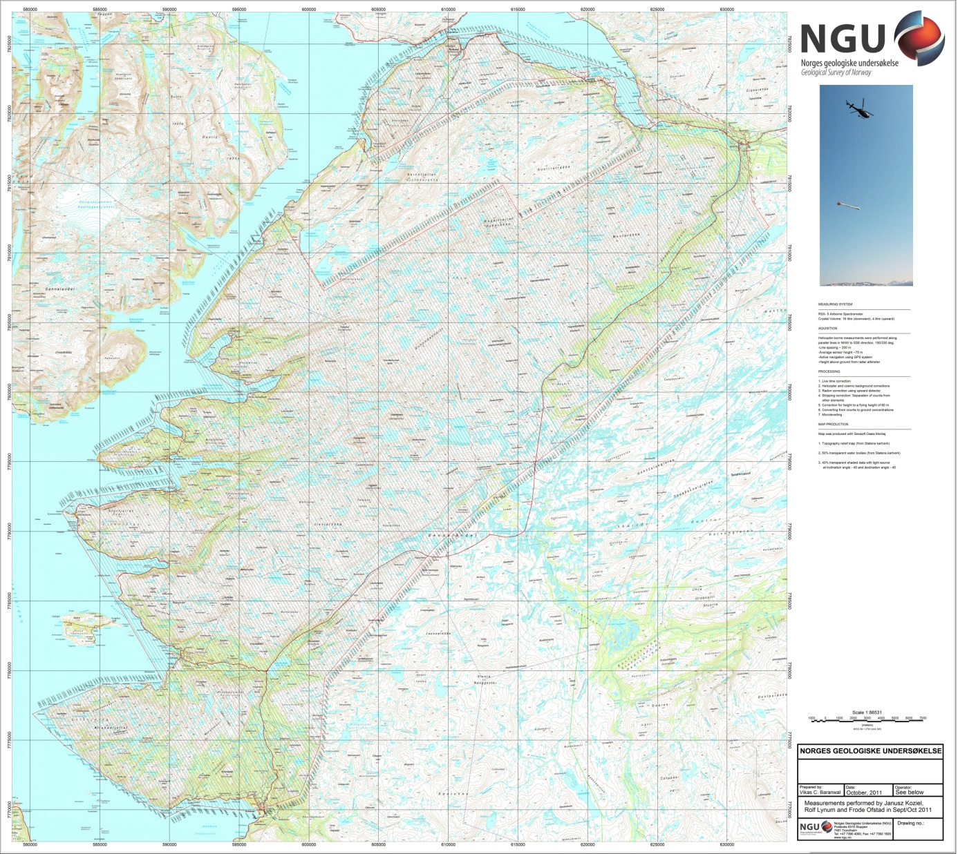
Figure 3. Repparfjord survey area with flight path

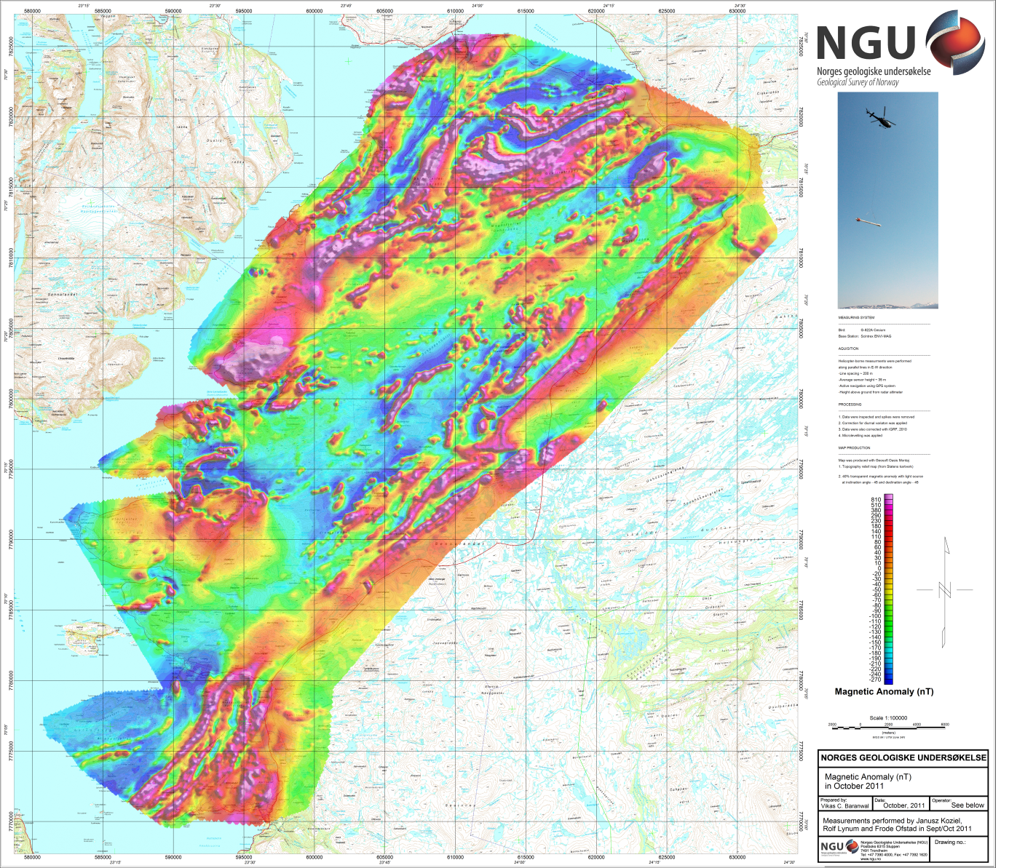
Figure 4: Total Magnetic Anomaly

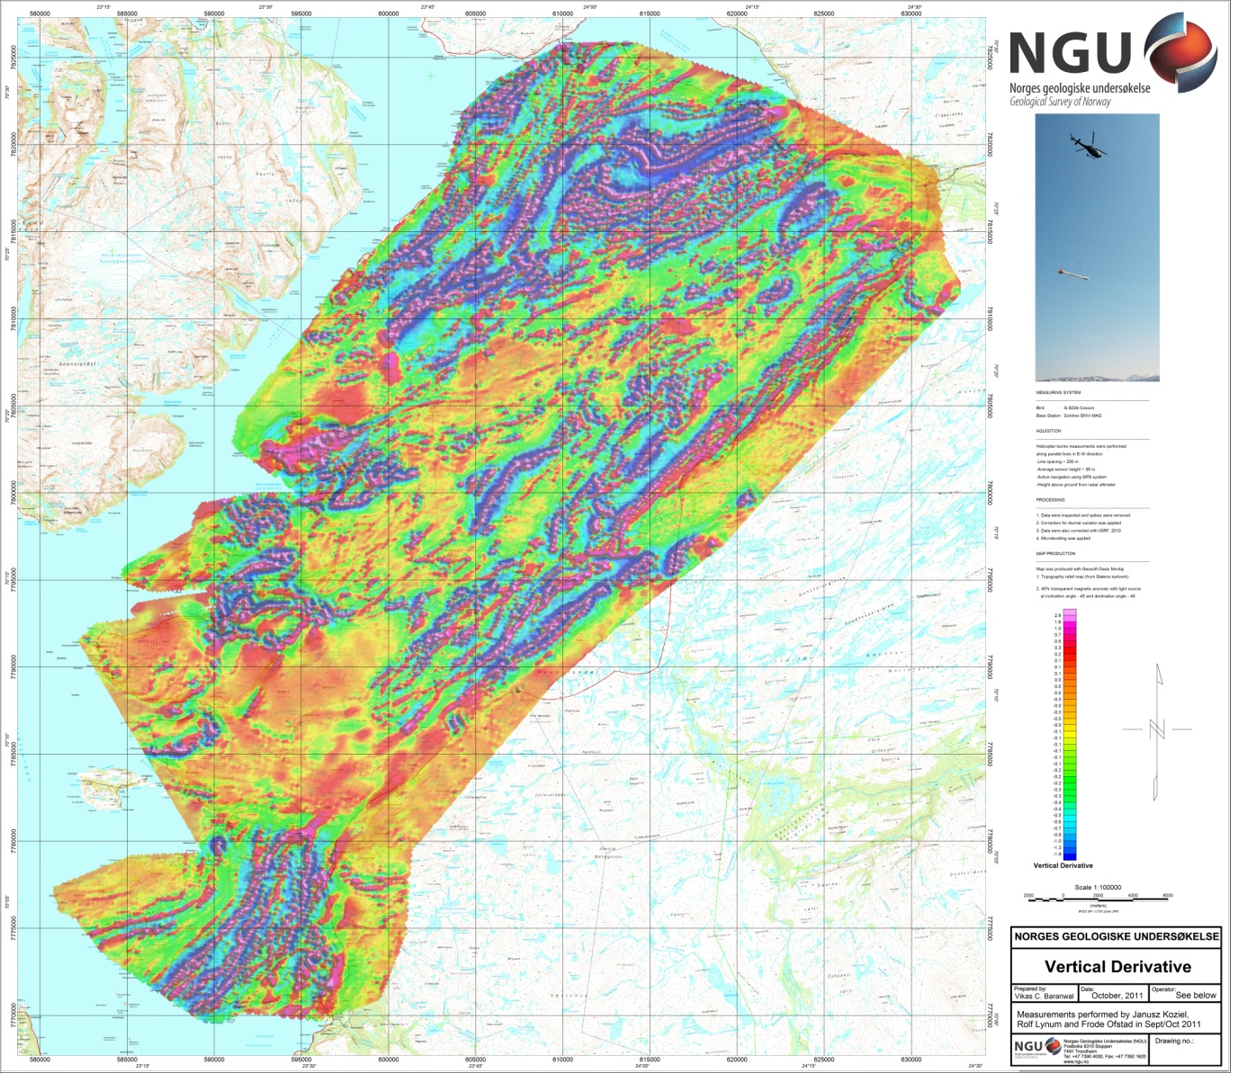
Figure 5: Magnetic Vertical Derivative

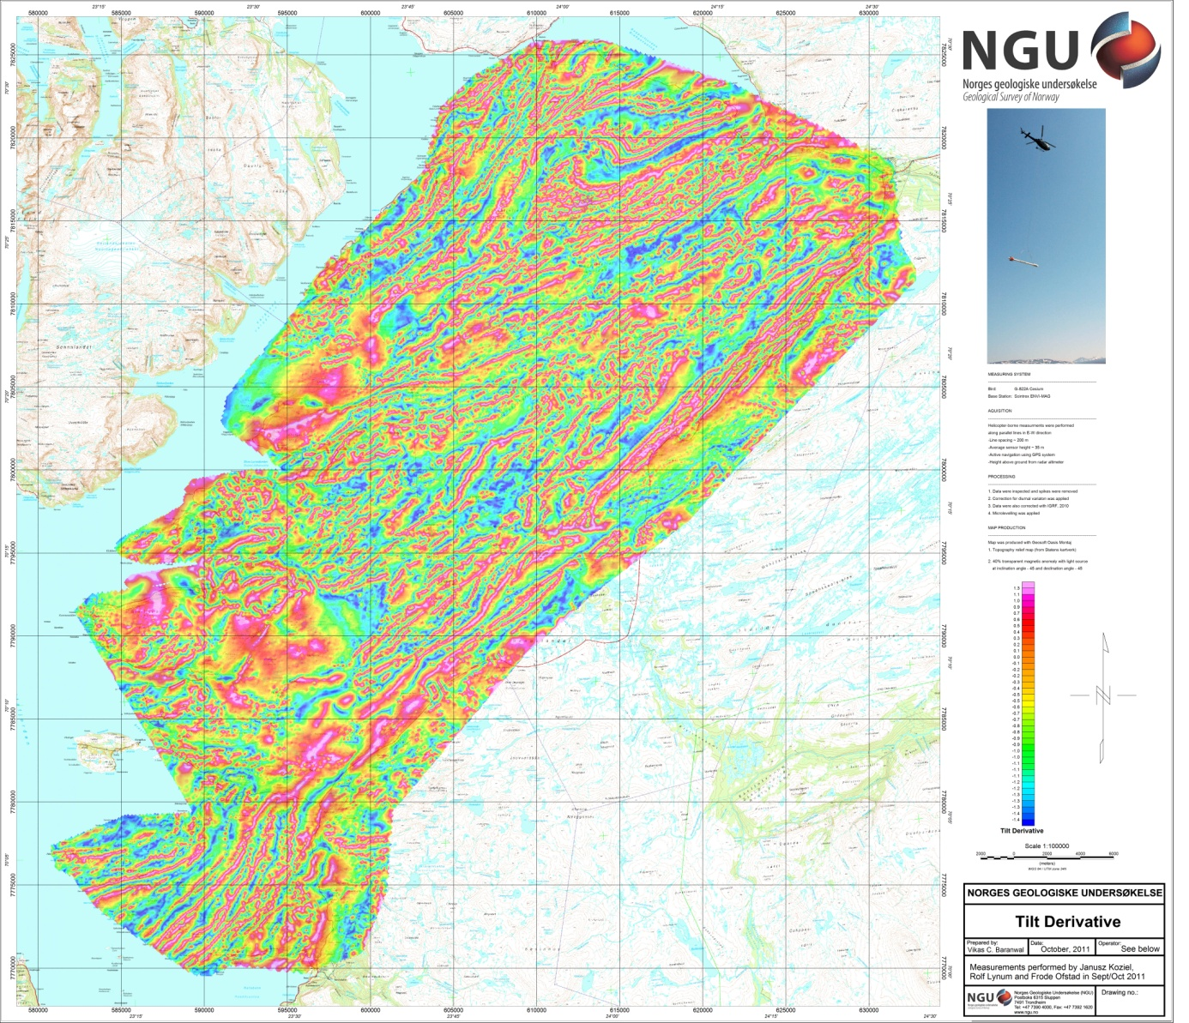
Figure 6: Magnetic Tilt Derivative

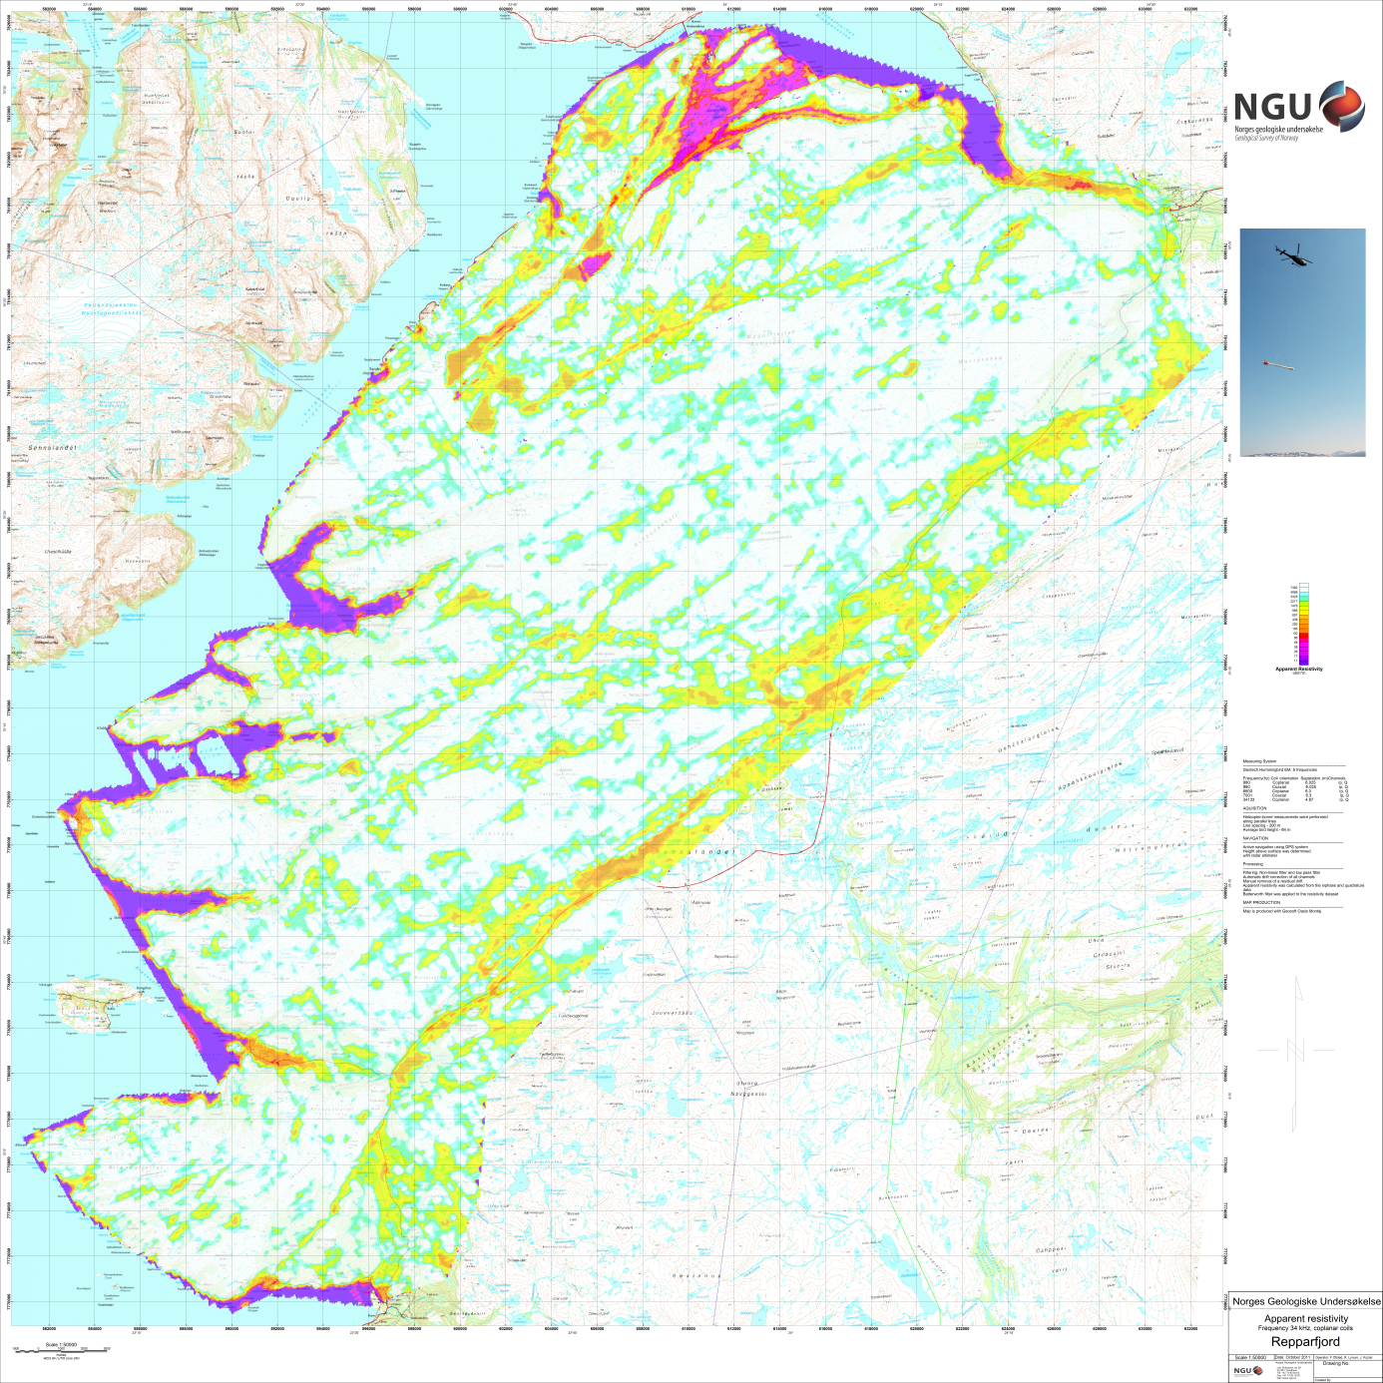
Figure 7: Apparent resistivity. Frequency 34000 Hz, Coplanar coils

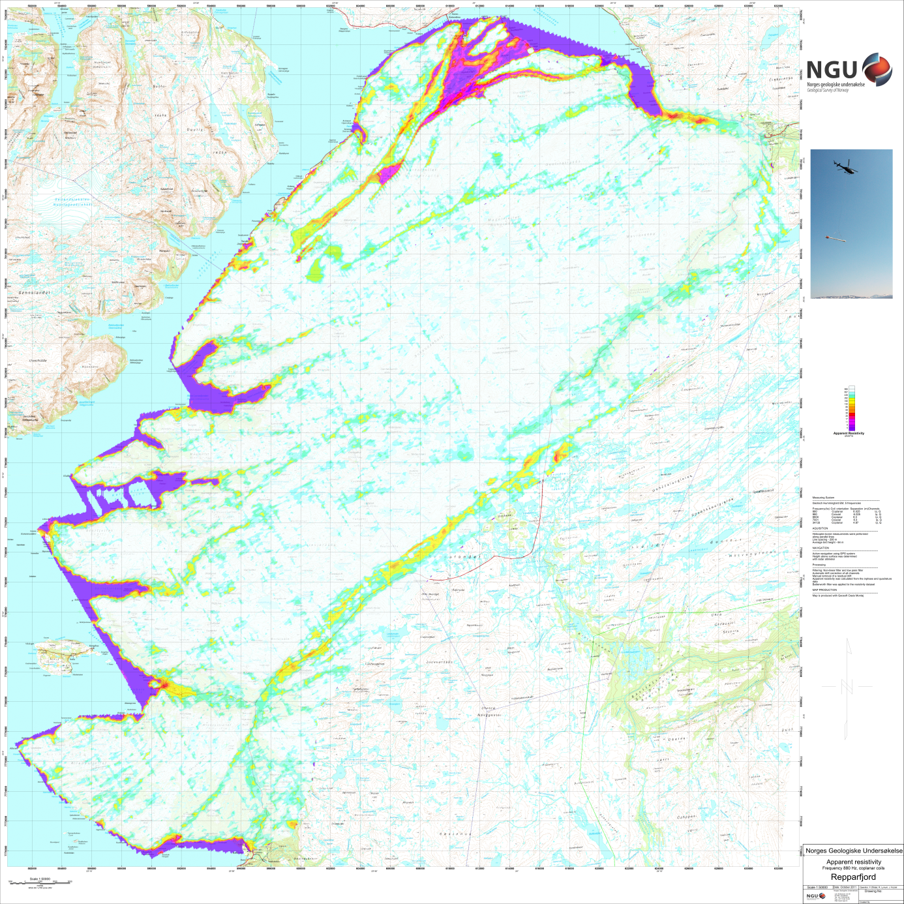
Figure 8: Apparent resistivity. Frequency 880 Hz, Coplanar coils

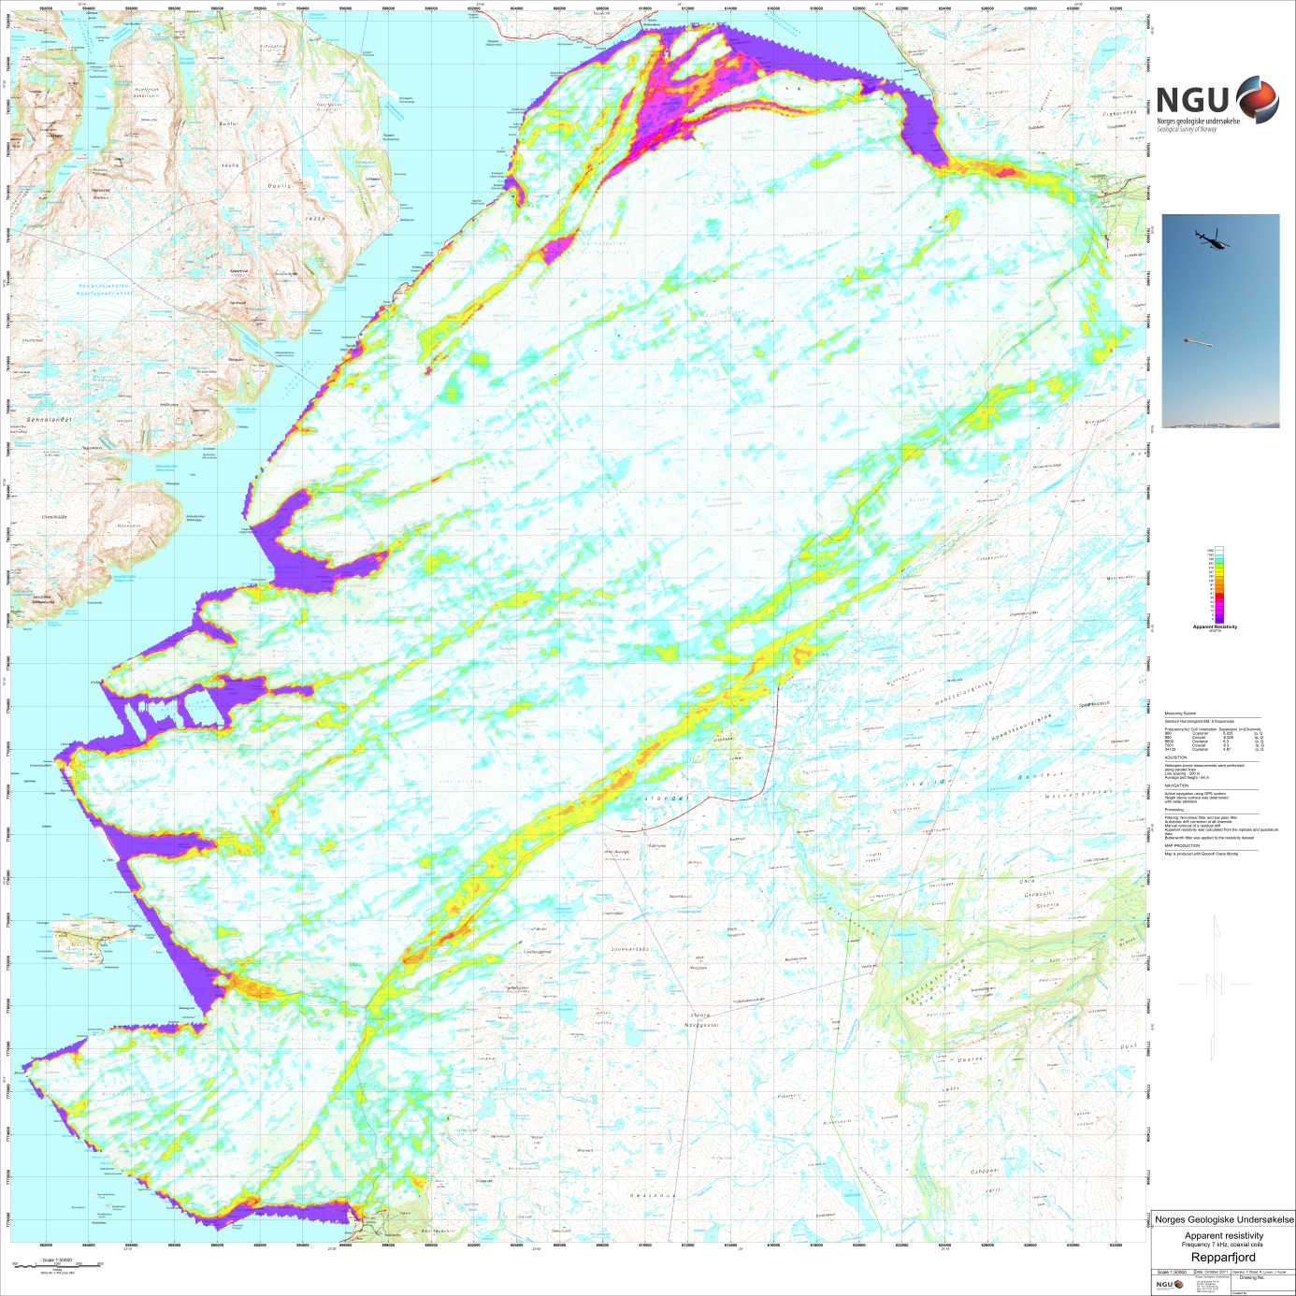
Figure 9:. Apparent resistivity. Frequency 7000 Hz, Coaxial coils

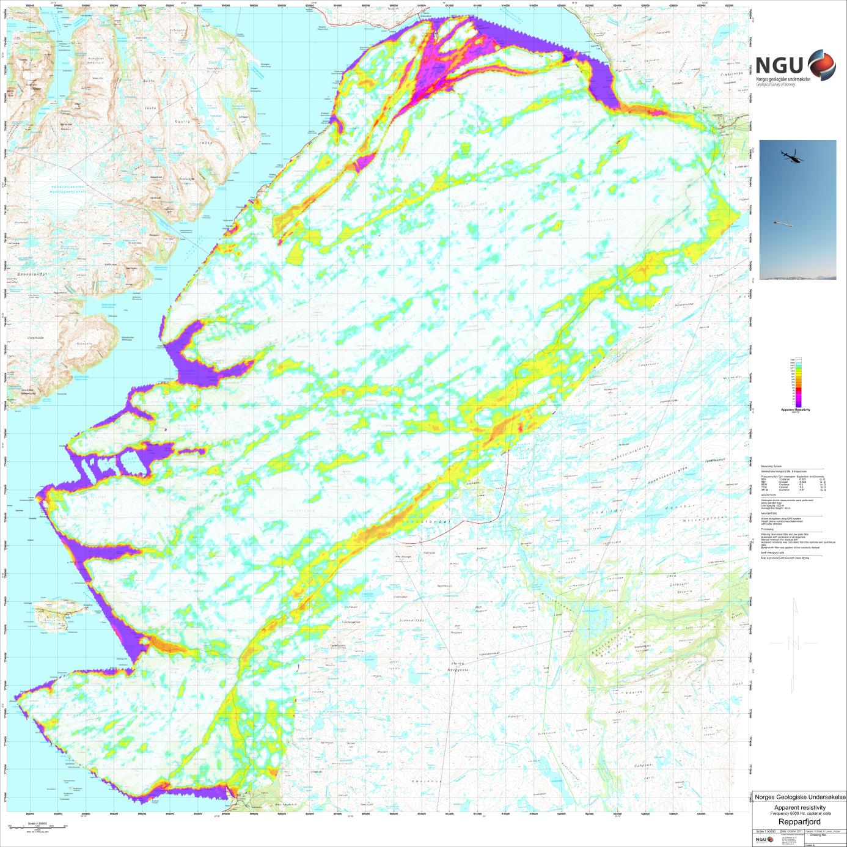
Figure 10: Apparent resistivity. Frequency 6600 Hz, Coplanar coils

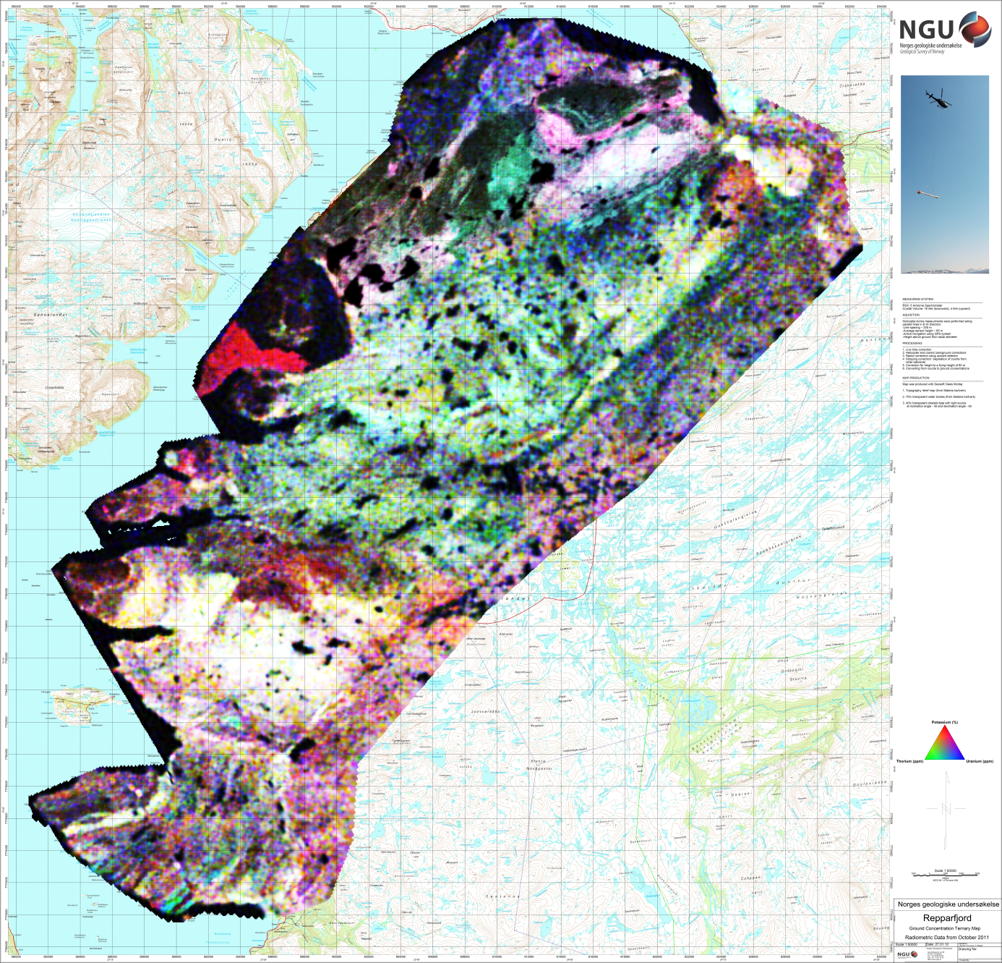
Figure 11: Radiometric Ternary Map

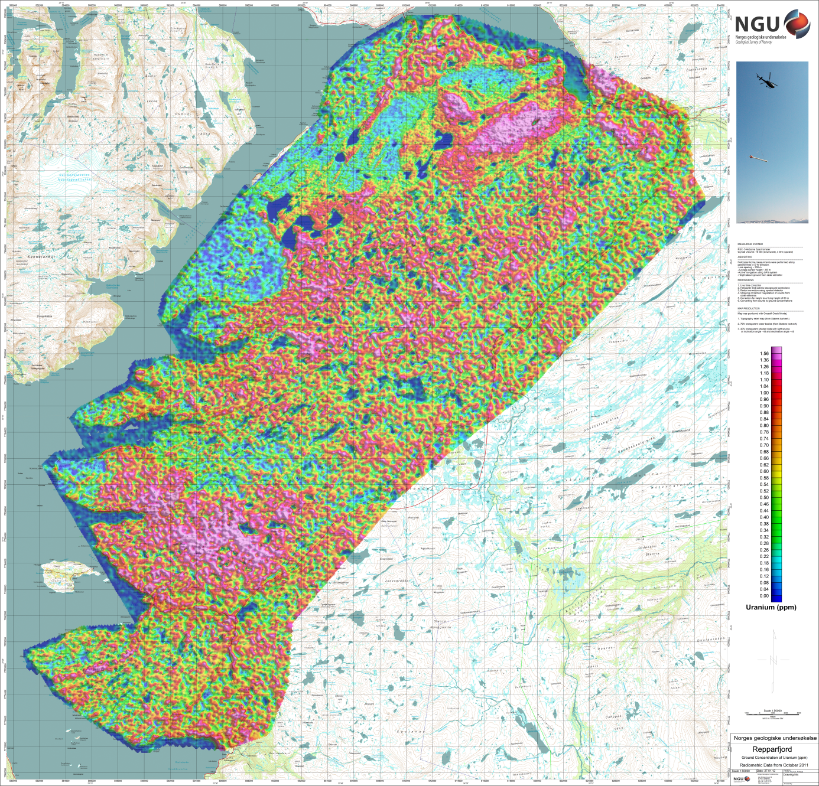
Figure 12: Uranium ground concentration

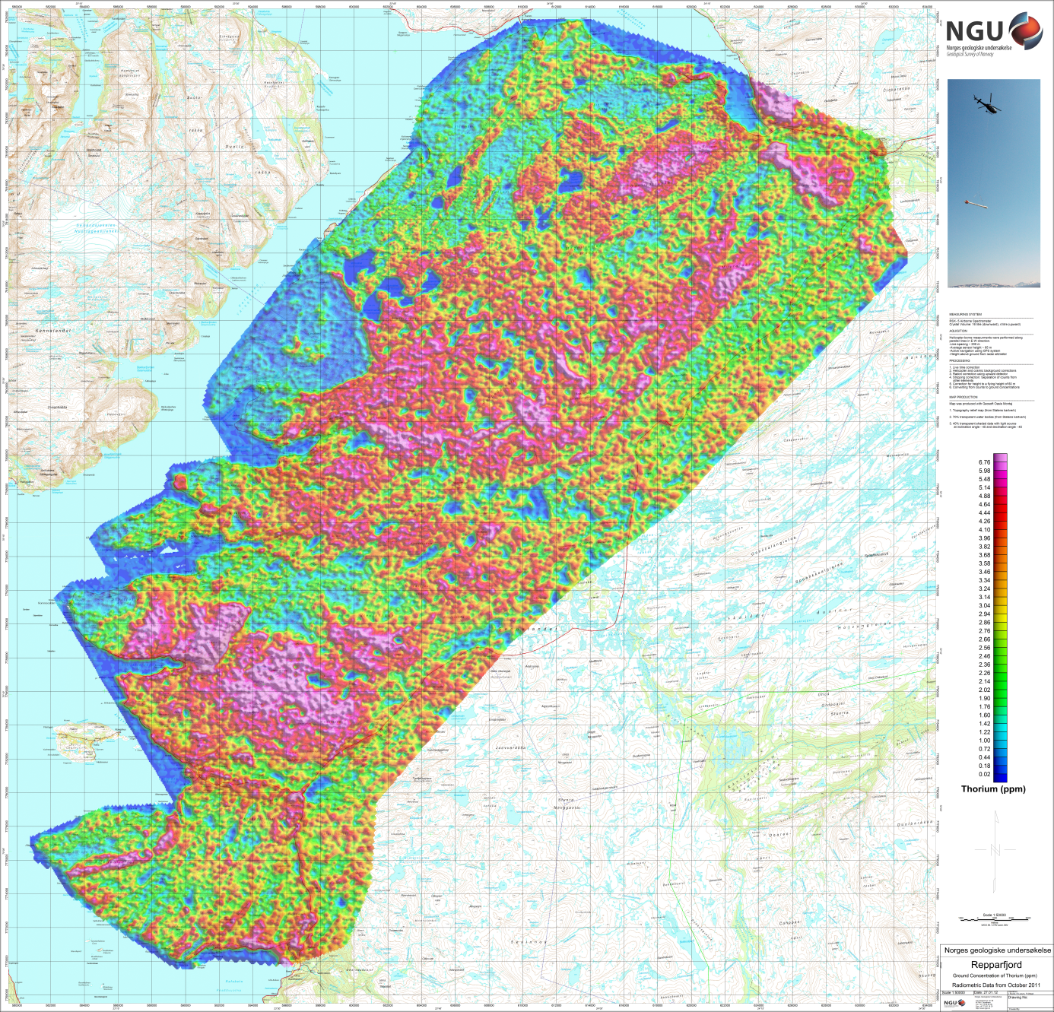
Figure 13: Thorium ground concentration

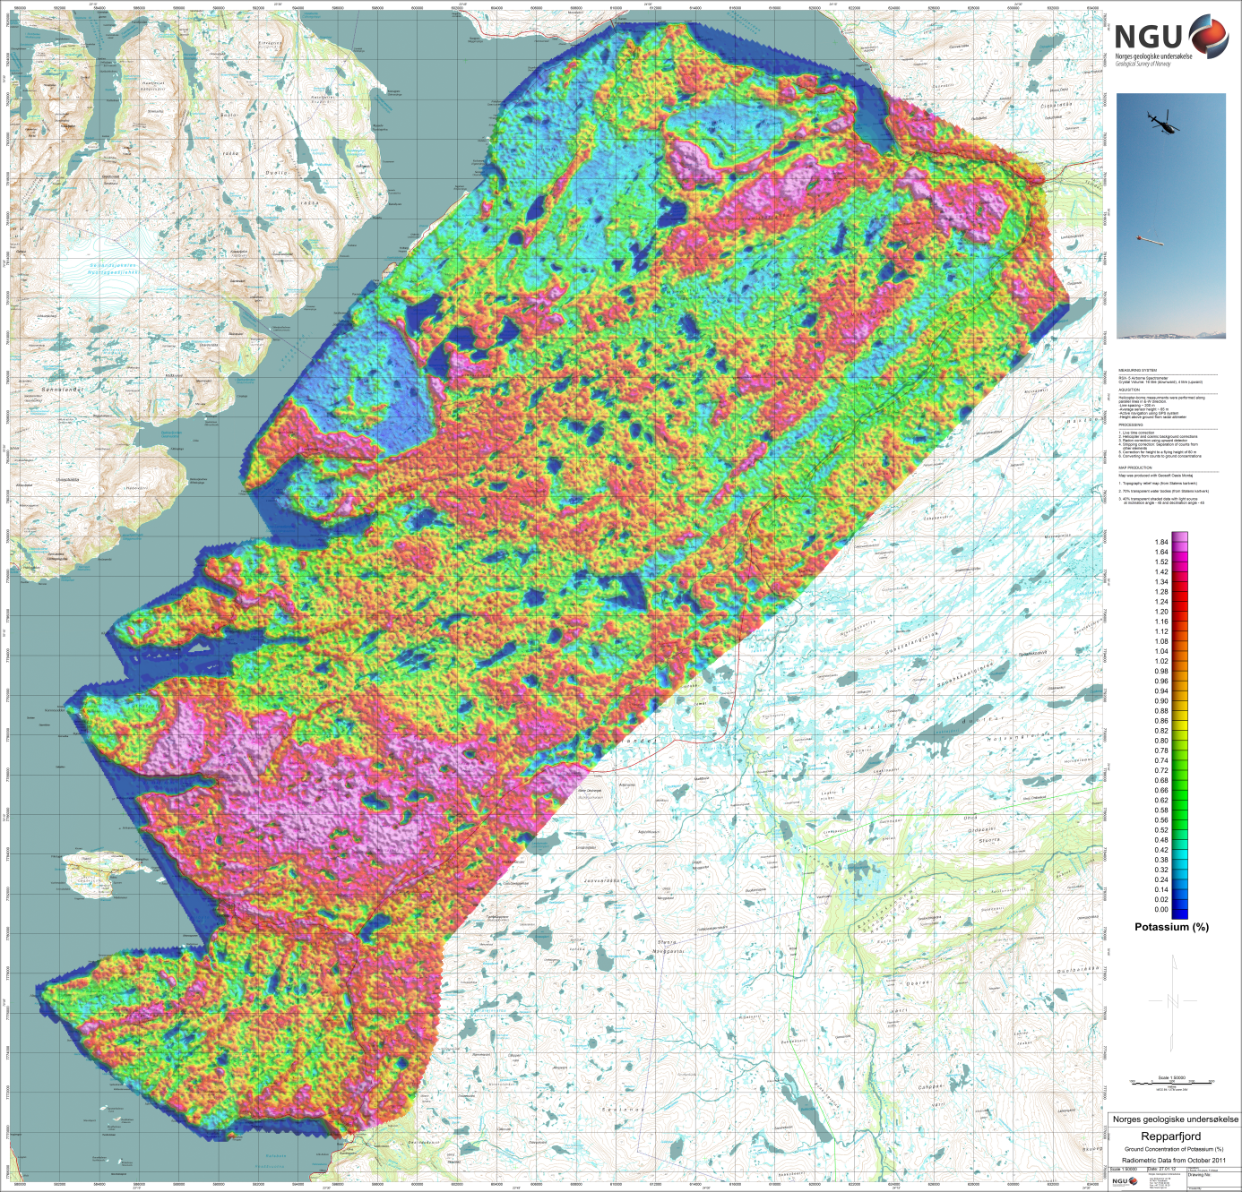
Figure 14: Potassium ground concentration

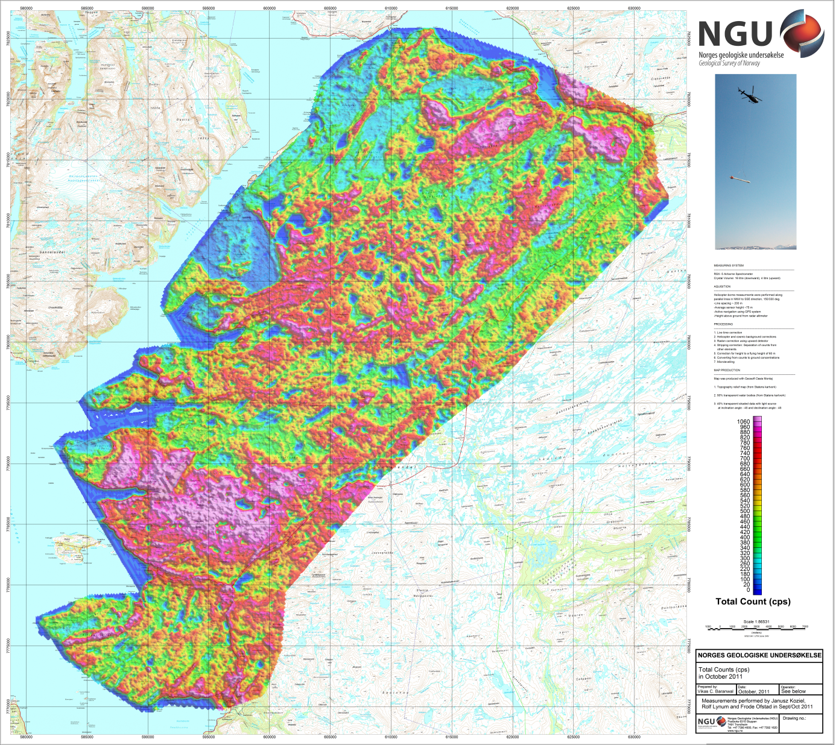
Figure 15: Radiometric Total Count

