NGU Report 2014.007

Helicopter-borne magnetic and radiometric geophysical survey at Austvågøya, Hinnøya, Tjeldøya and Hadseløya areas, in Troms and Nordland counties.

REPORT

Geological Survey of Norway  Postboks 6315 Sluppen  NO-7491 Trondheim, Norway  Tel.: 47 73 90 40 00  Telefax 47 73 92 16 20  Report no.: 2014.007 |  |  | ISSN 0800-3416 |  | Grading: Open
Title:
Helicopter-borne magnetic and radiometric geophysical survey at Austvågøya, Hinnøya, Tjeldøya and Hadseløya areas, in Troms and Nordland counties.
Authors:  Alexandros Stampolidis, Frode Ofstad and Vikas Baranwal |  |  |  | Client:  NGU
County:  Nordland and Troms |  |  |  | Municipalities:  Tjeldsund, Lødingen, Sortland, Hadsel og Vågan
Map-sheet name (M=1:250.000)  Narvik and Svolvær |  |  |  | Map-sheet no. and -name (M=1:50.000)  1331 IV Evenes 1332 III Tjeldsundet 1231 I Lødingen  1231 IV Raftsundet, 1232 II Gullesfjorden 1232 III Sortland 1132 II Stokmarknes, 1131 I Austvågøya
Deposit name and grid-reference: Hinnøya  WGS 84, UTM zone 33W, 530000 E, 7600000 N |  |  |  | Number of pages: 36 Price (NOK):  Map enclosures:
Fieldwork carried out:  July-August 2013 | Date of report:  March 10th 2014 |  |  | Project no.:  342900 |  |  | Person responsible:
Summary:
NGU conducted an airborne magnetic and radiometric survey over the Austvågøya, Hinnøya, Tjeldøya and Hadseløya islands, in Troms and Nordland counties between July-August 2013 as a part of the MINN project (Mineral resources in Northern Norway). This report describes and documents the acquisition, processing and visualization of recorded datasets. The geophysical survey results reported herein are approximately 8100 line km, covering an area of approximately 1620 km².

Two helicopter-borne systems were used in this survey. More than 95% of the measurements were done with a helicopter-borne system that was designed to obtain detailed airborne magnetic and radiometric data. It had a Scintrex Cs-3 magnetometer in a towed bird and a 1024 channels RSX-5 spectrometer installed under the helicopter belly. The other helicopter-borne system was similar, had a Scintrex Cs-2 for the magnetic field recordings and a similar 1024 channels RSX-5 spectrometer for gamma-rays installed under the helicopter.

The entire survey was flown with 200 m line spacing. The main flight line direction was 90º (E-W), but Hadseløya and Nipa, a small part of the western Hinnøya, were flown at 140º and 145º (NNE-SSW), respectively. The average speed over different parts of the surveyed areas ranged daily between 50 and 75 km/h, depending mainly on the local topography. The average terrain clearance of the bird for the whole survey was about 75 m.

Collected data were processed at NGU using Geosoft Oasis Montaj software. Raw total magnetic field data were corrected for diurnal variations and levelled using standard micro-levelling algorithm. Radiometric data were processed using standard procedures recommended by International Atomic Energy Association.

Data were gridded with a cell size of 50 x 50 m and presented as shaded relief maps at scales of 1:50.000 (Hadseløya) and1:80.000 (Austavågøya, Hinnøya, Tieldøya).

Keywords: |  | Geophysics |  |  |  | Airborne
Magnetic |  | Radiometric |  |  |  | Technical report

Table of Contents

1. INTRODUCTION 5

2. SURVEY SPECIFICATIONS 6
2.1 Airborne Survey Parameters 6
2.2 Airborne Survey Instrumentation 9
2.3 Airborne Survey Logistics Summary 9

3. DATA PROCESSING AND PRESENTATION 11
3.1 Total Field Magnetic Data 11
3.2 Radiometric data 13

4. PRODUCTS 17

5. REFERENCES 18

APPENDIX A1: Flow chart of magnetic processing 19
APPENDIX A2: Description of the Matlab code 19
APPENDIX A3: Flow chart of radiometry processing 19

TABLES

Table 1. Flight specifications of the surveyed areas 5
Table 2. Base station magnetometer locations (WGS-84, UTM-zone 33N) 7
Table 3. Instrument Specifications 9
Table 4. Survey Specifications Summary 9
Table 5. Specified channel windows for the 1024 RSX-5 systems used in this survey 13
Table 6. List of Geosoft XYZ files available from NGU on request. 17
Table 7. Maps available from NGU on request. 17

FIGURES

Figure 1: Surveyed areas.. 5
Figure 2: Base station magnetometer locations 7
Figure 3: A base station magnetometer (GEM GSM-19) 8
Figure 4: The first helicopter used in survey. 10
Figure 5: The second helicopter used in survey 10
Figure 6: An example of Gamma-ray spectrum 13
Figure 7: Total Magnetic Field anomaly Austvågøya-Hinnøya-Tjeldøya 21
Figure 8: Magnetic Vertical Gradient Austvågøya-Hinnøya-Tjeldøya 22
Figure 9: Magnetic Horizontal Gradient Austvågøya-Hinnøya-Tjeldøya 23
Figure 10: Magnetic Tilt Derivative Austvågøya-Hinnøya-Tjeldøya 24
Figure 11: Total Magnetic Field anomaly Hadseløya 25
Figure 12: Magnetic Vertical Gradient Hadseløya 26
Figure 13: Magnetic Horizontal Gradient Hadseløya 27
Figure 14: Magnetic Tilt Derivative Hadseløya 28
Figure 15: Uranium Ground Concentration Austvågøya-Hinnøya-Tjeldøya 29
Figure 16: Thorium Ground Concentration Austvågøya-Hinnøya-Tjeldøya 30
Figure 17: Potassium Ground Concentration Austvågøya-Hinnøya-Tjeldøya 31
Figure 18: Ternary Image of Radiation Concentrations Austvågøya-Hinnøya-Tjeldøya 32
Figure 19: Uranium Ground Concentration Hadseløya 33
Figure 20: Thorium Ground Concentration Hadseløya 34
Figure 21: Potassium Ground Concentration Hadseløya 35
Figure 22: Ternary Image of Radiation Concentrations Hadseløya 36

- INTRODUCTION

Recognising the impact that investment in mineral exploration and mining can have on the socio-economic situation of a region, the government of Norway initiated the MINN program (Mineral resources in North Norway). The goal of this program is to enhance the geological information that is relevant to an assessment of the mineral potential of the three northernmost counties. The airborne geophysical surveys - helicopter borne and fixed wing- are important integral parts of MINN program. The airborne survey results reported herein amount about 8100 line km (1620 km²) over the surveyed areas, as shown in Figure 1.

The surveyed area was divided into five sub-regions during the acquisition period. Area A is Hadseløya island and was flown at a NNW-SSE direction (140º). Area B eastern part of Austvågøya, area C southern part of Hinnøya, and D Tjeldøya island were flown at an East-West direction (90º). The last sub-region, E, is the small area called Nipa. It was flown by a different helicopter-borne system than the previous four areas, at a NNW-SSE direction (145º).

Table 1. Flight specifications of the surveyed areas
Sub-region | Name | Surveyed lines (km) | Surveyed area (Km²) | Flight direction | Average flight speed (km/h)
A | Hadseløya | 535 | 103 | NNW-SSE | 60
B | Austvågøya/Hinnøya | 1913 | 378 | E-W | 53
C | Hinnøya | 4577 | 925 | E-W | 75
D | Tjeldøya | 970 | 190 | E-W | 70
E | Nipa | 102 | 21 | NNW-SSE | 50
Total |  | 8097 | 1617

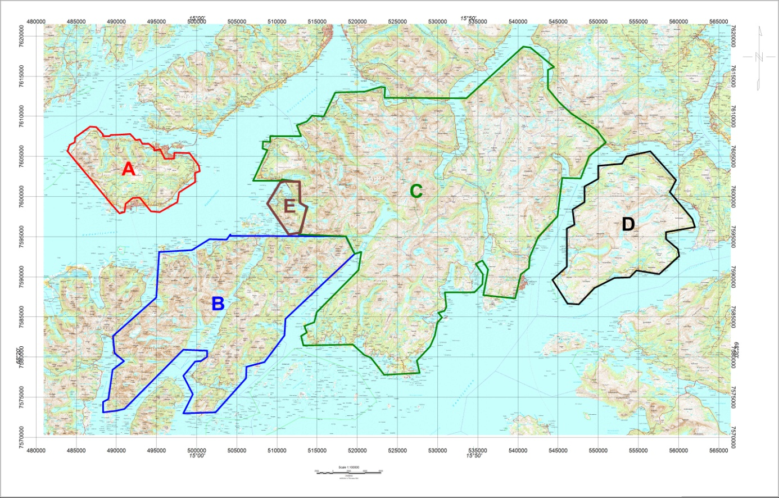
Figure 1: Surveyed areas. A. Hadseløya area (red line), B. Austvågøya/Hinnøya area (blue line), C. Hinnøya area (green line), D. Tjeldøya area (black line) and E. Nipa area (brown line).

The objective of the airborne geophysical survey was to obtain a dense high-resolution aero-magnetic and radiometric data set over the survey area. These data sets are required for the enhancement of a general understanding of the regional geology of the area. In this regard, the data can also be used to map contacts and structural features within the area. It also improves defining the potential of known zones of mineralization, their geological settings, and identifying new areas of interest.

The survey incorporated the use of a high-sensitivity Cesium magnetometers, gamma-ray spectrometers and radar altimeters. GPS navigation computer systems with flight path indicators ensured accurate positioning of the geophysical data with respect to the World Geodetic System 1984 geodetic datum (WGS-84).

- SURVEY SPECIFICATIONS

Airborne Survey Parameters
NGU used two helicopter-borne systems for the purposes of this survey.

The first system (fig. 4) had a optically pumped Cesium magnetometer (Cs-2) towed 30 meter below the helicopter for the magnetic field recordings and a 1024 channel RSX-5 gamma-ray spectrometer fixed under the belly of the helicopter to map ground concentrations of Uranium, Thorium and Potassium. This system was used to measure Nipa (sub-region E in fig 1.) and a few survey lines in Tjeldøya (sub-region D in fig 1.), and is described in more details in other NGU reports (i.e NGU Report 2013.047)

The second system (fig. 5), that made more than 95% of the measurements in this survey, is a helicopter-borne system that was designed to obtain detailed airborne magnetic and radiometric data. This system used a Scintrex Cs-3 housed in a 2 m long bird, towed 15 meters below the helicopter for the magnetic field recordings and a similar 1024 channel gamma-ray spectrometer to the one that was installed on the first system, to map ground concentrations of Uranium, Thorium and Potassium.

The airborne survey began on July 14th and ended on August 30th, 2013. A Eurocopter AS350-B2 from helicopter company HeliScan AS was used for the major part of the survey, while a Eurocopter AS350-B3 employed to fly over Nipa and some lines in Tjeldøya. The survey lines were spaced 200 m apart throughout the survey, but the fight direction was differing in some sub-regions as shown on Table 1. Instrument operation was performed by Heliscan AS employees.

Large water bodies, rugged terrain and abrupt changes in topography affected the pilot’s ability to ‘drape’ the terrain; therefore there are positive and negative variations in sensor height with respect to the standard helicopter height, which is defined as 60 m plus a height of obstacles (trees, power lines). The average survey height for the magnetometer was about 55m for the first system and about 80 m for the second system, while the spectrometer was at about 85m for the first system and about 95 m for the second system. Due to bad weather conditions in the acquisition period and the flight safety rules, parts of some profiles were flown at high altitudes. These data were discarded during the radiometric processing.

The ground speed of the aircraft varied from 40 – 120 km/h depending on topography, wind direction and its magnitude. On average the ground speed during the whole survey was about 70 km/h. The average ground speeds for each sub-region are given in Table 1.

Magnetic data were recorded at 0.2 second intervals resulting in approximately 4 m point spacing. Spectrometry data was recorded every 1 second giving a point spacing of approximately 20 meters.

The above parameters were designed to allow for sufficient detail in the data to detect subtle anomalies that may represent mineralization and/or rocks of different lithological and petro-physical composition.

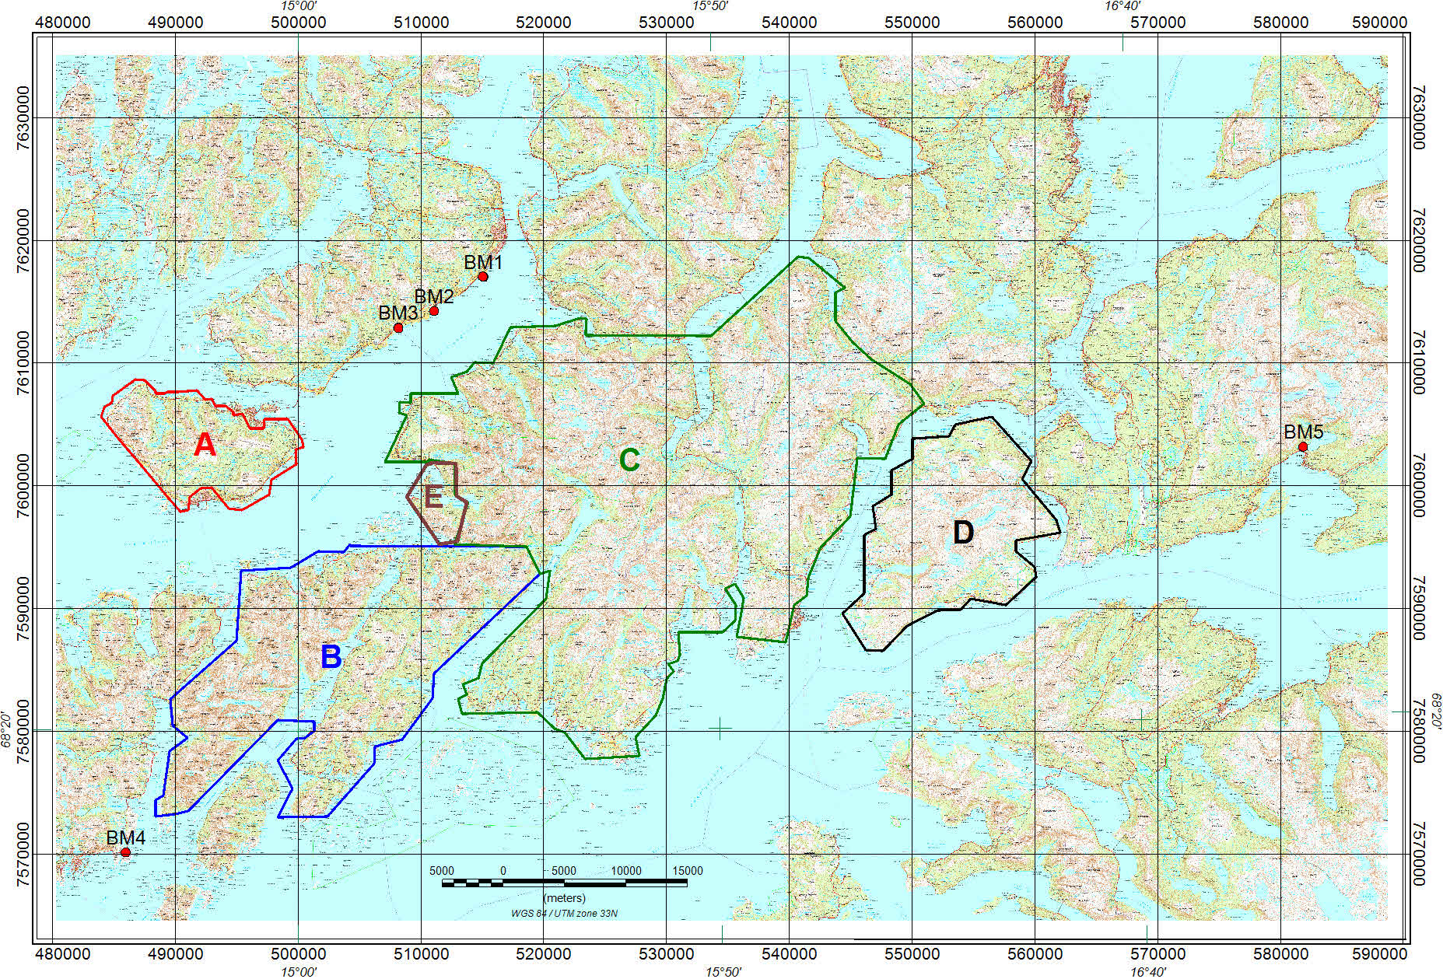
Figure 2: Base station magnetometer locations

A base magnetometer to monitor diurnal variations in the magnetic field, was installed close to the helicopter base during the whole survey period. The rough topography and the proximity to the areas under investigation impose changes to the helicopter base location, and therefore changes to the base magnetometer locations which are depicted on figure 2. Names and locations of the base magnetometer stations are given in Table 2.

Table 2. Base station magnetometer locations (WGS-84, UTM-zone 33N)
Base mag name | Location | UTM E  (m) | UTM N  (m) | Instrument | Sampling interval (sec)
BM1 | Sortland | 515050 | 7617050 | GEM GSM-19 | 3
BM2 | Sortland | 511060 | 7614250 | GEM GSM-19 | 3
BM3 | Sortland | 508150 | 7612860 | GEM GSM-19 | 3
BM4 | Svolvær | 485940 | 7570150 | GEM GSM-19 | 3
BM5 | Bogen | 581830 | 7603200 | GEM GSM-19  Scintrex CS3 | 3  1

A GEM GSM-19 base station magnetometer was used to record data every 3 seconds. The CPU clock of the magnetometer was synchronized through the built-in GPS receiver to permit subsequent removal of diurnal drift. During the last day of the acquisition a Scintrex Cs-3 magnetometer was used as base station instead. In order to bring the data from different base stations to the same level, complete recordings from the Andenes Observatory (540960E, 7687640N), for the whole period of the survey, were used as reference. The variations in the recorded magnetic field at the base stations were similar to those recorded at the magnetic observatory of Andenes, which lies just 70 km north of the surveyed area.

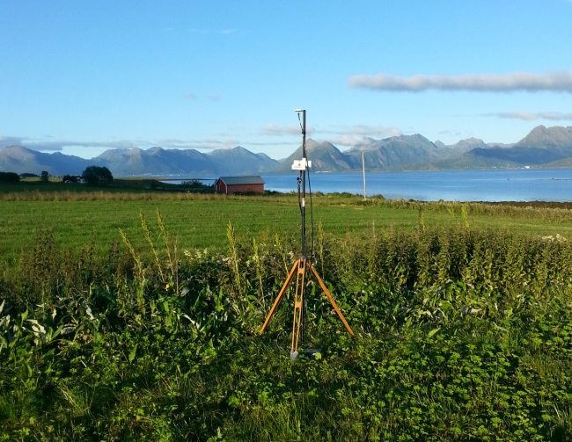
Figure 3: A base station magnetometer (GEM GSM-19) installed 8.5 km southwest of Sortland

Navigation system uses GPS/GLONASS satellite tracking systems to provide real-time WGS-84 coordinate locations for every second. The accuracy achieved with no differential corrections is reported to be ± 5 m in the horizontal directions. The GPS receiver antenna was mounted externally to the tail tip of the helicopter.

For quality control, the magnetic, radiometric, altitude and navigation data were monitored on two separate windows in the operator's display during flight while they were recorded in ASCII data streams to the acquisition PC hard disk drive.

Airborne Survey Instrumentation

Instrument specifications are given in table 3.

Table 3. Instrument Specifications
Instrument | Producer/Model | Accuracy / Sensitivity | Sampling frequency / interval
Magnetometer | Scintrex Cs-3  Scintrex Cs-2 | <2.5 nT  <2.5 nT | 5 Hz  5 Hz
Base magnetometer | GEM GSM-19  Scintrex Cs-3 | - nT  0.01 nT | 3 s  1 s
Gamma spectrometer | Radiation Solutions  RSX-5 | 1024 ch’s, 16 liters down, 4 liters up | 1 Hz
Radar altimeter | Bendix/King KRA 405B | ± 3 % 0 – 500 feet  ± 5 % 500 – 2500 feet | 1 Hz
Pressure/temperature | Honeywell PPT | ± 0.03 % FS | 1 Hz
Navigation | Topcon GPS-receiver | ± 5 meter | 1 Hz
Acquisition system | NGU custom software

The magnetic and radiometric, altitude and navigation data were monitored on the operator's displays during flight while they were recorded to the PC hard disk drive. Spectrometry data were also recorded to internal hard drive of the spectrometer. The data files were transferred to the field workstation via USB flash drive. The raw data files were backed up onto USB flash drive in the field.

Airborne Survey Logistics Summary
A summary of the survey specifications is shown in Table 4.

Table 4. Survey Specifications Summary
Parameter | Specifications
Traverse (survey) line spacing | 200 metres
Traverse line direction | E-W (sub-regions B,C and D)  NNW-SSE (sub-regions A and E)
Nominal aircraft ground speed | 40 - 120 km/h
Average sensor terrain clearance Mag | 55m (first system)  80m (second system)
Average sensor terrain clearance Rad | 85m (first system)  95m (second system)
Sampling rates:  Magnetometer  Spectrometer, GPS, altimeter | - seconds  1.0 second

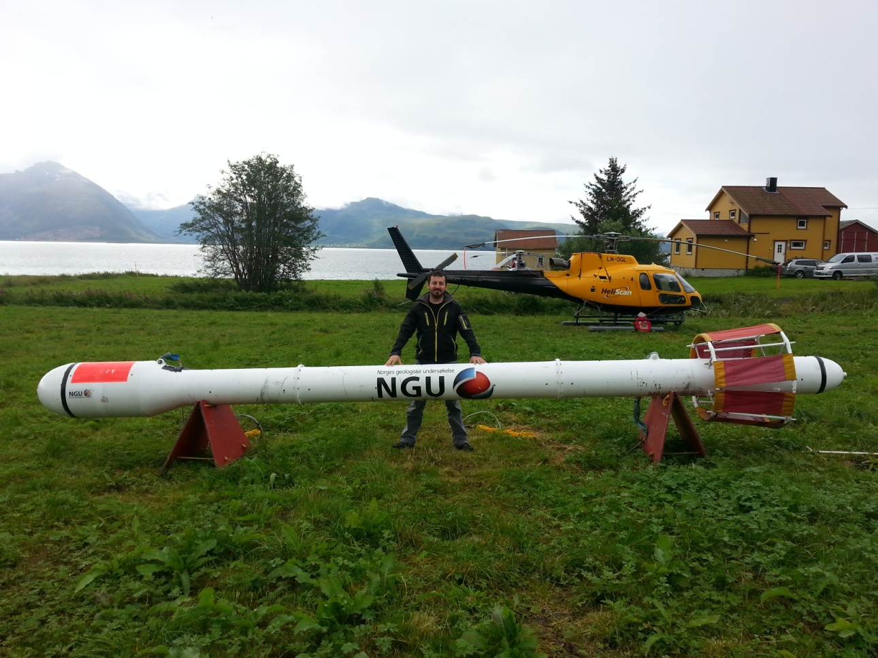
Figure 4: Operator A. Stampolidis with Hummingbird™ next to the first helicopter used in survey.

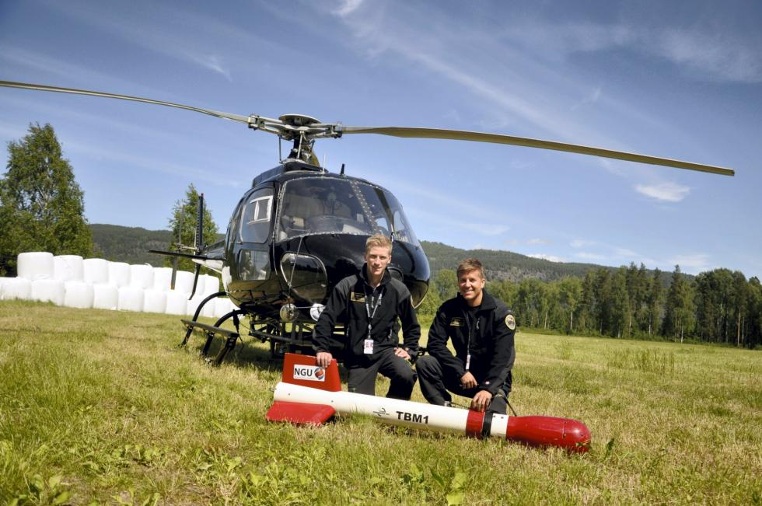
Figure 5: Pilots Småland and Lorentzen with Mag bird in front of the second helicopter used in survey. (P1)

- DATA PROCESSING AND PRESENTATION
All data were processed by Alexandros Stampolidis at NGU. The ASCII data files for each one of the five sub-regions were loaded into separate Oasis Montaj databases. The datasets were processed consequently according to processing flow charts shown in Appendix A1 and A3.

Total Field Magnetic Data
At the first stage the raw magnetic data of the five sub-regions were stored in different databases checked for spikes, using the 4th difference calculation as a flag. Obvious spikes were checked and then manually removed. The data from base stations were also inspected for spikes and spikes were removed manually if necessary. Typically, several corrections have to be applied to magnetic data before gridding – i.e. heading, lag and diurnal correction.

Special magnetic processing problems
The small wing area of the bird and the relative low flight speed during parts of the survey, caused the bird to swing with a pendulum effect. The 15 m rope gave this pendulum motion a period of about 7.5 seconds. The effect of the swinging motion was clearly visible in the magnetic data and made it necessary to apply a special filter in order to reduce the noise that was prominent in parts of the survey. This was achieved using a Matlab code developed by Alexandros Stampolidis (see description on Appendix A2). This step was applied before the diurnal corrections.

Diurnal Corrections
The temporal fluctuations in the magnetic field of the earth affect the total magnetic field readings during the airborne survey. This is commonly referred to as the magnetic diurnal variation. These fluctuations can be effectively removed from the airborne magnetic dataset by using a stationary reference magnetometer that records the magnetic field of the earth at a given short time interval. Magnetic diurnals that were recorded on the base station magnetometers, were within the standard NGU specifications during the entire survey (Rønning 2013).

From 14/7 to 24/8 diurnal variations were measured with a GEM GSM-19 base station magnetometer, while on 30/8 a Scintrex Cs-3 magnetometer was employed. The base station computer clock was continuously synchronized with GPS clock. The recorded data are merged with the airborne data and the diurnal correction is applied according to equation (1).

, (1)
Where:

The average datum base level () was set equal to 52510.8 nT for the entire survey, allowing us to bring all recorded magnetic data to a common level.

Corrections for Lag and heading
Neither a lag nor cloverleaf tests were performed before the survey. According to previous reports the lag between logged magnetic data and the corresponding navigational data was 1-2 fids. Translated to a distance it would be no more than 10 m - the value comparable with the precision of GPS. A heading error for a towed system is usually either very small or non-existent. So no lag and heading corrections were applied.

Magnetic data processing, gridding and presentation
The total field magnetic anomaly data () were calculated from the diurnal corrected data
() after subtracting the IGRF for the surveyed area calculated for the data period (eq.2)
(2)

The databases of Austvågøya/Hinnøya (B in fig.1), Hinnøya (B and C in fig.1) and Tjeldøya (D in fig.1), that were measured in the same flight direction (E-W), were joined in a single one after the IGRF correction processing step.

The total field anomaly data were split in lines and then were gridded using a minimum curvature method with a grid cell size of 50 meters. This cell size is equal to one quarter of the 200m average line spacing. In order to remove small line-to-line levelling errors that were detected on the gridded magnetic anomaly data, the Geosoft Micro-levelling technique was applied on the flight line based magnetic database. Then, the micro-levelled channel was gridded using again a minimum curvature method with 50 m grid cell size.

The processing steps of magnetic data presented so far were performed on point basis. The following steps are performed on grid basis. The Horizontal and Vertical Gradient along with the Tilt Derivative of the total magnetic anomaly were calculated from the micro-levelled total magnetic anomaly grid. The magnitude of the horizontal gradient was calculated according to equation (3)
(3)

where is the micro-levelled field. The vertical gradient (VG) was calculated by applying a vertical derivative convolution filter to the micro-levelled field. The Tilt derivative (TD) was calculated according to the equation (4)
(4)

The last step in the magnetic data processing involved a low pass Fourier filter applied on the gridded micro-levelled data. The cutoff wavelength was set equal to 300m (LP300). The gradients and Tilt derivative were recalculated setting LP300 as input grid in the calculations.

The produced grids for Austavågøya-Hinnøya-Tjeldøya were knitted together with grids for the small sub-region Nipa (E in fig.1) using the overlapping region to suture the grids. The grids of the large area (Austavågøya-Hinnøya-Tjeldøya) were kept unaltered and only changes on the Nipa grids were allowed during the knitting.

The results are presented in two series of coloured shaded relief maps, one for Hadseløya (1:50000) and one for the rest of sub-regions (1:80000). The maps for each series are:
- Total field magnetic anomaly
- Horizontal gradient of total magnetic anomaly
- Vertical gradient of total magnetic anomaly
- Tilt angle (or Tilt Derivative) of the total magnetic anomaly
and they are representative of the distribution of magnetization over the surveyed areas. A list of the produced maps is shown on Table 7.

Radiometric data
Airborne gamma-ray spectrometry measures the abundance of Potassium (K), Thorium (eTh), and Uranium (eU) in rocks and weathered materials by detecting gamma-rays emitted due to the natural radioelement decay of these elements. The data analysis method is based on the IAEA recommended method for U, Th and K (International Atomic Energy Agency, 1991; 2003). A short description of the individual processing steps of that methodology as adopted by NGU is given bellow:

Energy windows
The Gamma-ray spectra were initially reduced into standard energy windows corresponding to the individual radio-nuclides K, U and Th. Figure 6 shows an example of a Gamma-ray spectrum and the corresponding energy windows and radioisotopes (with peak energy in MeV) responsible for the radiation.

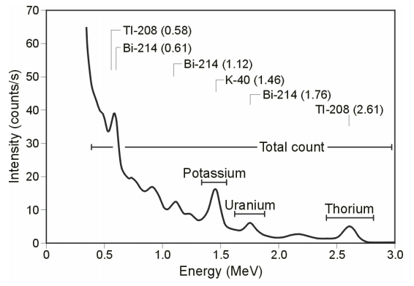
Figure 6: An example of Gamma-ray spectrum showing the position of the K, Th, U and Total count windows.

Table 5. Specified channel windows for the 1024 RSX-5 systems used in this survey
Gamma-ray spectrum | Cosmic | Total count | K | U | Th
Down | 1022 | 134-934 | 454-521 | 551-617 | 801-934
Up | 1022 |  |  | 551-617
Energy windows (MeV) | >3.07 | 0.41-2.81 | 1.37-1.57 | 1.66-1.86 | 2.41-2.81
The RSX-5 is a 1024 channel system with four downward and one upward looking detectors, which means that the actual Gamma-ray spectrum is divided into 1024 channels. The first channel is reserved for the “Live Time” and the last for the Cosmic rays. Table 5 shows the channels that were used for the reduction of the spectrum.

Live Time correction
The data were corrected for live time. “Live time” is an expression of the relative period of time the instrument was able to register new pulses per sample interval. On the other hand “dead time” is an expression of the relative period of time the system was unable to register new pulses per sample interval. The relation between “dead” and “live time” is given by the equation (5)
“Live time” = “Real time” – “Dead time” (5)
where the “real time” or “acquisition time” is the elapsed time over which the spectrum is accumulated (1 second).

The live time correction is applied to the total count, Potassium, Uranium, Thorium, upward Uranium and cosmic channels. The formula used to apply the correction is as follows:
(6)
where C_{LT} is the live time corrected channel in counts per second, C_{RAW} is the raw channel data in counts per second and Live Time is in microseconds.

Cosmic and aircraft correction
Background radiation resulting from cosmic rays and aircraft contamination was removed from the total count, Potassium, Uranium, Thorium, upward Uranium channels using the following formula:
(7)

where C_{CA} is the cosmic and aircraft corrected channel, C_{LT} is the live time corrected channel a_{c} is the aircraft background for this channel, b_{c} is the cosmic stripping coefficient for this channel and C_{Cos} is the low pass filtered cosmic channel.

Radon correction
The upward detector method, as discussed in IAEA (1991), was applied to remove the effects of the atmospheric radon in the air below and around the helicopter. Usages of over-water measurements where there is no contribution from the ground, enabled the calculation of the coefficients (a_{C} and b_{C}) of the linear equations that relate the cosmic corrected counts per second of Uranium channel with total count, Potassium, Thorium and Uranium upward channels over water. Data over-land was used in conjunction with data over-water to calculate the a₁ and a₂ coefficients used in equation (8) for the determination of the Radon component in the downward uranium window:
(8)
where Radon_{u} is the radon component in the downward uranium window, Uup_{CA} is the filtered upward uranium, U_{CA} is the filtered Uranium, Th_{CA} is the filtered Thorium, a₁, a₂, a_{U} and a_{Th} are proportional factors and b_{U} an b_{Th} are constants determined experimentally.

The effects of Radon in the downward Uranium are removed by simply subtracting Radon_{U} from U_{CA}. The effects of radon in the other channels are removed using the following formula:
(9)

where C_{RC} is the Radon corrected channel, C_{CA} is the cosmic and aircraft corrected channel, Radon_{U} is the Radon component in the downward uranium window, a_{C} is the proportionality factor and b_{C} is the constant determined experimentally for this channel from over-water data.
The same coefficients that were determined from survey data over land and water at Austvågøya-Hinnøya were used for the Radon correction in every sub-region.

Compton Stripping
Potassium, Uranium and Thorium Radon corrected channels, are subjected to spectral overlap correction. Compton scattered gamma rays in the radio-nuclides energy windows were corrected by window stripping using Compton stripping coefficients determined from measurements on calibrations pads at the Geological Survey of Norway in Trondheim (for values, see Appendix A3).

The stripping corrections are given by the following formulas:

(10)

(11)
(12)
(13)

where U_{RC}, Th_{RC}, K_{RC} are the radon corrected Uranium, Thorium and Potassium and a, b, g, α, β, γ are Compton stripping coefficients.

Reduction to Standard Temperature and Pressure
The radar altimeter data were converted to effective height (H_{STP}) using the acquired temperature and pressure data, according to the expression:
(14)
where H is the smoothed observed radar altitude in meters, T is the measured air temperature in degrees Celsius and P is the measured barometric pressure in millibars.

Height correction
Variations caused by changes in the aircraft altitude relative to the ground was corrected to a nominal height of 60 m. Data recorded at the height above 150 m were considered as non-reliable and removed from processing. Total count, Uranium, Thorium and Potassium stripped channels were subjected to height correction according to the equation:
(15)

where C_{ST} is the stripped corrected channel, C_{ht} is the height attenuation factor for that channel and H_{STP} is the effective height.

Conversion to ground concentrations
Finally, corrected count rates were converted to effective ground element concentrations using calibration values derived from calibration pads at the Geological Survey of Norway in Trondheim (for values, see Appendix A3). The corrected data provide an estimate of the apparent surface concentrations of Potassium, Uranium and Thorium (K, eU and eTh). Potassium concentration is expressed as a percentage, equivalent Uranium and Thorium as parts per million. Uranium and Thorium are described as “equivalent” since their presence is inferred from gamma-ray radiation from daughter elements (²¹⁴Bi for Uranium, ²⁰⁸TI for Thorium). The concentration of the elements is calculated according to the following expressions:
(16)

where C_{60m} is the height corrected channel, C_{SENS_60m} is experimentally determined sensitivity reduced to the nominal height (60m).

Spectrometry data gridding and presentation
Gamma-rays from Potassium, Thorium and Uranium emanate from the uppermost 30 to 40 centimetres of soil and rock in the crust (Minty, 1997). Variations in the concentrations of these radioelements largely related to changes in the mineralogy and geochemistry of the Earth’s surface.

The spectrometry data were stored in different databases, one for each sub-region, and the ground concentrations were calculated following the processing steps. A list of the parameters used in these steps is given in Appendix A3.

Subsequently, databases of Austvågøya/Hinnøya (B in fig.1), Hinnøya (C in fig.1) and Tjeldøya (D in fig.1) were joined into a single database. Then the data were split in lines and ground concentrations of the three main natural radio-elements Potassium, Thorium and Uranium and total gamma-ray flux (total count) were gridded using a minimum curvature method with a grid cell size of 50 meters. This cell size is equal to one quarter of the 200m average line spacing. In order to remove small line-to-line levelling errors appeared on those grids, the data were micro-levelled as in the case of the magnetic data, and re-gridded with the same grid cell size. Finally, a 3x3 convolution filter was applied to smooth the microlevelled concentration grids.

Grid knitting was also applied to join Nipa data as in the magnetic case. A list of the produced maps is shown on Table 7.

Quality of the radiometric data was within standard NGU specifications (Rønning 2013). For further reading regarding standard processing of airborne radiometric data, we recommend the publications from Minty et al. (1997).

- PRODUCTS
Processed digital data from the survey are presented as:
- Geosoft XYZ files as show in table 6:

Table 6. List of Geosoft XYZ files available from NGU on request.
no. | Name | Mag | Rad
1 | Austvågøya-Hinnøya-Tjeldøya | √ | √
2 | Hadseløya | √ | √
3 | Nipa | √ | √

- Georeferenced tiff files (Geo-tiff).

- Coloured maps (jpg) at the scale 1:50.000 for Hadseløya and 1:80.000 for the Austvågøya-Hinnøya-Tjeldøya are available from NGU on request (see Table 7.).

Table 7. Maps available from NGU on request.
Region | Map # | Scale | Name
Austvågøya  Hinnøya  Tjeldøya | 2014.007-01 | 1:80000 | Total filed magnetic anomaly
 | 2014.007-02 | 1:80000 | Magnetic Vertical Derivative
 | 2014.007-03 | 1:80000 | Magnetic Horizontal Derivative
 | 2014.007-04 | 1:80000 | Magnetic Tilt Derivative
Hadseløya | 2014.007-05 | 1:50000 | Total filed magnetic anomaly
 | 2014.007-06 | 1:50000 | Magnetic Vertical Derivative
 | 2014.007-07 | 1:50000 | Magnetic Horizontal Derivative
 | 2014.007-08 | 1:50000 | Magnetic Tilt Derivative
Austvågøya  Hinnøya  Tjeldøya | 2014.007-09 | 1:80000 | Uranium ground concentration
 | 2014.007-10 | 1:80000 | Thorium ground concentration
 | 2014.007-11 | 1:80000 | Potassium ground concentration
 | 2014.007-12 | 1:80000 | Radiometric Ternary Map
Hadseløya | 2014.007-13 | 1:50000 | Uranium ground concentration
 | 2014.007-14 | 1:50000 | Thorium ground concentration
 | 2014.007-15 | 1:50000 | Potassium ground concentration
 | 2014.007-16 | 1:50000 | Radiometric Ternary Map

Downscaled images of the maps are shown on figures 7 to 22.

- REFERENCES

Geosoft 2010: Montaj MAGMAP Filtering, 2D-Frequency Domain Processing of Potential Field Data, Extension for Oasis Montaj v 7.1, Geosoft Corporation

Geotech 1997: Hummingbird Electromagnetic System. User manual, Geotech Ltd, October 1997

Grasty, R.L., Holman, P.B. & Blanchard 1991: Transportable Calibration pads for ground and airborne Gamma-ray Spectrometers. Geological Survey of Canada, Paper 90-23: 62 pp.

IAEA 1991: Airborne Gamma-Ray Spectrometry Surveying, Technical Report No 323, Vienna, Austria, 97 pp.

IAEA 2003: Guidelines for radioelement mapping using gamma ray spectrometry data. IAEA-TECDOC-1363, Vienna, Austria, 173 pp.

Minty, B.R.S. 1997: The fundamentals of airborne gamma-ray spectrometry. AGSO Journal of Australian Geology and Geophysics, 17 (2): 39-50.

Minty, B.R.S., Luyendyk, A.P.J. and Brodie, R.C. 1997: Calibration and data processing for gamma-ray spectrometry. AGSO Journal of Australian Geology and Geophysics, 17(2): 51-62.

Naudy, H. and Dreyer, H. 1968: Non-linear filtering applied to aeromagnetic profiles. Geophysical Prospecting, 16(2): 171-178.

Rønning, J.S. 2013: NGUs helikoptermålinger. Plan for sikring og kontroll av datakvalitet. NGU Intern rapport 2013.001, (38 sider).

P1: Photo by Mari Nymoen, Telen Newspaper, Notodden

APPENDIX A1: Flow chart of magnetic processing
Meaning of parameters is described in the referenced literature.

Processing flow:

- Quality control.
- Visual inspection of airborne data and manual spike removal
- Inspection of basemag data and removal of spikes
- Special Matlab convolution lowpass-filter for removal of 7.5 sec pendulum noise
- Import basemag data to Geosoft database
- Correction of data for diurnal variation and IGRF
- Splitting flight data by lines
- Gridding
- Micro-leveling
- USGS 2D-Frequency Domain filtering to remove high frequency noise and smooth data
- Grid knitting

APPENDIX A2: Description of the Matlab code
The code is being used to filter the “pendulum effect” periodic noise on the magnetic data. The data are filtered by calling a Matlab built-in convolution routine called “conv” that convolves the input data vector with a vector that has coefficients of Gaussian lowpass filter at a certain frequency (Freq.1).

If the differences between the input and the filtered data are above a predefined threshold, this part of the data is reprocessed be employing a less severe filter (Freq.2) on the input data. Again a threshold is applied on the differences between the input and the filtered data and in this case if the differences are above the threshold then the input data are retained for that part on the final filtered dataset.

These steps enable us to preserves the amplitudes of strong anomalies in the data, which will be lost otherwise by typical convolution or Fourier filtering. The cutoff frequency that were used were Freq.1=0.04Hz and Freq.2=0.09Hz.

APPENDIX A3: Flow chart of radiometry processing
Underlined processing stages are applied to the K, U, Th and TC windows.
Meaning of parameters is described in the referenced literature.

Processing flow:
- Quality control
- Airborne and cosmic correction (IAEA, 2003)
Used parameters: (determined by high altitude calibration flights near Langoya in July 2013 for the first system and at Frosta in May 2013 for the second system)

Channel | Aircraft background counts |  | Cosmic background counts
 | first system | second system | first system | second system
K | 7.33 | 5.36 | 0.0617 | 0.0570
U | 0.90 | 1.43 | 0.0454 | 0.0467
Th | 0.89 | 0.00 | 0.0647 | 0.0643
Uup | 0.39 | 0.70 | 0.0423 | 0.0448
Total counts | 36.29 | 42.73 | 1.0379 | 1.0317

- Radon correction using upward detector method (IAEA, 2003)
Used parameters (determined from survey data over water and land at Austvågøya-Hinnøya):

Coefficient | Value | Coefficient | Value
a_{u} | 0.34094 | b_{u} | 0.0
a_{K} | 1.05146 | b_{K} | 1.2984
a_{Th} | 0.06509 | b_{Th} | 0.76857
a_{TC} | 20.4086 | b_{TC} | 0.0
a₁ | 0.0857759 | a₂ | 0.0173623

- Stripping correction (IAEA, 2003)
Used parameters (determined from measurements on calibrations pads at the NGU in May 2013):

Coefficient | first system | second system
a | 0.049524 | 0.046856
b | 0 | 0
c | 0 | 0
α | 0.29698 | 0.30346
β | 0.47138 | 0.47993
γ | 0.82905 | 0.82316

- Height correction to a height of 60 m
Used parameters (determined by high altitude calibration flights at Frosta in Jan 2014):
Attenuation factors in 1/m:

Channel | first system | second system
K | -0.008884 | -0.009523
U | -0.006528 | -0.006687
Th | -0.006617 | -0.007394
TC | -0.007331 | -0.00773

- Converting counts at 60 m heights to element concentration on the ground
Used parameters (determined from measurements on calibrations pads at the NGU in May 2013):
Sensitivity (elements concentrations per count):

Channel | first system | second system
K (%/count) | 0.007544793 | 0.007457884
U (ppm/count) | 0.088909372 | 0.087729968
Th (ppm/count) | 0.151433049 | 0.156658412

- Microlevelling using Geosoft menu and smoothening by a convolution filtering

Microlevelling parameters | values
De-corrugation cutoff wavelength (m) | 2000
Cell size for gridding (m) | 50
Naudy (1968) Filter length (m) | 800

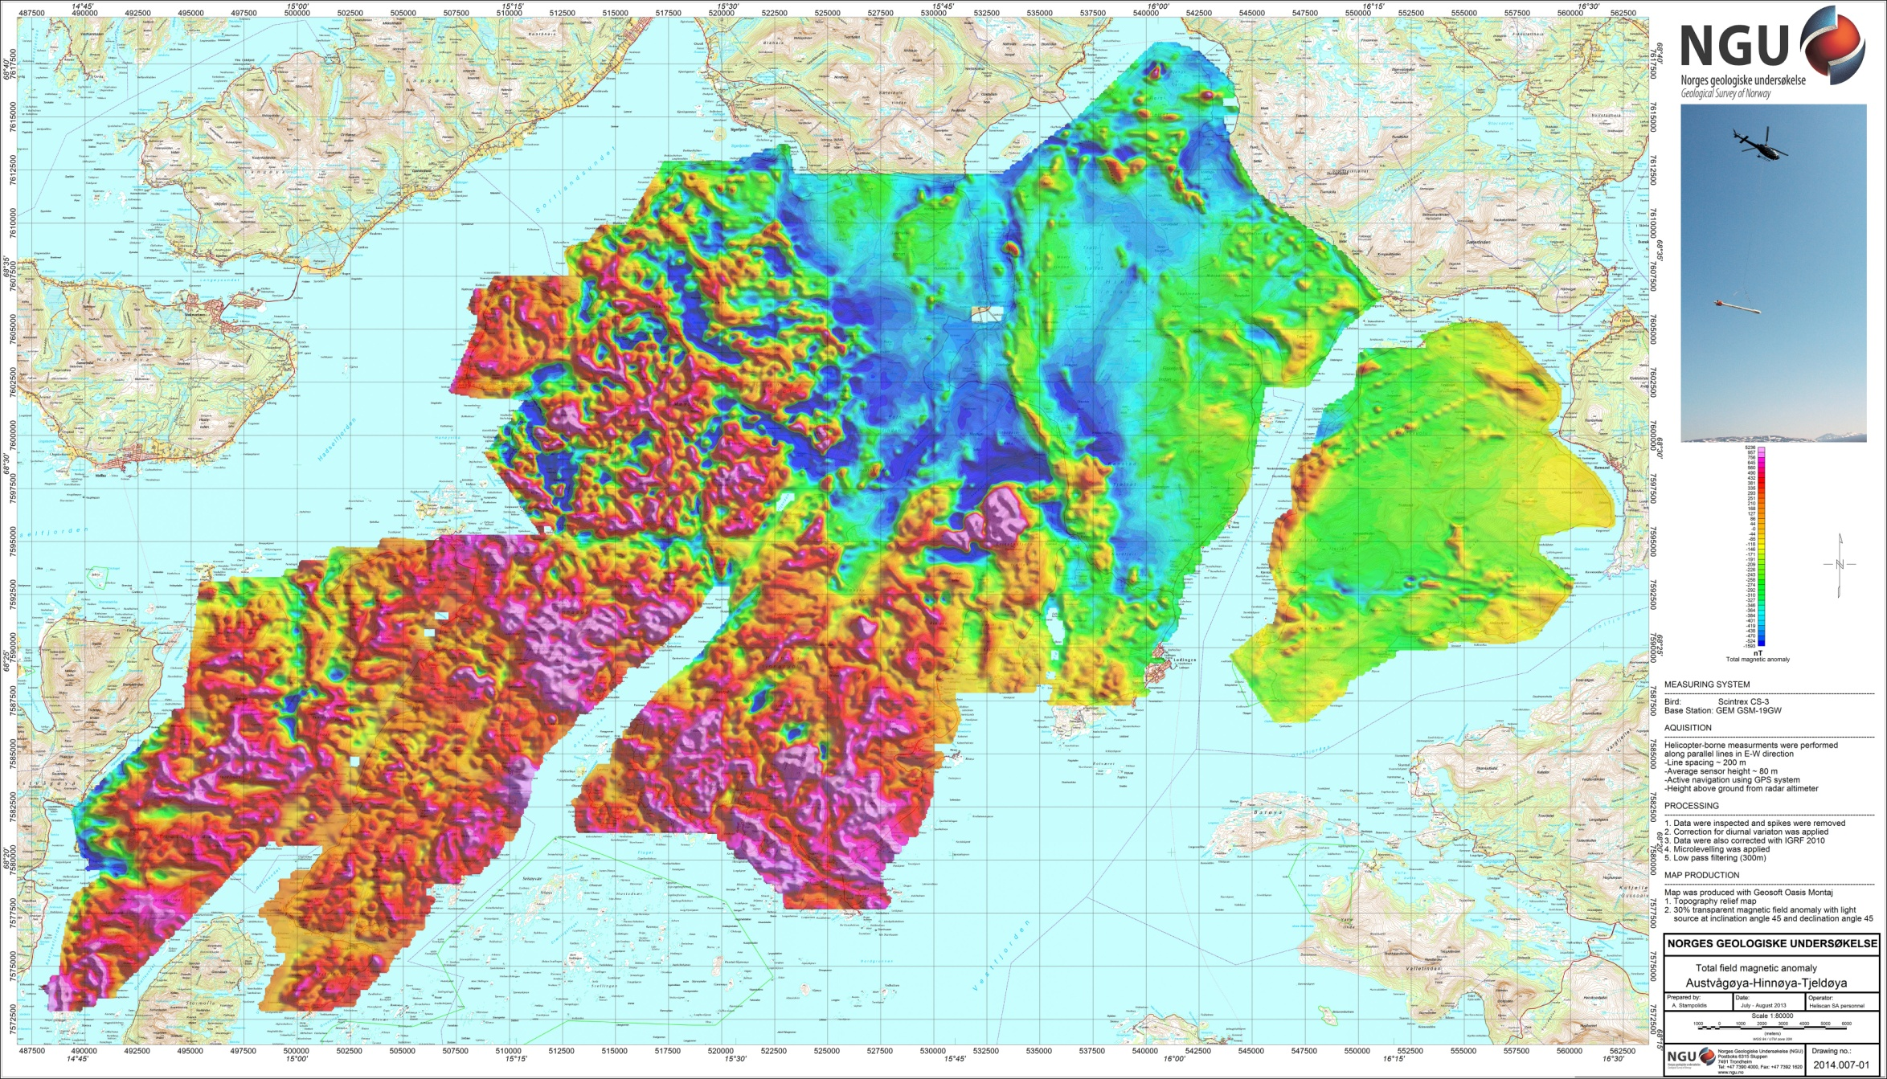
Figure 7: Total Magnetic Field anomaly Austvågøya-Hinnøya-Tjeldøya

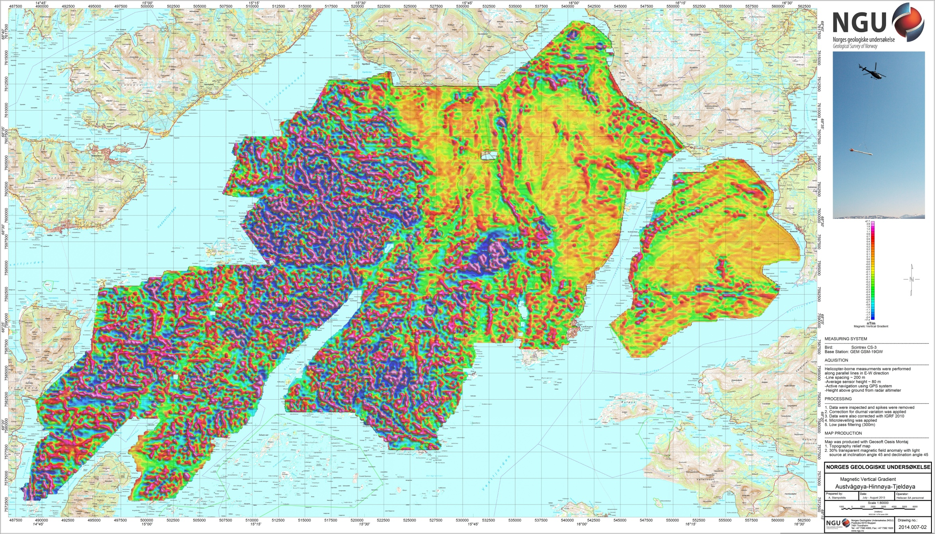
Figure 8: Magnetic Vertical Gradient Austvågøya-Hinnøya-Tjeldøya

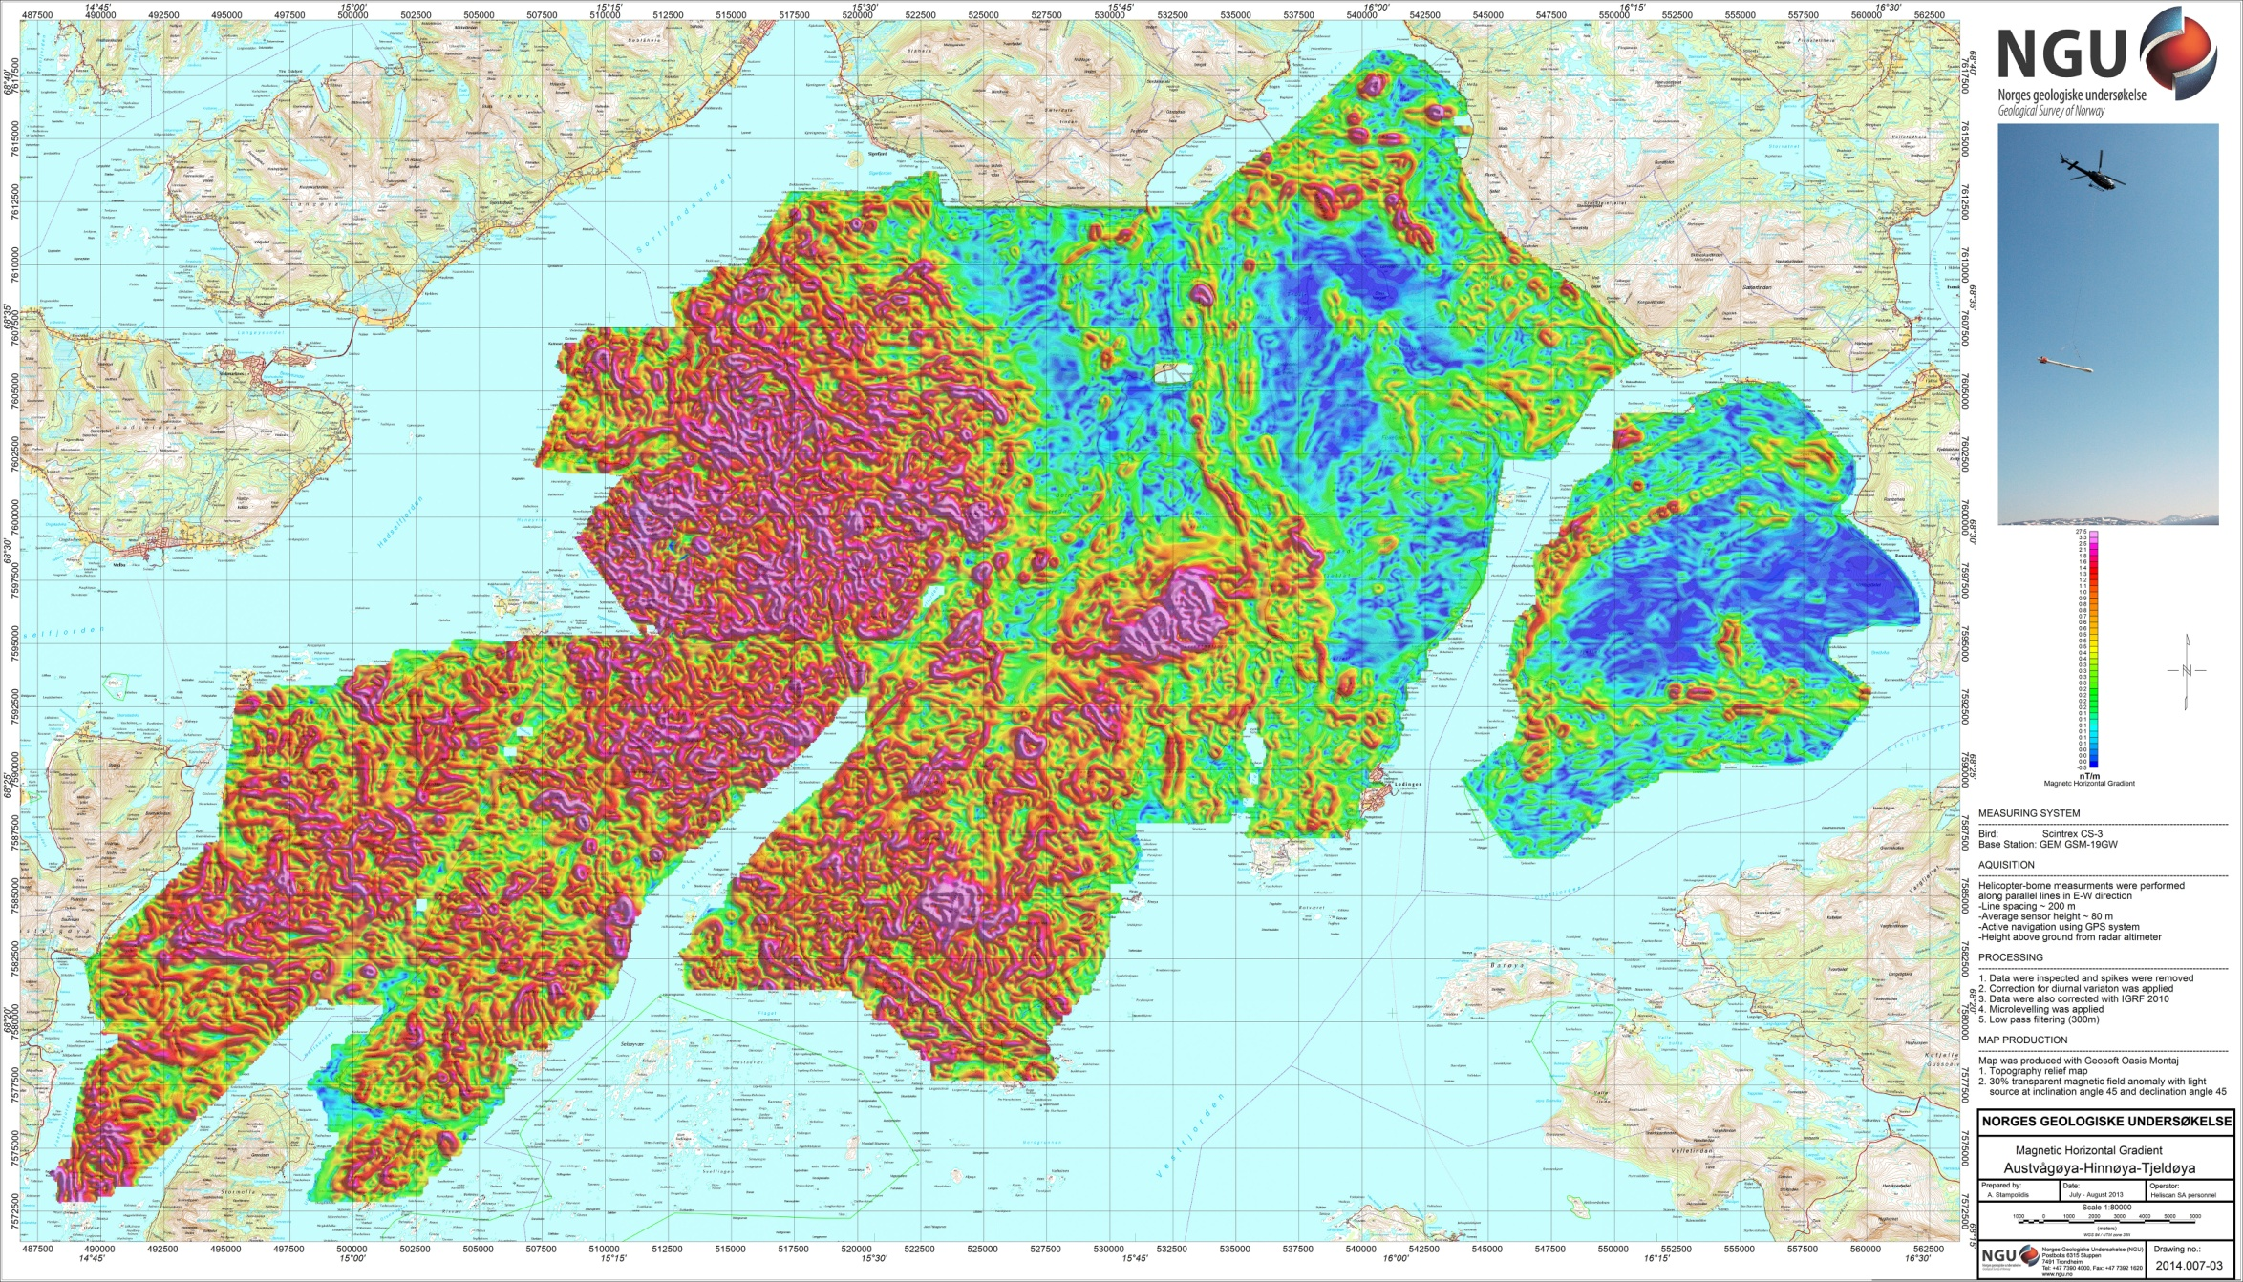
Figure 9: Magnetic Horizontal Gradient Austvågøya-Hinnøya-Tjeldøya

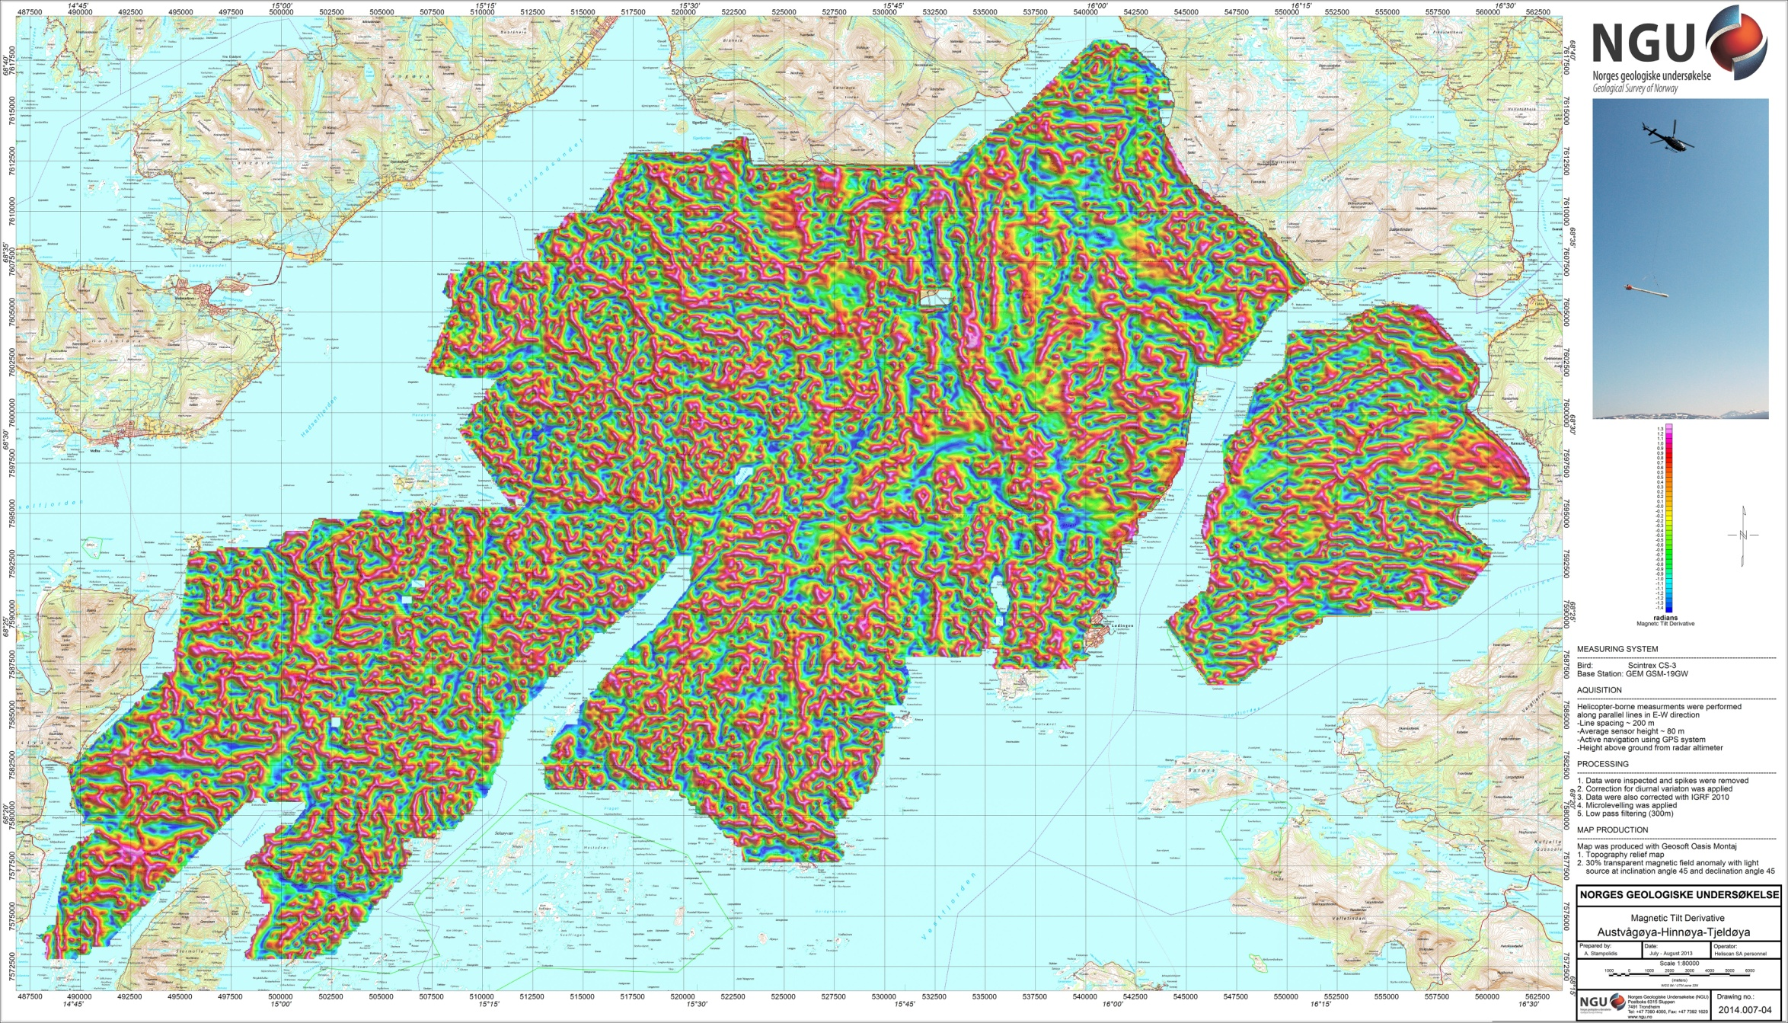
Figure 10: Magnetic Tilt Derivative Austvågøya-Hinnøya-Tjeldøya

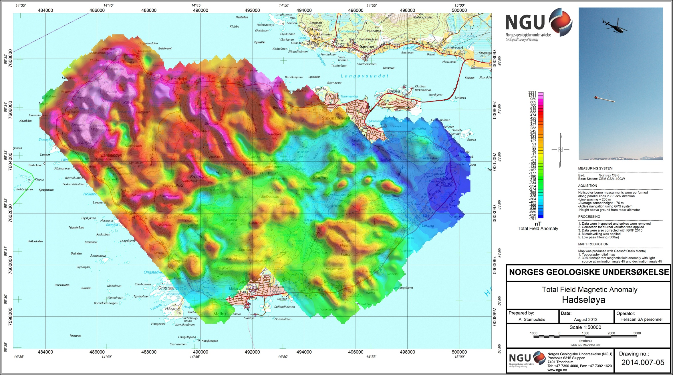
Figure 11: Total Magnetic Field anomaly Hadseløya

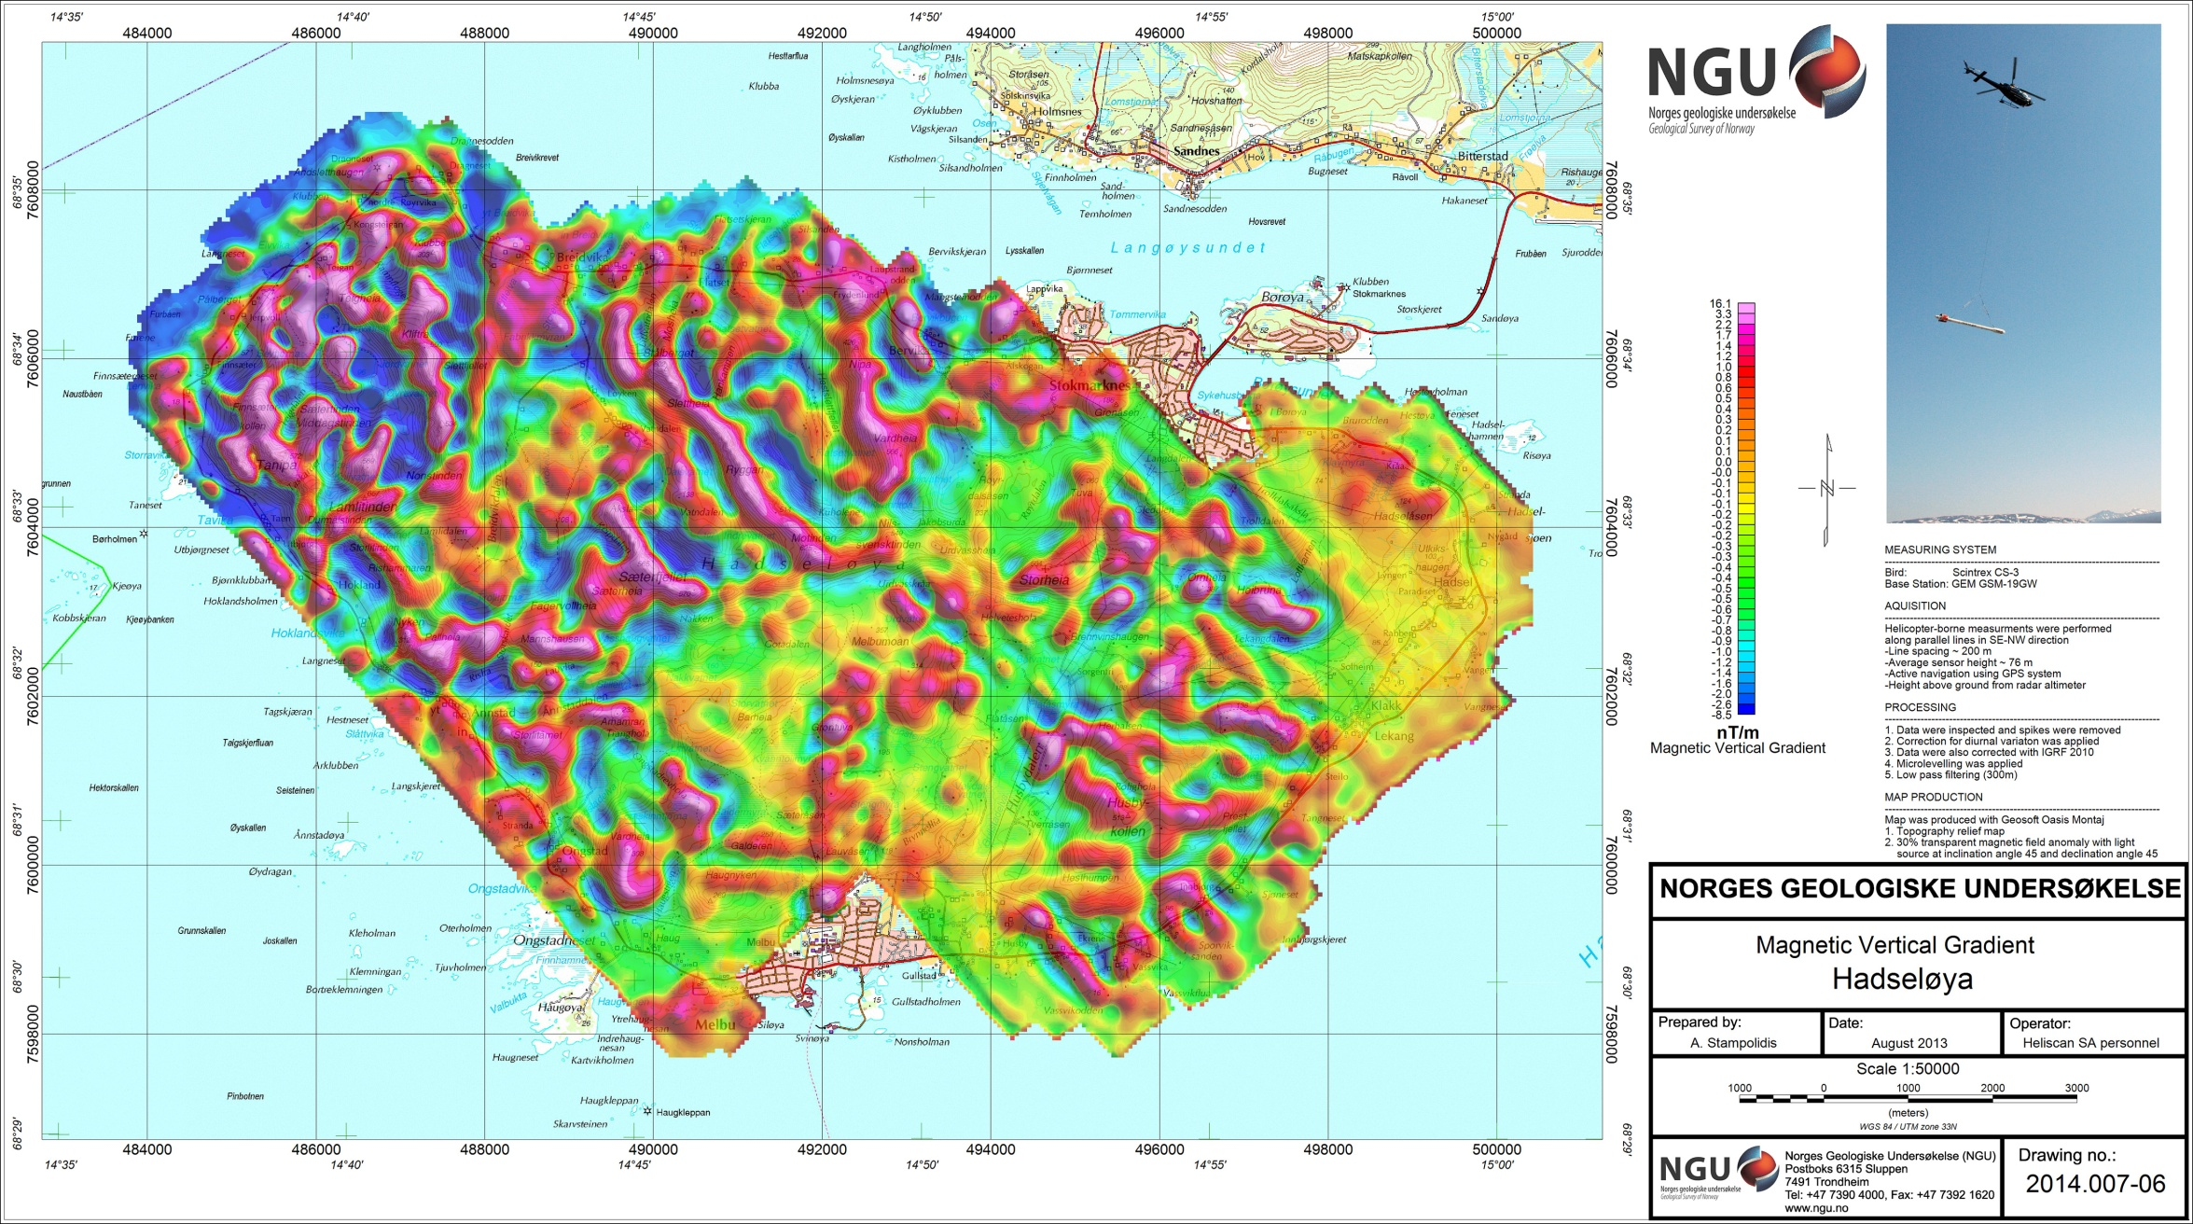
Figure 12: Magnetic Vertical Gradient Hadseløya

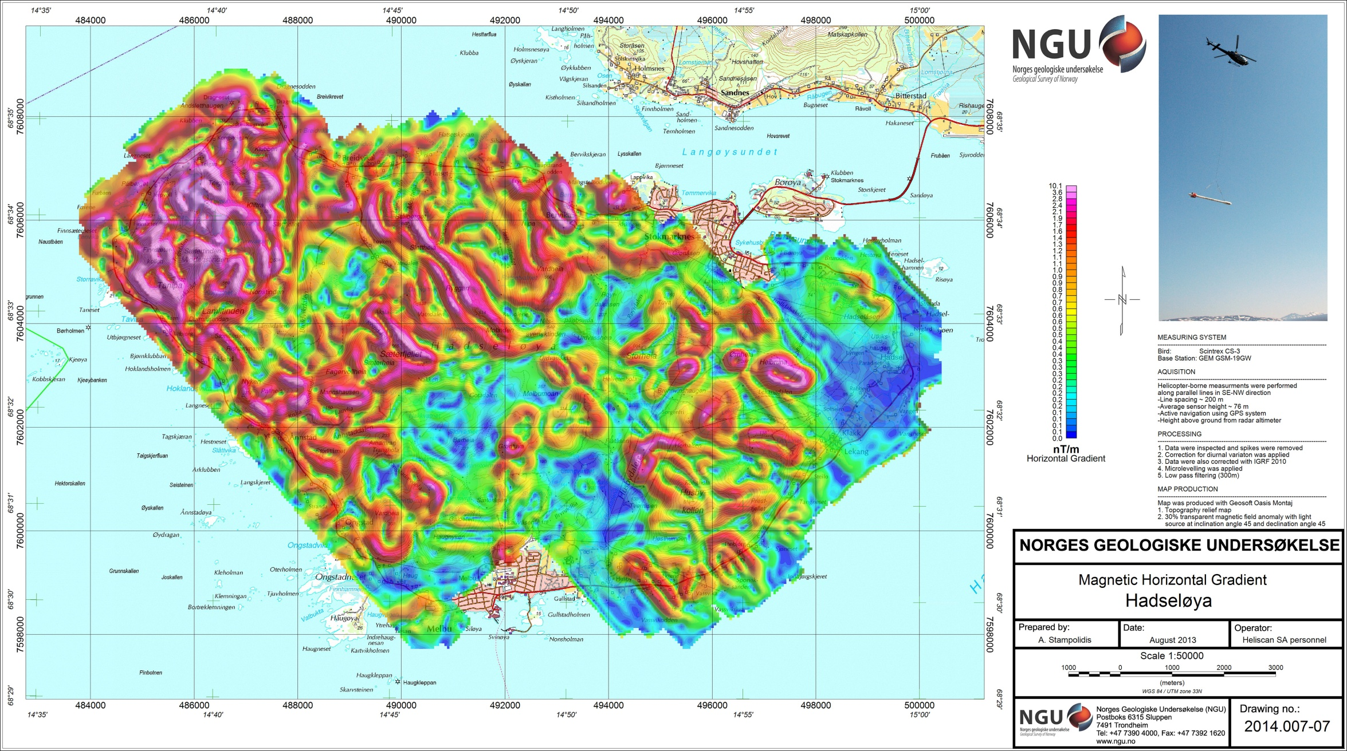
Figure 13: Magnetic Horizontal Gradient Hadseløya

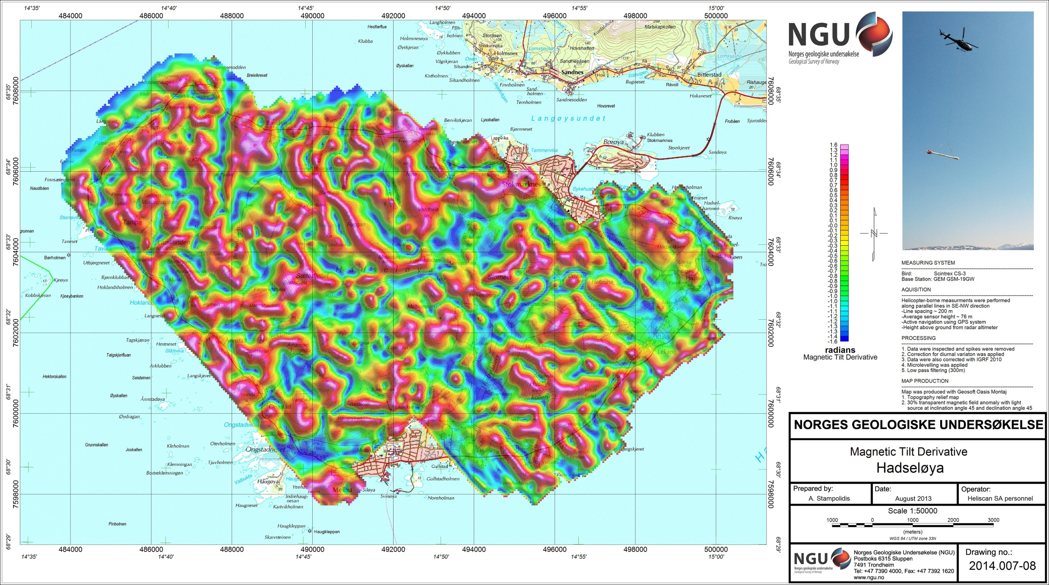
Figure 14: Magnetic Tilt Derivative Hadseløya

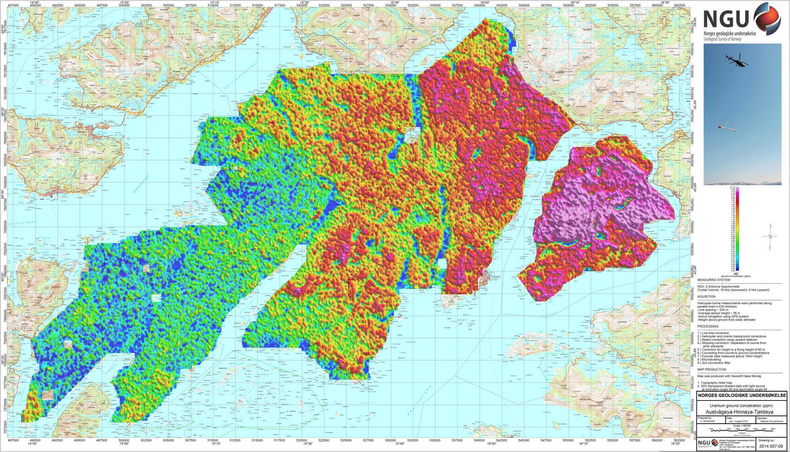
Figure 15: Uranium Ground Concentration Austvågøya-Hinnøya-Tjeldøya

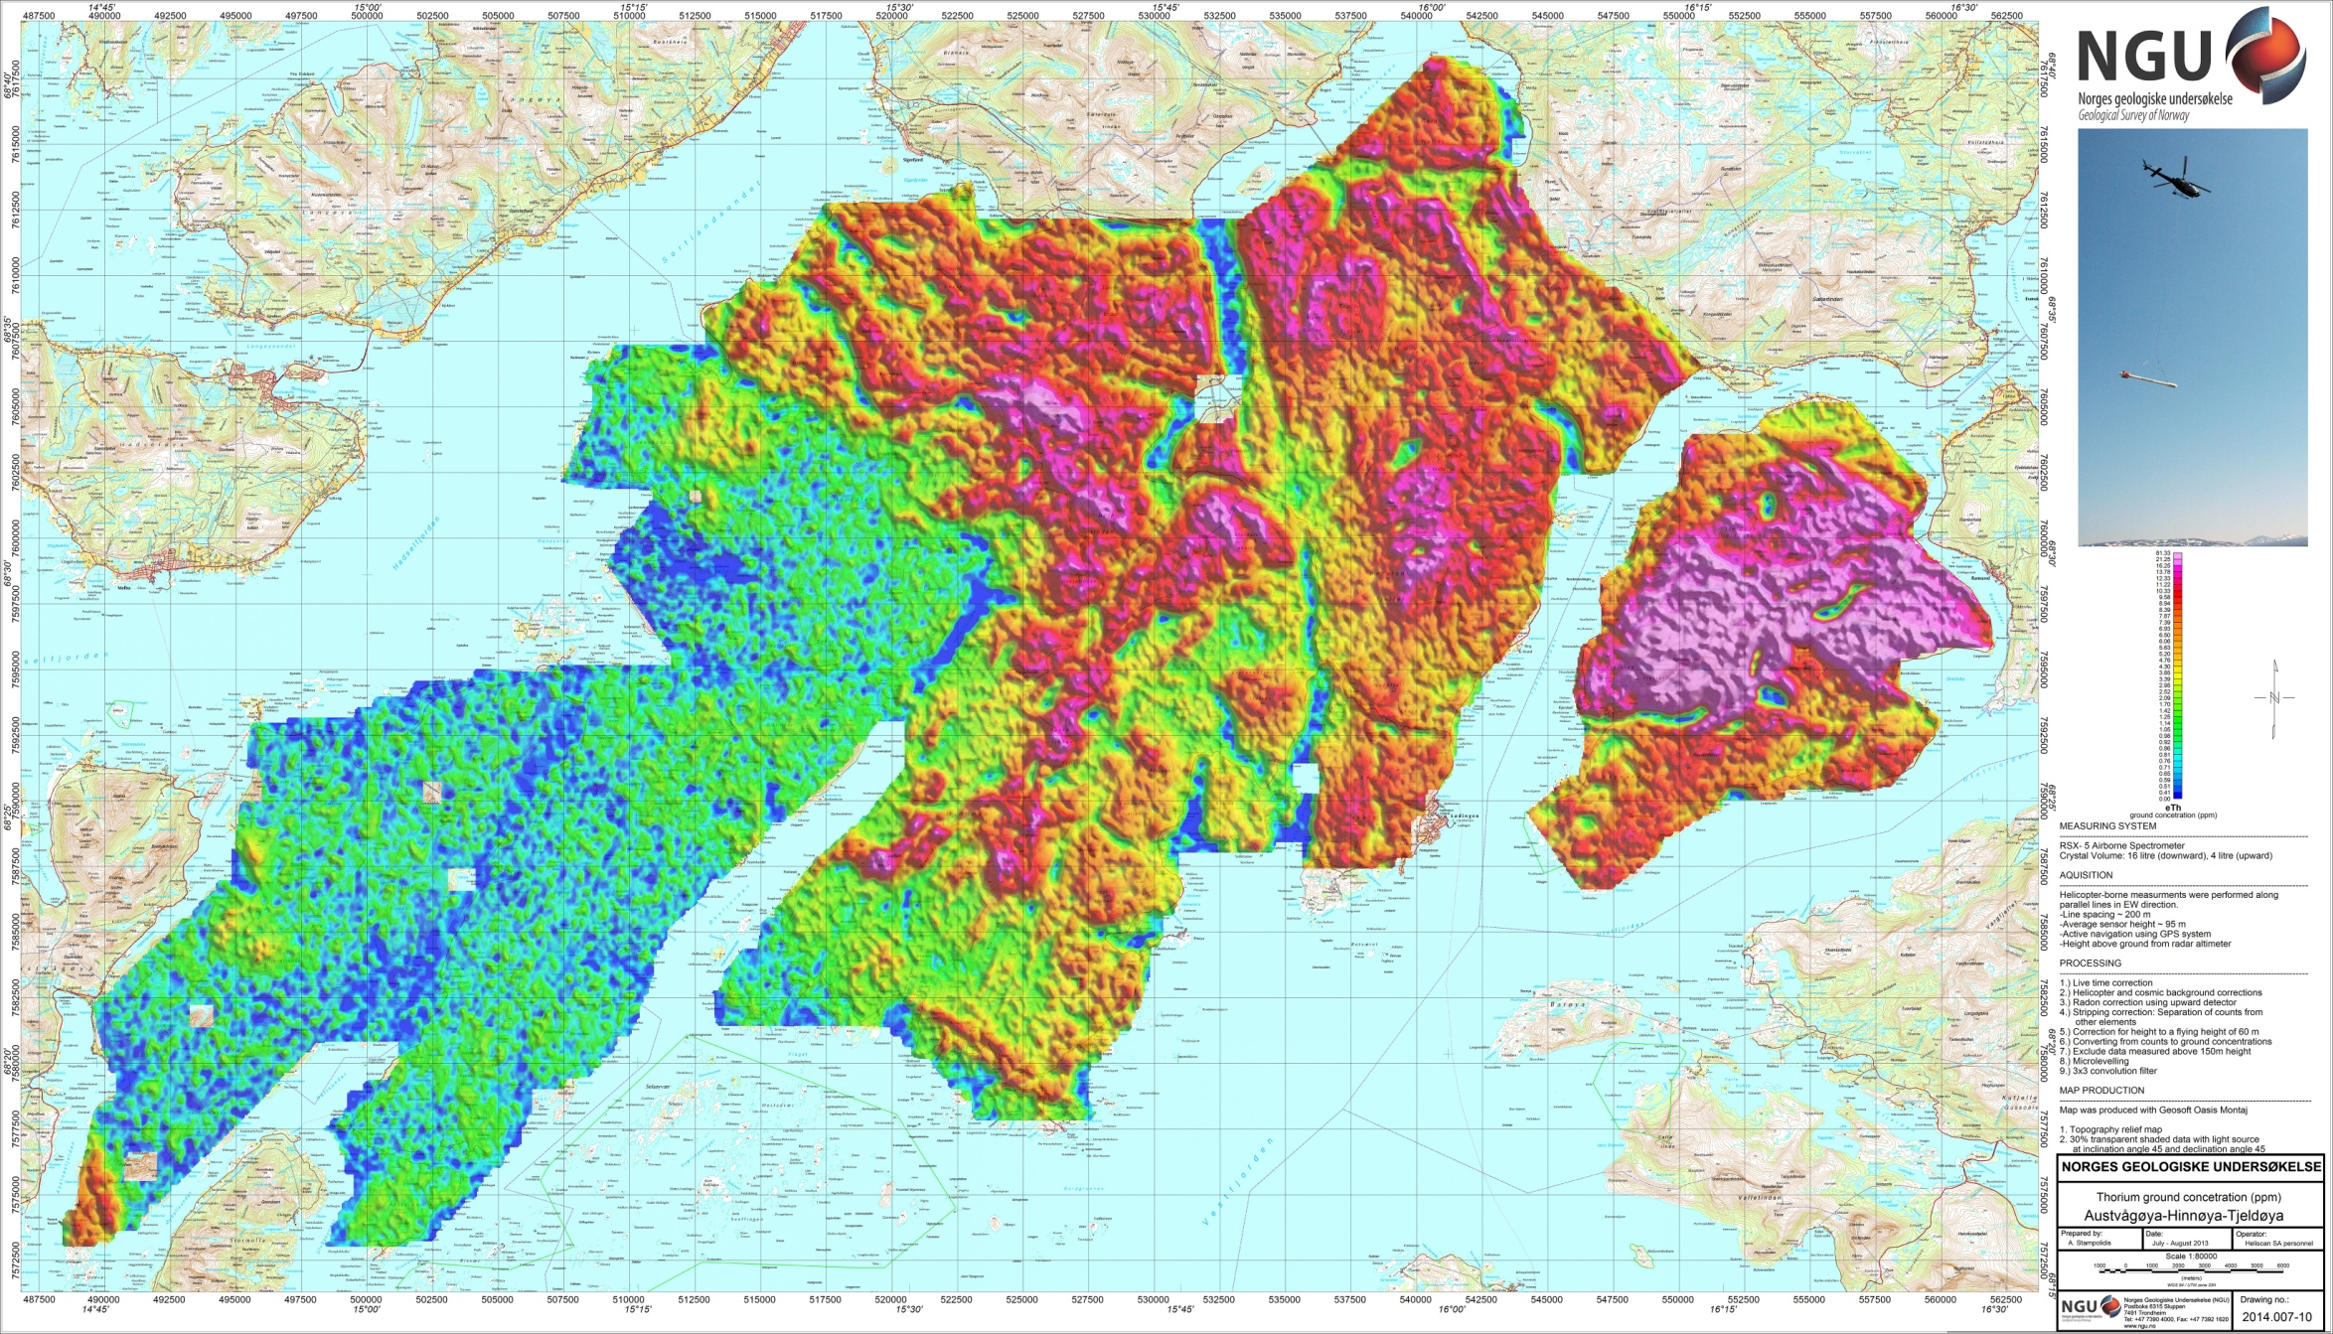
Figure 16: Thorium Ground Concentration Austvågøya-Hinnøya-Tjeldøya

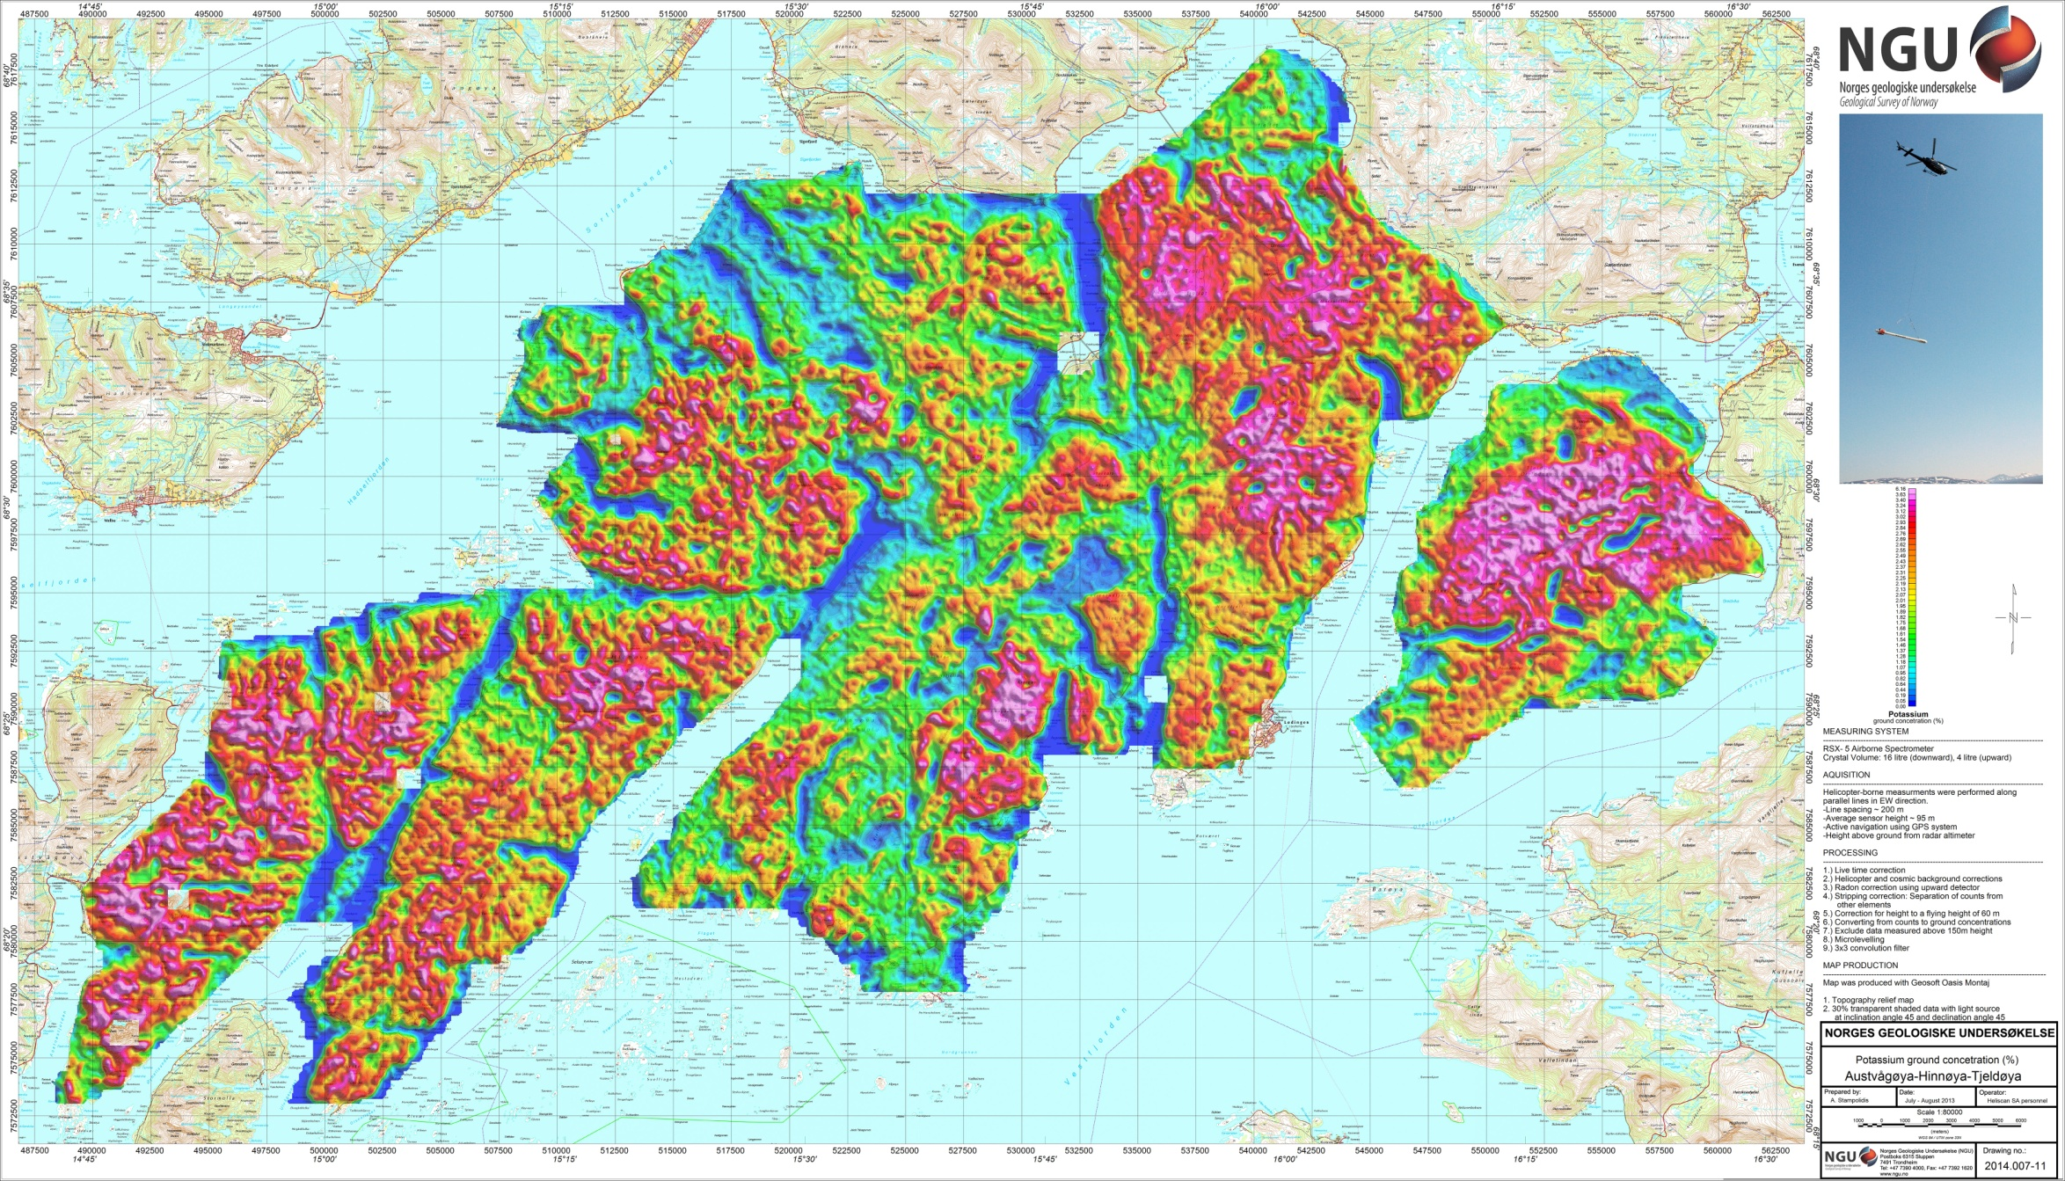
Figure 17: Potassium Ground Concentration Austvågøya-Hinnøya-Tjeldøya

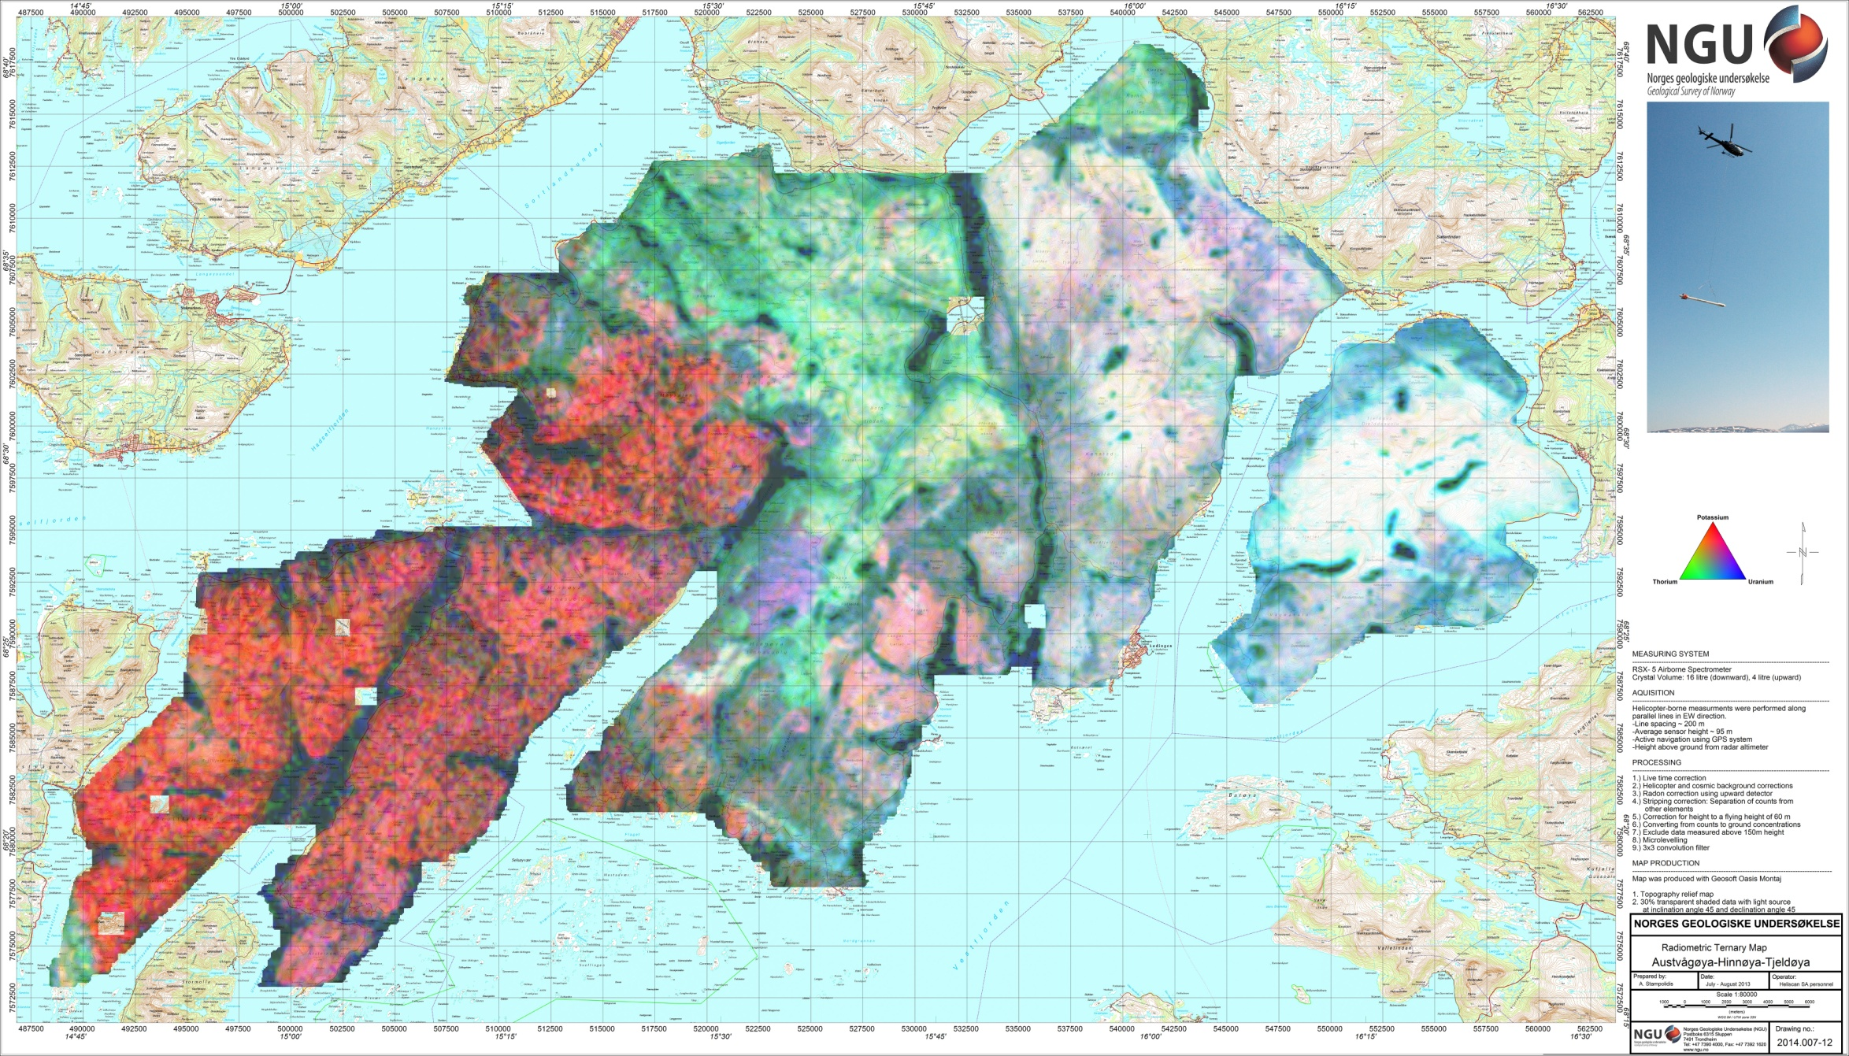
Figure 18: Ternary Image of Radiation Concentrations Austvågøya-Hinnøya-Tjeldøya

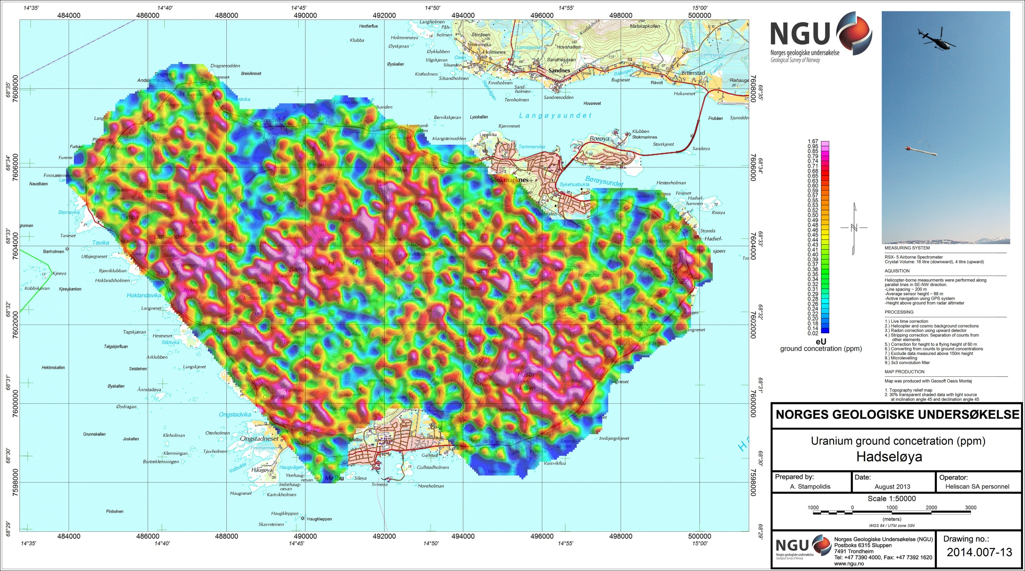
Figure 19: Uranium Ground Concentration Hadseløya

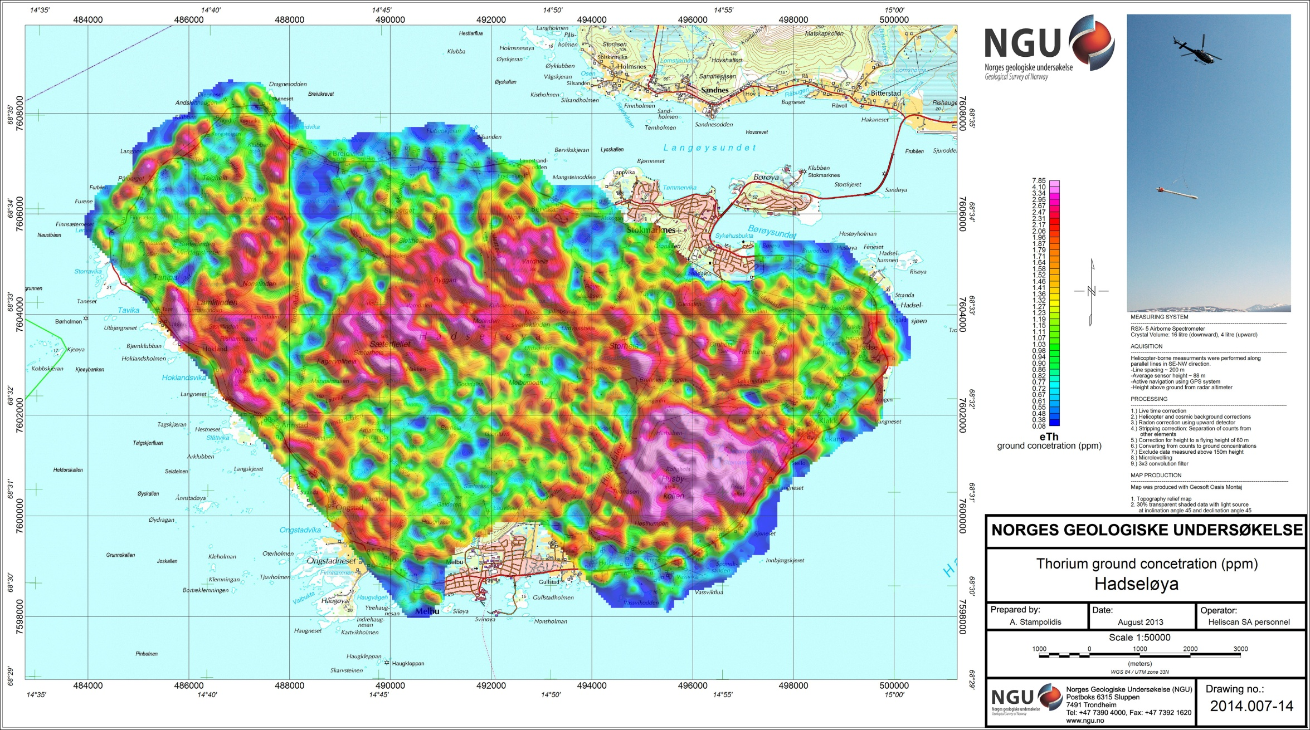
Figure 20: Thorium Ground Concentration Hadseløya

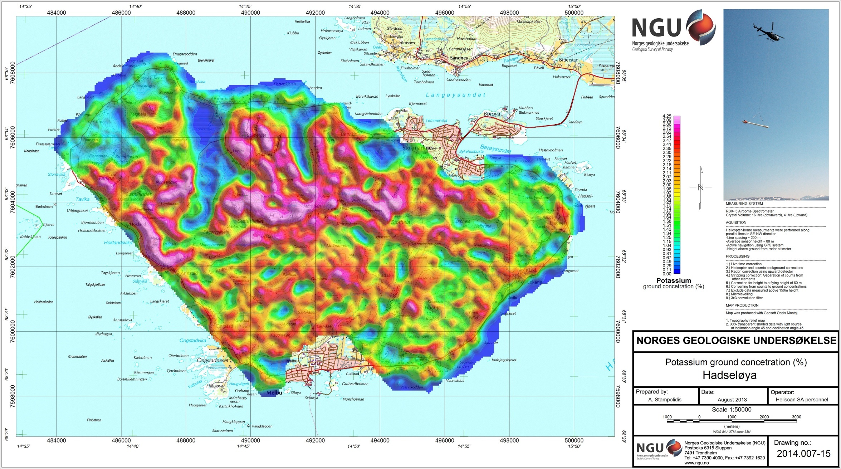
Figure 21: Potassium Ground Concentration Hadseløya

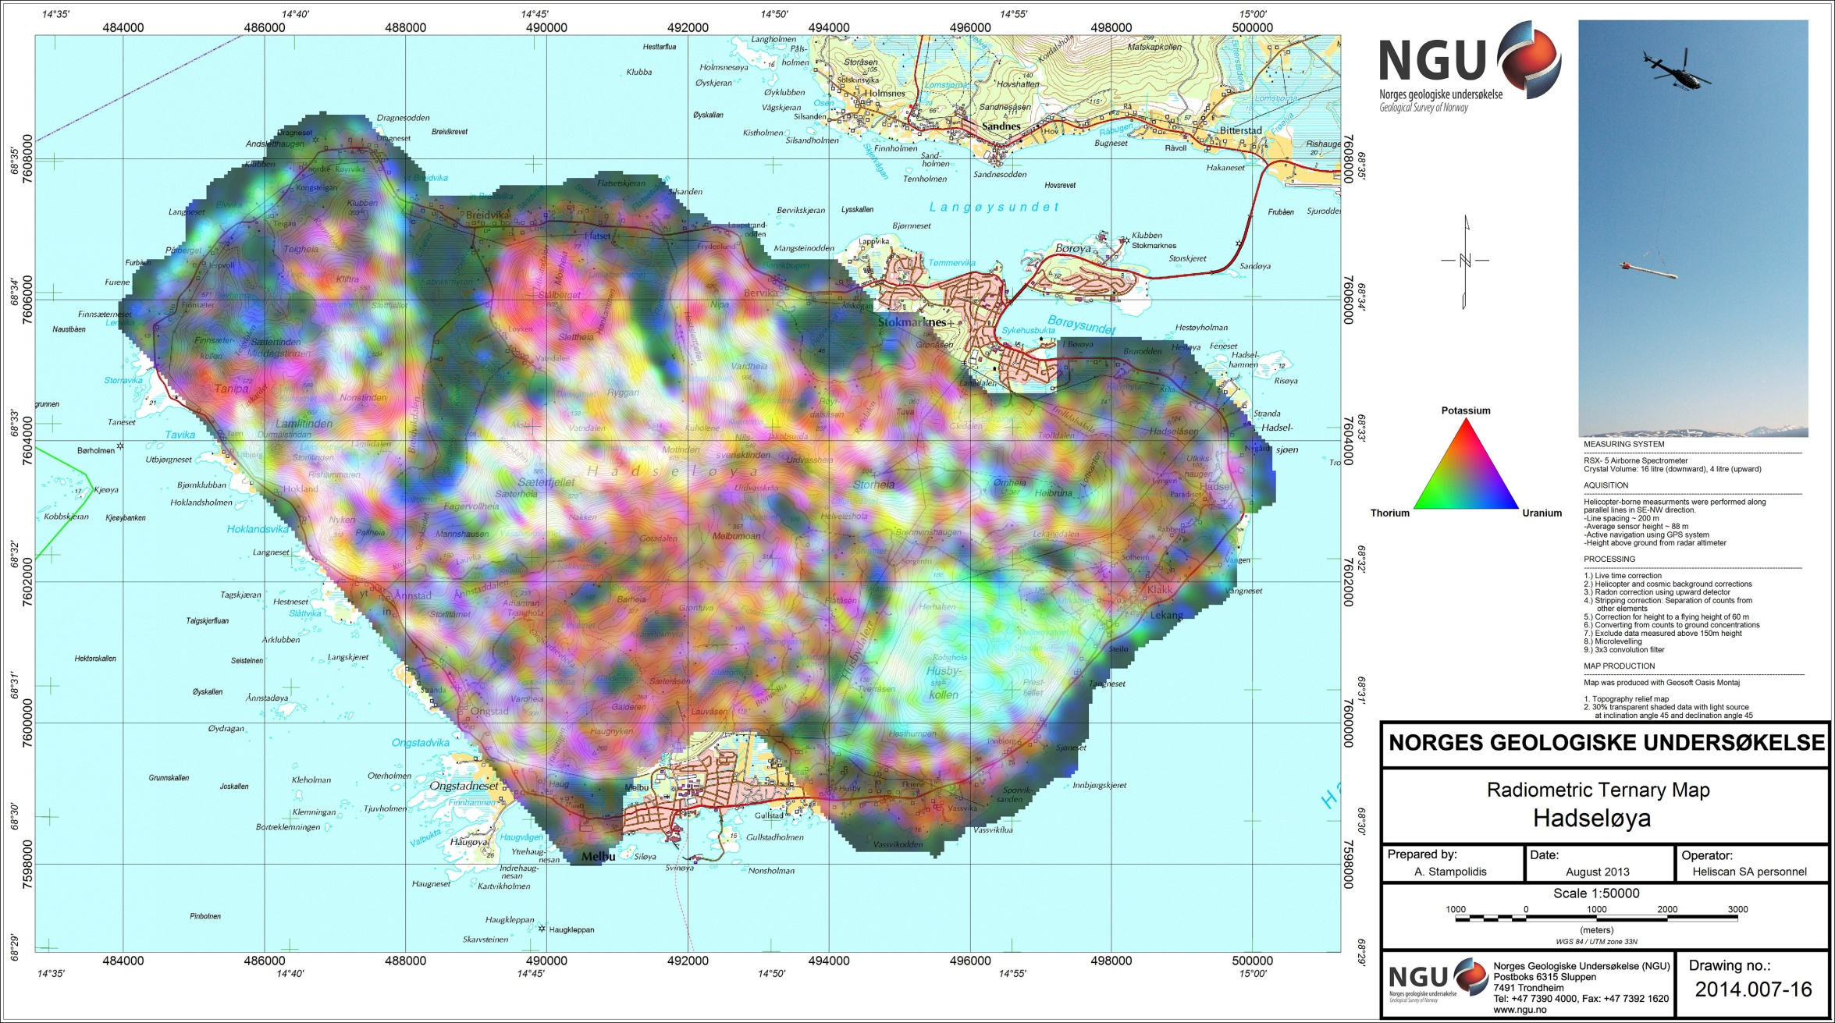
Figure 22: Ternary Image of Radiation Concentrations Hadseløya

