NGU Report 2014.010

Gravity Measurements Applied to the Mapping of Sediment Thickness and Bedrock Morphology in Orkdalen, Orkdal Municipality, Sør-Trøndelag

REPORT
Geological Survey of Norway
Postboks 6315 Sluppen
NO-7491 Trondheim, Norway
Tel.: 47 73 90 40 00
Telefax 47 73 92 16 20
Report no.: 2014.010 |  |  | ISSN 0800-3416 |  | Grading: Open
Title:
Gravity Measurements Applied to the Mapping of Sediment Thickness and Bedrock Morphology in Orkdalen, Orkdal Municipality, Sør-Trøndelag

Authors:  Georgios Tassis, Jomar Gellein & Jan Fredrik Tønnesen |  |  |  | Client:  NGU
County:  Sør-Trøndelag |  |  |  | Commune:  Orkdal
Map-sheet name (M=1:250.000)  Trondheim |  |  |  | Map-sheet no. and -name (M=1:50.000)  1521-1 Orkanger & 1521-2 Hølonda
Deposit name and grid-reference: |  |  |  | Number of pages: 37 Price (NOK): 120,-  Map enclosures:
Fieldwork carried out:  (1987 and) 1990 | Date of report:  08.07.2014 |  |  | Project no.:  351800 |  |  | Person responsible:
Summary:
This report presents geophysical interpretation results of gravity data as part of a project entitled KARMA-3D. The main goal of the project is to perform three dimensional mapping and characterization of Quaternary sediments in order to make the results more comprehensible to non geoscientists such as state officials and engineers. In this sense, gravity prospecting is one of the best techniques to construct density modeling and calculate sediment depths to bedrock due to its low cost compared to other methods and the fact that it can be easily implemented in urban areas. This is exactly the case with our study area which is situated in Orkdal municipality along the river Orkla and represents one of the most populated areas in Sør-Trøndelag county.

The gravity survey was constrained to the northernmost 14 km of the Orkdal valley, from the seafront at Orkanger and southwards to Vormstad. The survey contains 428 gravity stations, 391 of which are located along 12 profiles with usually 50 m spacing between stations along each profile. All profiles have been positioned normal to the axis of the Orkdal valley except one which is orientated parallel to the Orkla river. Elevation of all profile stations was calculated and the gravity data was processed to get Bouguer anomaly values. The regional trend in the area is characterized by a decrease in Bouguer gravity along the SE-NW direction from about -8 mGal to -30 mGal. The sediments in the valley are causing local anomaly lows with a maximum of 8.0 to 8.5 mGal in the north and decreasing to close to 2.0 mGal southernmost in the area.

For the density modeling we have used the GM-SYS module of the Geosoft Oasis Montaj software. Our models were constrained by data coming from several NGU databases such as drillhole depths, density sampling and geological maps. Throughout the process we have kept a constant sediment density of 1900 kg/m³ while the bedrock varied between 2730 and 3100 kg/m³.

The depths to bedrock that we obtained have shown a large sedimentation basin which in the north has a maximum thickness of more than 250 m. However, the maximum depth value is decreasing towards the south to less than100 m. The final product of this work is a 3D representation of the sediments in the Orkdal area.
Keywords: Geophysics  (Geofysikk) |  | Gravity  (Gravimetri) |  |  |  | Soil thickness  (Løsmassemektighet)
Modeling  (Modellering) |  | Bedrock  (Berggrunn) |  |  |  | Scientific report  (Fagrapport)

CONTENTS

1. INTRODUCTION 7
2. DATA ACQUISITION AND PROCESSING 7
2.1 Data acquisition 7
2.2 Data processing 9
3. BACKGROUND DATA 9
3.1 Bedrock geology 9
3.2 Depth to bedrock 11
3.3 Petrophysical properties 13
3.4 Deposits/Sediments 14
3.5 Modeling parameters 16
4. MODELING RESULTS AND DESCRIPTION 18
4.1 Profile 1 20
4.2 Profile 2 21
4.3 Profile 3 22
4.4 Profile 4 23
4.5 Profile 5 24
4.6 Profile 6 25
4.7 Profile 7 26
4.8 Profile 8 27
4.9 Profile 9 28
4.10 Profile 10 29
4.11 Profile 11 30
4.12 Profile 12 31
5. DEPTH TO BEDROCK 32
6. DISCUSSION AND CONCLUSIONS 35
7. REFERENCES 36

INTRODUCTION

Knowledge of the sediment distribution can be quite useful for construction development, raw material extraction, energy storage and output as well as tasks related to the EU Water Directive, climate adaption and risk assessments for safety and stability. KARMA-3D project has been initiated in order to perform three dimensional mapping and characterization of Quaternary sediments which can be used for the aforementioned purposes. Through this project, NGU is attempting to answer the increasing demand for better knowledge of the geological structure, sedimentary processes and properties of the deposits in the subsurface by using several new modeling and visualization tools. One of these tools is the 2D and subsequent pseudo 3D density modeling of Quaternary sediments by utilizing gravity measurements conducted during the past years on behalf of NGU. Gravity measurements are suitable for (semi-) urban areas and therefore provide the basis for calculating the thickness of both natural and anthropogenic deposits.

Identification and characterization of Quaternary sediments and presentation of 3D models is a means of bringing geological knowledge to an audience that does not have the education and experience to interpret the traditional two-dimensional map. This could be used to increase awareness and knowledge of the subsurface in politicians and decision -makers, such as to achieve a more efficient use and management of the underground, to avoid conflicting interests in land use and secure ecosystem services. This project is therefore aimed at those potential users, such as local and regional authorities (county or municipality) as well as land planners and consultants.

A pilot area for KARMA-3D has been chosen to be the Orkdal valley in Sør-Trøndelag where deep fjord basins have been formed by glacial erosion at the lower parts of valleys which afterwards have been filled with late to post-glacial deposits. The survey area belongs to the most populated in Trøndelag where the depth to bedrock is great and therefore the gravity method was the best suited for use in such urban areas. In this way, NGU has performed gravity measurements along profiles in the area which have been interpreted in this report within the framework of KARMA-3D. Through this process we have acquired reliable regional information on sediment thickness and morphology of those basins, a task performed at lower costs and to greater depths than other available geophysical methods such as refraction seismic prospection or electrical resistivity tomography. It should also be noted that similar gravity mapping of sediment thickness and bedrock morphology has been conducted in several valleys in Trøndelag municipalities in the past (Tønnesen, 1987; Tønnesen, 1991a; Tønnesen, 1991b; Tønnesen, 1993; Tønnesen, 1996) and in some other areas in Norway (Tønnesen, 1978; Gellein et al., 2005;).

DATA ACQUISITION AND PROCESSING

Data acquisition
Collection of gravity data has been done with a La Coste & Romberg gravity meter, model G no. 569. In total the survey has 428 gravity stations where 391 stations are located along 12 profiles with normally 50 m spacing between the stations along each profile. The other 37 gravity stations are regional measurements mainly located on bedrock outside the sediment basin area, but some of them are located in the basin area in between the profiles.
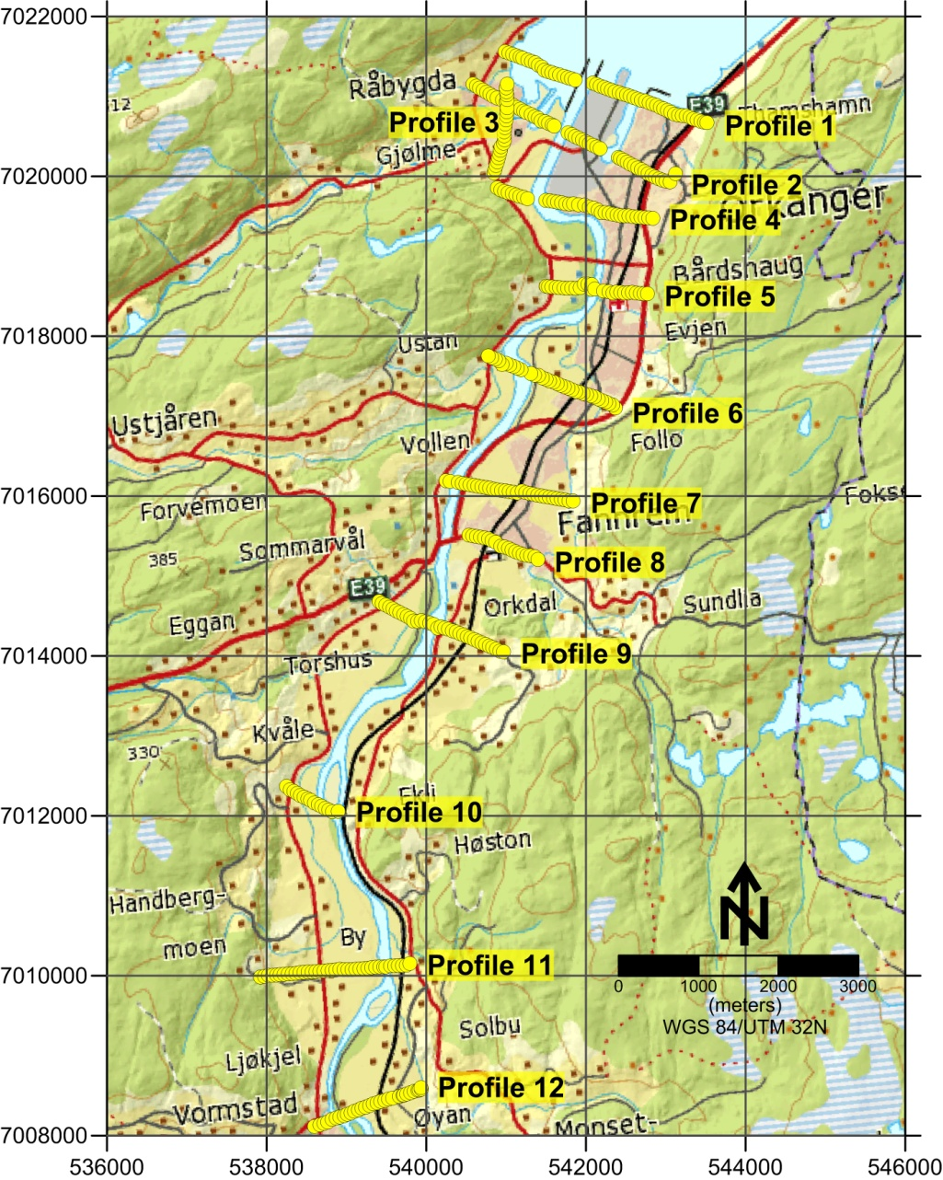

Figure 2.1: Distribution of gravity measurements along profiles in the Orkdal area.

Most of the profiles begin and end with measurements on exposed bedrock localities and are used as anchor points when modelling. In order to control diurnal drift, designated measurements have been taken at a base station within the Orkdal area. All of these data were tied to the Norwegian Mapping Authority’s base gravity station at the NGU (Trondheim S) for the correction to the absolute value of the gravity field.

The distance between the gravity stations along profiles was normally measured with a custom measuring line, while point heights were determined by levelling (theodolite and measuring rod). Absolute height determination was accomplished with the use of several reference points of the local network (trigonometric points). Elevation measurements use the Norwegian Mapping Authority height reference system, which is the mean sea level (NGO 1954).

The gravity survey was initiated and planned by Jan Fredrik Tønnesen. The survey started in 1987 and it was continued in autumn 1990. The fieldwork for the profile measurements was finished in a total of 14 days while the regional measurements (37 gravity stations) were finished in 2 days. Jan Fredrik Tønnesen has done all the gravity measurements. During the time of gravity measurements along profiles, Jomar Gellein has taken care of all the levelling work of the gravity stations, and after the fieldwork period he has made all the data processing of the gravity data.

Data processing
The measured gravity data was first corrected for the diurnal drift and then for the free-air effect wherever this was needed. Conversion to Bouguer anomalies was conducted by the standard NGU procedure (Mathisen, 1976). Both Bouguer and terrain corrections have utilized the standard density of 2670 kg/m³. For the immediate neighboring area around the measuring points, the terrain correction was determined from point elevation data selected with the use of 3 circles with radii of 100, 300 and 600 m respectively and 8 points per circle.

The 12 gravity profiles are located in the lower part of Orkdalen, from the seafront in the north at Orkanger and about 14 km southwards to Vormstad. Eleven of the profiles are crossing the valley and their directions vary from nearly W-E to NW-SE. One profile is located along the western bank of the river delta and has a S-N direction (figure 2.1).

BACKGROUND DATA

In order to be able to successfully model the Bouguer anomalies present in our profiles, it is important to have sufficient knowledge of the geology of the region and the density of both bedrock and quaternary sediments. Therefore, it is essential to establish which formations will be included in our models as dictated by the geology of the region and subsequently, what dimensions should they have (depth and superficial spread) and what density. This kind of additional data may come from geological maps of the Orkdal area (bedrock and quaternary), as well as rock sampling in the region and drillings that have reached as deep as bedrock. The NGU is in possession of such data which have been selected, evaluated and employed in our modeling procedure. This data have constrained our results within a more reasonable spectrum than inverting gravity alone.

Bedrock geology
During the past 60 years several NGU geoscientists have published detailed descriptions about the bedrock in the Orkdal area (Carstens, 1951; Peacey, 1963; Carter, 1967; Rutter et al., 1968; Johnsen, 1979; Tucker, 1986;). All these years of knowledge have been summed up in the 1:50.000 Bedrock map of the Orkdal municipality where we can easily see that the area is dominated by two large formations of similar characteristics with one thrusting on the other. The underlying formation which can be seen in light orange in the figure 3.1, is characterized by sandstones, medium-to fine-grained granular/granular quartz and feldspar sandstones with layers, flakes and boudin of hornblende-biotite-amphibolite. It is a thin unit of quartzites, sandstones and augen gneisses which belongs to the Middle Cover Series (Midtre Dekkeserie). The sandstone section is often called Sæter cover (Sæterdekket) or Leksdal cover (Leksdaldekket) while the augen gneiss section is called Risberg cover (Risbergsdekket).
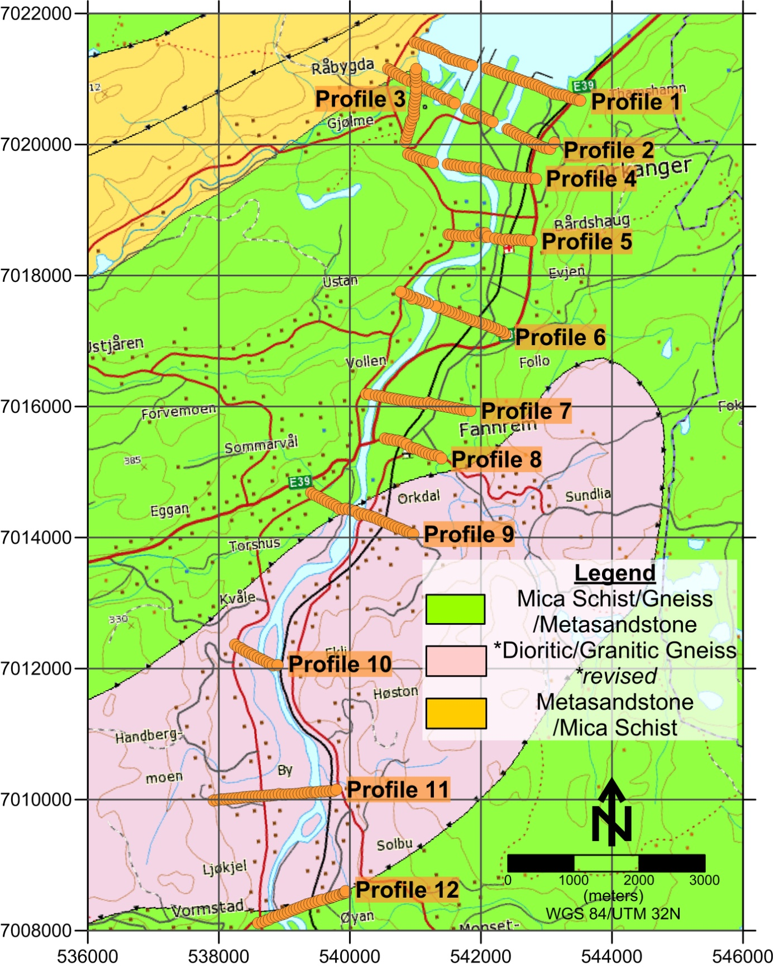

Figure 3.1: Positioning of gravity measurement profiles in relation with major bedrock formations of the Orkdal area (http://geo.ngu.no/kart/berggrunn/, Bedrock map 1:250000, County: Sør-Trøndelag, Municipality: Orkdal).

We have no control over the continuity of these layers in depth on top of the granite subsurface, but near the Orkanger fjord, they have considerable thickness. The overlying formation depicted in green and pink in the figure 3.1 is a layer of mica schists and gneisses with zones of meta-sandstones and amphibolites that thrusts on the aforementioned formation. This unit actually consists of two parts (hence the two colors), but since they have very similar composition they have been merged. In the Orkanger area, it is believed that both Skjøtings and Gula cover (Guladekket) occur. As can be seen in figure 3.1, all our profiles are positioned on top of the mica schist/gneiss formation while the sandstone cover lies in an unknown depth beneath it.

Depth to bedrock
NGU is responsible for mapping and monitoring of groundwater resources, the national groundwater database (GRANADA) and distribution of knowledge about groundwater in Norway. According to the Water Resources Act §46, NGU hosts a database containing well data and reports on groundwater investigations. The Orkdal area contains a number of boreholes drilled along the Orkla river which can be used as a direct regulating factor in gravity modeling. From a total record of almost 50 drillings that coincide with our study area, we have chosen the 25 most useful and plotted them in figure 3.2.

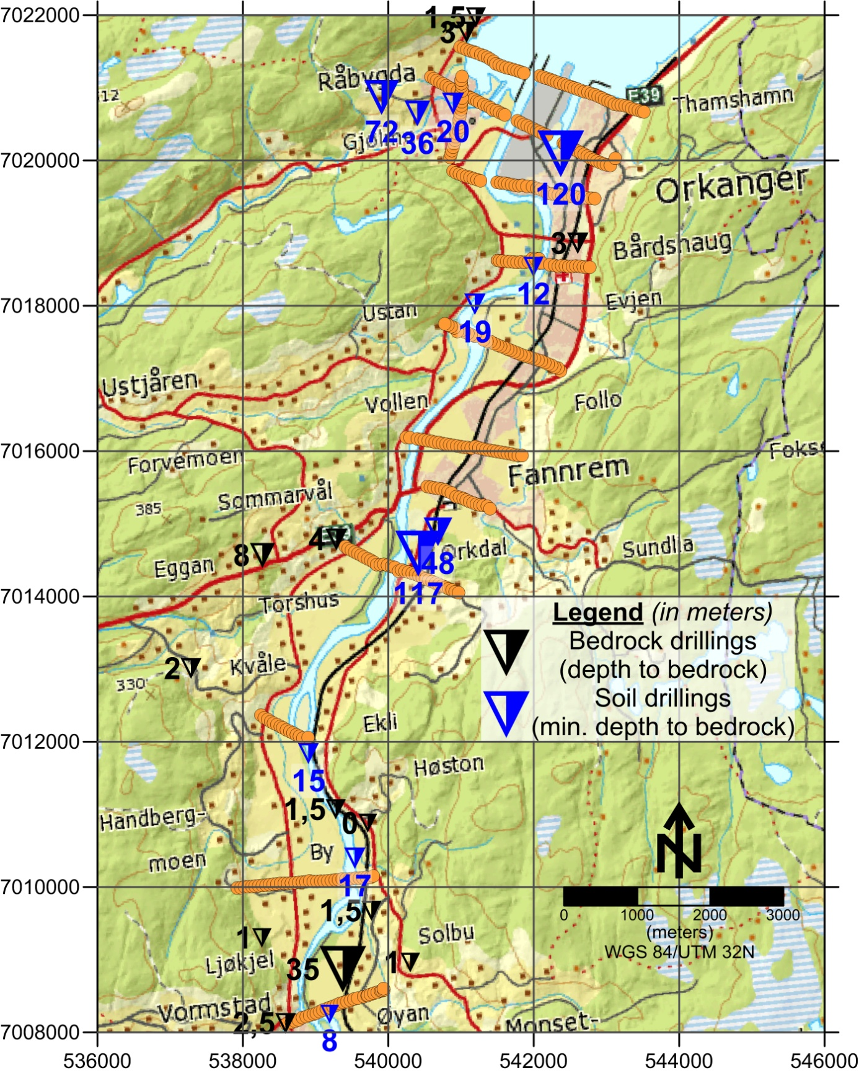

Figure 3.2: Positioning of NGU monitored boreholes in the Orkdal area. Triangulars sized in respect with the depth they represent, both for bedrock (black) and soil depth(blue). Orange dots depict gravity profiles. Data from NGU database GRANADA.
Table 3.1 shows these particular boreholes that been have drilled as deep as bedrock (fjellbrønn) while table 3.2 shows those that haven't reached it but can give us a hint since bedrock should be deeper than the maximum depth of these boreholes. It is clear that the southern part of the Orkla river is far better constrained when it comes to bedrock exposure while the mid and northern part contains mostly point indication of the minimum depth that bedrock should be expected. It is interesting to note that in isolated locations of the mid and northern part of our area, sediment depth can be larger than 120 meters (Løsmassebrønn nr. 45145 and 42294). Gravity modeling will try to answer the question of how much exactly.

Database no. | UTM 32N Easting | UTM 32N Northing | Depth to Bedrock  (in meters) | Drill type
60493 | 541079 | 7021764 | 3 | Fjellbrønn
24021 | 541205 | 7021970 | 1,5 | Fjellbrønn
28538 | 542606 | 7018862 | 3 | Fjellbrønn
32559 | 539286 | 7014784 | 4 | Fjellbrønn
37375 | 538271 | 7014565 | 8 | Fjellbrønn
36056 | 537286 | 7013008 | 2 | Fjellbrønn
24586 | 539278 | 7011070 | 1,5 | Fjellbrønn
25456 | 539718 | 7010878 | 0 | Fjellbrønn
76448 | 539770 | 7009675 | 1,5 | Fjellbrønn
28623 | 538260 | 7009300 | 1 | Fjellbrønn
45181 | 539374 | 7008867 | 35 | Fjellbrønn
67601 | 540303 | 7008963 | 1 | Fjellbrønn
67693 | 540304 | 7008960 | 1 | Fjellbrønn
28586 | 538587 | 7008125 | 2,5 | Fjellbrønn

Table 3.1: Bedrock drillings (fjellbrønn). Data from NGU database GRANADA.

Database no. | UTM 32N Easting | UTM 32N Northing | Borehole Depth (in meters) | Drill type
74717 | 540891 | 7020784 | 20 | Løsmassebrønn
58491 | 540399 | 7020648 | 36 | Løsmassebrønn
70143 | 539910 | 7020869 | 72 | Løsmassebrønn
45145 | 542371 | 7020092 | 120 | Løsmassebrønn
76421 | 541995 | 7018535 | 12 | Løsmassebrønn
62880 | 541190 | 7018025 | 19 | Løsmassebrønn
42294 | 540411 | 7014590 | 117 | Løsmassebrønn
57714 | 540684 | 7014888 | 48 | Løsmassebrønn
62889 | 538901 | 7011838 | 15 | Løsmassebrønn
9297 | 539538 | 7010396 | 17 | Løsmassebrønn
19281 | 539194 | 7008249 | 8 | Sonderboring

Table 3.2: Drillings that haven't reached bedrock (løsmasserbrønn). Data from: NGU database GRANADA.

Petrophysical properties
Another NGU maintained database is called DRAGON which comprises of ground measurements of gravity and petrophysical measurements. In our case it offers access to density values that have been calculated in the lab from samples taken in-situ from bedrock exposures by several geologists in the Orkdal area. Once again we have gathered all the measurements that coincide with our study area and present them in table 3.3. Figure 3.3 on the other hand presents the geographical distribution of the mean values of these density measurements. Bedrock density in the region varies locally between 2730 and 3100 kg/m³ and has a random distribution. The mean density over the wider region is about 2850-2900 kg/m³, values that can be useful in gravity modeling where no density measurements are available, especially in the middle part.

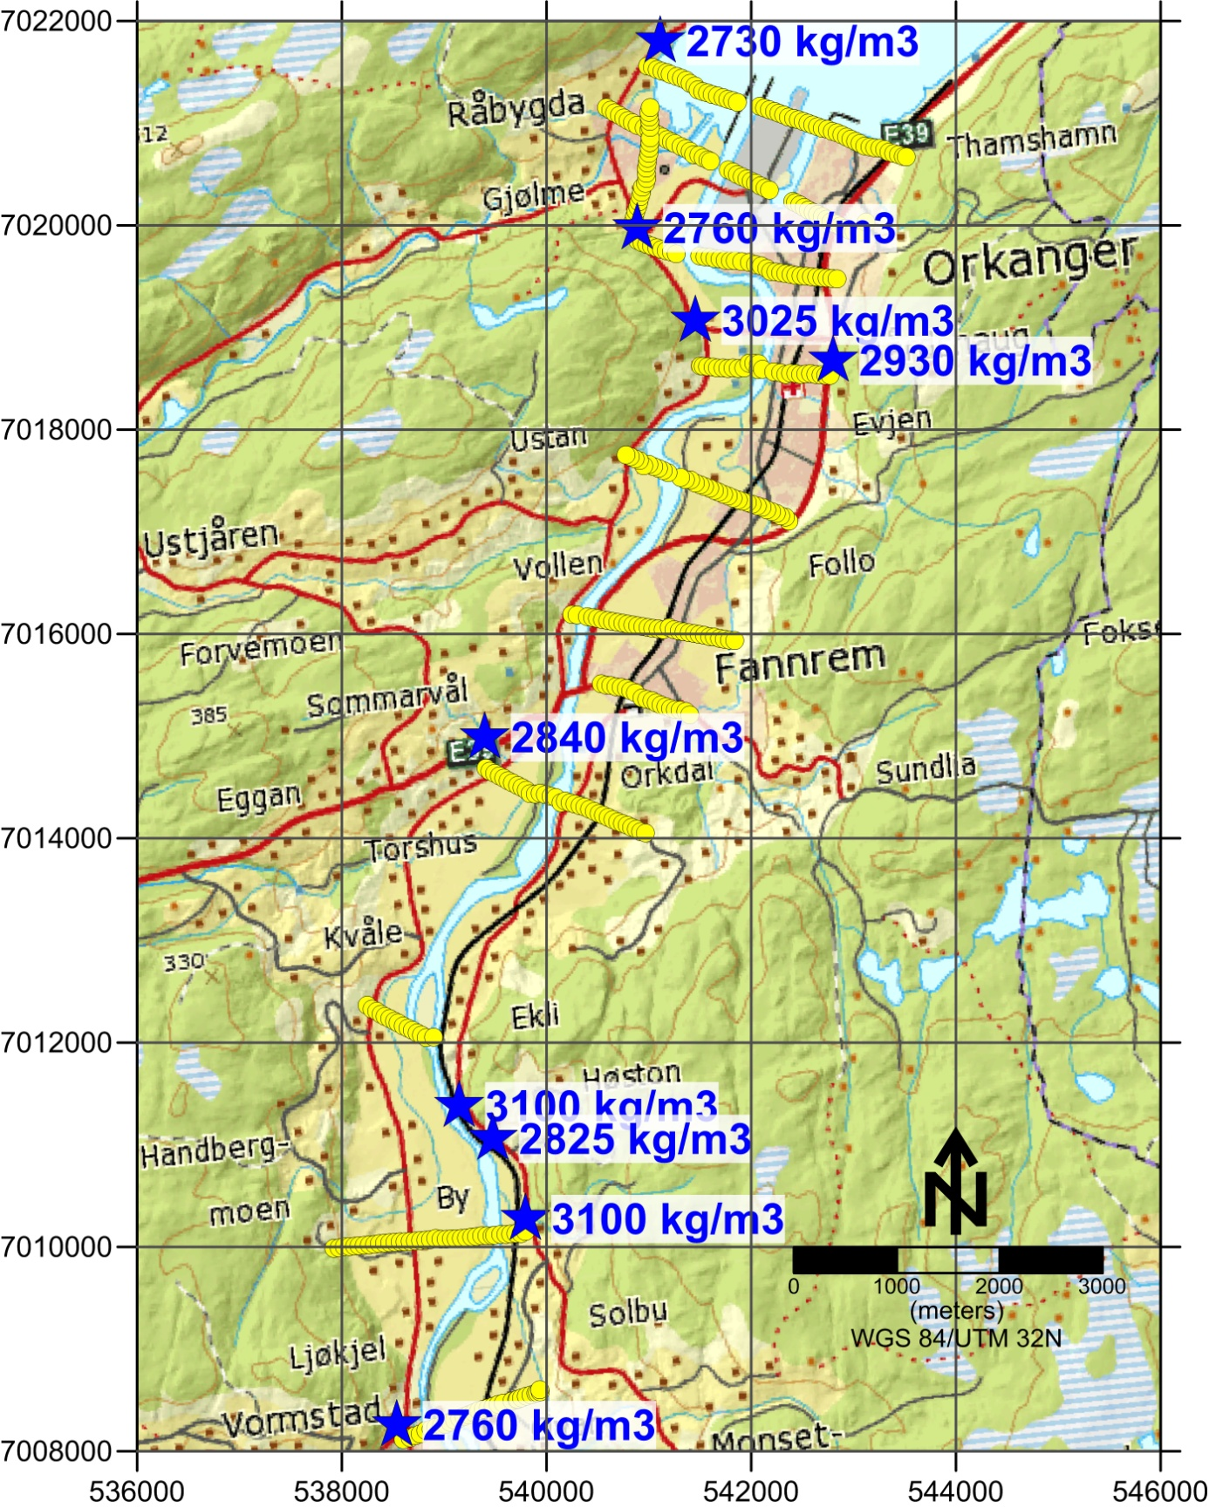

Figure 3.3: Geographical distribution of bedrock density values in the Orkdal area. Yellow dots depict gravity profiles. Data from NGU database DRAGON.
UTM 32N  Easting | UTM 32N  Northing | Densities  (in kg/m³) | Mean density  (in kg/m³) | Rock type
541109 | 7021803 | 2770, 2738, 2702, 2712, 2736 | 2730 | Arcose
544951 | 7022301 | 3002, 3043, 3000, 3021, 2936 | 3000 | Amphibolite
540884 | 7019973 | 2812, 2746, 2738, 2753, 2751 | 2760 | Sandstone
541454 | 7019066 | 3078, 3084, 3029, 2843, 3086 | 3025 | Amphibolite
542799 | 7018676 | 2963, 2885, 3010, 2906, 2881 | 2930 | Gneiss
539396 | 7014988 | 2828, 2781, 2889, 2845, 2844 | 2840 | Mica Slate
539145 | 7011378 | 3130, 3047, 3109, 3129, 3092 | 3100 | Amphibolite
539476 | 7011058 | 2844, 2795, 2839 | 2825 | Mica Slate
539792 | 7010274 | 3042, 3157 | 3100 | Amphibolite
538534 | 7008256 | 2778, 2724, 2760, 2778, 2766 | 2760 | Mica Slate

Table 3.3: Petrophysical properties (density) of bedrock types in Orkdal. Data from NGU database DRAGON.

Deposits/Sediments
The northern part of Orkdalen was probably deglaciated just prior to the Younger Dryas chronozone. Between Orkanger and Vormstad there are several sedimentary indications of minor halts in the recession of the ice sheet, e.g. a transverse ridge propagating nearly across valley at Kvåle. The marine limit in the lowermost part of Orkdalen varies from c. 160 - 165 meters above present sea level (NGO, 1956). As the sea level regressed towards the present day sea level, sediments in the valley were reworked and redistributed and the valley floor significantly altered (Rise et al. 2006; Reite, 1977; Reite, 1983).

Figure 3.4 presents the quaternary geology map of the region. Our profiles are crossing several formations, the two most important are: 1) the formation depicted in yellow which are river and stream deposits (fluvial deposits). The most typical forms are alluvial plains, terraces and fans. Sand and gravel dominates, and the material is sorted and rounded. The thickness of ranging from 0.5 to more than 10 m. 2) Sea and fjord deposition, continuous cover, often with great thickness. These are depicted in blue and are fine-grained marine deposits with thickness from 0.5 m to several hundred meters. These deposits also include avalanche materials of quick clay. Other sediments mapped in the area are glaciofluvial deposits (orange) and moraines (green). The first mentioned is dominated by sand and gravel and these deposits are most prominent in the southern area of Orkdalen and in the side valley NW in the area. Weathering materials are shown in purple and represent a patchy or thin cover over bedrock. This cover contains soils formed in situ by physical or chemical breakdown of rocks and numerous bedrock outcrops can be found within it.

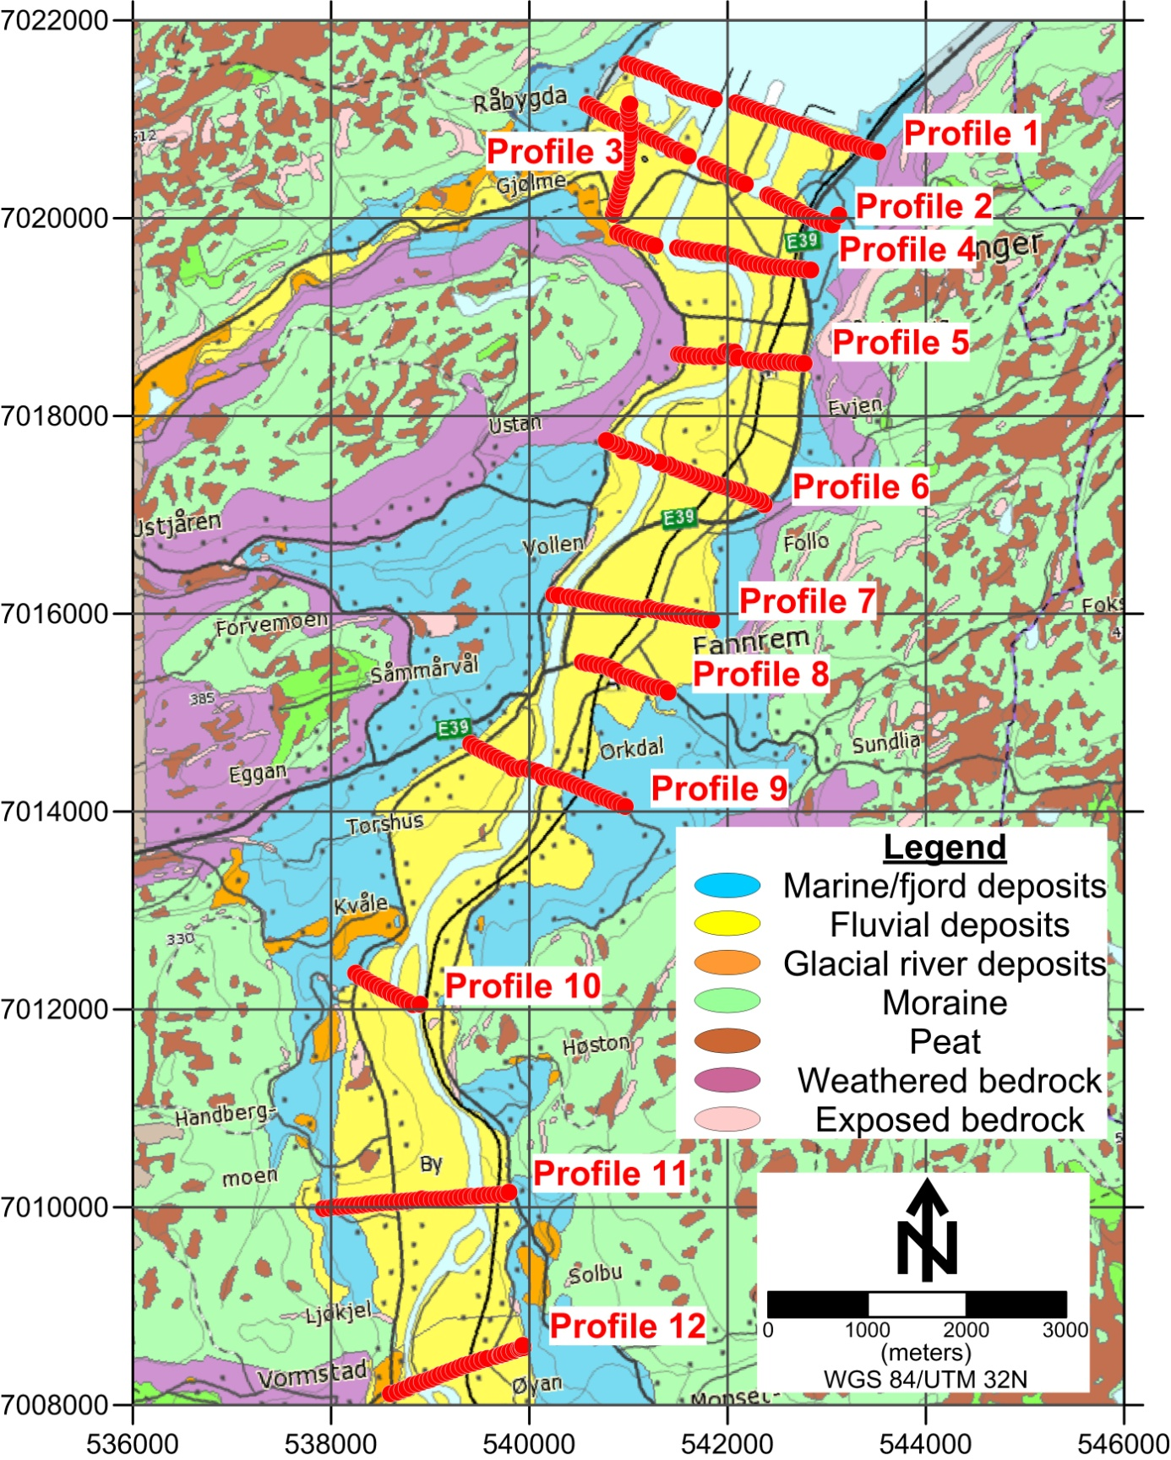

Figure 3.4: Map of quaternary deposits/sediments in the Orkdal area in relation with the gravity measurement profiles (http://geo.ngu.no/kart/losmasse/).

Moraines are divided in two color varieties. Pale green represents thin or patchy cover of moraines over bedrock. Dark green represents continuous layers of moraine material and can locally have great thickness. Moraine essentially means materials picked up, transported and deposited by glaciers. These formations have variable consolidation, are poorly sorted and can contain all grain sizes. Finally, location of pink color represents exposed bedrock. The map shows that the areas outside the valley are dominated by bedrock with a thin or patchy cover of moraine or weathering material. Brown color in the map represents areas covered by peat. Table 3.4 presents bulk densities for several of these deposits as well as their type. The sediment density value used is discussed in the following section.

Deposit/Sediment | Shown on map as | Bulk density  (kg/m³) | Author | Year
Moraine | Moraine (loose-medium dense) | 1600-2200 | G. Fransen | 1951
Dry, sandy sediments | Fluvial deposits | 1700 | C.K. Harris | 2003
Sand, gravel bed | Fluvial deposits | 1650 | D.O. Rosenberry | 2008
Silt | Marine sediments | 1900 | D.O. Rosenberry | 2008
Marine clay-sand mixtures | Marine sediments | 1800-2200 | L. Hansen et al. | 2011

Table 3.4: Bulk densities for the most important quaternary formations in the Orkdal region.

Modeling parameters
In this section we take a closer look at all the parameters used in gravity modeling. Figure 3.5 presents the Bouguer gravity anomaly in the wider Orkdal area. The color grid has been created with Krigging interpolation method and the point values used are illustrated as black stars on the map. Along the Orkla river one can easily detect the places where point values are placed along lines which are going to be processed and interpreted in a later section as gravity profiles. The regional trend in the area is characterized by a decrease in gravity along the SE-NW direction from about -8 mGal to -30 mGal. Most of our profiles are situated within the wider area of highest gravity, however they represent local lows which can be initially interpreted as influenced by the sediments deposited along the riverbed.
In the previous section we presented a small description of the most important quaternary formations within our study area. However, most of them are hardly thicker than several meters and considering the fact that most of our profiles are several hundreds of meters or kilometers long, we cannot use all these formations as separate entities in our modeling procedure. Our focus is mainly on two formations: marine sediments can be several hundred meters thick while fluvial sediments can reach a depth of several meters. Nevertheless, the latter formation even at its maximum depth (~15 m) compared to the vertical scale we are using is negligible. Therefore, in our modeling procedure we have tried to create a single sediment block which borrows elements from all deposits in the area. As we can see on table 3.4, marine sediments which are the most important deposit in our area, can have densities between 1800 and 2200 kg/m³. Most of the thinner layers have densities as low as 1650 kg/m³ which in our opinion means that we should stay on the lower part of this variability. Taking the aforementioned information under consideration we have chosen a density equal to 1900 kg/m³ for our sediment block. This value has been kept constant throughout our profiles for two reasons: one is that we feel that this is the most representative density value for our study area and two, because keeping a stable density value will lead to calculations which are more homogeneous and can link sediment blocks between profiles more coherently. Additionally, places were depth to bedrock was available from drillings have been used for bedrock density calibration, in connection to the aforementioned constant sediment density.

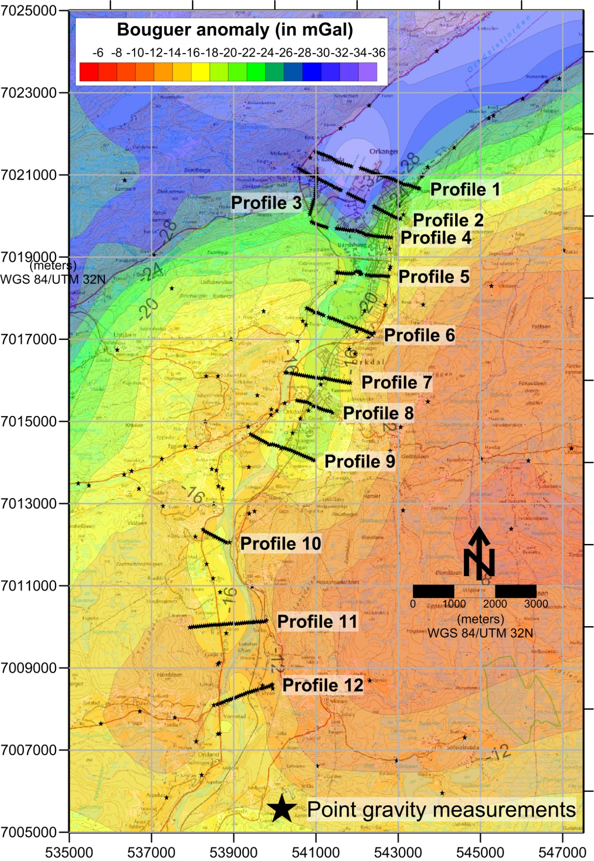

Figure 3.5:Bouguer anomaly distribution in the wider Orkdal area. Data from NGU database DRAGON.

Bedrock density value on the other hand is a bit more complex. Taking into consideration the variability of bedrock density shown in table 3.3, choosing a constant value for all our models like we did with sediments was impossible. In addition to that, the petrophysical data we have in our possession are ground measurements in specific locations which means that we can use them as long as they coincide with the beginning or ending of the profiles. In areas where we have no petrophysical data coverage, we have used the mean density value (2900 kg/m³) calculated from table 3.3 and adjusted it accordingly depending on the level of the Bouguer gravity curve. Another important modeling parameter has to do with dividing the half space assigned to bedrock in two parts in a vertical sense. Since no regional trend removal has been performed, some models were in need of an artificial way of matching the inclination of the Bouguer gravity curve inherent by the regional gravity trend in the region. This has been achieved via dividing the bedrock assigned half space into two segments with slightly different densities. This small offset in density causes the calculated Bouguer anomaly to shift in inclination and eventually match the measured one.
All modeling has been performed with the use of GM-SYS GX menu of the Geosoft Oasis Montaj software Version 8.1. In all cases we have used a reduction density equal to 2670 kg/m³ while each gravity station has been placed on the measured topographic height. The maximum half space depth for all our models was set equal to 1 km while in the horizontal sense, the model block rectangle was extended 30 km more than its normal length towards both directions. All models have been exported from GM-SYS and illustrated in Golden Software's Surfer 11 program, version 11.6.1159 (64-bit). This was done in order to create a more presentable illustration of our results.

MODELING RESULTS AND DESCRIPTION

Each interpreted profile is illustrated in two parts. Bottom part contains the resulting cross section which shows the formations included in the models, the densities attributed to them during processing and their eventual calculated dimensions. The colors have been chosen to match those of the respective formations shown in the quaternary and bedrock geological maps. Therefore, sediments are shown in a blue color (marine sediments in figure 3.4) while bedrock is shown in two similar versions of green according to its blocks' density (schist and gneiss in figure 3.1). By doing so we have tried to present results which are coherent with the already existing maps. All models have been plotted down to 350 meters of depth. Both axes are in meters and the X and Y axis ratio is 1:1. In this way, the depth of sediments illustrated can be seen in its true extent compared to its lateral dimensions. A general direction of each cross section is given at the beginning and end of the X axis with geographical coordinates in the WGS 1984 system. Beginning and ending of each profile as well as general direction are given in table 4.1 in WGS84, UTM 32N zone. It should also be noted that all depths have been transformed into depths from topography instead of depths from zero level that GM-SYS software calculates. This was done by interpolating the topography in places where point depths have been calculated and then adding their absolute values. In all figures, we maintain the zero level setting with all values above being positive and all values below being negative however, all assessments concerning the depth of sediments is done with topography as reference point and not zero level.
Top part shows the graph between the observed gravity values (black dots), the calculated ones (blue line) and a graph of the mathematical error of the model (red line). Y axis represents gravity and is in milligals while X axis is in meters. The horizontal scale of the X axis has been kept equal between graph and cross section for viewing purposes and easier comparison. All graphs contain a legend which is showing the color correspondence, as well as the arithmetical value of the calculated error. The calculated error is equal to the standard deviation of the differences between observed and calculated Bouguer values in each model. We should also note that the error values do not correspond to the Y axis scale. The error value in each figure represents the standard deviation of the differences between measured and calculated gravity for the entire profile. The red line on the other hand represents the plot of these differences in each station. Y axis represents the gravity value range which is not the same for the differences. The plotting takes place after adding to these differences a mean value corresponding to the minimum and maximum value of the Y axis of each profile in order to plot them along with the measured and calculated gravity. This was done in order to highlight areas where the model is less reliable i.e. areas where the red line is deflecting from its horizontal mean value.

Profile no. | Beginning |  | Ending |  | Direction
 | Easting | Northing | Easting | Northing
1 | 540986 | 7021560 | 543516 | 7020669 | NW-SE
2 | 540583 | 7021152 | 543121 | 7020031 | NW-SE
3 | 540849 | 7020040 | 540986 | 7021560 | S-N
4 | 540892 | 7019854 | 542838 | 7019475 | WNW-ESE
5 | 541504 | 7018623 | 542768 | 7018530 | W-E
6 | 540774 | 7017753 | 542367 | 7017102 | NW-SE
7 | 540248 | 7016190 | 541839 | 7015937 | WNW-ESE
8 | 540533 | 7015511 | 541398 | 7015208 | NW-SE
9 | 539408 | 7014684 | 540965 | 7014050 | NW-SE
10 | 538249 | 7012367 | 538896 | 7012054 | NW-SE
11 | 537924 | 7009984 | 539792 | 7010152 | W-E
12 | 538598 | 7008113 | 539936 | 7008579 | WSW-ENE

Table 4.1: Coordinates of beginning and ending of each gravity profile in UTM 32N/WGS84 as well as their general direction.

The modeling results will be presented along with some comments in the following subsections. Each profile will be displayed in a single page for better representation purposes.

Profile 1
Profile number 1 is the northernmost profile in our study area. It is situated in the far north end of the Orkla river where it meets Orkdalsfjorden and stretches across the Orkanger harbor. It is 2682 meters long and contains 52 gravity measuring points. Some lack of measured gravity data in the middle part of the profile are due to marine conditions, however, this does not affect the modeling. Starting point is close inland from the western shore of Orkdalsfjorden and ending point is across the sea at Thamshamn also next to the shoreline. Both starting and ending point are measured on exposed bedrock while the general direction of the line is NW to SE. The Bouguer anomaly variation is equal to 12 mGals and the maximum anomaly effect of the sediments is about 8.0 to 8.5 mGal in the area between 1040-1420 meters. That alone is a strong indication that sediment thickness in the area should be significant.
As we can see in figure 4.1 this assertion has been verified through modeling. Sediments in the area reach a maximum depth of 270 m at about 1200-1300 meters. The sediment formation is then gradually reduced in depth towards both ends, but with a higher rate towards the east-southeastern shore. The bedrock has been divided in two blocks at about 1700 m from the start in order for our calculated values to match the regional gravity field trend inclination. The western block has a density of 2760 kg/m³ which is almost equal to the petrophysical data we have near this area (2730 kg/m³ - figure 3.3) while the eastern one has a slightly higher density of 2800 kg/m³ (40 kg/m³ offset). The only depth to bedrock information available for this profile is a depth of 1,5 m at the western shore of Orkdalsfjorden (figure 3.2) which cannot be used directly in our modeling due to the negligible anomaly caused by such a thin layer. This is also the case on the opposite shore where we have calculated exposed bedrock all the way to the shoreline. The calculated error for this modeling result is 0.176 which means that our model is pretty accurate in a mathematical sense.

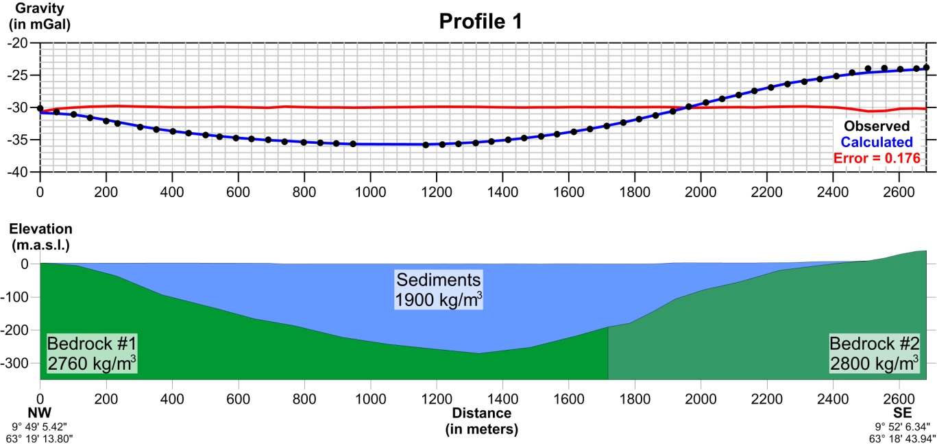

Figure 4.1: Modeled depth to bedrock - Profile 1. Bottom side: cross section showing the sediment formation dimensions (in meters) and distribution as well as utilized densities for both sediments and bedrock (in kg/m³). Top side: Observed and calculated gravity data graph with error estimation.

Profile 2
Profile number 2 is situated southwest and is near parallel to profile 1. The distance from profile 1 is about 550 m in the NW and 800 in the SE end. It lies within the general Orkla deltaic region and also stretches across the Orkanger harbor. Profile 2 has two small areas where no gravity measurements have been conducted. Its total length is equal to 2774 m within which 50 measurements have been taken.
The general direction of the profile is NW to SE. Once again both end points have been measured on exposed bedrock in order to facilitate the modeling process. The Bouguer variation along the profile is about 11 mGal, and the maximum anomaly effect of the sediments is about 7.0 mGal in the area between 1250-1500 meters. Again, the modeling procedure has attributed this big anomaly to a sediment layer which after about 1200 meters from the starting point has a maximum depth of around 220 meters.
Figure 4.2 illustrates the shape of this low density body which is almost identical to the one in profile 1. Sediment depth is again diminishing towards the profile's ends, giving its place to exposed bedrock. Unfortunately, no drillings or petrophysical data coincide with profile 2, therefore we have used the same setting as in profile 1: two bedrock blocks with densities of 2770 and 2810 kg/m³ each. The error for this modeling setup is 0.324 which also means a pretty good match between observed and calculated values.

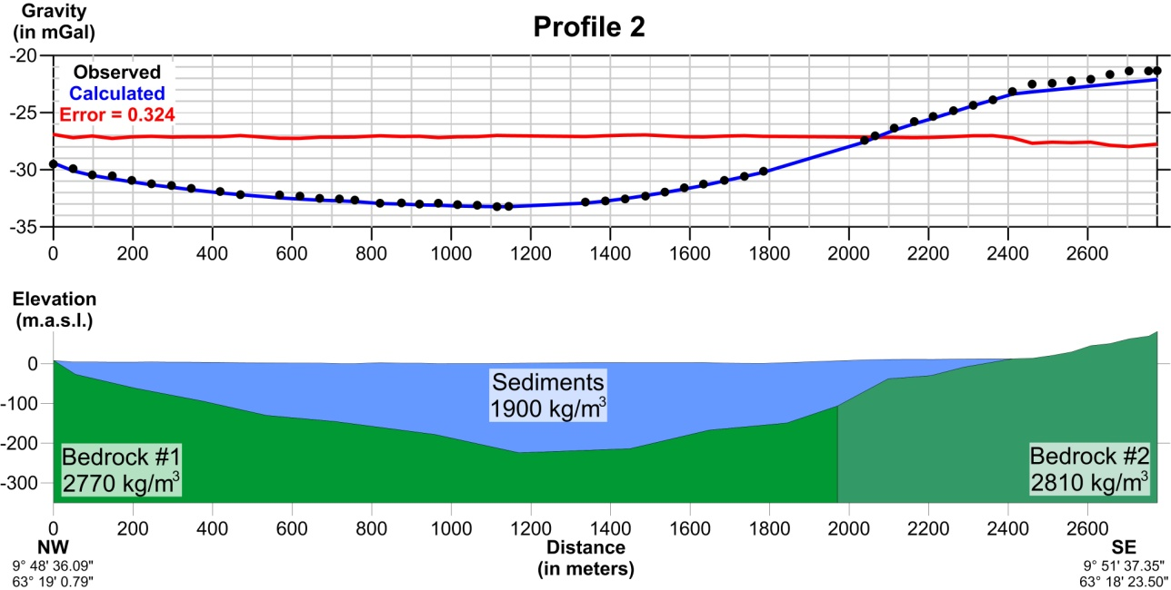

Figure 4.2: Modeled depth to bedrock - Profile 2. Bottom side: cross section showing the sediment formation dimensions (in meters) and distribution as well as utilized densities for both sediments and bedrock (in kg/m³). Top side: Observed and calculated gravity data graph with error estimation.

Profile 3
Profile number 3 has been measured differently than the other profiles. It does not cross over the Orkla riverbed like all the other profiles, instead it is almost vertical to the ones already presented with a general S to N direction situated in Gjølme and crossing a smaller valley west of Orkdalen. It is situated on the western part of the area and its starting point is almost identical to the starting point of profile 4.
However, as already mentioned, this particular profile is expanding towards the North and ending exactly where profile 1 starts. Its total length is equal to 1526 meters, contains 24 point gravity measurements and the maximum anomaly effect of the sediments is about 4.0 mGal in the area between 750-1000 meters. In figure 4.3 we can see that the gravity Bouguer anomaly variation in this profile is 8 mGal. For this profile we had density measurements on both ends of the profile therefore we split the bedrock formation into two blocks according to figure 3.3. The southern block's density is 2780 kg/m³ (2760 in figure 3.3) while the northern one's is 2725 kg/m³ (2730 in figure 3.3). This setting has resulted in a maximum calculated depth that can be found at 900 meters and is equal to 140 m. Drillings in the proximity of profile 3 only indicate minimum bedrock depth equal to 20 m or more (neighboring areas show a maximum depth of at least 72 meters - figure 3.2). In this area we have calculated a sediment depth of about 100 m which is in good agreement with the aforementioned data.
As seen in figure 4.3, sediments are increasing in depth towards Orkdalsfjorden to the north as expected. Considering the fact that this profile has less measurement points than the first two, its modeling error is relatively smaller with a value of 0.089.

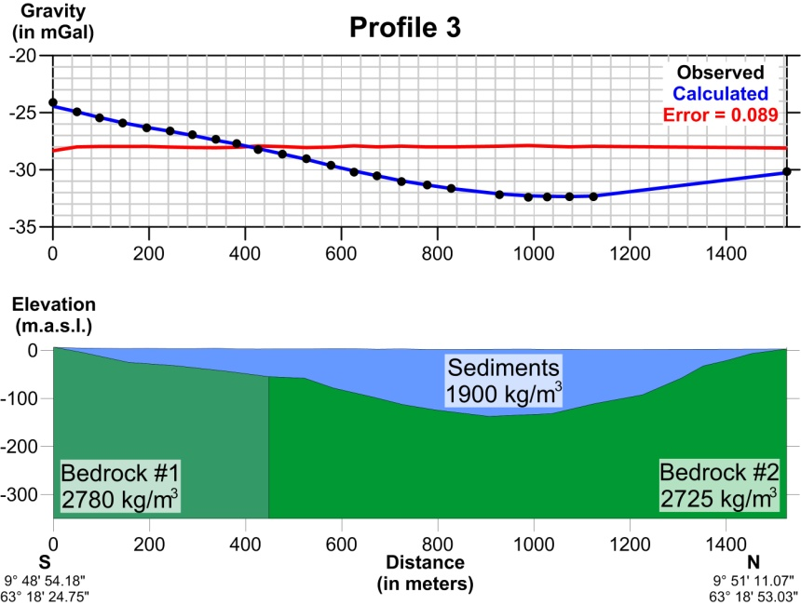

Figure 4.3: Modeled depth to bedrock - Profile 3. Bottom side: cross section showing the sediment formation dimensions (in meters) and distribution as well as utilized densities for both sediments and bedrock (in kg/m³). Top side: Observed and calculated gravity data graph with error estimation.

Profile 4
Profile number 4 has a Bouguer variation of 8 mGal and the maximum effect of the sediments is 6.0-6.2 mGal in the area 880-1120 meters. Profile 4 is situated south of profile 2 within the town of Orkanger and has a general W-NW to E-SE direction with a distance from profile 2 which varies from 1000 m at the west and 500 m at the east end. Its total length is equal to 1982 meters and contains 36 point gravity measurements, which are shown in figure 4.4 with black dots. Blue line indicates the modeled anomaly which is caused by the density model in the bottom. Figures 3.2 and 3.3 provide us with some useful depth to bedrock and density information which constrain our model. We have a density measurement of 2760 kg/m³ next to the start of the profile and a depth to bedrock of at least 120 m about 1300 meters within the line.
Bottom part of figure 4.4 shows the resulting density model for profile 4. Sediments present a maximum thickness of slightly over 210 m at about 1050 meters and a gradual decrease in depth towards each end of the profile. Once again the bedrock formation has been split in two blocks in order to imitate the regional trend of the field. The western block has been given the measured density value of 2760 kg/m³ while the eastern block was attributed a slightly higher density of 2790 kg/m³. The vertical error for this model is again negligible (0.140).

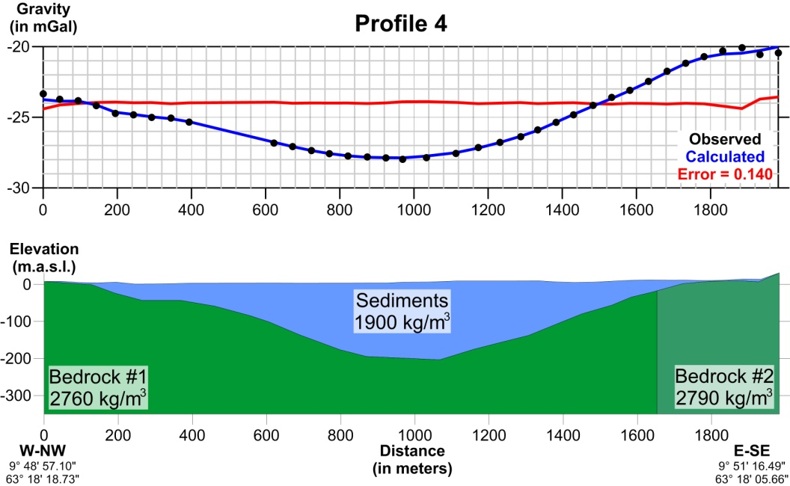

Figure 4.4: Modeled depth to bedrock - Profile 4. Bottom side: cross section showing the sediment formation dimensions (in meters) and distribution as well as utilized densities for both sediments and bedrock (in kg/m³). Top side: Observed and calculated gravity data graph with error estimation.

Profile 5
Profile number 5 is located about 1000 m south of profile 4 and is stretching across the suburb of Bårdshaug in an almost W to E direction. It includes a gravity anomaly of 6 mGal and the maximum effect of the sediments is 5.0-5.2 mGal in the area 420-860 meters. It is 1267 meters long and contains 26 measurements. Profile 5 is one of the few profiles that has density information available on both ends. As we see on figure 3.3 the west end is neighboring an area with a density equal to 3025 kg/m³ while the east end's point measurement is 2930 kg/m³. Like in previous profiles, we have split the bedrock formation into two parts with a slightly different density attributed to each one. The western block has density equal to 2910 kg/m³ while the eastern one is denser by 10 kg/m³ (2920 kg/m³). The limit between these two formations was set at around 1100 meters. Figure 3.2 only feeds us with a small depth to bedrock measurement (3 meters) on the eastern part of the profile. This information is only useful to roughly delineate the eastern limit of bedrock exposure.
Figure 4.5 presents a sediment thickness which becomes as deep as 170 m thick between 650-700 meters horizontal distance and decreasing towards the edges. Vertical error for this density model has been calculated to 0.093.

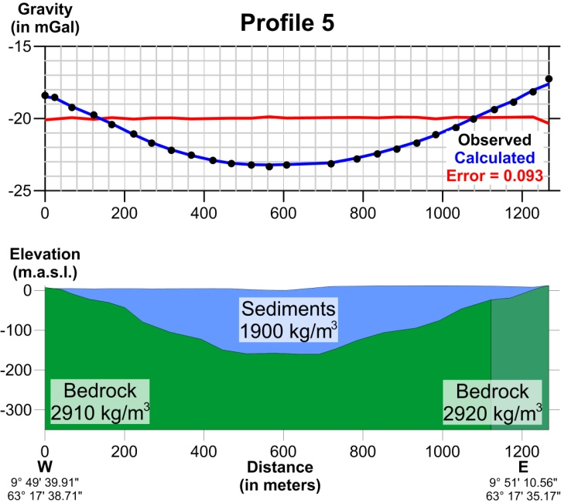

Figure 4.5: Modeled depth to bedrock - Profile 1. Bottom side: cross section showing the sediment formation dimensions (in meters) and distribution as well as utilized densities for both sediments and bedrock (in kg/m³). Top side: Observed and calculated gravity data graph with error estimation

Profile 6
Profile number 6 shows a Bouguer anomaly variation of about 7 mGal and the maximum effect of the sediments is 5.2-5.5 mGal in the area 600-850 meters. It crosses the area of Evjen across the Orkla riverbed 1200 meters south of profile 5, extends to a length of 1720 meters, contains 33 measurements and is oriented NW to SE. Unfortunately, the only additional information we have for profile 6 is a 19 meter deep drilling which hasn't reached bedrock near the western end of the line. Since no density measurements have been performed near the profile, we decided to use arbitrary values within the mean density spectrum of the entire region (2850-2900 kg/m³). Once again we have divided bedrock into two blocks of which the western part has a density of 2860 kg/m³ and the eastern 2880 kg/m³.

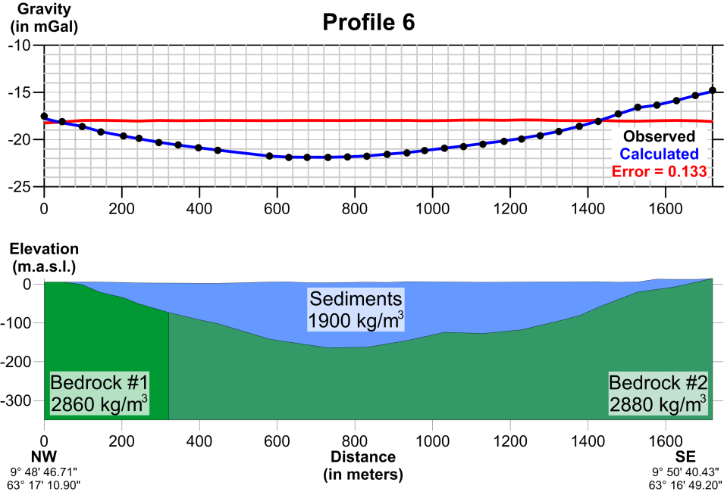

Figure 4.6: Modeled depth to bedrock - Profile 6. Bottom side: cross section showing the sediment formation dimensions (in meters) and distribution as well as utilized densities for both sediments and bedrock (in kg/m³). Top side: Observed and calculated gravity data graph with error estimation.

The anomaly shape is reflected in the shape of the modeled sediment layer in figure 4.6. It's maximum depth of over 170 m may be found before the middle part of the basin at around 700 meters distance with the sediments decreasing smoothly towards the profile's edges. The calculated error was once again small (0.133).

Profile 7
Profile 7 lies about 1500 m southwest of profile 6. This particular profile crosses the suburb of Fannremsmoen in a general W-NW/E-SE direction. The total length of the line is 1610 meters and contains 32 gravity measurements. The Bouguer anomaly variation along the profile is about 6 mGal and the maximum effect of the sediments is 5.0-5.6 mGal in the area 680-1100 meters. Unfortunately, neither density measurements nor drillings have been performed in the vicinity of profile 7, therefore all model attributes have been decided in correspondence with the previous models. This essentially means that bedrock is once again split in two counterparts with the western one having a density of 2850 kg/m³ and the eastern of 2860 kg/m³.
Figure 4.7 shows a local maximum depth of 200 m after 1000 meters of horizontal distance which has been calculated with an error of 0.046. Moreover, the depth decrease towards the ends of the profile is somewhat rapid compared to previous models.

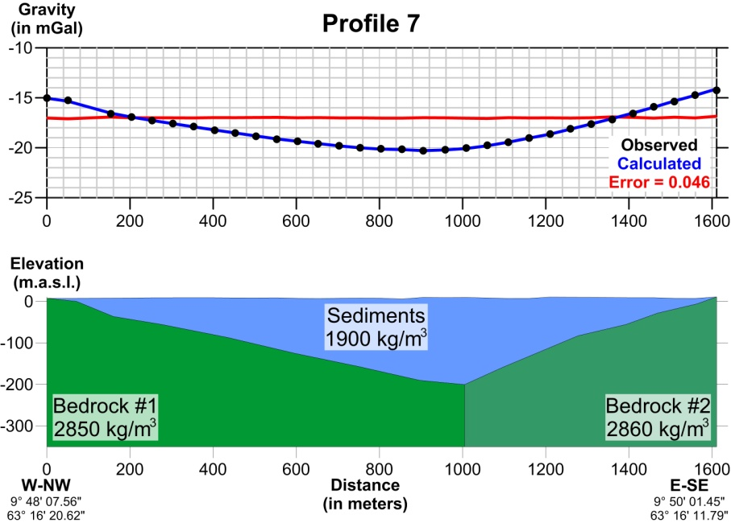

Figure 4.7: Modeled depth to bedrock - Profile 7. Bottom side: cross section showing the sediment formation dimensions (in meters) and distribution as well as utilized densities for both sediments and bedrock (in kg/m³). Top side: Observed and calculated gravity data graph with error estimation.

Profile 8
Profile 8 is one of the shortest, extending to 916 meters only and containing 19 measurements. It is stretching across Fannrem in a NW-SE direction about 700 m south of profile 7 but doesn't cross the riverbed. The end points of the profile are not on exposed bedrock and cannot be used as anchor points when modeling. Measuring on exposed bedrock about 300 m west of the profile shows a Bouguer anomaly value of -15.4 mGal. This value is used in modeling and extends our profile to a total length of about 1180 meters. The maximum effect of the sediments is then 4.2-4.4 mGal in the area 750-950 meters in the profile. The bedrock formation used in this profile has a uniform density value equal to 2850 kg/m³.
Figure 4.8 shows the modeled density responsible for the above described anomaly which ascertains the claim that sediments in this area are thinner. The thickest sediments may be found at 800 meters distance where their bottom surface lies at 135 m, a depth much smaller than the maximum sediment thickness calculated for the previous profile. With an error of 0.027 we can conclude that our model for profile 8 is accurate enough.

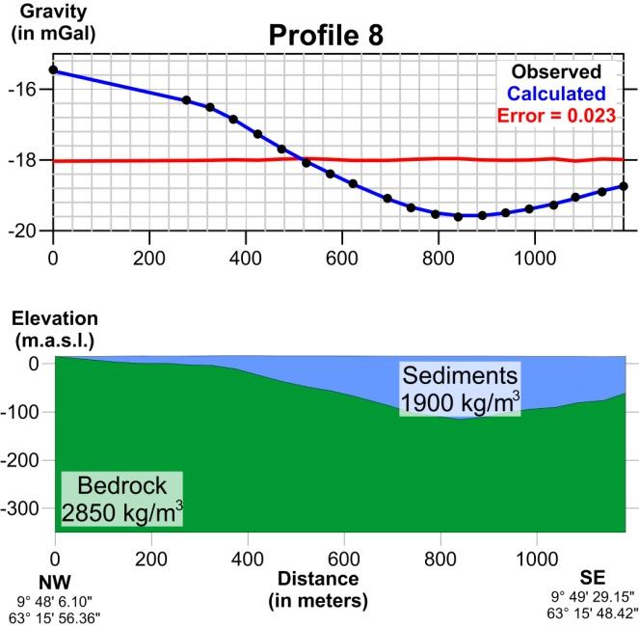

Figure 4.8: Modeled depth to bedrock - Profile 8. Bottom side: cross section showing the sediment formation dimensions (in meters) and distribution as well as utilized densities for both sediments and bedrock (in kg/m³). Top side: Observed and calculated gravity data graph with error estimation.

Profile 9
About 1200 m southwest of profile 8 and following the same NW-SE orientation lies profile number 9. The line is 1681 meters long crossing over the Orkla river. 35 gravity measurements have been conducted for this profile and maximum effect of the sediments is about 4.0 mGal in the area 950-1400 meters in the profile. Profile 9 is starting on exposed bedrock, but finishes off in an area where bedrock is still lying beneath sediments. As seen in figure 3.2 this particular setting is followed in our modeling.
Near the beginning of the profile we have 4 m of sediments before drilling into bedrock while at about only 300 meters before the ending point at vertical coordinate 1400 meters, depth to bedrock should be at least 117 meters. Figure 3.3 also feeds us with a density of 2840 kg/m³ at the western end of the line.
Figure 4.9 presents the modeled density in which sediments maintain a maximum value of about 120 m and more between 1300 and 1400 meters along the profile. As described above, the profile ends with no bedrock exposure while at 1400 meters horizontal distance, calculated depth is over 120 meters which is just a bit above the drill value at the same location (117 m). The error has a value of 0.095.

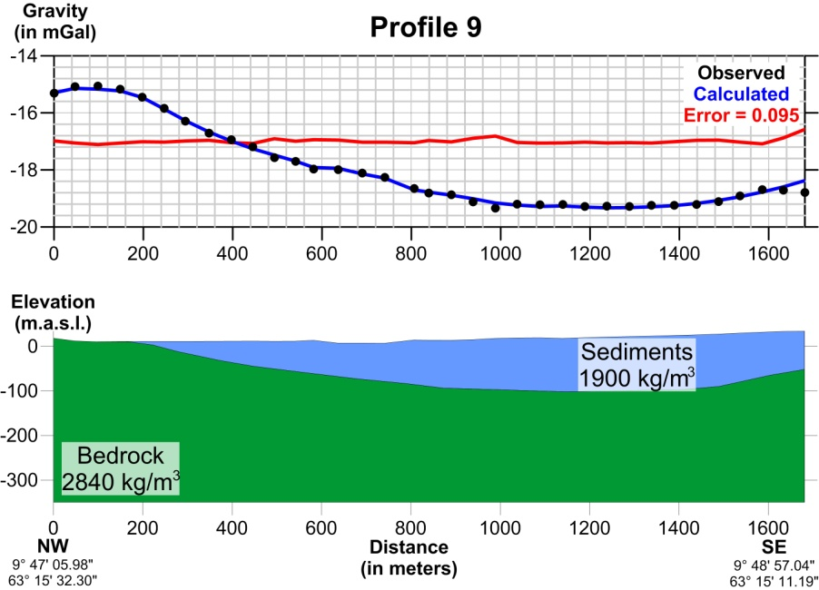

Figure 4.9: Modeled depth to bedrock - Profile 9. Bottom side: cross section showing the sediment formation dimensions (in meters) and distribution as well as utilized densities for both sediments and bedrock (in kg/m³). Top side: Observed and calculated gravity data graph with error estimation.

Profile 10
Profile 10 is 2700 meters southwest of profile 9. It is oriented in a NW-SE direction and starts near Kvåle and ends at Ekli. The profile is 718 meters long and constitutes the shortest measured line in the area, with only 15 gravity measurements. As shown in figure 3.3 the closest petrographic measurement done near the profile indicates that a value of 3100 kg/m³ is to be assigned to bedrock. However, we believe that a lower value is more reasonable so we have chosen a density of 2950 kg/m³ for the whole bedrock block. Depth to bedrock is also not sufficiently abetted by additional data, since only one drilling of at least 15 m depth lies close enough to the eastern end of the profile.
Figure 4.10 displays the modeling results for this particular profile. The Bouguer anomaly is about 3 mGal and the maximum effect of the sediments is about the same (2.8-2.9 mGal) in the area 420-520 meters. This anomaly has been interpreted with an error of 0.034 as a result of a sediment layer which has a maximum depth of over 100 m after 490 meters from the start and diminishes towards the edges of the profile.

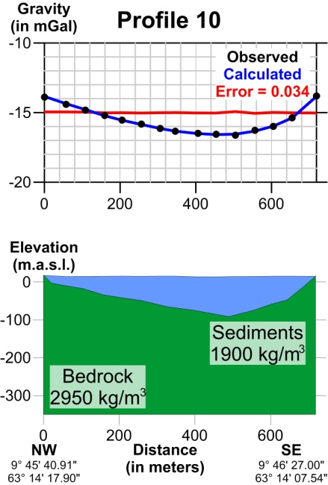

Figure 4.10: Modeled depth to bedrock - Profile 10. Bottom side: cross section showing the sediment formation dimensions (in meters) and distribution as well as utilized densities for both sediments and bedrock (in kg/m³). Top side: Observed and calculated gravity data graph with error estimation.

Profile 11
Profile number 11 can be found 2200 meters south of profile 10, stretching along an almost W-E direction. Its total length is 1910 meters and measurements have been performed in 39 stations. The Bouguer anomaly variation is about 5 mGal while the maximum effect of the sediments is 3.8-3.9 mGal in the area 500-700 meters. At the western end of the profile, a density of 3100 kg/m³ has been measured from several bedrock samples (figure 3.3), a value which we consider too high. In this case, we have divided again the bedrock formation into two blocks: a western part which has density 2990 kg/m³ and an eastern one which has density 3010 kg/m³. Additionally, figure 3.2 presents only one drilling that coincides with our line and indicates bedrock depth which is larger than 17 meters.
Figure 4.11 presents a modeled sediment block which reaches its maximum depth of about 90 m, 700 meters within the profile while diminishing towards the edges of the profile with a more rapid inclination towards the northwest. The error is once again small (0.066).

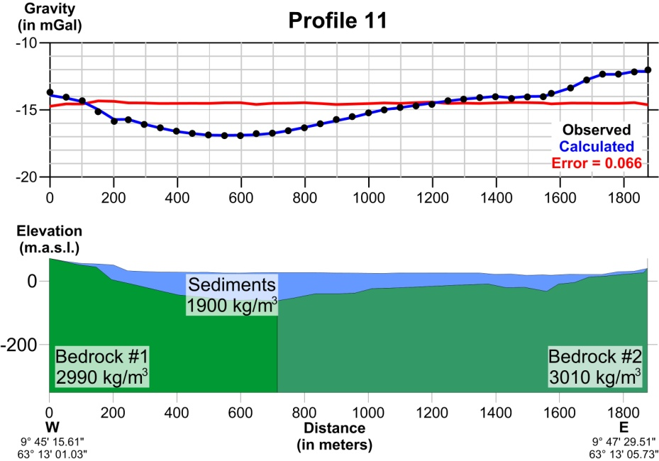

Figure 4.11: Modeled depth to bedrock - Profile 11. Bottom side: cross section showing the sediment formation dimensions (in meters) and distribution as well as utilized densities for both sediments and bedrock (in kg/m³). Top side: Observed and calculated gravity data graph with error estimation.

Profile 12
Profile number 12 is the southernmost profile and can be found 1800 m south of profile 11 and over 13 km south of profile 1. It is the only line which is oriented W-SW to E-NE. Profile 12 is stretching from Ljøkjel towards Øyan for 1422 meters and contains 28 gravity stations along the line. The Bouguer anomaly variation along the profile is about 3.0 mGal, and the maximum effect of the sediments is 2.2-2.4 mGal in the area 500-700 meters in the profile. The sediment effect is less than 1.0 mGal in the western part (position 0-300 meters) and in the eastern part from position 840 meters until the end. Figure 3.2 gives us quite a nice outline of the sediment depth along this profile. A drilling about 850 meters in the line but 200 m away from it towards the north shows a sediment thickness of 35 m. Figure 3.3 feeds us with a density measurement for the starting point of the profile. However, the presented value of 2760 kg/m³ has been assigned only to the western block of the bedrock formation while the eastern part was given a slightly higher value of 2790 kg/m³.
Figure 4.12 presents modeling results after using the aforementioned constraints. Sediments seem to be distributed in two areas, the deepest of which presents a maximum depth of about 80-85 m at about 550 meters. Bedrock is exposed both in the beginning and the ending of the profile. Error has been calculated equal to 0.083.

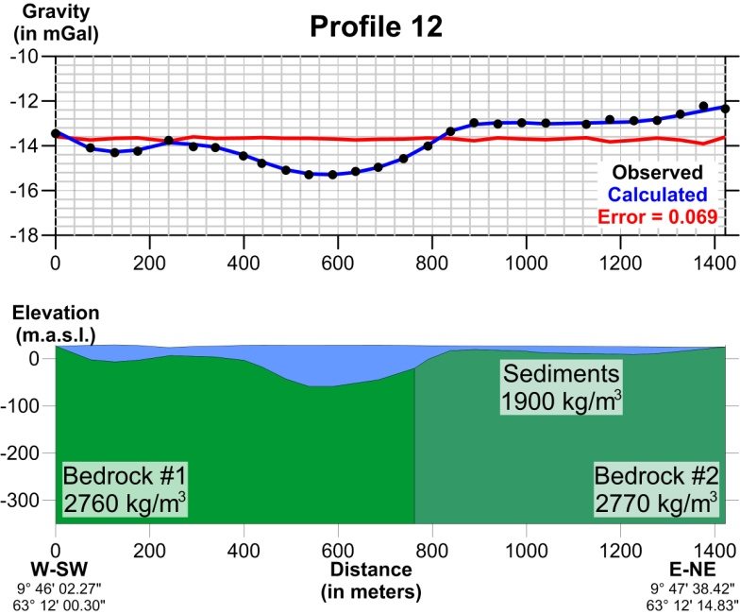

Figure 4.12: Modeled depth to bedrock - Profile 12. Bottom side: cross section showing the sediment formation dimensions (in meters) and distribution as well as utilized densities for both sediments and bedrock (in kg/m³). Top side: Observed and calculated gravity data graph with error estimation.

DEPTH TO BEDROCK

As shown in figure 2.1 our profiles do not form a regular grid of the area, instead they are distanced several hundreds of meters apart varying from 650 to 2700. As we can see, the spacing along the Y axis is much bigger than the spacing along the X axis (50 meters) which means that trying to create a horizontal grid of the depth to bedrock will result in large areas of speculated values which only depend on the interpolation method used.

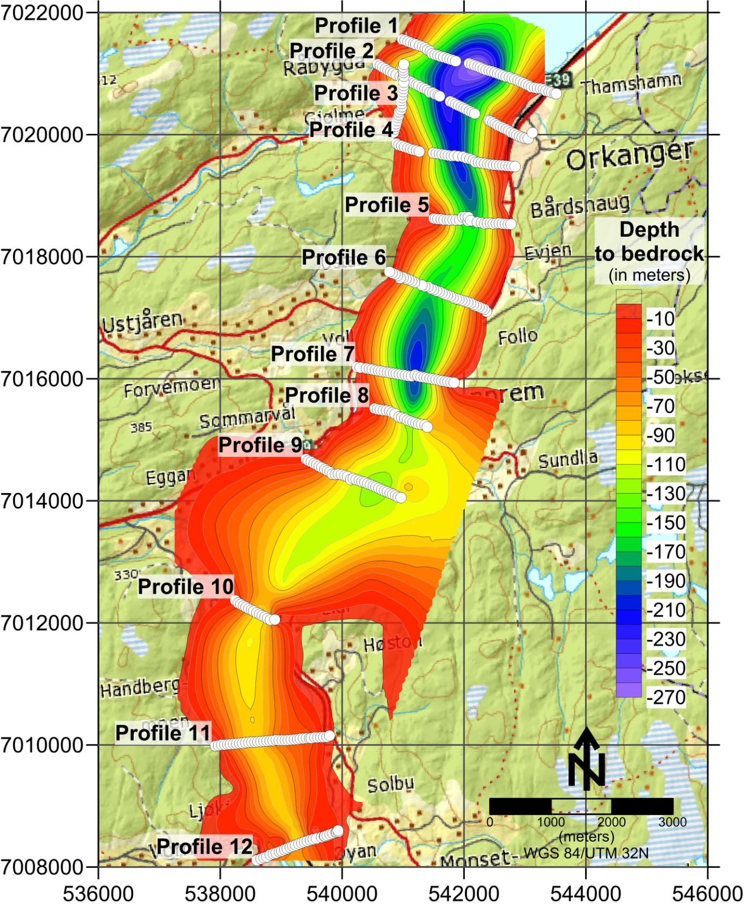

Figure 5.1: Depth to bedrock distribution in meters as measured from topography.

To overcome this problem we had to enrich our depth to bedrock file with several additional data. These data refer to: a) drillings that reached bedrock (table 3.1 - figure 3.2), b) a few areas of bedrock exposure as shown in the geological map to constrain the interpolation calculations and c) a line crossing all profiles and containing the largest calculated depths with interpolated values between lines. Adding these points does not eliminate the uneven spacing effect, neither does it improve the interpolation procedure much. However, it gives us a more or less acceptable image of how depth is varying not only in the vertical, but also in the horizontal direction along the X and Y axes. Figure 5.1 presents the results of the gridding procedure.
The resulting grid has been compiled with Krigging gridding method with a step of 50 m per axis. This led to a rather smooth version of depth to bedrock which also has an elongated tendency along the N-S direction. This is to be expected since not enough gravity and/or interpreted depth data exist in between profiles. Main contouring was done with a 20 meter interval while all values above zero have been rendered transparent. Once again we should note that these depths indicate depth from topography and not depth from zero level as exported from GM-SYS. It should also be noted that the northern part of the study area has denser profile distribution and this results into a more coherent grid image. South of Profile 9 however, lines become increasingly sparse and areas in between have no bedrock depth anchor points to push interpolation towards a more coherent result. Between Profile 9 and 10 not enough data points exist and therefore the resulting depth gridding appears widened. Despite all of the above limitations, figure 5.1 presents a map of sediment depth along the Orkla river whose accuracy is strongly dependent on the gravity data availability i.e. in the areas where profiles are dense the grid is more accurate than in areas where profiles are distanced farther away. Figure 5.2 shows the grid plotted in Google Earth which gives a pseudo-3D impression of the Orkla sediments.

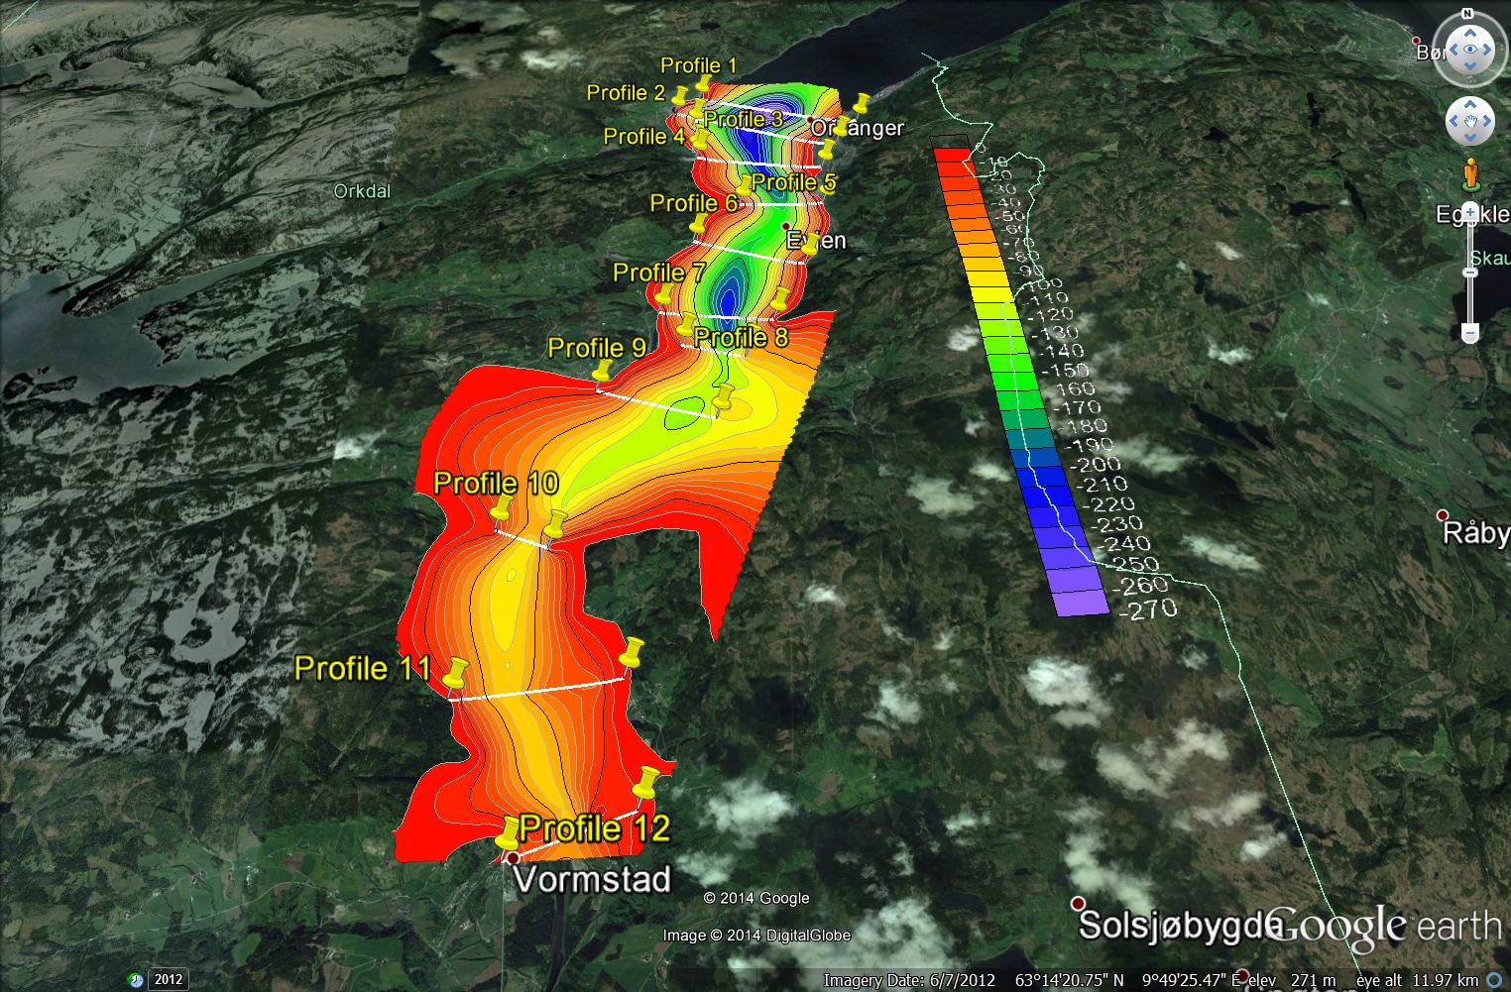

Figure 5.2: Google Earth image of the Orkdal area with gridded depth to bedrock plotted.

Figure 5.3:3D representation of the calculated sediment body in Orkdalen: a. 3D plotting of the interpreted profiles. b. Resulting 3D body after wireframing the profiles together. c. Side of the sediment body (view from the east). d. The bottom part of the sediment body as seen from northeast and below (all distances and depths in meters, all coordinates in WGS84/UTM 32N and all profiles vertically exaggerated by 4).

Figure 5.3 shows a 3D representation of the sediment body as calculated with GM-SYS. It should be noted however, that profiles in the mid-northern part of the study area are much denser than in the mid-southern part. This means that the northernmost part of the 3D body is better shaped than its southernmost counterpart, where wireframing connected 2D slices with larger areas of data unavailability in between (Figure 5.3a). Figure 5.3b shows the resulting 3D sediment body after connecting all 2D profiles together. In this figure we have used a vertical exaggeration of 4 in order to highlight its vertical characteristics i.e. the depth of sediments. This was done due to the fact that the horizontal length of the body was much greater than its maximum vertical dimension (~15 km vs. 250 meters respectively) producing a rather thin 3D body where no significant details were visible enough. The outspread of sediments is more schematically shown in figure 5.3c where we present a side view of the body. From this figure we can easily conclude that sediments are thicker in the northern part of the Orkdalen area and as we move southwards sedimentation is decreasing gradually. Finally, figure 5.3d presents a view of the 3D body from below in order to highlight the details of the sediments' bottom surface. The whole 3D sediment body is also available on 3D pdf format where users can rotate it freely to any angle according to their desired perspective.

DISCUSSION AND CONCLUSIONS

In this study we have attempted to map the sediment depth along the Orkla river in Orkdal municipality by using all available NGU databases that coincide with our area. In addition to gravity data, we have also incorporated borehole depth and density measurements as well as bedrock and quaternary geological maps. By doing so, we have ensured that our models share properties (at least to the knowledge database extent) with the actual formations in the area. Figures 5.1, 5.2 and 5.3 present the undulations of a sediment layer whose density has been set equal to 1900 kg/m³ and kept constant throughout the process. This layer is embedded in bedrock of variable density depending on the rock formations dominating the immediate area of each gravity measurement point.
The sediment thickness is gradually decreasing as we move inlands from the sea with a rate of about 10 meters for every kilometer of horizontal distance. The thickest sediments in the area can be found along the northernmost profile which is adjacent to Orkdalsfjorden and can reach as deep as 270 m. Profile 5 marks an area where the smaller depths have been calculated compared to the neighboring profiles however, after profile 9 the decreasing of depth to bedrock is continued. It should be noted that the calculated depths are not affected by small density changes in the sediments (for example if we had used 2000 kg/m³) however, the general shape of the sediment valley may change in shape and become steeper towards its edges. The whole shift is no more than 5-15 meters per point.
According to our results we can say that a general increase of depth to bedrock has been identified along the S-N direction. The sediment valley along the Orkla river is relatively narrow and follows the riverbed of the Orkla river. Profiles 5 and 10 represent the narrowest sediment spreading areas in our study which can be easily seen in figure 5.1. These profiles represent boundaries where bedrock exposure is limiting the superficial spreading of sediments.Last but not least we should remind that between profiles 9 and 10 the widening of the sediment spreading is due to interpolation without enough depth to bedrock data and therefore probably uncertain. As for the other profiles, the superficial exposure of sediments is varying in width between 500 and 2500 meters perpendicularly to the riverbed. We can imagine the overall superficial shape of the sediment basin if we follow the 0 to 20 m contour on figure 5.1 (red to orange limit).

REFERENCES

Carstens, C.W. 1951: Løkkenfeltets geologi. Norsk geologisk forening, Norsk geologisk tidsskrift; Foredrag i Norsk geologisk forening 7. Desember 1949 29 (1-4); Sidetall 9-25.
Carter, P. 1967: The geology of an area north of Gåsbakken, Sør-Trøndelag. Norges geologiske undersøkelse, NGU; Årbok 1966, 247; Sidetall 150-161.
Fransen, G. 1951: Handledning i schaktning med djupgrävmaskiner. State board of water power, Stockholm, Sweden, p. 136. In Swedish.
Gellein, J., Dalsegg, E. and Tønnesen, J.F. 2005: Gravimetrimålinger og 2D resistivitet for kartlegging av løsmasser, Askim, Trøgstad og Eidsberg, Østfold. NGU rapport nr. 2005.038.
Hansen, L., L'Heureux, J.S. and Longva, O. 2011: Turbiditic, clay-rich event beds in fjord-marine deposits caused by landslides in emerging clay deposits - paleoenvironmental interpretation and role for submarine mass-wasting. Sedimentology, 58 (2011), pp. 890–915.
Harris, C.K. 2003. Sediment transport processes in coastal environments. Virginia Institute of Marine Science, Spring Semester course.
Johnsen, S.O. 1979: Geology of the area west and northwest of Orkdalsfjorden, Sør-Trøndelag. Norges geologiske undersøkelse, NGU 348, Sidetall 33-46.
Mathisen, O. 1976: A method for Bouguer Reduction with Rapid Calculation of Terrain Corrections. Norges geografiske oppmåling, Geodetiske arbeider 18.
NGO (Norges Geografiske Oppmåling) 1956: Høyder for presisjonsnivellement i Sør-Norge. Geodetiske arbeider, hefte 6.
Peacey, J.S. 1963: Deformation in the Gangåsvann area. Norges geologiske undersøkelse; NGU, Årbok 1962, 223, Sidetall 275-293.
Reite, A.J. 1977: Orkanger, kvartærgeologisk kart 1521 I – M 1:50 000. Norges geologiske undersøkelse.
Reite, A.J. 1983: Orkanger 1521 I. Beskrivelse til kvartærgeologisk kart – M 1:50 000. Norges geologiske undersøkelse, 392 (Skrifter 47), 1-39.
Rise, L., Bøe, R., Sveian, H., Lyså, A. & Olsen, H.A. 2006: The deglaciation history of Trondheimsfjorden and Trondheimsleia, Central Norway. Norwegian Journal of Geology, Vol. 86, pp. 419-438. Trondheim 2006. ISSN 029-196X.
Rosenberry, D.O. 2008: Influence of fluvial processes on exchange between groundwater and surface water. Doctorare thesis at the Department of Geography, University of Colorado. UMI number 3284456.
Rutter, E.H.; Chaplow, R. & Matthews, J.E. 1968: The geology of the Løkken area, Sør-Trøndelag. Norges geologiske undersøkelse, NGU 255, Sidetall 21-36.
Solli, A., Grenne, T., Slagstad, T. & Roberts, D. 2003: Berggrunnskart TRONDHEIM 1621 IV, M 1:50 000, foreløpig utgave. Norges geologiske undersøkelse.
Tucker, R.D. 1986: Geology of the Hemnefjord-Orkanger area, south-central Norway. Norges geologiske undersøkelse, Bulletin 404, Sidetall 1-21.
Tønnesen, J.F. 1978: Geofysiske undersøkelser av kvartære sedimenter i Numedal. Hovedoppgave, UiO Inst. for geologi.
Tønnesen, J.F. 1987: Gravity measurements applied to the mapping of Sediment thickness and Bedrock morphology in valleys in Trøndelag. Geoexploration, Vol. 24, no. 3, October 1987, pp. 255-256.
Tønnesen, J.F. 1991a: Gravimetri for kartlegging av løsmassemektigheter i Gaulosen. NGU rapport nr. 91.211.
Tønnesen, J.F. 1991b: Gravimetri for kartlegging av løsmassemektigheter i Stjørdal. NGU rapport nr. 91.224.
Tønnesen, J.F. 1993: Gravimetri for kartlegging av løsmassemektigheter i Verdalen. NGU rapport nr. 92.295.
Tønnesen, J.F. 1996: Gravimetri for kartlegging av løsmassemektigheter i Trondheim. NGU rapport nr. 95.078.
Wolff, F. Chr. 1976: Geologisk kart over Norge, berggrunnskart TRONDHEIM 1:250 000, Norges geologiske undersøkelse.

