NGU REPORT 2015.007

Helicopter-borne magnetic and radiometric geophysical survey in Kvinesdal and Sirdal area,
Vest-Agder and Rogaland

REPORT

Geological Survey of Norway
P.O.Box 6315 Sluppen
NO-7491 TRONDHEIM
Tel.: 47 73 90 40 00

Report no.: 2015.007 |  |  | ISSN: 0800-3416 (print)  ISSN: 2387-3515 (online) |  | Grading: Open
Title:
Helicopter-borne magnetic and radiometric geophysical survey in Kvinesdal and Sirdal,
Vest-Agder.

Authors:  Frode Ofstad |  |  |  | Client:  Statens Vegvesen / NGU
County:  Vest-Agder and Rogaland |  |  |  | Municipalities:  Kvinesdal, Sirdal, Soknedal, Lund, Bjerkreim, Audnedal, Hægebostad, Flekkefjord, Åseral.
Map-sheet name (M=1:250.000)  Mandal |  |  |  | Map-sheet no. (M=1:50.000)  1311-1&4, 1312-2& 3, 1411-1,2,3 & 4, 1412-2 & 3
Deposit name and grid-reference:  UTM sone 32V 400000E - 650000N Knaben |  |  |  | Number of pages: 25 Price (NOK): 80,-  Map enclosures:
Fieldwork carried out:  Oct-Nov 2013, July 2014, Oct-Nov 2014 | Date of report:  27.02.15 |  |  | Project no.:  353200 |  |  | Person responsible:
Summary:

NGU conducted an airborne magnetic and radiometric survey in Kvinesdal and Sirdal area in October to November 2013, July 2014 and October to November 2014 as a part of the MINS program (Mineral resources in Southern Norway).

This report describes and documents the acquisition, processing and visualization of the recorded datasets. The geophysical survey results reported herein are from 14600 line km, covering an area of 2920 km².

A Scintrex CS-3 magnetometer in a towed bird and a 1024 channels RSX-5 spectrometer installed under the helicopter belly was used for data acquisition.

The survey was flown with 200 m line spacing, line direction 90º (E - W) at an average speed of 71 km/h. The average terrain clearance was 55 m for the bird and 82 m for the spectrometer.

The collected data were processed at NGU using Geosoft Oasis Montaj software. Raw total magnetic field data were corrected for diurnal variation and levelled using standard micro-levelling algorithm.

Radiometric data were processed using standard procedures recommended by International Atomic Energy Association.

Data were gridded with the cell size of 50 x 50 m and presented as a shaded relief maps at the scale of 1:100.000.

Keywords: |  | Airborne |  |  |  | Geophysics
Magnetics |  | Radiometrics |  |  |  | Technical Report

CONTENTS

1. SURVEY SPECIFICATIONS 5
1.1 Airborne Survey Parameters 5
2. AIRBORNE SURVEY INSTRUMENTATION 6
2.1 Airborne Survey Logistics Summary 6
3. DATA PROCESSING AND PRESENTATION 7
3.1 Total Field Magnetic Data 7
3.2 Radiometric data 9
4. PRODUCTS 13
5. REFERENCES 13

Appendix A1: Description of magnetic data processing 14
Appendix A2: Description of radiometry data processing 14

FIGURES

Figure 1: Kvinesdal-Sirdal survey area in Vest-Agder and Rogaland 4
Figure 2: Pilots with Mag bird in front of the helicopter used in survey. 5
Figure 3: Gamma-ray spectrum with K, Th, U and Total Count windows. 9
Figure 4: Kvinesdal and Sirdal survey area with flight path 16
Figure 5: Total Magnetic Field Anomaly 17
Figure 6: Magnetic Vertical Gradient 18
Figure 7: Magnetic Horizontal Gradient 19
Figure 8: Magnetic Tilt Derivative 20
Figure 9: Radiation Total Counts 21
Figure 10: Uranium Ground Concentration 22
Figure 11: Thorium Ground Concentration 23
Figure 12: Potassium Ground Concentration 24
Figure 13: Ternary Image of Radiation Concentrations 25

TABLES

Table 1: Instrument Specifications 6
Table 2: Channel windows for the 1024 RSX-5 systems used in this survey 9
Table 3: Maps in scale 1:100.000 available from NGU on request. 13

INTRODUCTION

NGU (Geological Survey of Norway) conducted in October-November 2013, July 2014 and October-November 2014, an airborne geophysical survey in Kvinesdal and Sirdal area, where the different areas flown are shown in Figure 1. The helicopter survey consists of 14600 line-km of data, covering an area of 2920 km² in Vest-Agder and Rogaland Counties.

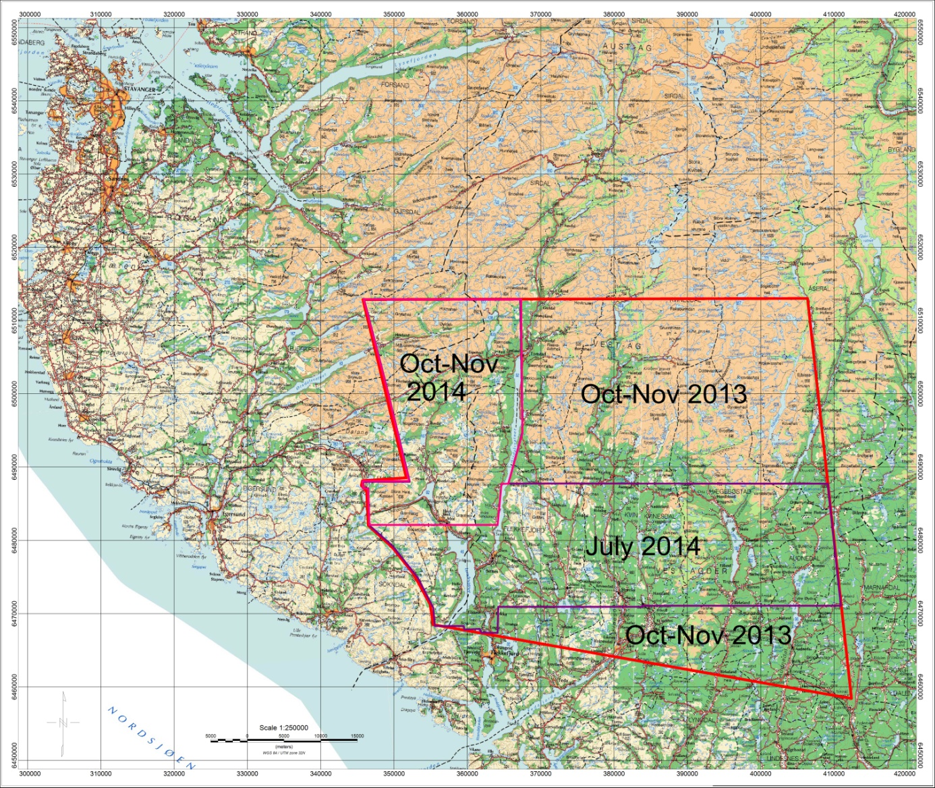
Figure 1: Kvinesdal-Sirdal survey area in Vest-Agder and Rogaland

The objective of the airborne geophysical survey was to obtain a dense high-resolution aero-magnetic and radiometric data set over the survey area to improve the general understanding of the geology. The data can be used to map bedrock geology, contacts and structural features within the area, the potential of fracture zones, their geological settings, and identifying other areas of interest.

The survey incorporated the use of a high-sensitivity Cesium magnetometer, gamma-ray spectrometer and radar altimeter. A GPS navigation computer system with flight path indicators ensured accurate positioning of the geophysical data with respect to the World Geodetic System 1984 geodetic datum (WGS-84).

SURVEY SPECIFICATIONS

Airborne Survey Parameters
NGU used a helicopter survey system designed to obtain high detailed airborne magnetic data. The magnetic sensor was supplemented by one 1024 channel gamma-ray spectrometer with 16 liters downward and 4 liters upward crystal volume, which was used to map ground concentrations of Uranium, Thorium and Potassium.

The survey started October 12th and aborted at November 30th, 2013, d.t weather conditions. The survey was continued from June 30th to July 17th 2014, and finally completed between October 14th and November 20th 2014. A Eurocopter AS350-B2 from helicopter company HeliScan AS was used during the survey (Figure 2). The survey lines were spaced 200 m apart, and oriented at a 90° azimuth in UTM zone 32V. Instrument operation was performed by Heliscan AS employees.

The magnetic sensor was housed in a single 1.8 meters long bird, which was flown at a constant altitude above the topographic surface. The Radiation Solutions RSX-5 gamma-ray spectrometer was installed under the belly of the helicopter, registering natural gamma ray radiation simultaneously with the acquisition of magnetic data.

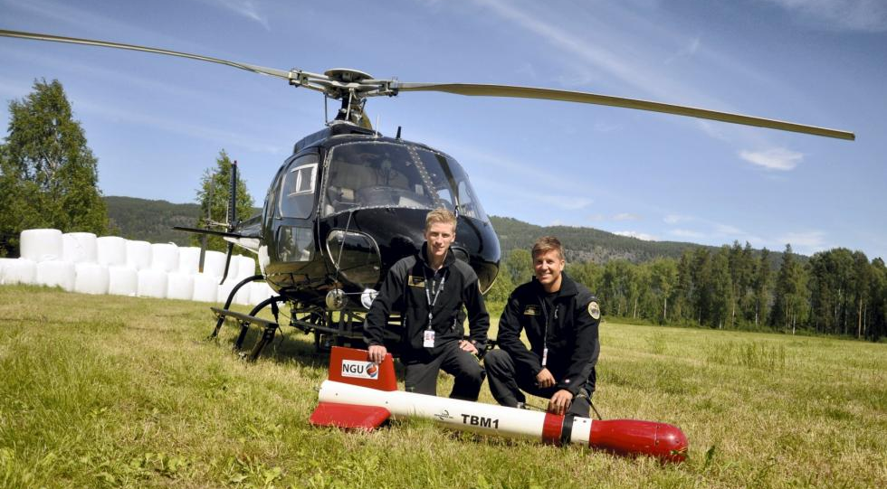
Figure 2: Pilots with Mag bird in front of the helicopter used in survey. (P1)

Rugged terrain and abrupt changes in topography affected the pilot’s ability to ‘drape’ the terrain; therefore there are positive and negative variations in helicopter altitude with respect to the standard, which is defined as 60 m (200 ft), plus a height of obstacles (trees, power lines). The average altitude for the magnetometer in this survey was 55 m, and 82 m for the spectrometer.

The ground speed of the aircraft varied from 60 – 120 km/h depending on topography, wind direction and its magnitude. On average the ground speed during the whole survey was calculated to 71 km/h. Magnetic data were recorded at 0.2 second intervals resulting in approximately 4 meters point spacing. Spectrometry data was recorded every 1 second giving an average point spacing of 20 meters.

For the October 2013 flights, the base magnetometer to monitor diurnal variations in the magnetic field was located at Tonstad, UTM 32V 6505300 N, 368300 E. In November 2013 and July 2014 the base station was located at Utsikten Hotel near Åmot, UTM 32V 6464700 N, 381100 E. For October to November 2014 flights, the base-station was located 2 km west of Tonstad, at UTM 32V 6505000 N, 365400 E.

The GEM GSM-19 base-station data were recorded once every 3 seconds. The CPU clock of the magnetometer was synchronized through the built-in GPS receiver, providing precise diurnal variation corrections of the magnetic data.

Navigation system uses GPS/GLONASS satellite tracking systems to provide real-time WGS-84 coordinate locations for every second. The accuracy achieved with no differential corrections is reported to be less than ± 5 m in the horizontal directions. The GPS receiver antenna was mounted externally to the cabin roof of the helicopter.

For quality control, the magnetic, radiometric, altitude and navigation data were monitored on two separate windows in the operator’s display during flight while they were recorded in ASCII data streams to the acquisition PC hard disk drive.

AIRBORNE SURVEY INSTRUMENTATION

Table 1: Instrument Specifications
Instrument | Producer / Model | Accuracy / Sensitivity | Sampling frequency/ interval
Magnetometer | Scintrex Cs-3 | 2.5 nT / 0.002 nT | 5 Hz
Base magnetometer | GEM GSM-19 | - nT | 3 s
Gamma spectrometer | Radiation Solutions  RSX-5 | 1024 ch’s, 16 liters down, 4 liters up | 1 Hz
Radar altimeter | Bendix/King KRA 405B | ± 3 % 0 – 500 ft  ± 5 % 500-2500 ft | 1 Hz
Pressure/temperature | Honeywell PPT | ± 0,03 % FS | 1 Hz
Navigation | Topcon GPS-receiver | ± 5 meter | 1 Hz
Acquisition system | NGU custom software

The magnetic and radiometric, altitude and navigation data were monitored on the operator’s displays during flight while they were recorded to the PC hard disk drive. Spectrometry data were also recorded to internal hard drive of the spectrometer. The raw data files were backed up onto USB flash drive in the field.

Airborne Survey Logistics Summary
Traverse (survey) line spacing: 200 meters
Traverse line direction: 90° E-W
Nominal aircraft ground speed: 60 – 120 km/h
Average sensor terrain clearance Mag: 55 meters
Average sensor terrain clearance Rad: 82 meters

DATA PROCESSING AND PRESENTATION
All data were processed by Frode Ofstad at NGU. The raw data files were loaded into Oasis Montaj databases and processed according to the descriptions in Appendix A1 and A2.

Total Field Magnetic Data
At the first stage the magnetic data were visually inspected and spikes were removed manually. A two-fiducial lag filter and a non-linear filter were applied to eliminate short-period spikes. Then the data from basemag station were imported into the magnetic database. Diurnal variation channel was also inspected for spikes and spikes were removed manually. Typically, several corrections have to be applied to magnetic data before gridding.

Diurnal Corrections
The temporal fluctuations in the magnetic field of the earth affect the total magnetic field readings recorded during the airborne survey. This is commonly referred to as the magnetic diurnal variation. These fluctuations can be effectively removed from the airborne magnetic dataset by using a stationary reference magnetometer that records the magnetic field of the earth simultaneously with the airborne sensor. Magnetic diurnals variations were within the standard NGU specifications during the entire survey (Rønning 2013).

Diurnal variations were measured with a GEM GSM-19 base magnetometer. The base station computer clock was continuously synchronized with GPS time. The recorded data are merged with the airborne data and the diurnal correction is applied according to equation (1).

, (1)
where:

The average datum base level () was set to 50037nT for flights 1 to 23 in 2013, when the base was near Tonstad. It was set to 50559nT for flights 24 to 38, with base near Åmot. The average base level was 50037nT in July 2014, with base near Åmot, and 50630nT for the October-November 2014 survey data with base west of Tonstad. Using these values will bring all magnetic data to a common level.

Corrections for Lag and heading
Neither a lag nor cloverleaf tests were performed before the survey. According to previous reports the lag between logged magnetic data and the corresponding navigational data was 1-2 fids. Translated to a distance it would be less than 10 m – the value comparable with the precision of GPS.

Magnetic data processing, gridding and presentation
The total field magnetic anomaly data () were calculated from the diurnal corrected data () after subtracting the IGRF for the surveyed area calculated for the data period (eq.2)
(2)

The total field anomaly data were split in lines and then were gridded using a minimum curvature method with a grid cell size of 50 meters. This cell size is equal to one quarter of the 200m average line spacing. In order to remove small line-to-line levelling errors that were detected on the gridded magnetic anomaly data, the Geosoft Microlevelling technique was applied on the flight line based magnetic database. Then, the microlevelled channel was gridded using again a minimum curvature method with 50 m grid cell size.

The processing steps of magnetic data presented so far were performed on point basis. The following steps are performed on grid basis. The Horizontal and Vertical Gradient along with the Tilt Derivative of the total magnetic anomaly were calculated from the microlevelled total magnetic anomaly grid. The magnitude of the horizontal gradient was calculated according to equation (3)

(3)

where is the microlevelled field. The vertical gradient (VG) was calculated by applying a vertical derivative convolution filter to the microlevelled field. The Tilt Derivative (TD) was calculated according to the equation (4)

TD = atan(VG/HG) (4)

Magnetic data gridding and presentation
After the micro levelling technique was applied to the magnetic data to remove small line-to-line levelling errors, a 5x5 grid cells convolution filter was passed over the final grid to smooth the grid image.

The Vertical Gradient, Horizontal Gradient and the Tilt Derivative of the total magnetic field were calculated from the resulting total magnetic field grid. These signals transform the shape of the magnetic anomaly from any magnetic inclination to positive body-centered anomaly and it’s widely utilized for mapping of structures. A list of the produced maps is shown in Table 3.

Radiometric data
Airborne gamma-ray spectrometry measures the abundance of Potassium (K), Thorium (eTh), and Uranium (eU) in rocks and weathered materials by detecting gamma-rays emitted due to the natural radioelement decay of these elements. The data analysis method is based on the IAEA recommended method for U, Th and K (International Atomic Energy Agency, IAEA 1991). A short description of the individual processing steps of that methodology as adopted by NGU is given bellow.

Energy windows
The Gamma-ray spectra were initially reduced into standard energy windows corresponding to the individual radio-nuclides K, U and Th. Figure 3 shows an example of a Gamma-ray spectrum and the corresponding energy windows.

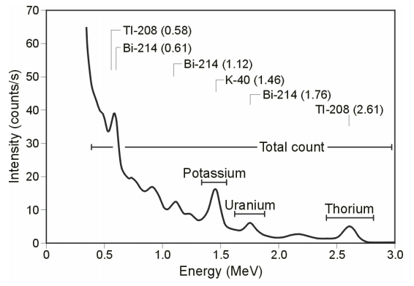
Figure 3: Gamma-ray spectrum with K, Th, U and Total Count windows

The RSX-5 is a 1024 channel system with a four downward looking and one upward looking detector, with a total crystal volume of 16 liters downward and 4 liters upward for cosmic corrections. The Gamma-ray spectrum of 0 to above 3000 keV is divided into 1024 channels, where each channel has a 3.0 keV range. Table 2 shows the channels and energies that were used for the reduction of the spectrum.

Table 2: Channel windows for the 1024 RSX-5 systems used in this survey
Spectrum | Cosmic | Total count | K | U | Th
Down | 1022 | 134-934 | 454-521 | 551-617 | 801-934
Up | 1022 |  |  | 551-617
Energy, keV | >3000 | 407-2807 | 1367-1568 | 1658-1856 | 2408-2807
Peak, keV |  |  | 1460 | 1765 | 2614
Peak channel |  |  | 486 | 586 | 872

Live Time correction
The data were corrected for live time. “Live time” is an expression of the relative period of time the instrument was able to register new pulses per sample interval. On the other hand “dead time” is an expression of the relative period of time the system was unable to register new pulses per sample interval. The relation between “dead” and “live time” is given by the equation (5)

“Live time” = “Real time” – “Dead time” (5)

where the “real time” or “acquisition time” is the elapsed time over which the spectrum is accumulated.

The live time correction is applied to the total count, Potassium, Uranium, Thorium, upward Uranium and cosmic channels. The formula used to apply the correction is as follows:
(6)
where C_{LT} is the live time corrected channel in counts per second, C_{RAW} is the raw channel data in counts per second and Live Time is in microseconds.

Cosmic and aircraft correction
Background radiation resulting from cosmic rays and aircraft contamination was removed from the Total Count, Potassium, Uranium, Thorium and Upward Uranium channels using the following formula:

(7)

where C_{CA} is the cosmic and aircraft corrected channel, C_{LT} is the live time corrected channel a_{c} is the aircraft background for this channel, b_{c} is the cosmic stripping coefficient for this channel and C_{Cos} is the low pass filtered cosmic channel.

Radon correction
The upward detector method, as discussed in IAEA (1991), was applied to remove the effects of the atmospheric radon in the air below and around the helicopter. Usages of over-water measurements where there is no contribution from the ground, enabled the calculation of the coefficients a_{c} and b_{c} of the linear equations that relate the cosmic corrected counts per second of Uranium channel with total count, Potassium, Thorium and Uranium upward channels over water. Data over-land was used in conjunction with data over-water to calculate the a₁ and a₂ coefficients used in equation (8) for the determination of the Radon component in the downward uranium window:

(8)

where Radon_{U} is the radon component in the downward uranium window, Uup_{CA} is the filtered upward uranium, U_{CA} is the filtered Uranium, Th_{CA} is the filtered Thorium, a₁, a₂, a_{U} and a_{Th} are proportional factors and b_{U} an b_{Th} are constants determined experimentally.

The effects of Radon in the downward Uranium are removed by simply subtracting Radon_{U} from U_{CA}. The effects of radon in the other channels are removed using the following formula:
(9)

where C_{RC} is the Radon corrected channel, C_{CA} is the cosmic and aircraft corrected channel, Radon_{U} is the Radon component in the downward uranium window, a_{c} is the proportionality factor and b_{c} is the constant determined experimentally for this channel from over-water data.

Compton Stripping
Potassium-, Uranium- and Thorium- Radon corrected channels are subjected to spectral overlap correction. Compton scattered gamma rays in the radio-nuclides energy windows were corrected by window stripping using Compton stripping coefficients determined from measurements on calibrations pads at the Geological Survey of Norway in Trondheim (for values see Appendix A2).

The stripping corrections are given by the following formulas:

(10)

(11)

(12)

(13)

where U_{RC}, Th_{RC}, K_{RC} are the radon corrected Uranium, Thorium and Potassium, a, b, g, α, β, γ are Compton stripping coefficients.

Reduction to Standard Temperature and Pressure
The radar altimeter data were converted to effective height (H_{STP}) using the acquired temperature and pressure data, according to the expression:

(14)

where H is the smoothed observed radar altitude in meters, T is the measured air temperature in degrees Celsius and P is the measured barometric pressure in millibars.

Height correction
Variations caused by changes in the aircraft altitude relative to the ground corrected to a nominal height of 60 m. Data recorded at the height above 150 m were considered as non-reliable and removed from processing. Total count, Uranium, Thorium and Potassium stripped channels were subjected to height correction according to the equation:
(15)

where C_{ST} is the stripped corrected channel, C_{ht} is the height attenuation factor for that channel and H_{STP} is the effective height.

Conversion to ground concentrations
Corrected count rates were converted to effective ground element concentrations using calibration values derived from calibration pads at the Geological Survey of Norway (see Appendix A2). The corrected data provide an estimate of the apparent surface concentrations of Potassium, Uranium and Thorium (K, eU and eTh).
Potassium concentration is expressed as a percentage, equivalent Uranium and Thorium as parts per million (ppm). Uranium and Thorium concentrations are described as “equivalent” since their presence is inferred from gamma-ray radiation from daughter elements (²¹⁴Bi for Uranium, ²⁰⁸TI for Thorium). The concentration of the elements is calculated according to the following expressions

(16)

where C_{60m} is the height corrected channel, C_{SENS_60m} is experimentally determined sensitivity reduced to the nominal height (60m).

Spectrometry data gridding and presentation
Gamma-rays from Potassium, Thorium and Uranium emanate from the uppermost 30 to 40 centimeters of soil and rock in the crust (Minty, 1997). Variations in the concentrations of these radio-elements largely related to changes in the mineralogy and geochemistry of the Earth’s surface.

The calculated ground concentrations of the three main natural radio-elements Potassium, Thorium and Uranium, along with total gamma-ray flux (Total Count) were microlevelled to remove small line-to-line levelling errors, and then gridded using a minimum curvature method with a grid cell size of 50 meters.

During the radiometric data processing, it became obvious that there were some variations in final concentration levels, mostly caused by the variations in weather conditions during the long survey period. The moisture in the air and soil are not recorded by the temperature/pressure sensor, so it will not be taken into account during the processing steps, thus creating level differences in the data.

The Total Counts and Potassium ground concentration from the 2013 flights were slightly lower than the 2014 flights. It was not possible to take away all the effects of the weather during processing, so the levels of Total Counts and Potassium are not consistent for the whole survey. To counteract this, the 2013 grids are stitched to the 2014 grids, using Geosoft, to improve the appearance of the grids in the report.

A list of the maps is shown in Table 3. A list of the parameters used in the processing schemes is given in Appendix A2. For further reading regarding standard processing of airborne radiometric data, we recommend the publication from Minty et al. (1997).

PRODUCTS

Processed digital data from the survey are presented as:
- Geosoft XYZ files: Kvinesdal_Sirdal_Mag.xyz, Kvinesdal_Sirdal_Rad.xyz.

- Geo-referenced tiff files (Geo-tiff).

- Coloured maps (jpg) at the scale 1:100.000 available from NGU on request.

Table 3: Maps in scale 1:100.000 available from NGU on request.
Map # | Name | Figure No
2015.007-01 | Total Magnetic Field Anomaly | 5
2015.007-02 | Magnetic Vertical Gradient | 6
2015.007-03 | Magnetic Horizontal Gradient | 7
2015.007-04 | Magnetic Tilt Derivative | 8
2015.007-05 | Radiation Total Counts | 9
2015.007-06 | Uranium Ground Concentration | 10
2015.007-07 | Thorium Ground Concentration | 11
2015.007-08 | Potassium Ground Concentration | 12
2015.007-09 | Ternary Image of Radiation Concentrations | 13

Downscaled images of the maps are shown in figures 5 to 13.

REFERENCES
IAEA 1991: Airborne Gamma-Ray Spectrometry Surveying, Technical Report No 323, Vienna, Austria, 97 pp.

IAEA 2003: Guidelines for radioelement mapping using gamma ray spectrometry data. IAEA-TECDOC-1363, Vienna, Austria, 173 pp.

Minty, B.R.S. 1997: The fundamentals of airborne gamma-ray spectrometry. AGSO Journal of Australian Geology and Geophysics, 17 (2): 39-50.

Minty, B.R.S., Luyendyk, A.P.J. and Brodie, R.C. 1997: Calibration and data processing for gamma-ray spectrometry. AGSO Journal of Australian Geology and Geophysics, 17(2): 51-62.

Naudy, H. and Dreyer, H. 1968: Non-linear filtering applied to aeromagnetic profiles. Geophysical Prospecting. 16(2). 171-178.

Rønning, J.S. 2013: NGUs helikoptermålinger. Plan for sikring og kontroll av datakvalitet. NGU Intern rapport 2013.001, (38 sider).

Geosoft 2010: Montaj MAGMAP Filtering, 2D-Frequency Domain Processing of Potential Field Data, Extension for Oasis Montaj v 7.1, Geosoft Corporation

P1: Photo by Mari Nymoen, Telen Newspaper, Notodden.

Appendix A1: Description of magnetic data processing
Meaning of parameters is described in the referenced literature.

Processing flow:

- Quality control.
- Visual inspection of airborne data and manual spike removal
- Import basemag data to Geosoft database
- Inspection of basemag data and removal of spikes
- Correction of data for diurnal variation
- Splitting flight data by lines
- Gridding
- Micro-levelling
- 5x5 Convolution filter

Appendix A2: Description of radiometry data processing

Underlined processing stages are applied to the K, U, Th and TC windows.
Meaning of parameters is described in the referenced literature.

1: Quality control
2: Airborne and cosmic correction (IAEA, 2003)
Used parameters: (From high altitude calibration flights, Langøya and Frosta)
Aircraft background counts:
2013 Parameters Langøya
K window 5.36
U window 1.43
Th window 0
Uup window 0.7
Total counts 42.73
2014 Parameters Frosta
K window 7.33
U window 0.90
Th window 0.89
Uup window 0.39
Total counts 36.29

Cosmic background counts (normalized to unit counts in the cosmic window):

2013 Parameters Langøya
K window 0.0570
U window 0.0467
Th window 0.0643
Uup window 0.0448
Total counts 1.0317
2014 Parameters Frosta
K window 0.0617
U window 0.0454
Th window 0.0647
Uup window 0.0423
Total counts 1.0379

3: Radon correction using upward detector method (IAEA, 2003)
Used parameters for Oct-Nov 2013 (from survey data over water and land):
a_{u}: 0.26027 b_{u:} 0.23732
a_{Th}: 0.45732 b_{Th}: 1.05604
a_{K}: 1.83784 b_{K}: 1.63798
a_{Tc}: 24.2542 b_{Tc}: 23.3374
a₁: 0.030590 a₂: 0.025650

Used parameters for July 2014 (from survey data over water and land):
a_{u}: 0.28061 b_{u:} 0
a_{Th}: 0.16026 b_{Th}: 0.72418
a_{K}: 1.43313 b_{K}: 3.57206
a_{Tc}: 23.8118 b_{Tc}: 5.77249
a₁: 0.081680 a₂: 0.004587

Used parameters for Oct-Nov 2014 (from survey data over water and land):
a_{u}: 0.26056 b_{u:} 0.03878
a_{Th}: 0.16334 b_{Th}: 0.78124
a_{K}: 1.02777 b_{K}: 8.75474
a_{Tc}: 15.2873 b_{Tc}: 65.1499
a₁: 0.046965 a₂: 0.011640

4: Stripping correction (IAEA, 2003)
Used parameters (data from calibrations pads at NGU, May 2013):

2013 Data Parameters
a 0.046856
b 0
g 0
alpha 0.30346
beta 0.47993
gamma 0.82316
2014 Data Parameters
a 0.0482594
b 0
g 0
alpha 0.30408
beta 0.46654
gamma 0.80597

5: Height correction to a height of 60 m
Used parameters (from high altitude calibration flights at Frosta, Jan 2014):
Attenuation factors in 1/m:

2013 Data Parameters:
K: -0.009523
U: -0.006687
Th: -0.007394
TC: -0.007731
2014 Data Parameters:
K: -0.008884
U: -0.006528
Th: -0.006617
TC: -0.007331

6: Converting counts at 60 m heights to element concentration on the ground
Used parameters (data from calibrations pads at NGU, May 2013):
Sensitivity (elements concentrations per count):

2013 Data Parameters
K: 0.007458 %/counts
U: 0.08773 ppm/counts
Th: 0.15666 ppm/counts
2014 Data Parameters
K: 0.007555 %/counts
U: 0.08773 ppm/counts
Th: 0.15274 ppm/counts

7: Microlevelling using Geosoft menu and smoothening by a convolution filtering
Used parameters for microlevelling:
De-corrugation cutoff wavelength: 1200 m
Cell size for gridding: 50 m
Naudy (1968) Filter length: 800 m

5x5 Convolution filtering

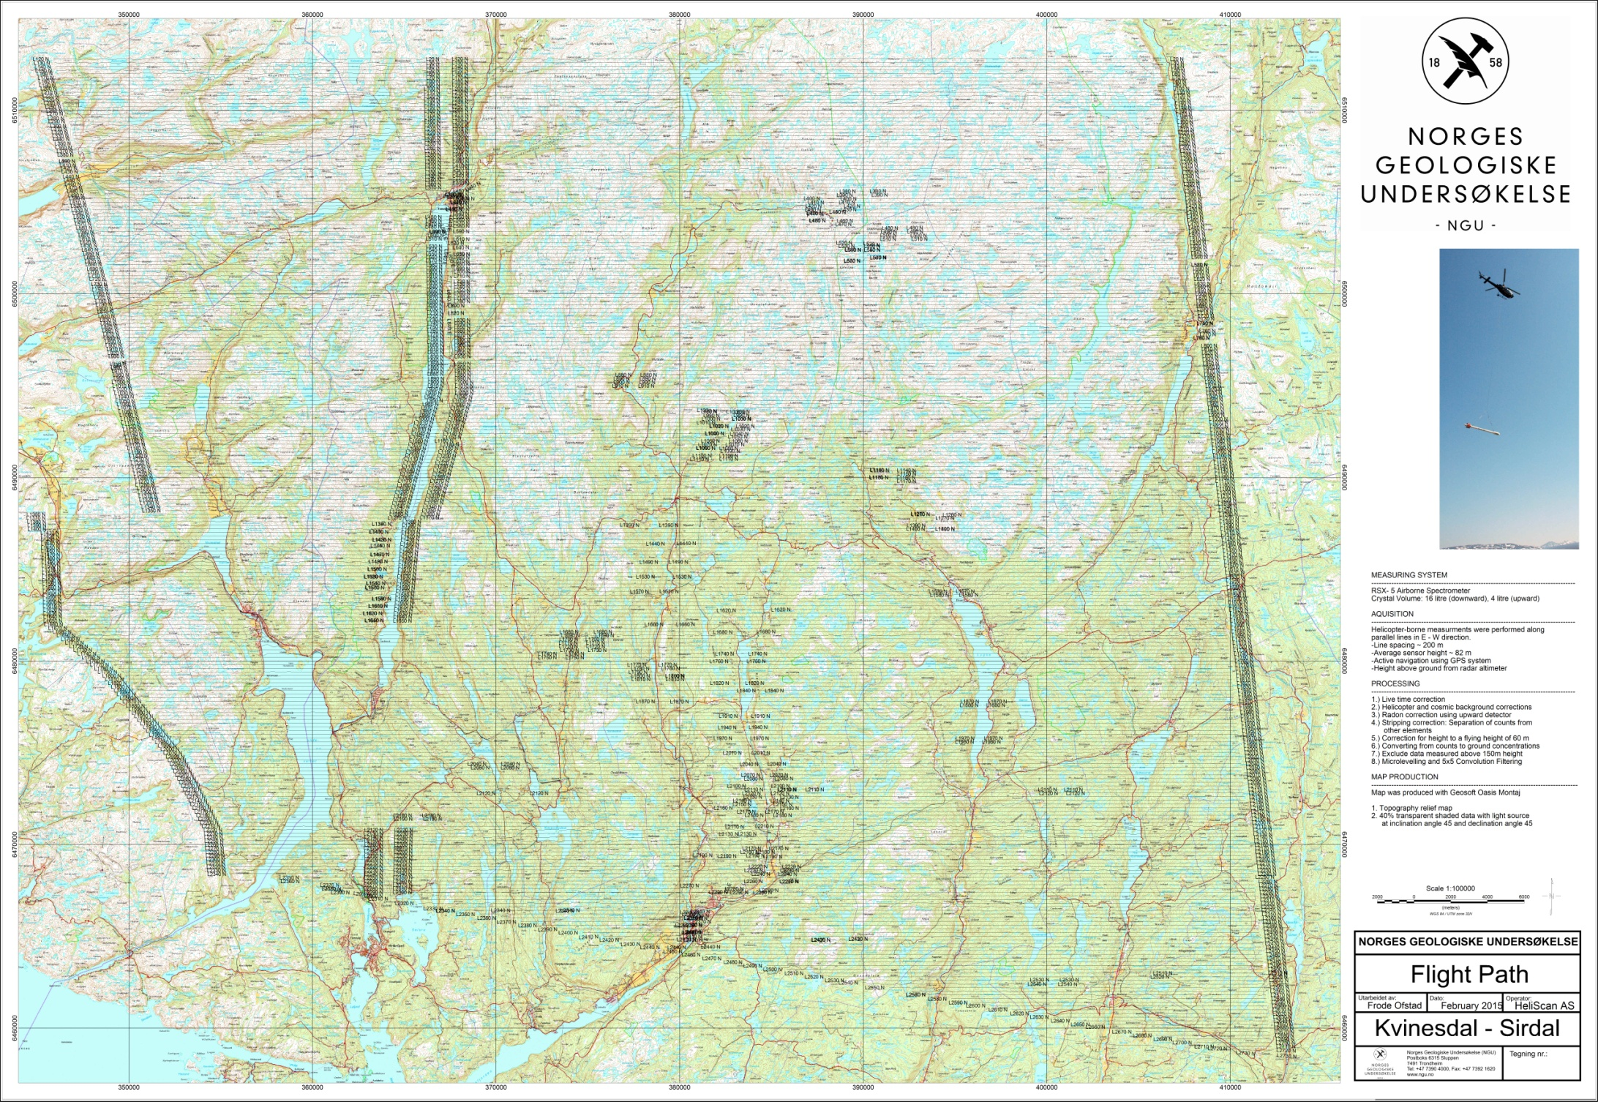
Figure 4: Kvinesdal and Sirdal survey area with flight path.
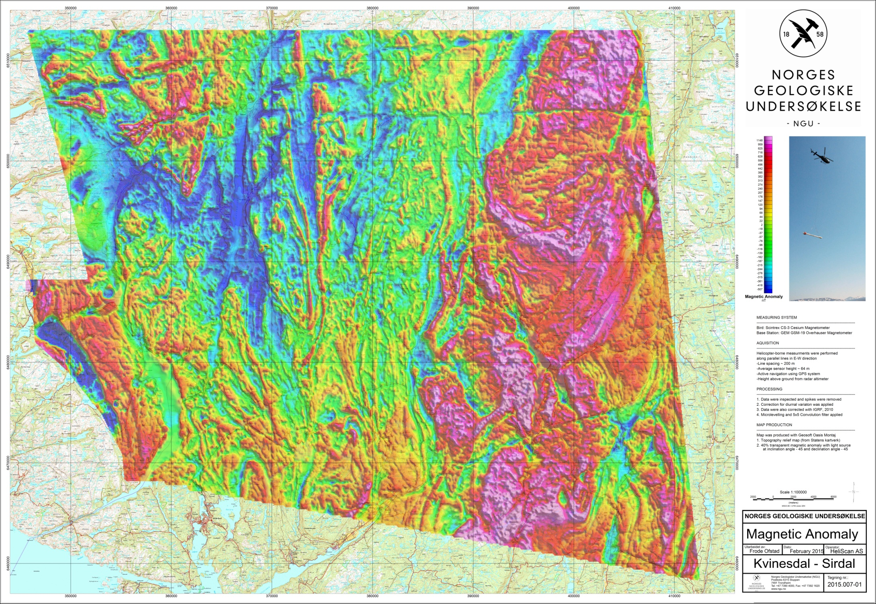
Figure 5: Total Magnetic Field Anomaly
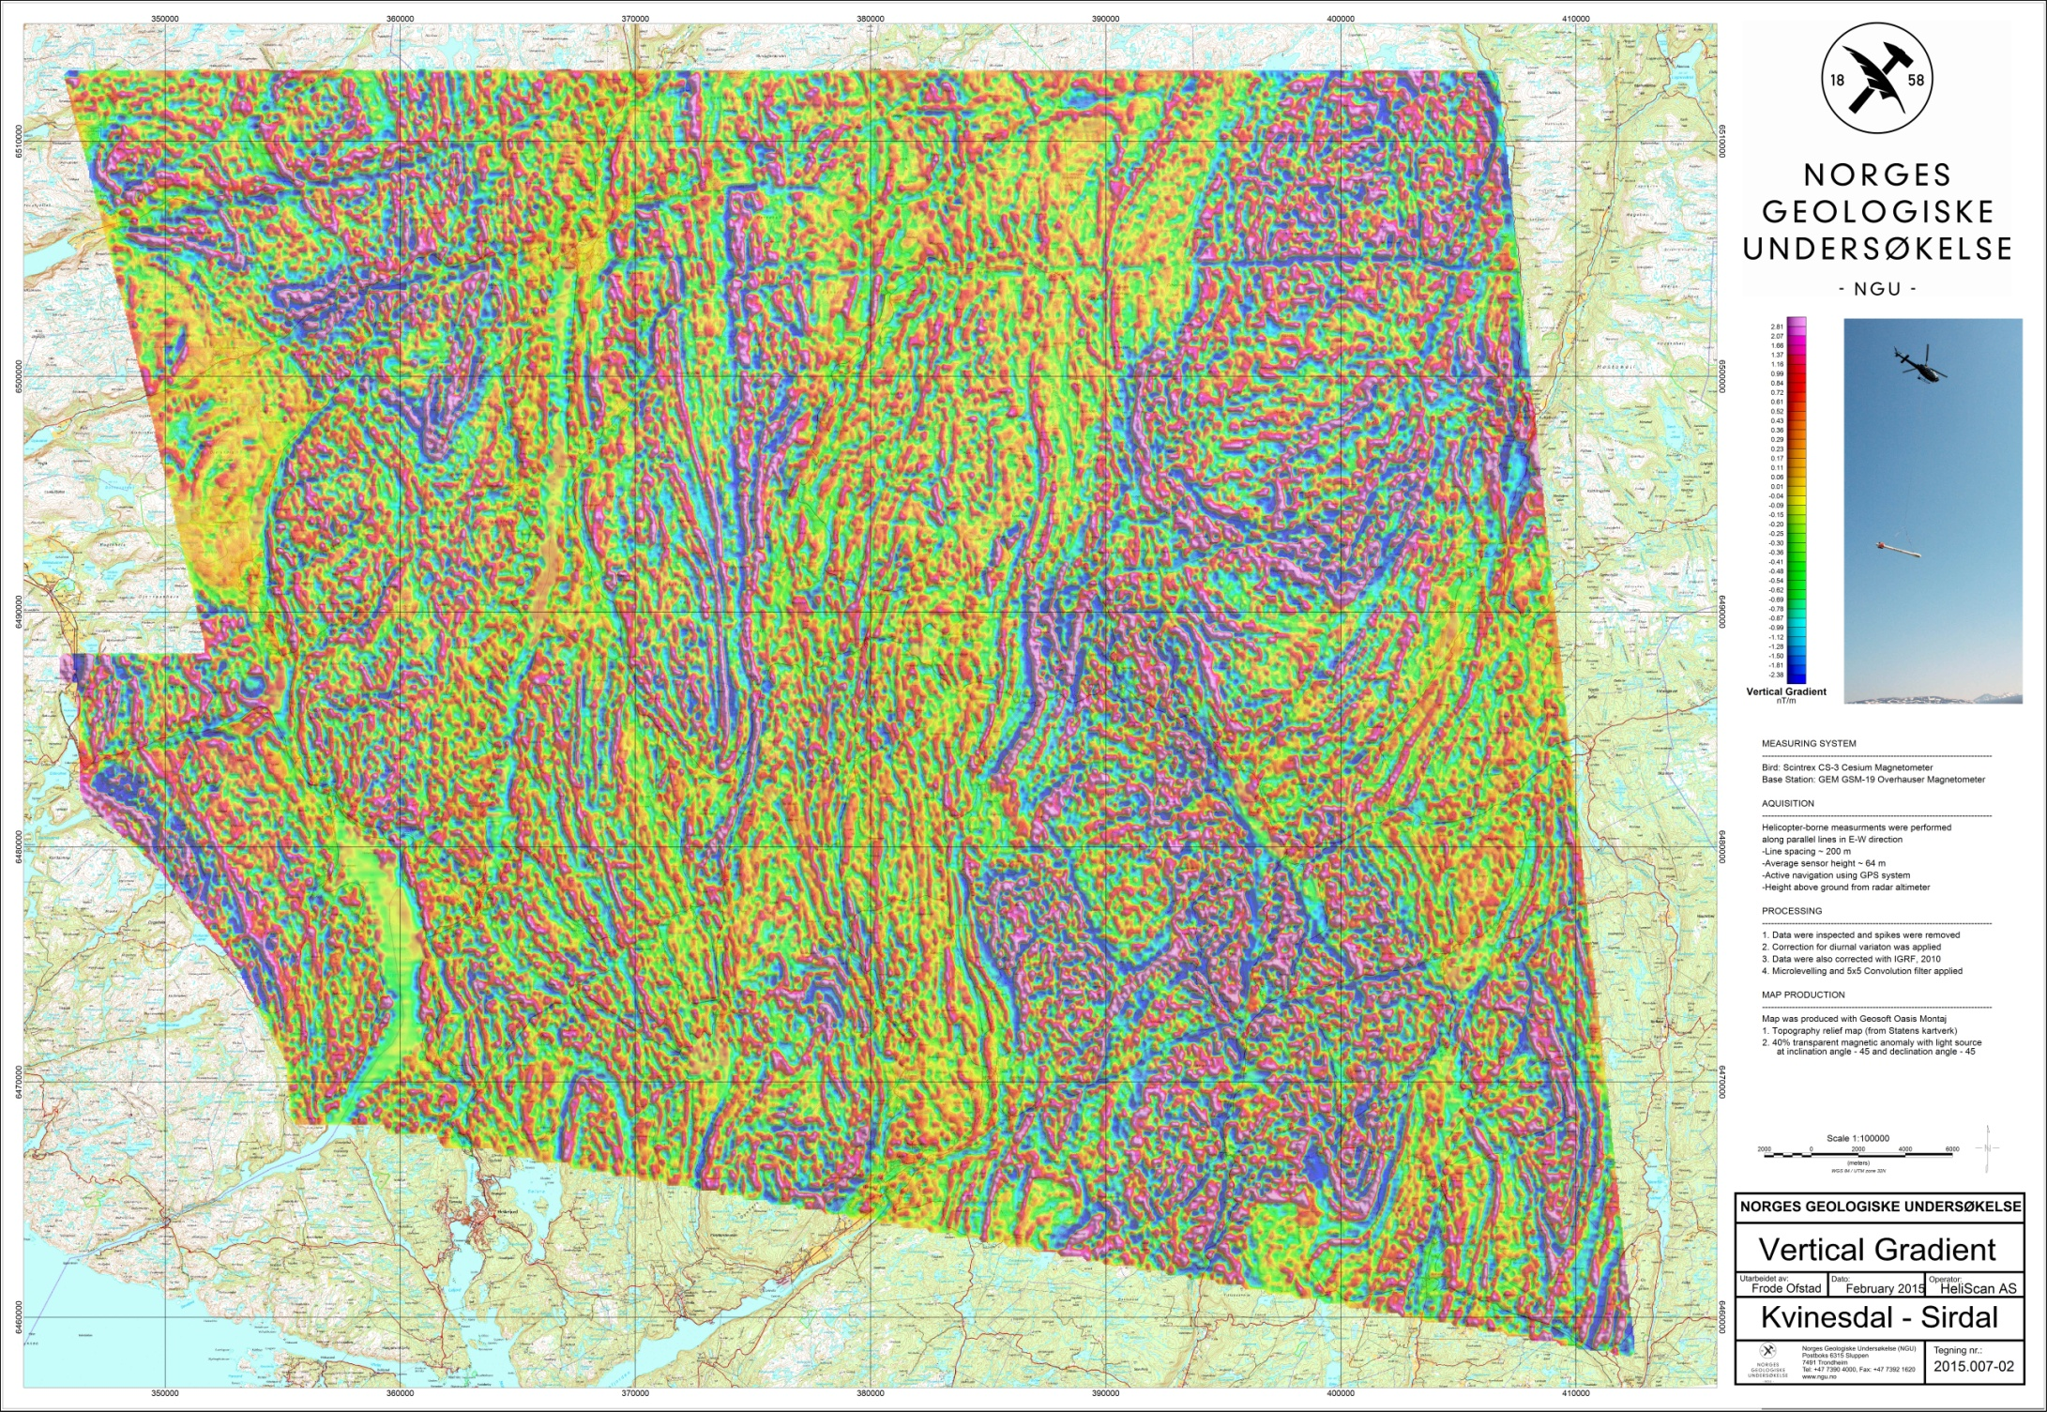
Figure 6: Magnetic Vertical Gradient
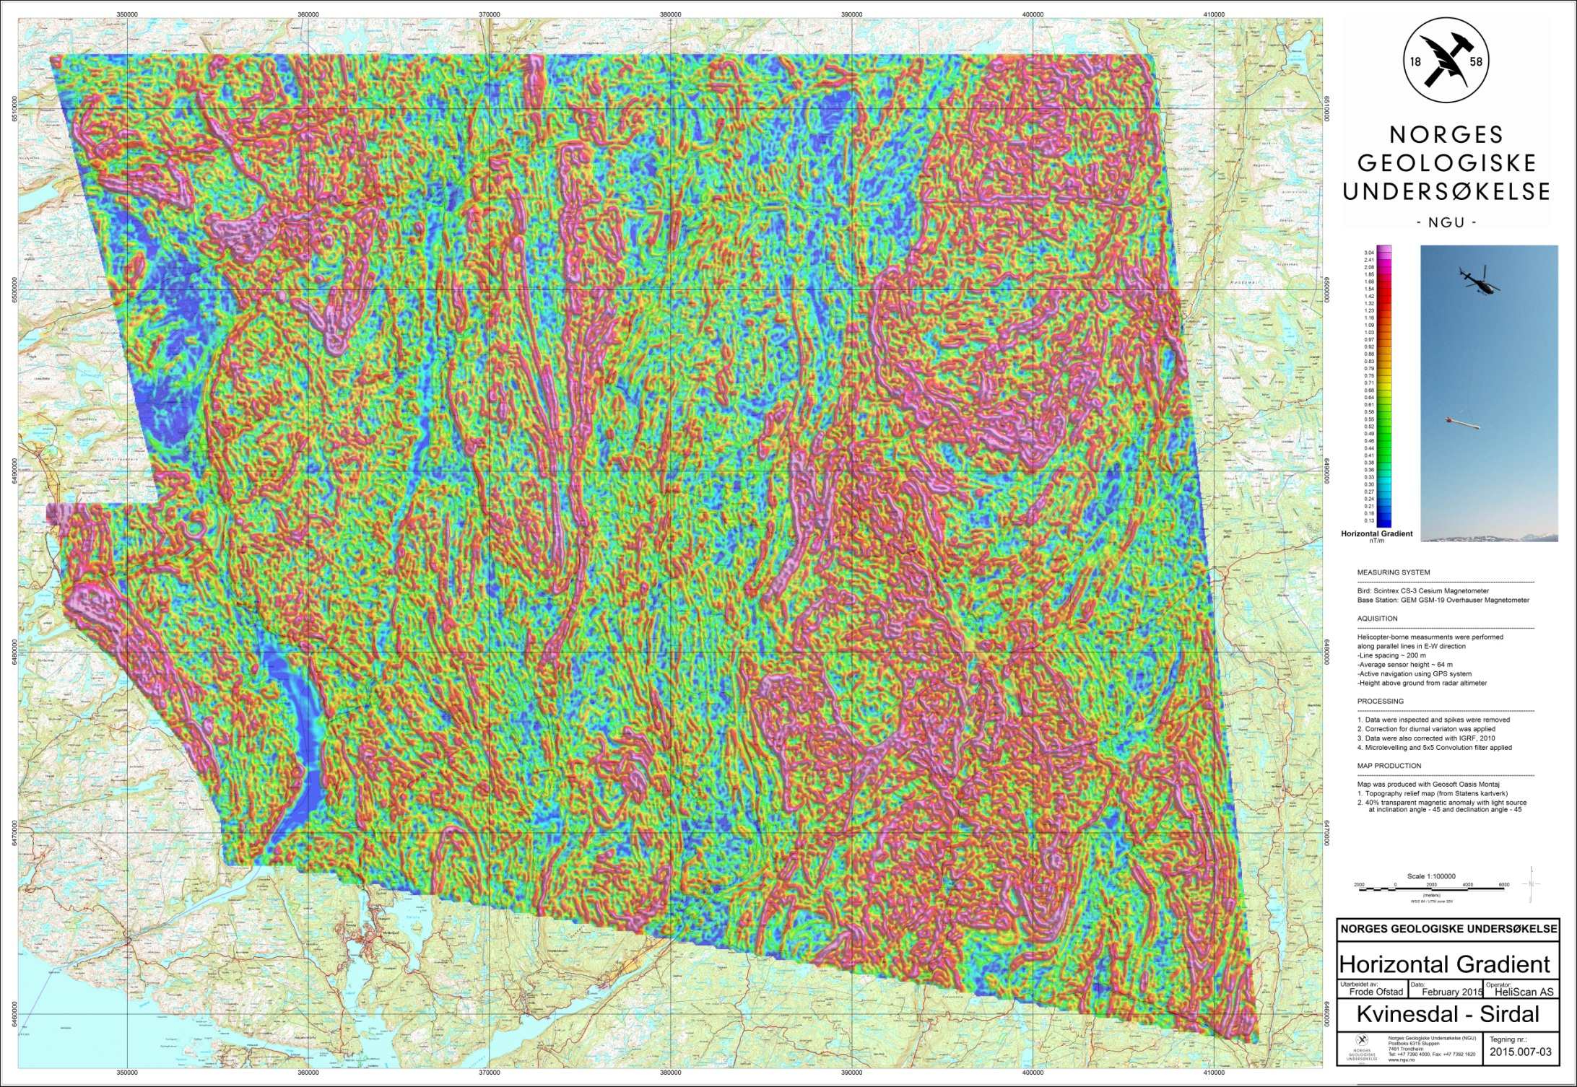
Figure 7: Magnetic Horizontal Gradient
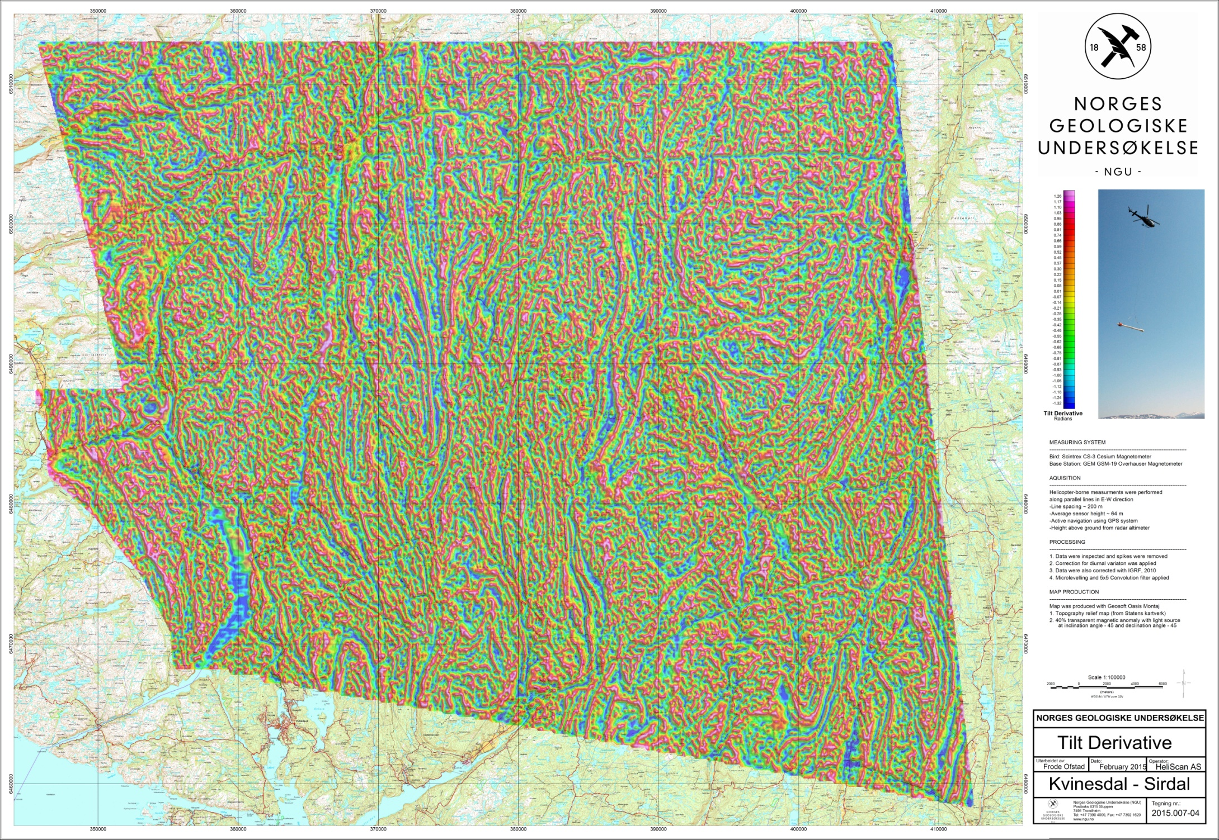
Figure 8: Magnetic Tilt Derivative
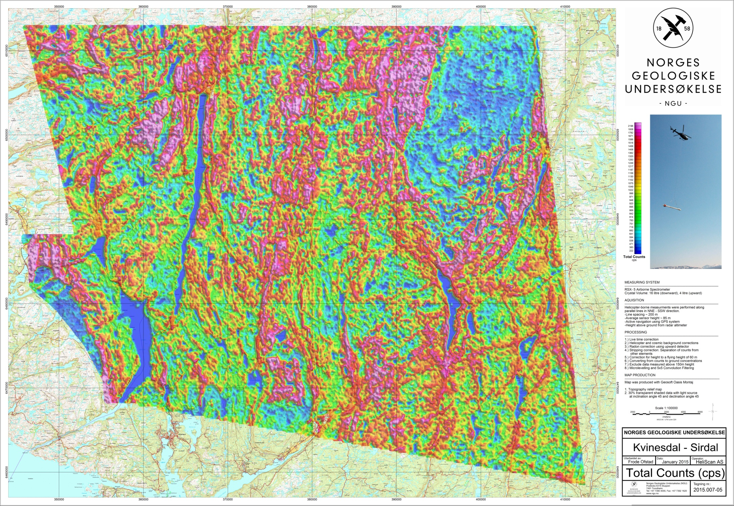
Figure 9: Radiation Total Counts
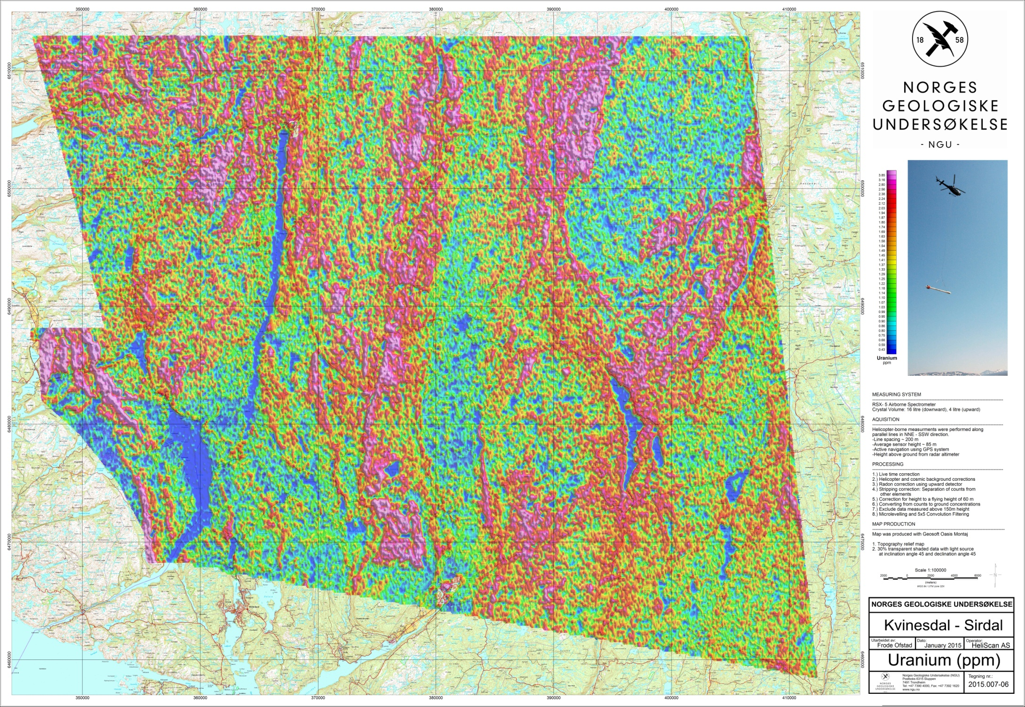
Figure 10: Uranium Ground Concentration
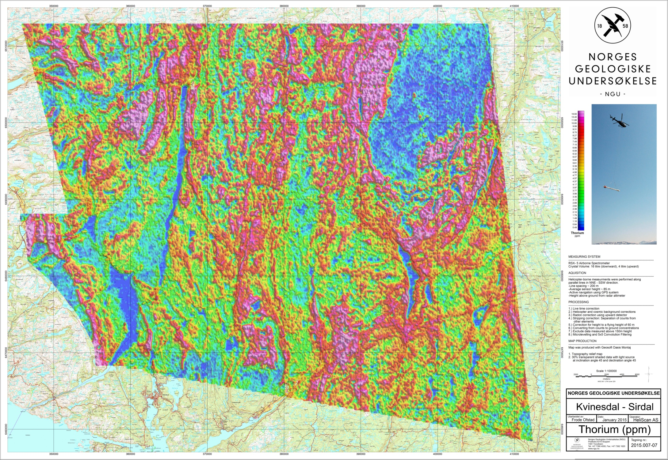
Figure 11: Thorium Ground Concentration
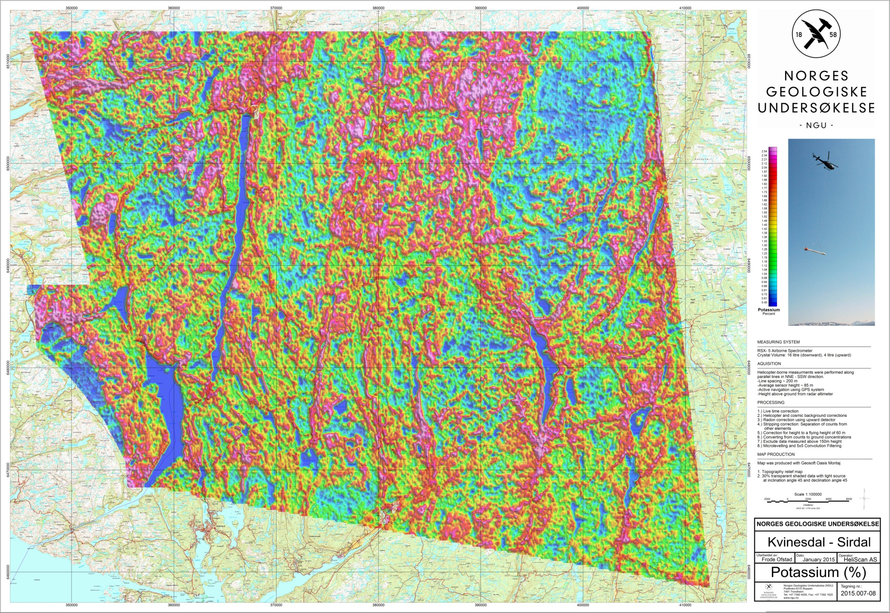
Figure 12: Potassium Ground Concentration
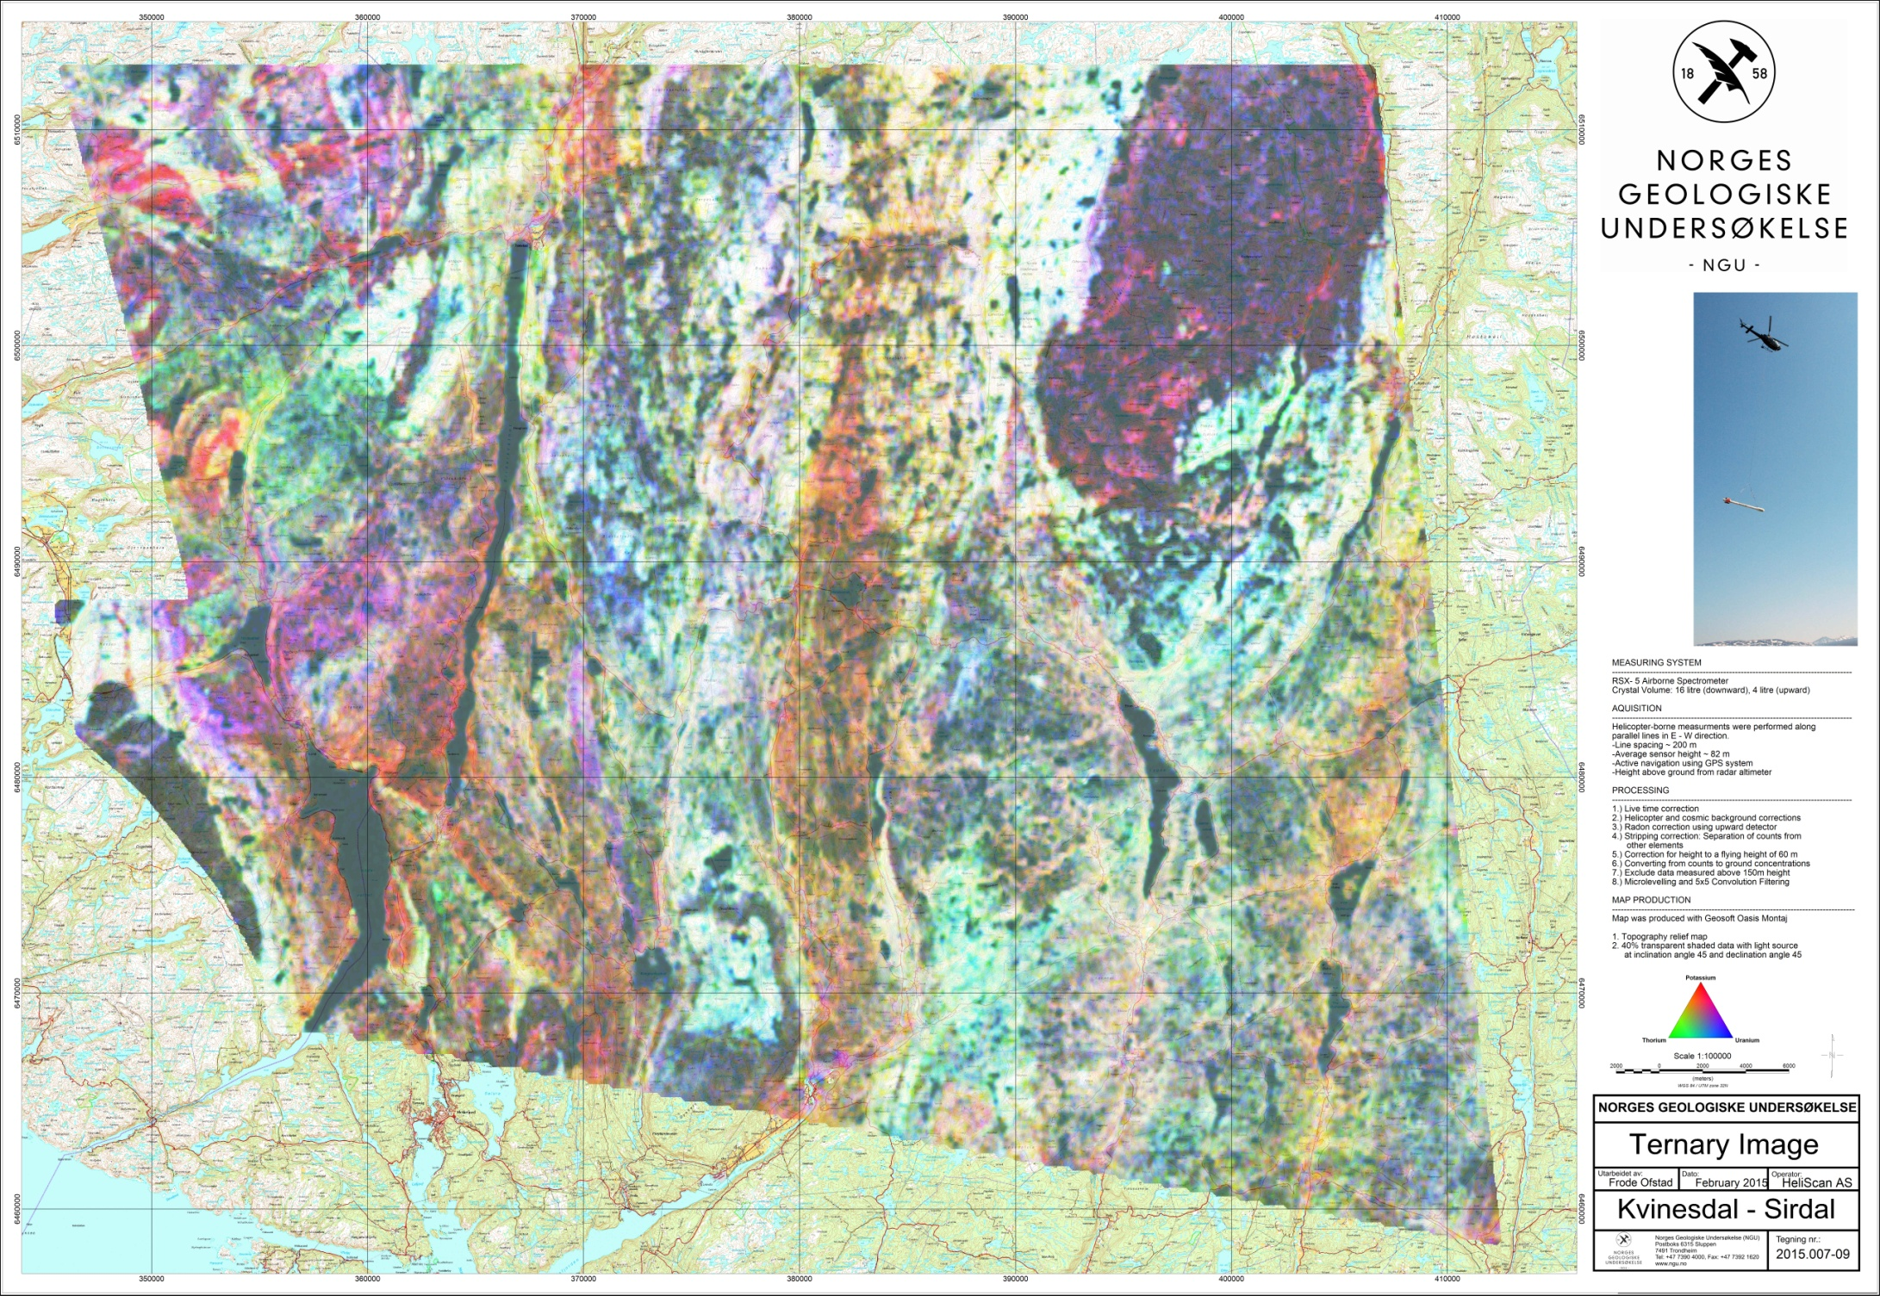
Figure 13: Ternary Image of Radiation Concentrations

