NGU Report 2013.045

Helicopter-borne magnetic, electromagnetic and radiometric geophysical survey in the
western part of Austvågøya, Lofoten archipelago, Nordland

REPORT

Geological Survey of Norway  Postboks 6315 Sluppen  NO-7491 Trondheim, Norway  Tel.: 47 73 90 40 00  Telefax 47 73 92 16 20  Report no.: 2013.027 |  |  | ISSN 0800-3416 |  | Grading: Open
Title:

Helicopter-borne magnetic, electromagnetic and radiometric geophysical survey in the western part of Austvågøya, Lofoten archipelago, Nordland

Authors:  Alexei Rodionov, Frode Ofstad & Georgios Tassis |  |  |  | Client:  NGU
County:  Nordland |  |  |  | Municipalities:  Vågan and Hadsel
Map-sheet name (M=1:250.000)  SVOLVÆR |  |  |  | Map-sheet no. and -name (M=1:50.000)  1131 I Oddvær, 1131 II Kabelvåg  1131 II Stamsund, 1131 IV Kvalsnes
Deposit name and grid-reference:  Svolvær UTM 33W 482000 – 7570000 |  |  |  | Number of pages: 26 Price (NOK): 120,-  Map enclosures:
Fieldwork carried out:  August 2013 | Date of report:  September 16th 2013 |  |  | Project no.:  342900 |  |  | Person responsible:
Summary:

NGU conducted an airborne geophysical survey in Austvagoya area in August 2013 as a part of the MINN project. This report describes and documents the acquisition, processing and visualization of recorded datasets. The geophysical survey results reported herein are 1956 line km, covering an area of 390 km².

The NGU modified Geotech Ltd. Hummingbird frequency domain system supplemented by optically pumped Cesium magnetometer and 1024 channels RSX-5 spectrometer was used for data acquisition.

The survey was flown with 200 m line spacing, line direction 90º (West to East), and average speed 75 km/h. The average terrain clearance of the bird was 53 m. Collected data were processed by Alexei Rodionov (AR GeoConsulting, Calgary) using Geosoft Oasis Montaj software.

Raw total magnetic field data were corrected for diurnal variation and levelled using standard micro levelling algorithm. EM data were filtered and levelled using both automated and manual levelling procedure. Apparent resistivity was calculated from in-phase and quadrature data for each of the five frequencies separately using a homogeneous half space model. Apparent resistivity dataset was filtered using 3x3 convolution filter. Radiometric data were processed using standard procedures recommended by International Atomic Energy Association.

All data were gridded with the cell size of 50 x 50 m and presented as a shaded relief maps at the scale of 1:25 000.

Keywords: Geophysics |  | Airborne |  |  |  | Magnetic
Electromagnetic |  | Gamma spectrometry |  |  |  | Radiometric
 |  |  |  |  |  | Technical report

Table of Contents
1. INTRODUCTION 4
2. LOCATION 4
3. SURVEY SPECIFICATIONS 5
3.1 Airborne Survey Parameters 5
3.2 Airborne Survey Instrumentation 6
3.3 Airborne Survey Logistics Summary 6
4. DATA PROCESSING AND PRESENTATION 7
4.1 Total Field Magnetic Data 7
4.2 Electromagnetic Data 8
4.3 Radiometric data 9
5. PRODUCTS 10
6. REFERENCES 11

Appendix A1: Flow chart of magnetic processing 12
Appendix A2: Flow chart of EM processing 12
Appendix A3: Flow chart of radiometry processing 12

FIGURES

Figure 1: Austvagoya survey area 4
Figure 2: Hummingbird system in air 7
Figure 3: Austvagoya survey area with flight path 14
Figure 4: Total Magnetic Field 15
Figure 5: Magnetic Vertical Derivative 16
Figure 6: Magnetic Tilt Derivative 17
Figure 7: Apparent resistivity. Frequency 34000 Hz, Coplanar coils 18
Figure 8: Apparent resistivity. Frequency 6600 Hz, Coplanar coils 19
Figure 9: Apparent resistivity. Frequency 880 Hz, Coplanar coils 20
Figure 10: Apparent resistivity. Frequency 7000 Hz, Coaxial coils 21
Figure 11: Apparent resistivity. Frequency 980 Hz, Coaxial coils 22
Figure 12: Uranium ground concentration 23
Figure 13: Thorium ground concentration 24
Figure 14: Potassium ground concentration 25
Figure 15: Radiometric Ternary map 26

TABLES

Table 1. Instrument Specifications 6
Table 2. Hummingbird electromagnetic system, frequency and coil configurations 6
Table 3: Maps in scale 1:50000 available from NGU on request. 10

INTRODUCTION
Recognising the impact that investment in mineral exploration and mining can have on the socio-economic situation of a region, the government of Norway initiated the MINN program (Mineral resources in North Norway). The goal of this program is to enhance the geological information that is relevant to an assessment of the mineral potential of the three northernmost counties. The airborne geophysical surveys - helicopter borne and fixed wing- are important integral part of MINN program. The airborne survey results reported herein amount to 1956 line-km flown (390 km²) over the western part of Austvågøya, as shown in Figure 1.

The objective of the airborne geophysical survey was to obtain a dense high-resolution aero-magnetic, electromagnetic and radiometric data over the survey area. This data is required for the enhancement of a general understanding of the regional geology of the area. In this regard, the data can also be used to map contacts and structural features within the property. It also improves defining the potential of known zones of mineralization, their geological settings, and identifying new areas of interest.

The survey incorporated the use of a Hummingbird™ five-frequency electromagnetic system supplemented by a high-sensitivity caesium magnetometer, gamma-ray spectrometer and radar altimeter. A GPS navigation computer system with flight path indicators ensured accurate positioning of the geophysical data with respect to the World Geodetic System 1984 geodetic datum (WGS-84).

LOCATION
Austvågøya is the north easternmost of the larger islands in the Lofoten archipelago in Nordland county, Norway. (Fig.1)
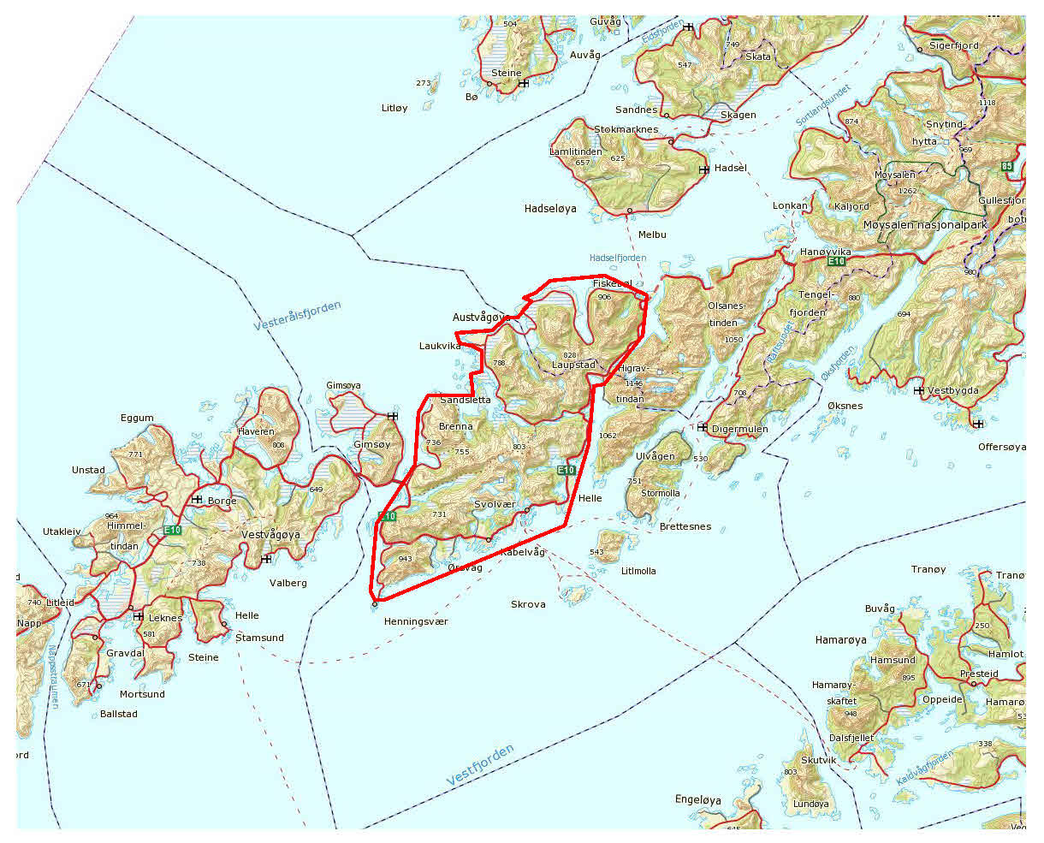
Figure 1: Austvågøya survey area

SURVEY SPECIFICATIONS

Airborne Survey Parameters

NGU used a modified Hummingbird™ electromagnetic and magnetic helicopter survey system designed to obtain low level, slow speed, detailed airborne magnetic and electromagnetic data (Geotech 1997). The system was supplemented by 1024 channel gamma-ray spectrometer which was used to map ground concentrations of U, Th and K.

The airborne survey began on August 8th and ended on August 14th, 2013. A Eurocopter AS350-B3 helicopter from helicopter company HeliScan AS was used to tow the bird. The survey lines were spaced 200 m apart and oriented at a 7° azimuth in UTM zone 33W coordinates.

The magnetic and electromagnetic sensors are housed in a single 7.5 m long bird, which was maintained at an average of 53 m above the topographic surface. A gamma-ray spectrometer, installed under the belly of the helicopter, registered natural gamma ray radiation simultaneously with the acquisition of magnetic/EM data.

Rugged terrain and abrupt changes in topography may affect the aircraft pilot’s ability to ‘drape’ the terrain; therefore there are positive and negative variations in sensor height with respect to the standard height, which is defined as 30 m plus a height of obstacles (trees, power lines etc.).

The ground speed of the aircraft varied from 50 – 110 km/h depending on topography, wind direction and its magnitude. On average the ground speed during measurements is calculated to 75 km/h. Magnetic data were recorded at 0.2 second intervals resulting in approximately 4 m point spacing. EM data were recorded at 0.1 second intervals resulting in data with a sample increment of 2.0 m along the ground in average. Spectrometry data were recorded every 1 second giving a point spacing of approximately 21 meter. The above parameters were designed to allow for sufficient detail in the data to detect subtle anomalies that may represent mineralization and/or rocks of different lithological and petrophysical composition.

A base magnetometer to monitor diurnal variations in the magnetic field was located at Hellneset next to Svolvær Airport (UTM 485942 – 7570145) inside the survey area. Base station magnetometer data were recorded once every 3 second. The CPU clock of the base magnetometer computer was synchronized to the CPU clock of the DAS on a daily basis.

Navigation system uses GPS/GLONASS satellite tracking systems to provide real-time WGS-84 coordinate locations for every second. The accuracy achieved with no differential corrections is reported to be ± 5 m in the horizontal directions. The GPS receiver antenna was mounted externally to the tail tip of the helicopter.

For quality control, the electromagnetic, magnetic and radiometric, altitude and navigation data were monitored on four separate windows in the operator's display during flight while they were recorded in three data ASCII streams to the PC hard disk drive.

Airborne Survey Instrumentation

Instrument specification is given in table 1. Frequencies and coil configuration for the Hummingbird EM system is given in table 2.

Table 1. Instrument Specifications
Instrument | Producer/Model | Accuracy | Sampling frequency /interval
Magnetometer | Scintrex Cs-2 | 0,002 nT | 5 Hz
Base magnetometer | GEM GSM-19 | - nT | 3 sec
Electromagnetic | Geotech Hummingbird | 1 – 2 ppm | 10 Hz
Gamma spectrometer | Radiation Solutions RSX-5 | 1024 ch’s, 16 liters down, 4 liters up | 1 Hz
Radar altimeter | Bendix/King KRA 405B | ± 3 % 0 – 500 fot  ± 5 % 500 – 2500 fot | 1 Hz
Pressure/temperature | Honeywell PPT | ± 0,03 % FS | 1 Hz
Navigation | Topcon GPS-receiver | ± 5 meter | 1 Hz
Acquisition system | NGU in house software

Table 2. Hummingbird electromagnetic system, frequency and coil configurations
Coils: | Frequency | Orientation | Separation
A | 7700 Hz | Coaxial | 6.20 m
B | 6600 Hz | Coplanar | 6.20 m
C | 980 Hz | Coaxial | 6.025 m
D | 880 Hz | Coplanar | 6.025 m
E | 34000 Hz | Coplanar | 4.87 m

The electromagnetic, magnetic and radiometric, altitude and navigation data were monitored on the operator's displays during flight while they were recorded to the PC hard disk drive. Spectrometry data were also recorded to internal hard drive of the spectrometer. The data files were transferred to the field workstation via USB flash drive. The raw data files were backed up onto USB flash drive in the field.

Airborne Survey Logistics Summary

Traverse (survey) line spacing: 200 metres
Traverse line direction: 90° W-E
Nominal aircraft ground speed: 50 - 110 km/h
Average sensor terrain clearance EM+Mag: 53 metres
Average sensor terrain clearance Rad: 83 metres
Sampling rates: 0.2 seconds - magnetometer
0.1 seconds - electromagnetics
1.0 second - spectrometer, GPS, altimeter

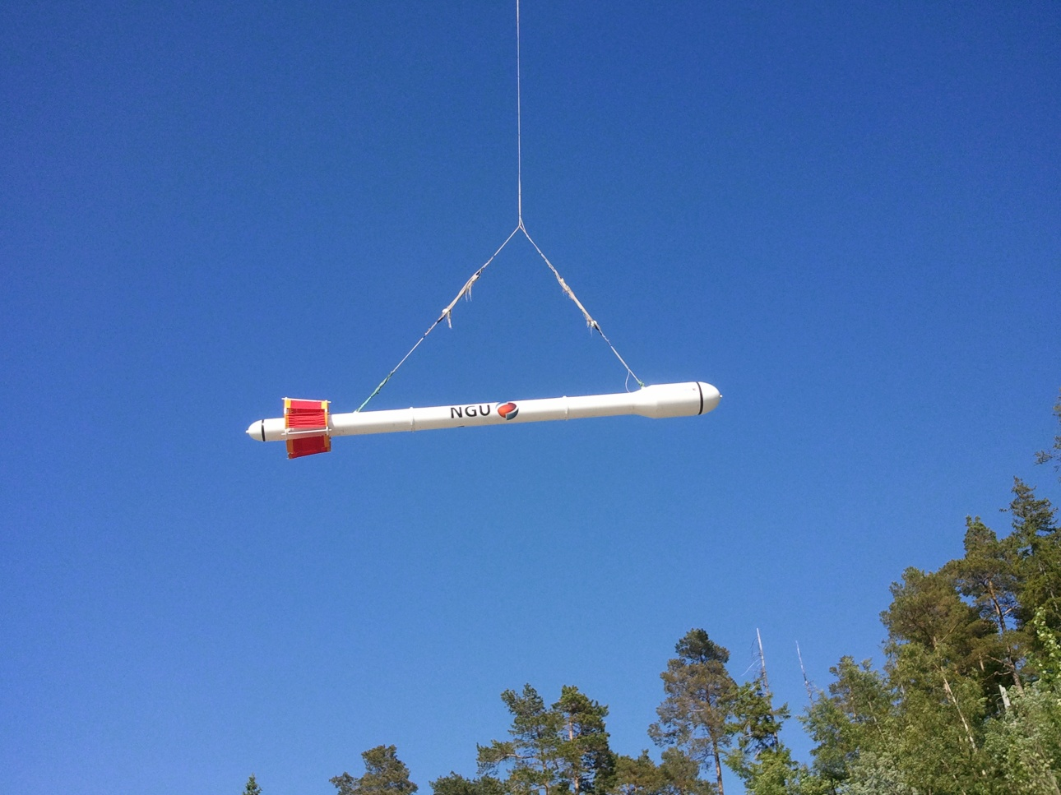
Figure 2: Hummingbird system in air

DATA PROCESSING AND PRESENTATION
All data were processed by Alexei Rodionov (AR Geoconsulting Ltd., Canada) in Calgary. The ASCII data files were loaded into three separate Oasis Montaj databases. All three datasets were processed consequently according to processing flow charts shown in Appendix A1, A2 and A3.

Total Field Magnetic Data
At the first stage the magnetic data were visually inspected and spikes were removed manually. Non-linear filter was also applied to airborne raw data to eliminate short-period spikes. Then the data from basemag station were imported in magnetic database using the standard Oasis magbase.gx module. Diurnal variation channel was also inspected for spikes and spikes were removed manually if necessary. Typically, several corrections have to be applied to magnetic data before gridding - heading correction, lag correction and diurnal correction.

Diurnal Corrections
The temporal fluctuations in the magnetic field of the earth affect the total magnetic field readings recorded during the airborne survey. This is commonly referred to as the magnetic diurnal variation. These fluctuations can be effectively removed from the airborne magnetic dataset by using a stationary reference magnetometer that records the magnetic field of the earth simultaneously with the airborne sensor. Magnetic diurnals were within the standard NGU specifications during the entire survey (Rønning 2013).

The base magnetometer was located at Hellneset, next to Svolvær Airport (UTM 485942 – 7570145) inside the survey area. Diurnal variations were measured with GEM GSM-19 magnetometer. The average magnetic field was 52718 nT. The base station computer clock was synchronized with the DAS clock on a daily basis. The recorded data are merged with the airborne data and the diurnal correction is applied according to equation (1).
, (1)
Where:

Corrections for Lag and heading
Neither a lag nor cloverleaf tests were performed before the survey. According to previous reports the lag between logged magnetic data and the corresponding navigational data was 1-2 fids. Translated to a distance it would be no more than 10 m - the value comparable with the precision of GPS. A heading error for a towed system is usually either very small or non-existent. So no lag and heading corrections were applied.

Magnetic data gridding and presentation
Before gridding, flight data were split by lines. For the purposes of data presentation and interpretation the total field magnetic data are gridded with a cell size of 50 m, which represents one quarter of the 200 m average line spacing. A micro levelling technique was applied to the magnetic data to remove small line-to-line levelling errors and a 3 x 3 convolution filter was passed over the final grid to smooth the grid image.

The Vertical Gradient (VG) and the Tilt Derivative (TD) of the total magnetic field was calculated from the resulting total magnetic field map. These signals transforms the shape of the magnetic anomaly from any magnetic inclination to positive body-centred anomaly and it's widely utilized for mapping of structures.

Electromagnetic Data
The DAS computer records both an in-phase and a quadrature value for each of the five coil sets of the electromagnetic system. Instrumental noise and drift should be removed before computation of an apparent resistivity.

Instrumental noise
In-phase and quadrature data were filtered with 3 fids non-linear filter to eliminate spheric spikes which were represented as irregular spikes of large amplitude in records. Simultaneously, the 30 fids low-pass filter was also applied to suppress high frequency components of instrumental and cultural noise. Cultural noise was relatively low within the survey area and observed occasionally on 980 and 880 Hz at the intersection with power lines.
Cultural noise, visible at some lines on 34000 Hz, is probably attributed to radio transmitters and/or bird swaying. Generally, cultural noise did not affected EM data significantly.

Instrument Drift
In order to remove the effects of instrument drift caused by gradual temperature variations in the transmitting and receiving circuits, background responses are recorded during each flight. To obtain a background level the bird is raised to an altitude of approximately 1200 ft above the topographic surface so that no electromagnetic responses from the ground are present in the recorded traces. The EM traces observed at this altitude correspond to a background (zero) level of the system. If these background levels are recorded at 20-30 minute intervals, then the drift of the system (assumed to be linear) can be removed from the data by resetting these points to the initial zero level of the system. The drift must be removed on a flight-by-flight basis, before any further processing is carried out. Geosoft HEM module was used for applying drift correction. Residual instrumental drift, usually small, but often non-linear, was manually removed on line-to-line basis. During half of the flights, instrument drift on 880 Hz coplanar coils was strongly non-linear in periods, especially on inphase channel.

Apparent resistivity calculation and presentation
When levelling of the EM data was complete, apparent resistivity was calculated from in-phase and quadrature EM components using a homogeneous half space model of the Earth (Geosoft HEM module) for four frequencies. Apparent resistivity for 880Hz was calculated from quadrature component only, because inphase component could not be levelled correctly due to strong non-linear drift. Threshold of 1 ppm was set for inversion for all frequencies.

Secondary electromagnetic field decays rapidly with the distance (height of the sensors) – as z⁻² – z⁻⁵ depending on the shape of the conductors and, at certain height, signals from the ground sources become comparable with instrumental noise. Levelling errors or precision of levelling can lead sometimes to appearance of artificial resistivity anomalies when data were collected at high instrumental altitude. Application of threshold height values allows excluding such data from an apparent resistivity calculation, though not completely. It’s particularly noticeable in low frequencies datasets. Resistivity data were visually inspected; artificial anomalies associated with high altitude measurements were manually removed and then levelled.

Data, recorded at the height above 100 m were considered as non-reliable and removed, giving white areas on the resistivity maps. Revised resistivity data were gridded with a cell size 50 m and 3x3 convolution filter was applied to smooth the grids.

Radiometric data
In processing of the airborne gamma ray spectrometry data, live time corrected U, Th and K were corrected for the aircraft and cosmic background (e.g. Grasty et al. 1991; IAEA 2003). The upward detector method, as discussed in IAEA (2003), was applied to remove the effects of radon in the air below and around the helicopter. Window stripping was used to isolate count rates from the individual radio-nuclides K, U and Th (IAEA, 2003). The topography in the region was rough, and the sensor was not always at a constant altitude. Stripped window counts were therefore corrected for variations in flying height to a constant height of 60 m.

Data, recorded at the height above 150 m were considered as non-reliable and removed from processing, giving white areas in the concentration maps. Finally, count rates were converted to effective ground element concentrations using calibration values derived from calibration pads at the Geological Survey of Norway in Trondheim. A list of the parameters used in the processing scheme is given in Appendix A3. For further reading regarding standard processing of airborne radiometric data, we recommend the publication from Minty et al. (1997).

Quality of the radiometric data was within standard NGU specifications (Rønning 2013) except for a few short line segments where data were lost due to lack of GPS-signal and areas with sensor heights above 150 m a.g.l..

PRODUCTS
Processed digital data from the survey are presented as:
- Three Geosoft XYZ files:
Austvagoya_Mag.xyz, Austvagoya_EM.xyz, Austvagoya_Rad.xyz,
- Coloured maps at the scale 1:25000 available from NGU on request.

Table 3: Maps in scale 1:25000 available from NGU on request.
Map # | Name
2013.045-01 | Total magnetic field
2013.045-02 | Magnetic Vertical Derivative
2013.045-03 | Magnetic Tilt Derivative
2013.045-04 | Apparent resistivity, Frequency 34000 Hz, coplanar coils
2013.045-05 | Apparent resistivity, Frequency 6600 Hz, coplanar coils
2013.045-06 | Apparent resistivity, Frequency 880 Hz, coplanar coils
2013.045-07 | Apparent resistivity, Frequency 7000 Hz, coaxial coils
2013.045-08 | Apparent resistivity, Frequency 9800 Hz, coaxial coils
2013.045-09 | Uranium ground concentration
2013.045-10 | Thorium ground concentration
2013.045-11 | Potassium ground concentration
2013.045-12 | Radiometric Ternary Map

Downscaled images of the maps are shown on figures 4 to 15.

REFERENCES
Geotech 1997: Hummingbird Electromagnetic System. User manual. Geotech Ltd. October 1997

Grasty, R.L., Holman, P.B. & Blanchard 1991: Transportable Calibration pads for ground and airborne Gamma-ray Spectrometers. Geological Survey of Canada. Paper 90-23. 62 pp.

IAEA 2003: Guidelines for radioelement mapping using gamma ray spectrometry data. IAEA-TECDOC-1363, Vienna, Austria. 173 pp.

Minty, B.R.S., Luyendyk, A.P.J. and Brodie, R.C. 1997: Calibration and data processing for gamma-ray spectrometry. AGSO – Journal of Australian Geology & Geophysics. 17(2). 51-62.

Naudy, H. and Dreyer, H. 1968: Non-linear filtering applied to aeromagnetic profiles. Geophysical Prospecting. 16(2). 171-178.

Rønning, J.S. 2013: NGUs helikoptermålinger. Plan for sikring og kontroll av datakvalitet. NGU Intern rapport 2013.001, (38 sider).

Appendix A1: Flow chart of magnetic processing
Meaning of parameters is described in the referenced literature.

Processing flow:

- Quality control.
- Visual inspection of airborne data and manual spike removal
- Import magbase data to Geosoft database
- Inspection of magbase data and removal of spikes
- Correction of data for diurnal variation
- Splitting flight data by lines
- Gridding
- Microlevelling
- Convolution filter

Appendix A2: Flow chart of EM processing

Meaning of parameters is described in the referenced literature.

Processing flow:
- Filtering of in-phase and quadrature channels with low pass filters
- Automated leveling
- Quality control
- Visual inspection of data.
- Splitting flight data by lines
- Manual removal of remaining part of instrumental drift
- Calculation of an apparent resistivity for each frequency using both - in-phase and quadrature channels (except 880 Hz where resistivity was calculated using quadrature component only)
- Gridding
- Convolution filter.

Appendix A3: Flow chart of radiometry processing

Underlined processing stages are not only applied to the K, U and Th window, but also to the total.
Meaning of parameters is described in the referenced literature.

Processing flow:
- Quality control
- Airborne and cosmic correction (IAEA, 2003)
Used parameters: (determined by high altitude calibration flights near Seljord in June 2012)
Aircraft background counts:
K window 7
U window 0.9
Th window 0.9
Uup window 0
Total counts 36
Cosmic background counts (normalized to unit counts in the cosmic window):
K window 0.0617
U window 0.0454
Uup window 0.0423
Th window 0.0647
Total counts 1.0379
- Radon correction using upward detector method (IAEA, 2003)
Used parameters (determined from survey data over water and land):
a_{u}: 0.2411 b_{u:} 0.613
a_{K}: 2.5017 b_{K}: 2.5759
a_{T}: 0.4294 b_{T}: 0.0
aTc: 30.337 bTc: 3.4156
_{a1}: 0.07667 a₂: 0.01262

- Stripping correction (IAEA, 2003)
Used parameters (determined from measurements on calibrations pads at the NGU on May 6 2013):
a 0.049524
b -0.00169
g -0.00131
alpha 0.29698
beta 0.47138
gamma 0.82905

- Height correction to a height of 60 m
Used parameters (determined by high altitude calibration flights near Langoya in July 2013):
Attenuation factors in 1/m:
K: -0.001634
U: -0.00777
Th: -0.0088
Total counts: -0.01148

- Converting counts at 60 m heights to element concentration on the ground
Used parameters (determined from measurements on calibrations pads at the NGU on May 6 2013):
Sensitivity (elements concentrations per count)::
K: 0.007545 %/counts
U: 0.088909 ppm/counts
Th: 0.151433 ppm/counts

- Microlevelling using Geosoft menu and smoothening by a convolution filtering
Used parameters for microlevelling:
De-corrugation cutoff wavelength: 600 m
Cell size for gridding: 200 m
Naudy (1968) Filter length: 600 m

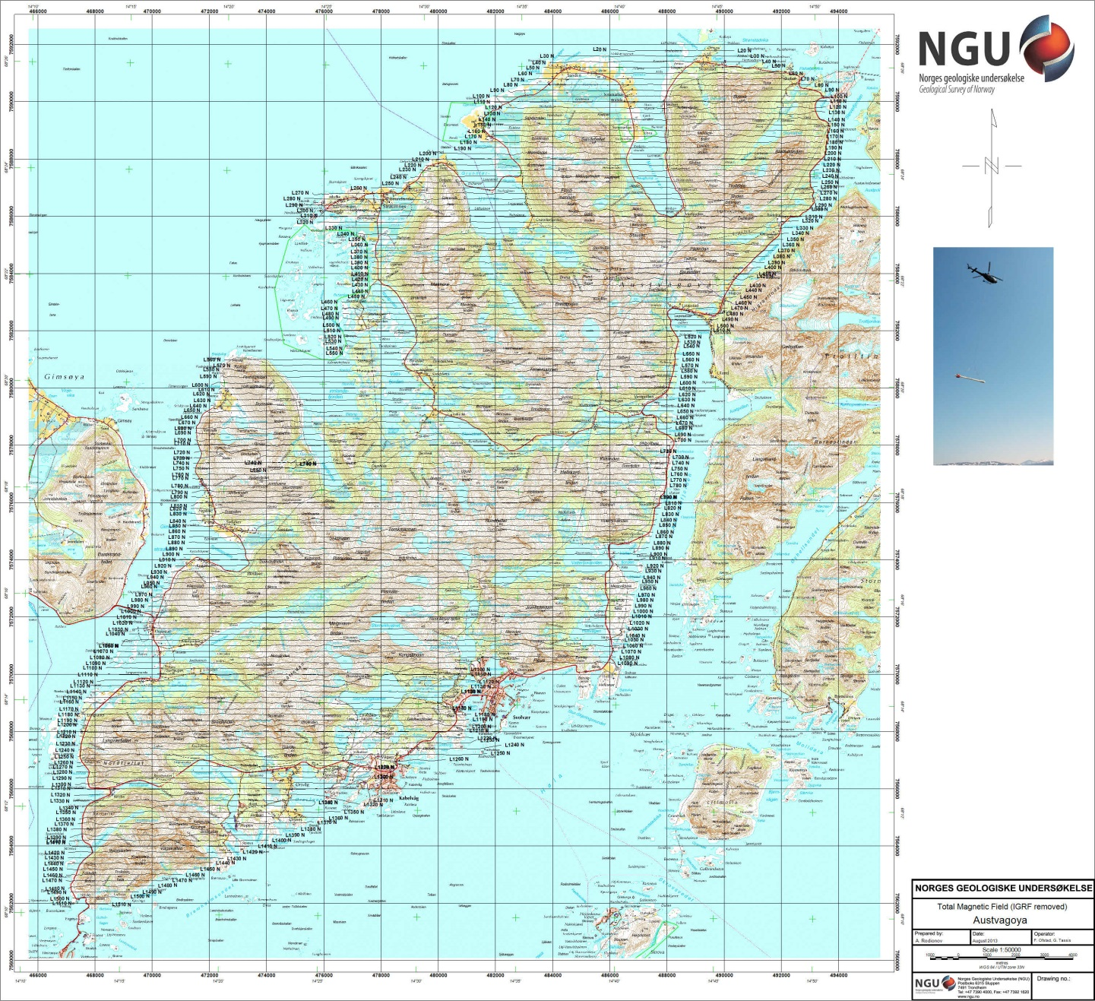
Figure 3: Austvågøya survey area with flight path

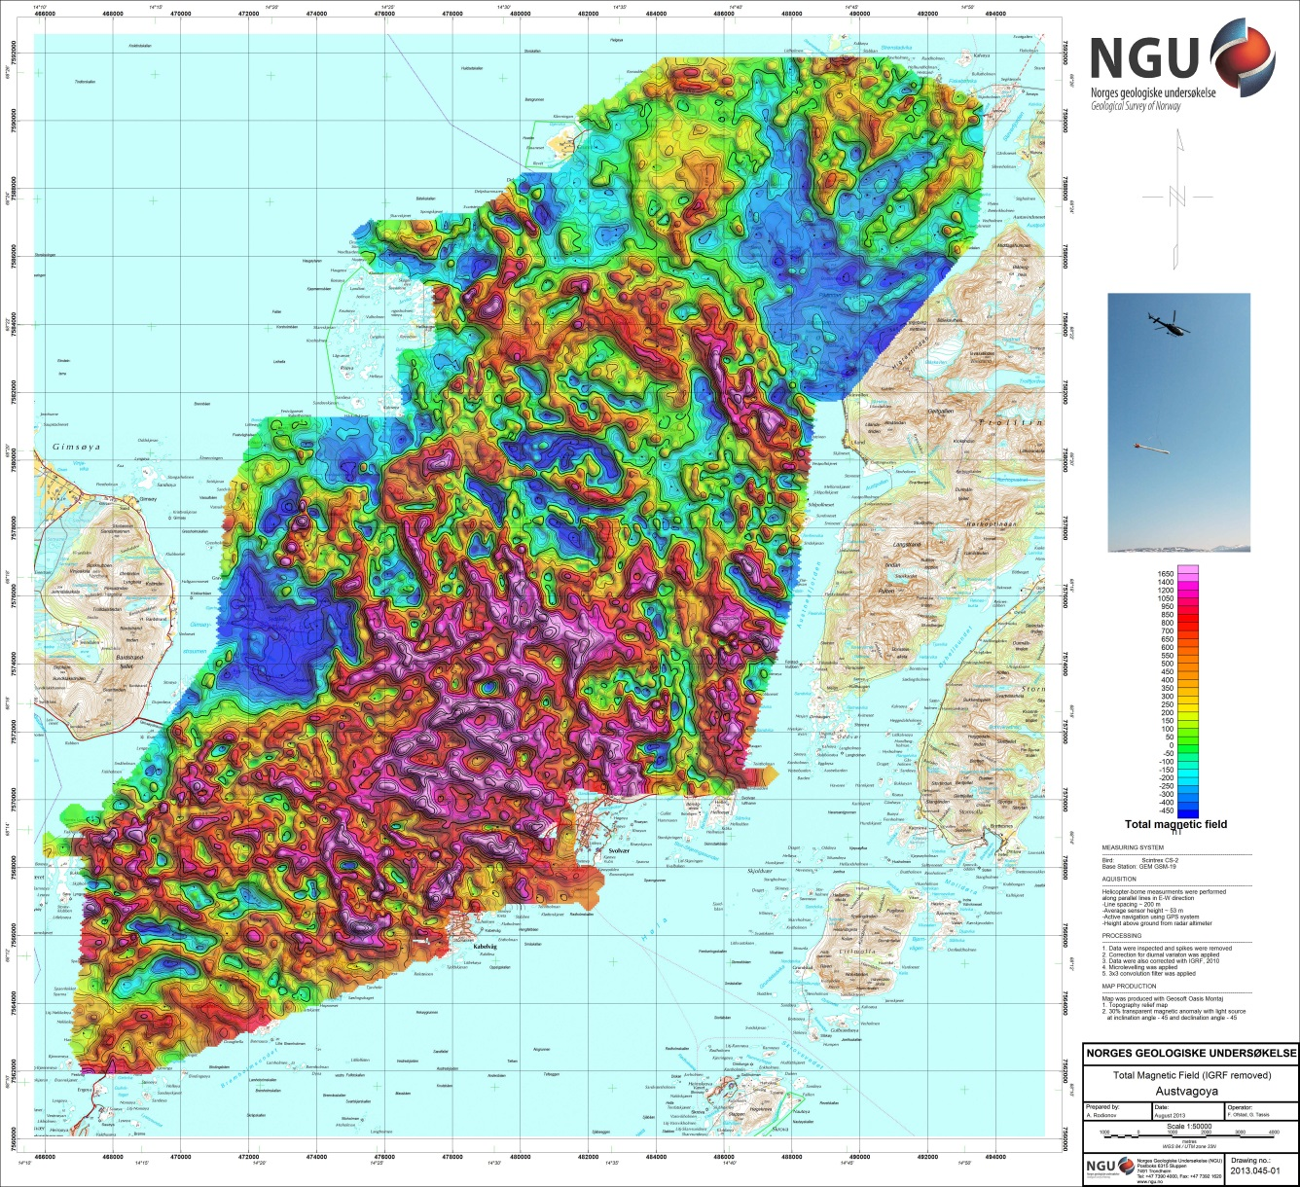
Figure 4: Total Magnetic Field

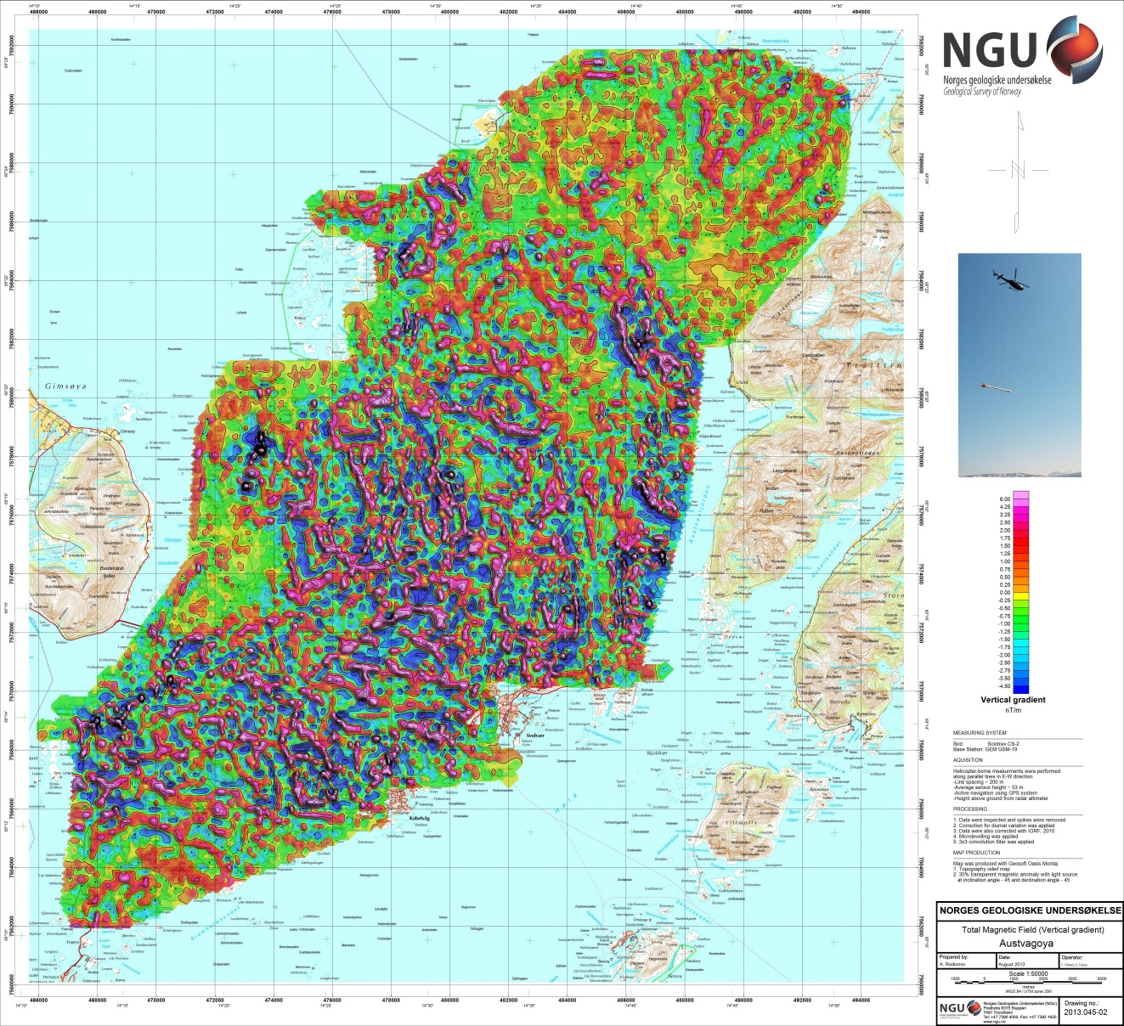
Figure 5: Magnetic Vertical Derivative

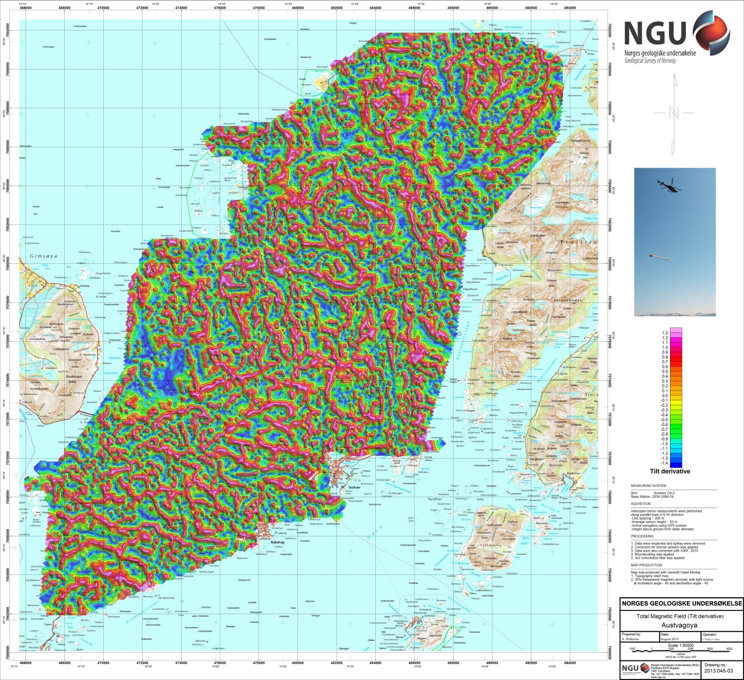
Figure 6: Magnetic Tilt Derivative

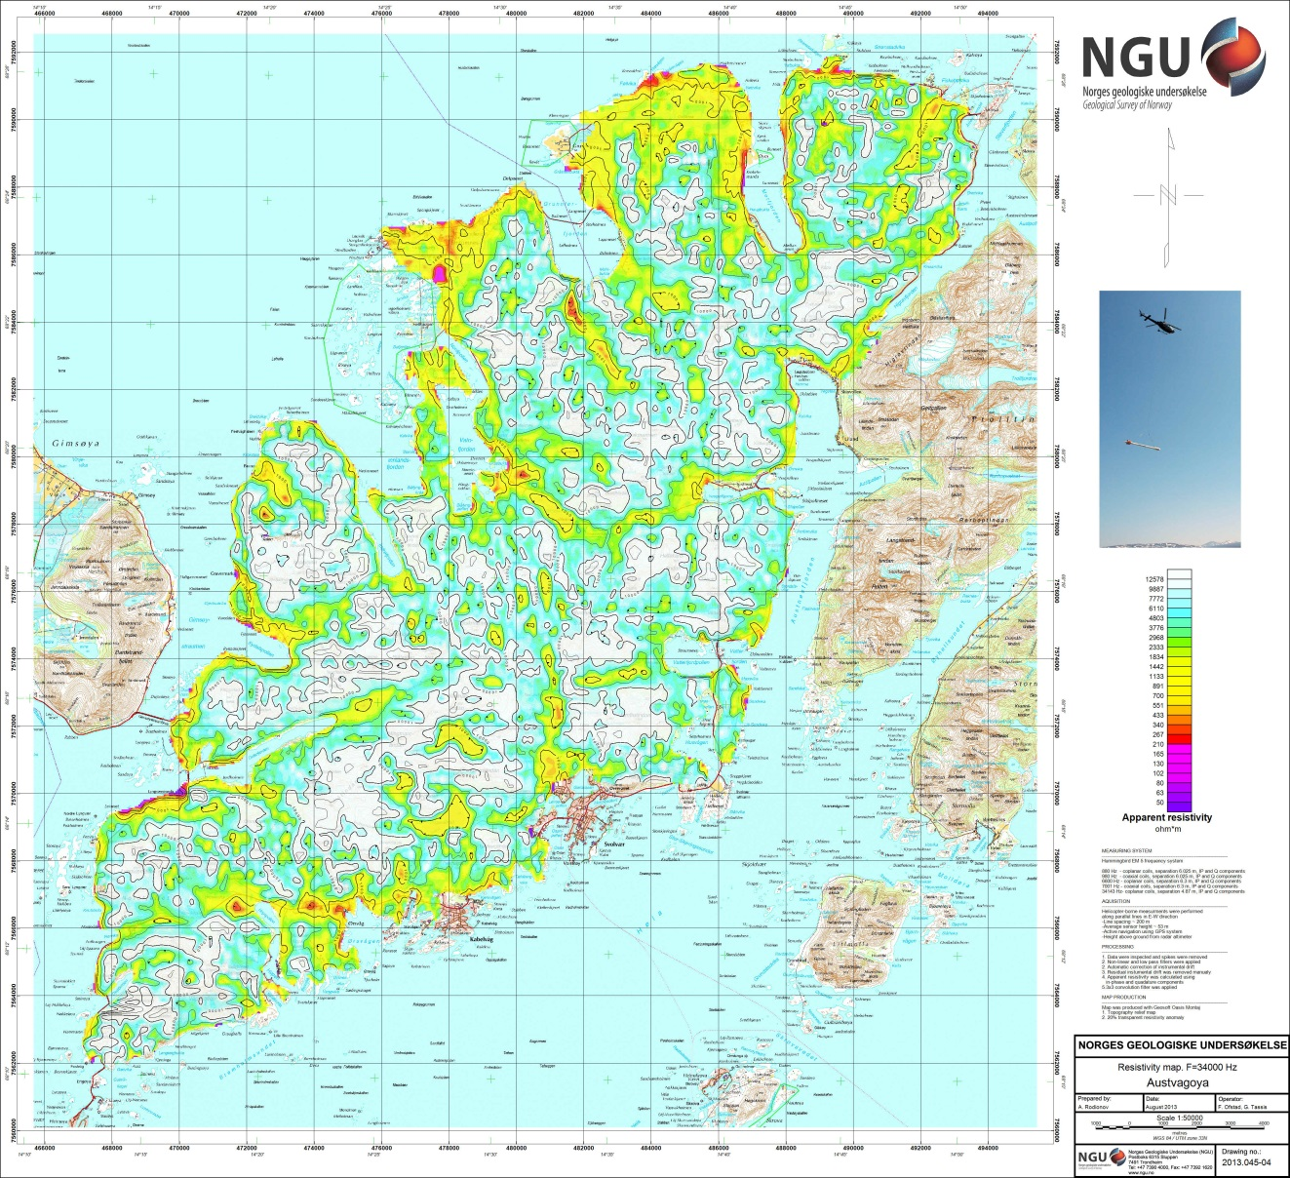
Figure 7: Apparent resistivity. Frequency 34000 Hz, Coplanar coils

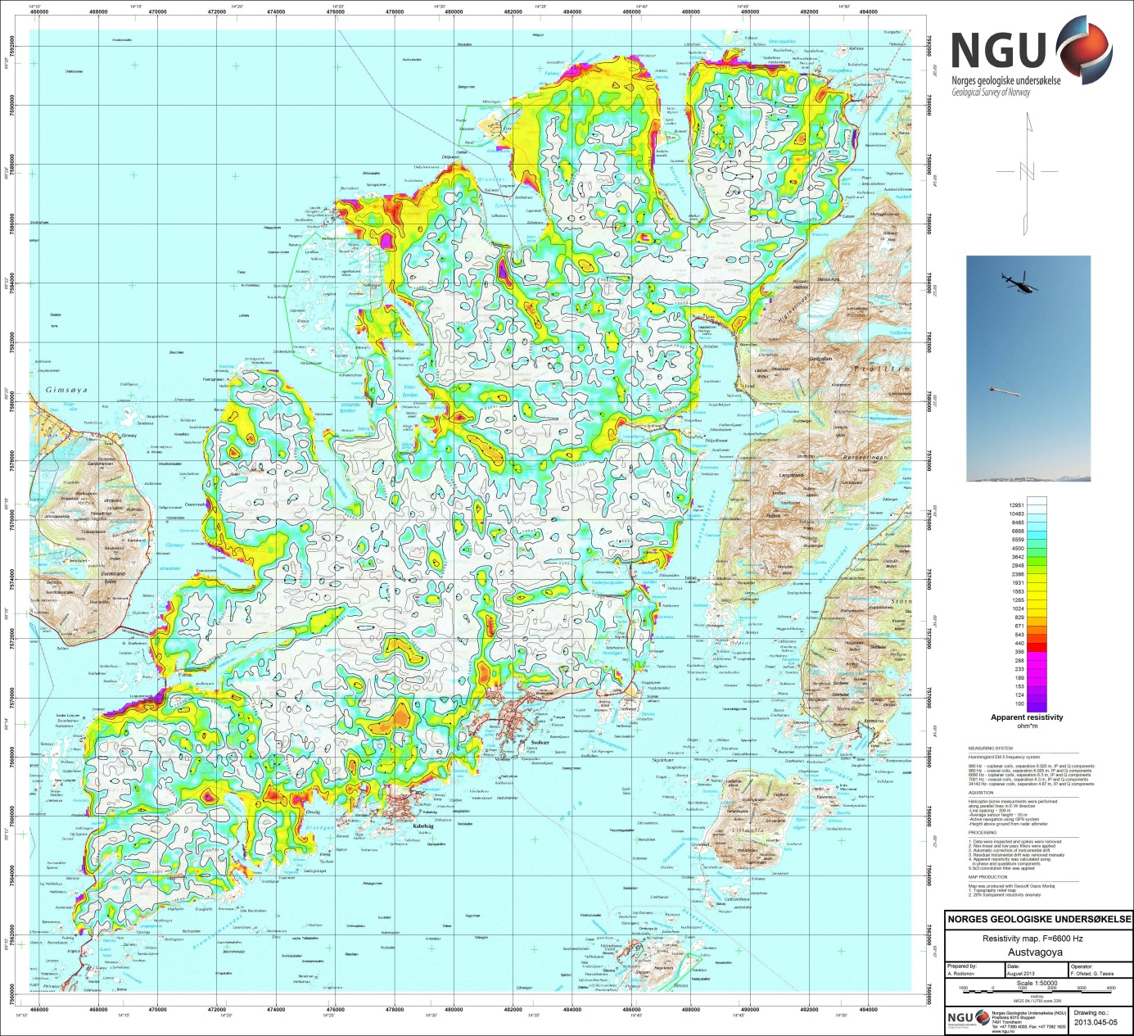
Figure 8: Apparent resistivity. Frequency 6600 Hz, Coplanar coils
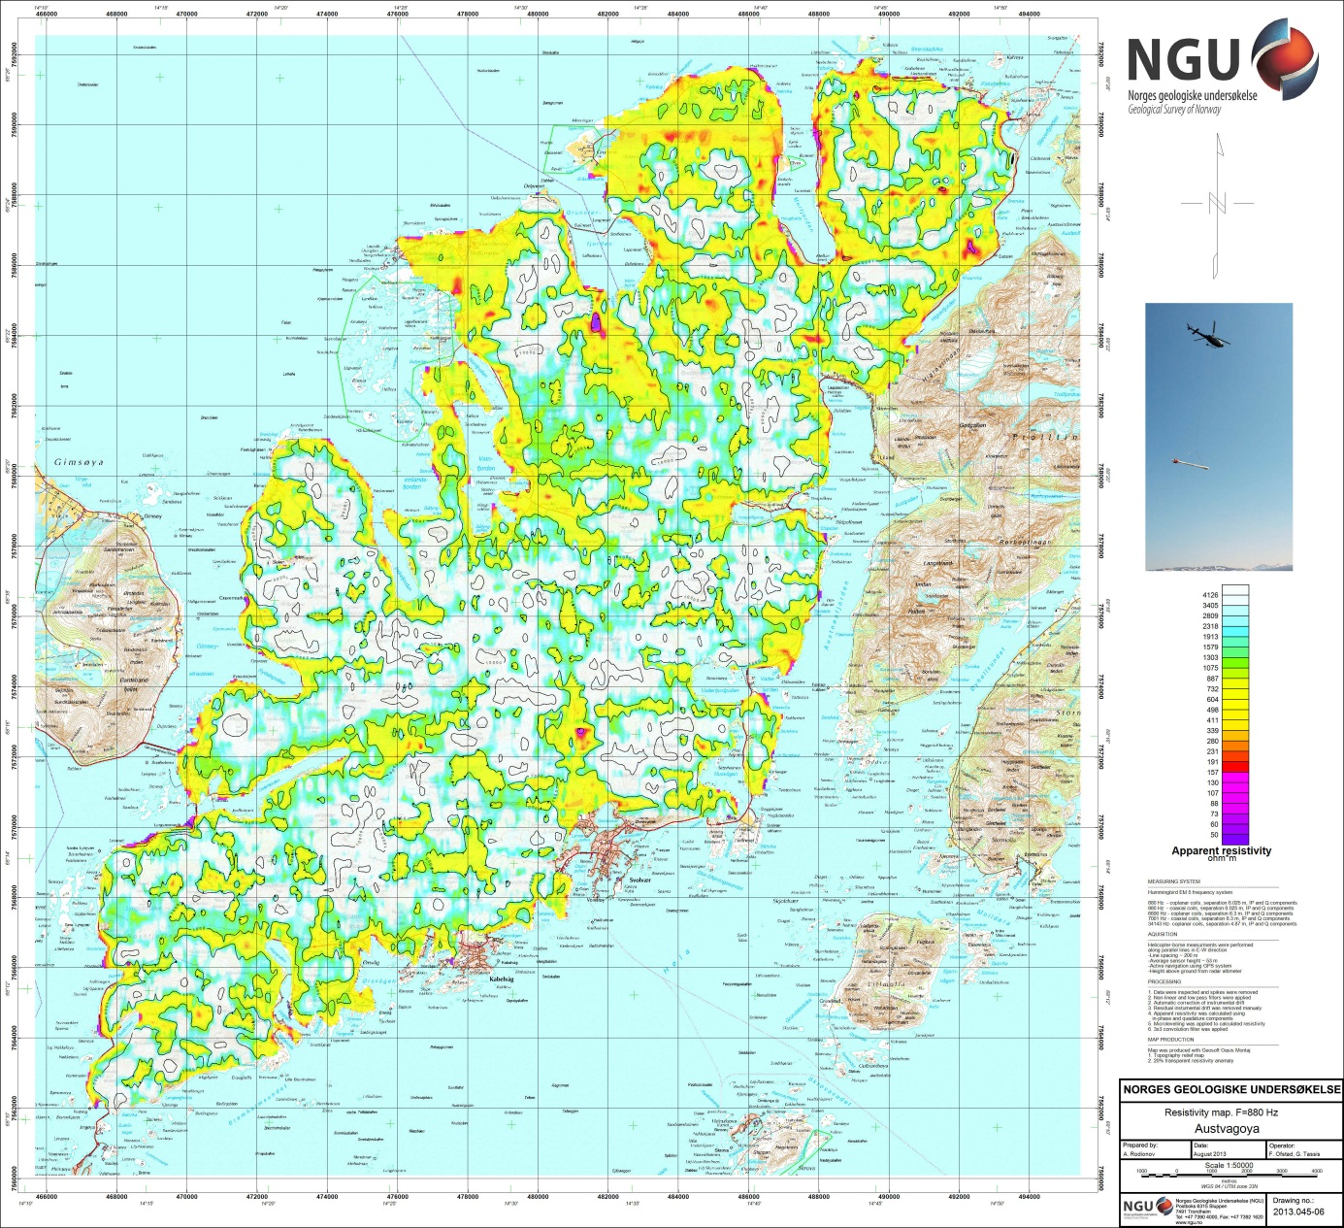
Figure 9: Apparent resistivity. Frequency 880 Hz, Coplanar coils

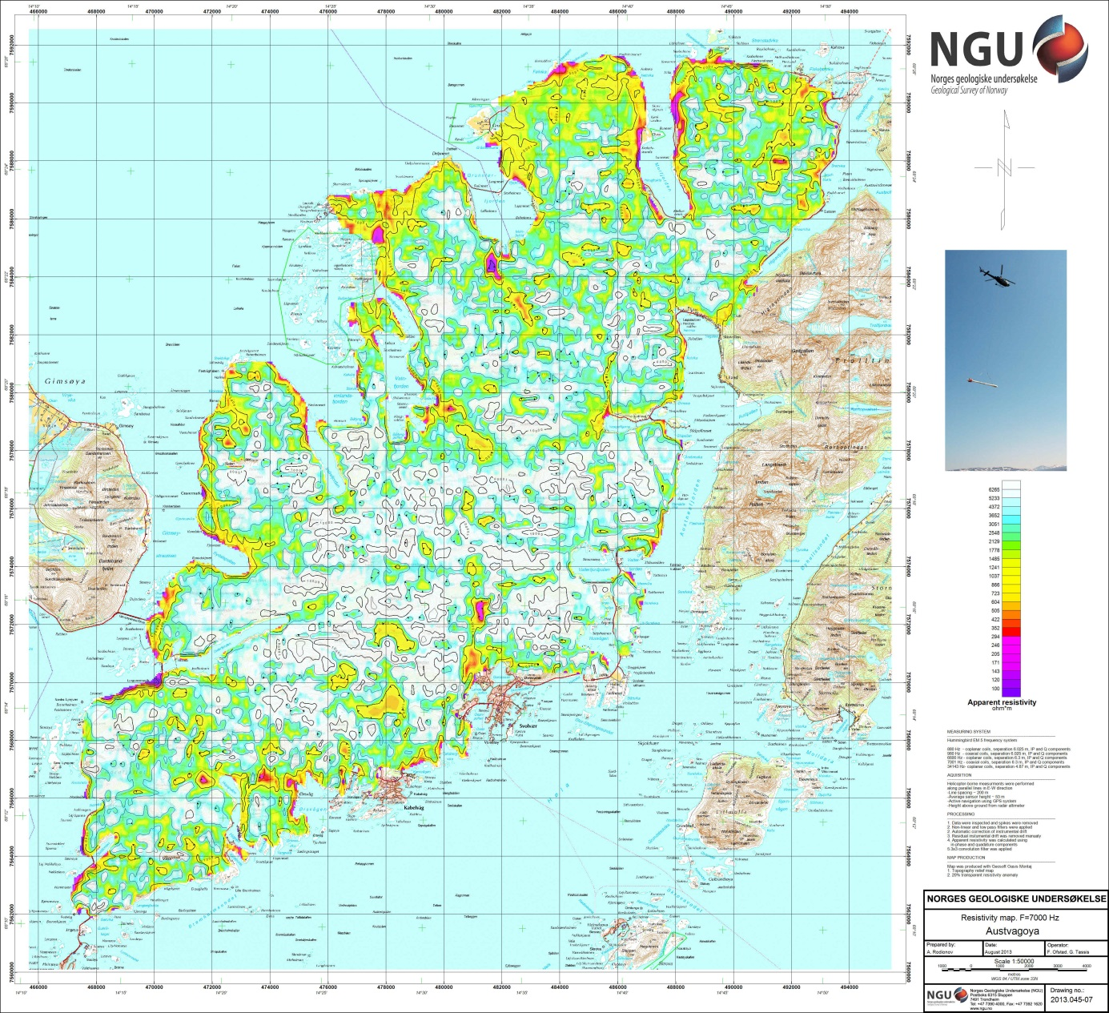
Figure 10: Apparent resistivity. Frequency 7000 Hz, Coaxial coils
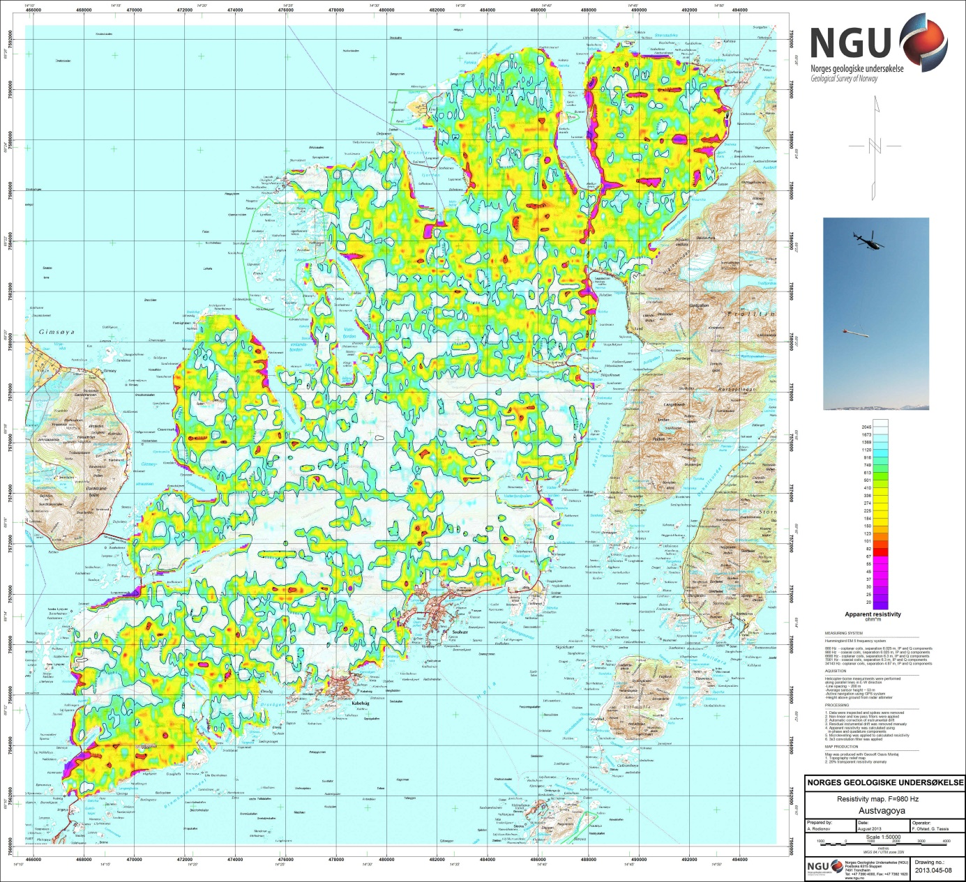
Figure 11: Apparent resistivity. Frequency 980 Hz, Coaxial coils

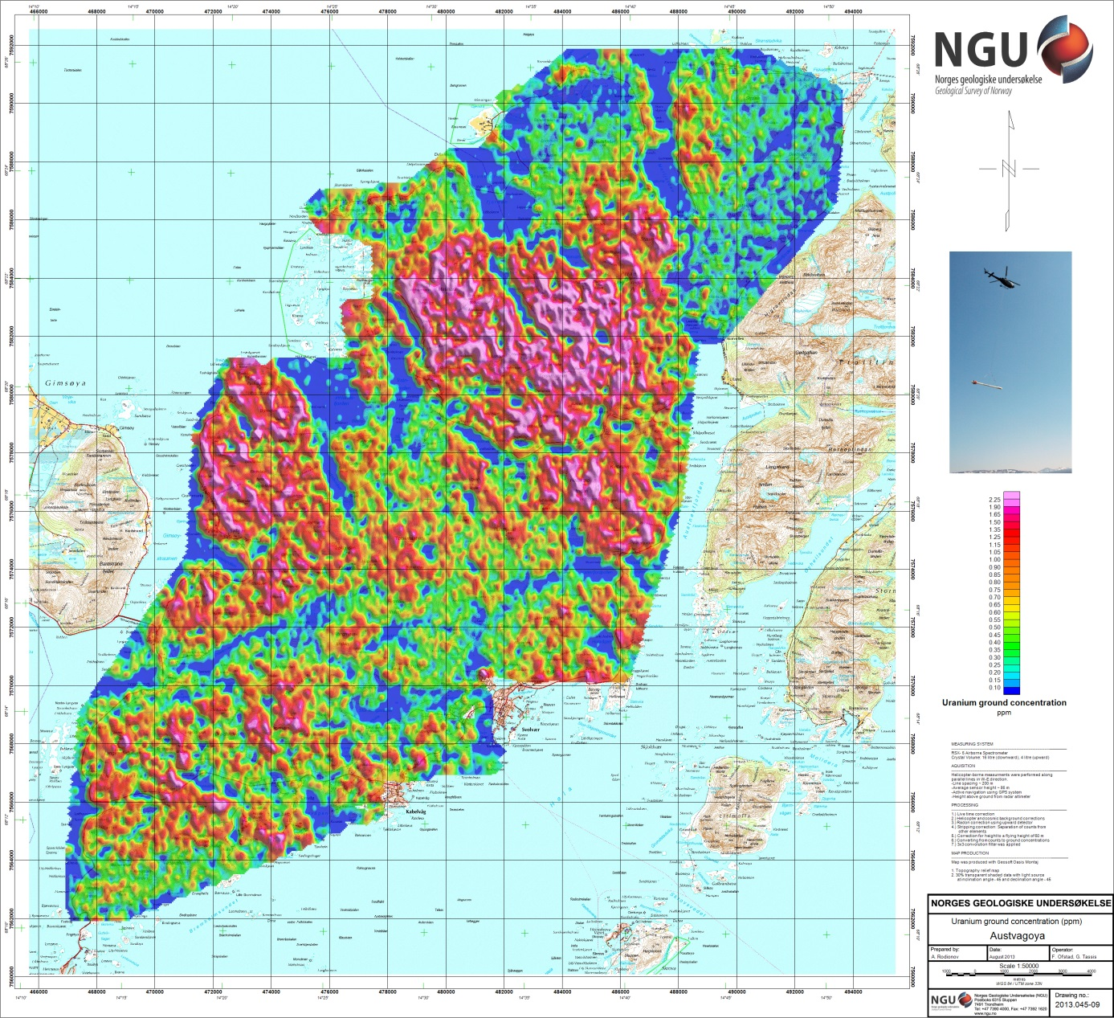
Figure 12: Uranium ground concentration

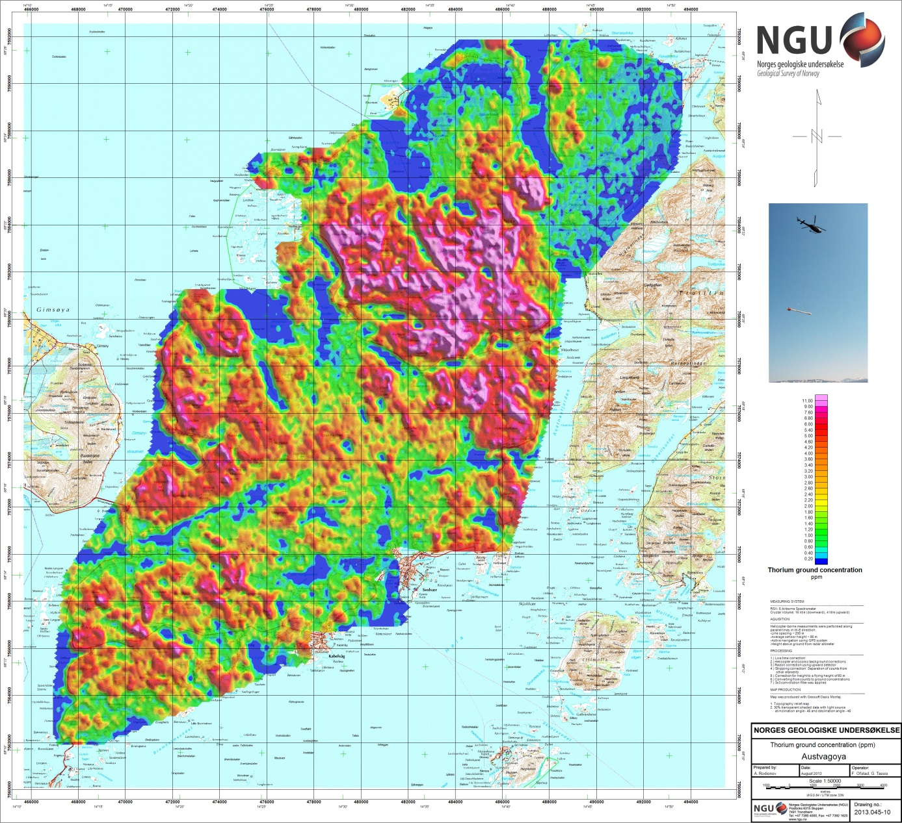
Figure 13: Thorium ground concentration

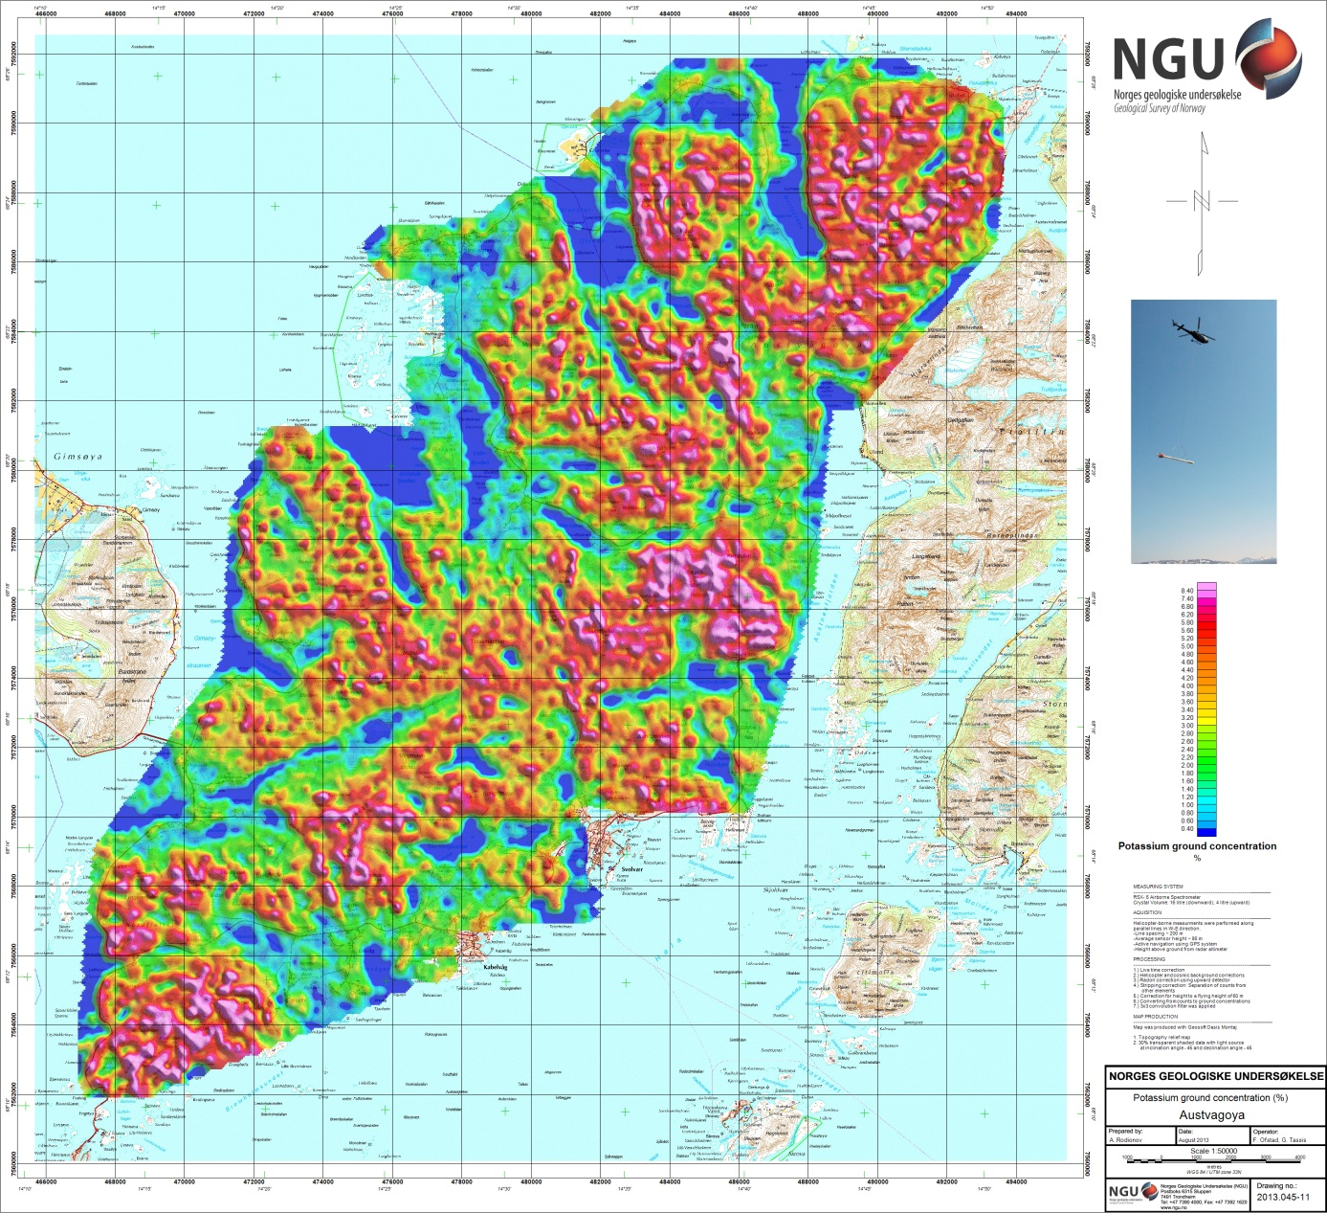
Figure 14: Potassium ground concentration

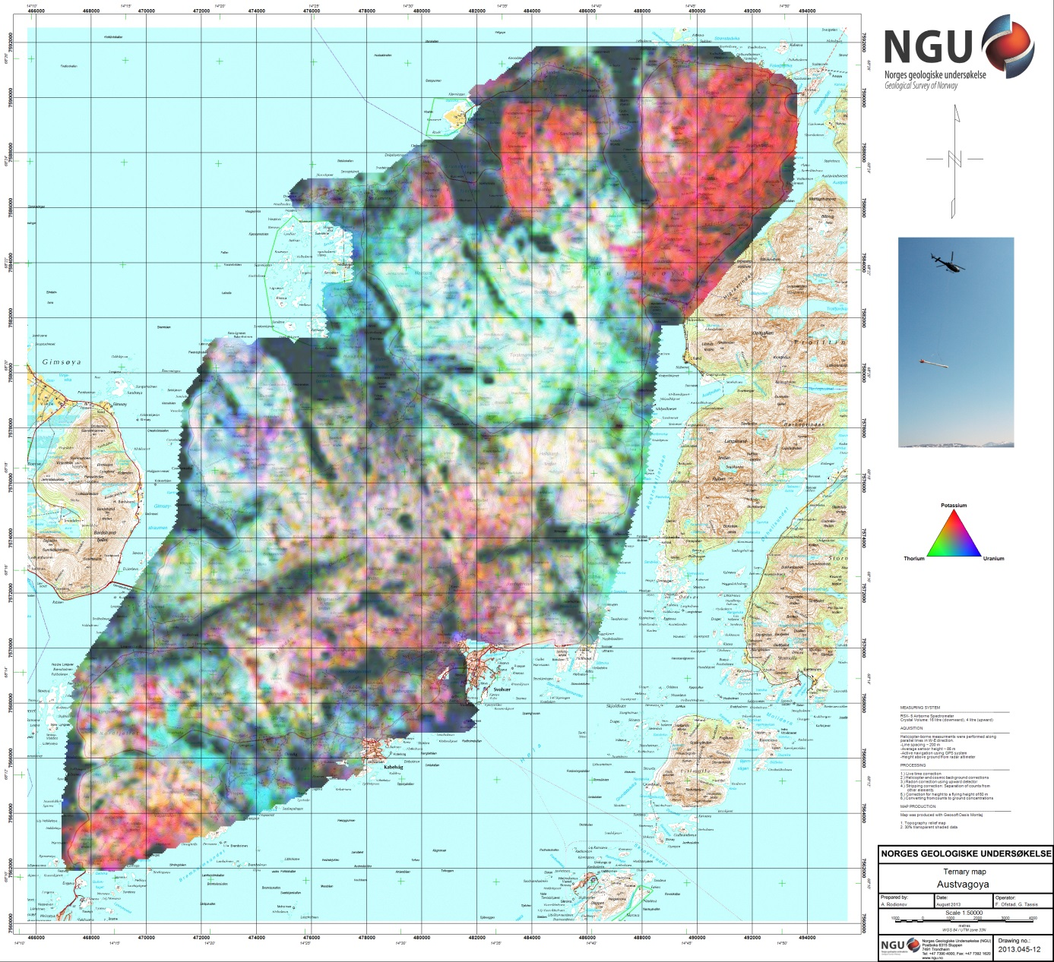
Figure 15: Radiometric Ternary map

