NGU Report 2014.009

Helicopter-borne magnetic and radiometric geophysical survey in the Altevann area, Bardu and Målselv Municipalities, Troms

REPORT

Geological Survey of Norway  Postboks 6315 Sluppen  NO-7491 Trondheim, Norway  Tel.: 47 73 90 40 00  Telefax 47 73 92 16 20  Report no.: 2014.009 |  |  | ISSN 0800-3416 |  | Grading: Open
Title:
Helicopter-borne magnetic and radiometric geophysical survey in the Altevann area, Bardu and Målselv Municipalities, Troms.
Authors:  Frode Ofstad and Alexandros Stampolidis |  |  |  | Client:  NGU
County:  Troms |  |  |  | Municipalities:  Bardu and Målselv
Map-sheet name (M=1:250.000)  NARVIK |  |  |  | Map-sheet no. and -name (M=1:50.000)  1531 I Geavdnjajávri, 1631 IV Leinavatn  1532 II Altevatnet, 1632 III Julosvárri
Deposit name and grid-reference: Altevann  UTM 33W – 700000 E and 7600000 N |  |  |  | Number of pages: 24 Price (NOK): 100,-  Map enclosures:
Fieldwork carried out:  September-Oktober 2013 | Date of report:  March 12th 2014 |  |  | Project no.:  342900 |  |  | Person responsible:
Summary:
NGU conducted an airborne magnetic and radiometric survey in the Altevann area in September-October 2013 as a part of the MINN project (Mineral resources in Northern Norway).

This report describes and documents the acquisition, processing and visualization of recorded datasets. The geophysical survey results reported herein are 4160 line km, covering an area of 832 km².

A Scintrex CS-3 magnetometer in a towed bird and a 1024 channels RSX-5 spectrometer installed under the helicopter belly was used for data acquisition.

The survey was flown with 200 m line spacing, line direction 28º (NNE to SSW) and average speed 93 km/h. The average terrain clearance was 70 m for the bird and 85 m for the spectrometer.

Collected data were processed at NGU using Geosoft Oasis Montaj software. Raw total magnetic field data were corrected for diurnal variation and levelled using standard micro-levelling algorithm.

Radiometric data were processed using standard procedures recommended by International Atomic Energy Association.

Data were gridded with the cell size of 50 x 50 m and presented as a shaded relief maps at the scale of 1:100.000.

Keywords: |  | Geophysics |  |  |  | Airborne
Magnetic |  | Technical report |  |  |  | Radiometric

Table of Contents
1. INTRODUCTION 4

2. SURVEY SPECIFICATIONS 5
2.1 Airborne Survey Parameters 5
2.2 Airborne Survey Instrumentation 6
2.3 Airborne Survey Logistics Summary 6

3. DATA PROCESSING AND PRESENTATION 7
3.1 Total Field Magnetic Data 7
3.2 Radiometric data 9

4. PRODUCTS 13

5. REFERENCES 13

Appendix A1: Flow chart of magnetic processing 14
Appendix A2: Description of the Special Matlab filtering step 14
Appendix A3: Flow chart of radiometry processing 15

FIGURES

Figure 1: Altevann survey area in Bardu and Målselv municipalities in Troms. 4
Figure 2: Pilots with Mag bird in front of the helicopter used in survey. (P1) 6
Figure 3: Gamma-ray spectrum with K, Th, U and Total count windows. 9
Figure 4: Altevann survey area with flight path 16
Figure 5: Total Magnetic Field 17
Figure 6: Magnetic Vertical Gradient 18
Figure 7: Magnetic Horizontal Gradient 19
Figure 8: Magnetic Tilt Derivative 20
Figure 9: Uranium Ground Concentration 21
Figure 10: Thorium Ground Concentration 22
Figure 11: Potassium Ground Concentration 23
Figure 12: Ternary Image of Radiation Concentrations 24

TABLES

Table 1. Instrument Specifications 6
Table 2. Specified channel windows for the 1024 RSX-5 systems used in this survey 9
Table 3: Maps in scale 1:100.000 available from NGU on request. 13

INTRODUCTION
Recognising the impact that investment in mineral exploration and mining can have on the socio-economic situation of a region, the government of Norway initiated the MINN program (Mineral resources in North Norway). The goal of this program is to enhance the geological information that is relevant to an assessment of the mineral potential of the three northernmost counties. The airborne geophysical surveys - helicopter borne and fixed wing- are important integral part of MINN program.

The airborne survey results reported herein amount to 4160 line km (832 km²) over the Altevann survey area, mainly in Bardu municipality, about 50 km south-east of Setermoen, as shown in Figure 1. The survey area is located between Dividalen National Park and the Swedish border.

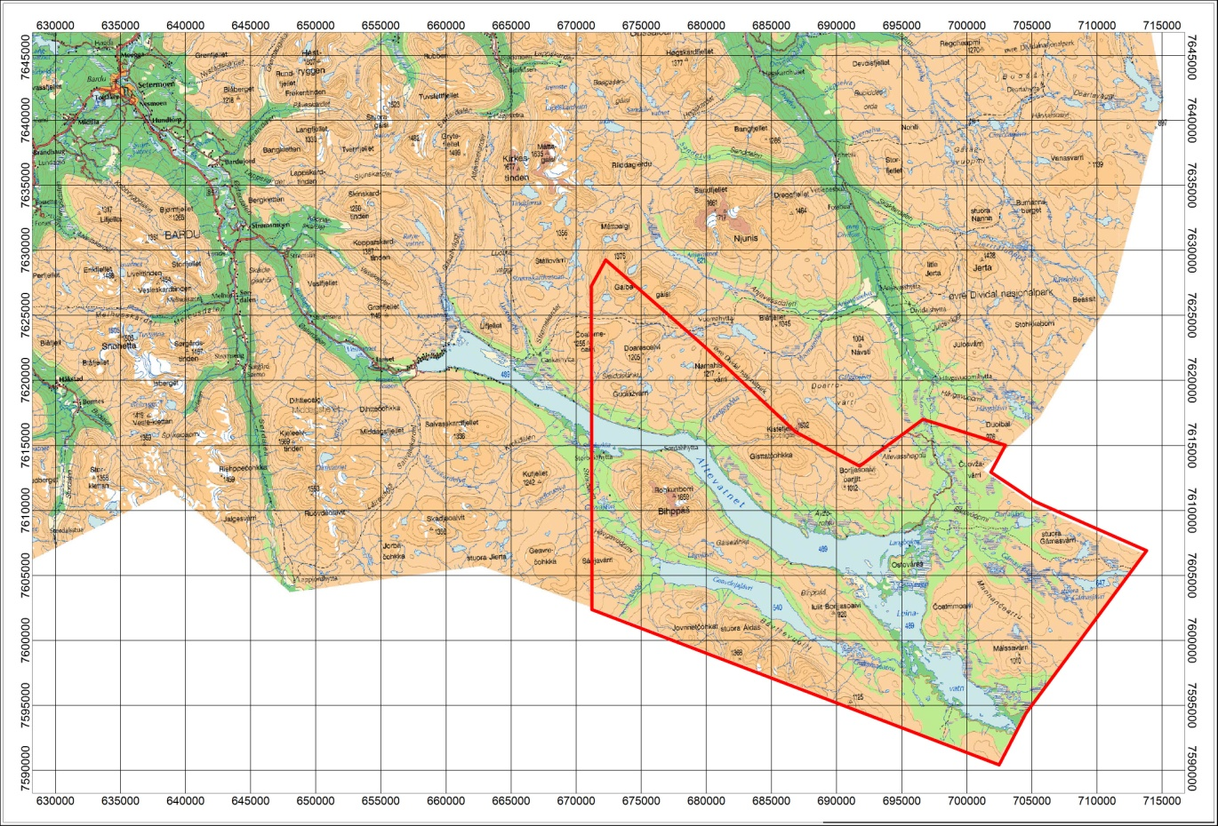
Figure 1: Altevann survey area in Bardu and Målselv municipalities in Troms.

The objective of the airborne geophysical survey was to obtain a dense high-resolution aero-magnetic and radiometric data set over the survey area. This data set is required for the enhancement of a general understanding of the regional geology of the area. In this regard, the data can also be used to map contacts and structural features within the area. It also improves defining the potential of known zones of mineralization, their geological settings, and identifying new areas of interest.

The survey incorporated the use of a high-sensitivity Cesium magnetometer, gamma-ray spectrometer and radar altimeter. A GPS navigation computer system with flight path indicators ensured accurate positioning of the geophysical data with respect to the World Geodetic System 1984 geodetic datum (WGS-84).

SURVEY SPECIFICATIONS

Airborne Survey Parameters

NGU used a helicopter survey system designed to obtain detailed airborne magnetic data. The system was supplemented by one 1024 channel gamma-ray spectrometer with 16 litres downward and 4 litres upward crystal volume, which was used to map ground concentrations of Uranium, Thorium and Potassium.

The airborne survey began on August 31st and ended on October 4th, 2013. A Eurocopter AS350-B2 from helicopter company HeliScan AS was used during the survey (Figure 2). The survey lines were spaced 200 m apart, and oriented at a 28° azimuth in UTM zone 33W. Instrument operation was performed by Heliscan AS employees for the whole survey.

The magnetic sensor was housed in a single 2 meters long bird towed 15 meters below the helicopter (Figure 2) which was flown at a constant altitude above the topographic surface. The Radiation Solutions RSX-5 gamma-ray spectrometer was installed under the belly of the helicopter, registering natural gamma ray radiation simultaneously with the acquisition of magnetic data.

Large water bodies, rugged terrain and abrupt changes in topography affected the pilot’s ability to ‘drape’ the terrain; therefore there are positive and negative variations in sensor height with respect to the standard height, which is defined as 60 m plus a height of obstacles (trees, power lines). The average survey height for the magnetometer was 70 m, and 85 m for the spectrometer. Due to bad weather conditions in the acquisition period and the flight safety rules, profiles were flown at high altitude and partly missing above the lake Altevann.

The ground speed of the aircraft varied from 60 – 120 km/h depending on topography, wind direction and its magnitude. On average the ground speed during the whole survey was calculated to 93 km/h. Magnetic data were recorded at 0.2 second intervals resulting in approximately 5 meters point spacing. Spectrometry data was recorded every 1 second giving a point spacing of approximately 26 meters.

The above parameters were designed to allow for sufficient detail in the data to detect subtle anomalies that may represent mineralization and/or rocks of different lithological and petro-physical composition.

A base magnetometer to monitor diurnal variations in the magnetic field was located at Innset, approximately at UTM 654600E – 7621000N, close to the survey area. The GEM GSM-19 station magnetometer data were recorded once every 3 seconds. The CPU clock of the base magnetometer is synchronized through the built-in GPS receiver.

Navigation system uses GPS/GLONASS satellite tracking systems to provide real-time WGS-84 coordinate locations for every second. The accuracy achieved with no differential corrections is reported to be ± 5 m in the horizontal directions. The GPS receiver antenna was mounted externally to the cabin roof of the helicopter.

For quality control, the magnetic, radiometric, altitude and navigation data were monitored on two separate windows in the operator's display during flight while they were recorded in ASCII data streams to the acquisition PC hard disk drive.

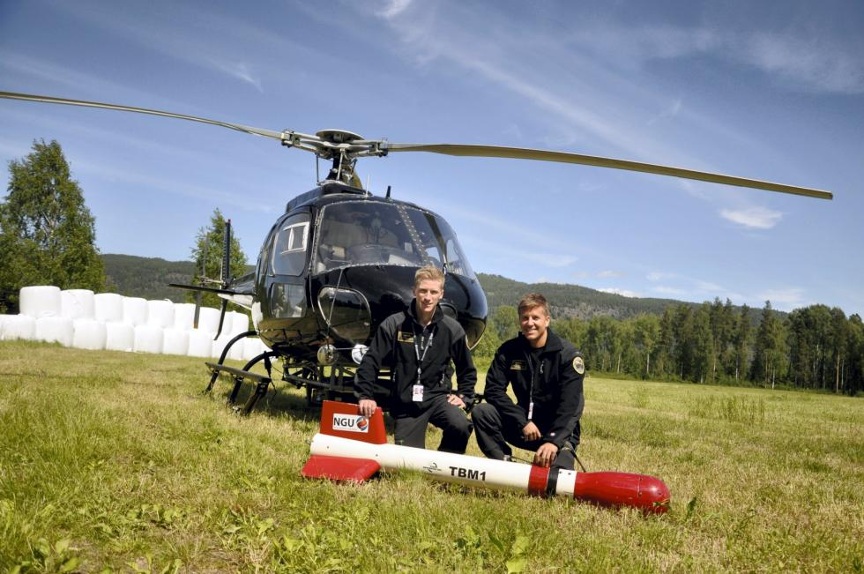
Figure 2: Pilots Småland and Lorentzen with Mag bird in front of the helicopter used in survey. (P1)

Airborne Survey Instrumentation
Table 1. Instrument Specifications
Instrument | Producer / Model | Accuracy / Sensitivity | Sampling freq / interval
Magnetometer | Scintrex Cs-3 | <2.5 nT | 5 Hz
Base magnetometer | GEM GSM-19 | - nT | 3 s
Gamma spectrometer | Radiation Solutions  RSX-5 | 1024 ch’s, 16 liters down, 4 liters up | 1 Hz
Radar altimeter | Bendix/King KRA 405B | ± 3 % 0 – 500 ft  ± 5 % 500-2500 ft | 1 Hz
Pressure/temperature | Honeywell PPT | ± 0,03 % FS | 1 Hz
Navigation | Topcon GPS-receiver | ± 5 meter | 1 Hz
Acquisition system | NGU custom software

The magnetic and radiometric, altitude and navigation data were monitored on the operator's displays during flight while they were recorded to the PC hard disk drive. Spectrometry data were also recorded to internal hard drive of the spectrometer. The raw data files were backed up onto USB flash drive in the field.

Airborne Survey Logistics Summary
Traverse (survey) line spacing: 200 metres
Traverse line direction: 28° NNE-SSW
Nominal aircraft ground speed: 60 - 120 km/h
Average sensor terrain clearance Mag: 70 metres
Average sensor terrain clearance Rad: 85 metres

DATA PROCESSING AND PRESENTATION
All data were processed by Alexandros Stampolidis and Frode Ofstad at NGU. The ASCII data files were loaded into separate Oasis Montaj databases. The datasets were processed according to processing flow charts shown in Appendix A1 and A3.

Total Field Magnetic Data
At the first stage the magnetic data were visually inspected and spikes were removed manually. Non-linear filter was applied to eliminate short-period spikes. Then the data from basemag station were imported into the magnetic database. Diurnal variation channel was also inspected for spikes and spikes were removed manually. Typically, several corrections have to be applied to magnetic data before gridding – i.e. heading, lag and diurnal correction, in addition to a few special processing steps necessary for this survey.

Special problem 1: Pendulum noise problems
The small wing area of the bird and the relative low flight speed during parts of the survey caused the bird to swing with a pendulum effect. The 15 m rope gave this pendulum motion a period time of about 7.5 seconds. The effect of the swinging motion was clearly visible in the magnetic data and made it necessary to apply a special filter in order to reduce the noise that was prominent in parts of the survey. This was achieved using a Matlab code developed by Alexandros Stampolidis (see description in Appendix A2). This step was applied before the diurnal corrections described below.

Diurnal Corrections
The temporal fluctuations in the magnetic field of the earth affect the total magnetic field readings recorded during the airborne survey. This is commonly referred to as the magnetic diurnal variation. These fluctuations can be effectively removed from the airborne magnetic dataset by using a stationary reference magnetometer that records the magnetic field of the earth simultaneously with the airborne sensor. Magnetic diurnals were within the standard NGU specifications during the entire survey (Rønning 2013).

Diurnal variations were measured with a GEM GSM-19 base magnetometer. The base station computer clock was continuously synchronized with GPS time. The recorded data are merged with the airborne data and the diurnal correction is applied according to equation (1).
, (1)
Where:

The average datum base level () was set equal to 53206 nT for the entire survey, allowing us to bring all recorded magnetic data to a common level.

Corrections for Lag and heading
Neither a lag nor cloverleaf tests were performed before the survey. According to previous reports the lag between logged magnetic data and the corresponding navigational data was 1-2 fids. Translated to a distance it would be no more than 10 m - the value comparable with the precision of GPS. A heading error for a towed system is usually either very small or non-existent. So no lag and heading corrections were applied.

Magnetic data processing, gridding and presentation
The total field magnetic anomaly data () were calculated from the diurnal corrected data () after subtracting the IGRF for the surveyed area calculated for the data period (eq.2)
(2)

The total field anomaly data were split in lines and then were gridded using a minimum curvature method with a grid cell size of 50 meters. This cell size is equal to one quarter of the 200m average line spacing. In order to remove small line-to-line levelling errors that were detected on the gridded magnetic anomaly data, the Geosoft Microlevelling technique was applied on the flight line based magnetic database. Then, the microlevelled channel was gridded using again a minimum curvature method with 50 m grid cell size.

The processing steps of magnetic data presented so far were performed on point basis. The following steps are performed on grid basis. The Horizontal and Vertical Gradient along with the Tilt Derivative of the total magnetic anomaly were calculated from the microlevelled total magnetic anomaly grid. The magnitude of the horizontal gradient was calculated according to equation (3)
(3)

where is the microlevelled field. The vertical gradient (VG) was calculated by applying a
vertical derivative convolution filter to the microlevelled field. The Tilt Derivative (TD) was calculated according to the equation (4)

TD = atan(VG/HG) (4)

Special Problem 2: Downward Continuation Processing
Due to the large water bodies in the survey area and the lack of flotation devices on the helicopter, the pilot had to increase the flight altitude above the Altevann lake for safety reasons. Because of these changes of altitude, the magnetic anomaly was not always consistent between neighbouring lines over the lake. The differences in height produced magnetic artefacts between lines, and made it necessary to level the magnetic data using the downward continuation method. This was done using the frequency-domain filtering package in Geosoft, as described in the Geosoft 2010; MAGMAP filtering tutorial.

Magnetic data gridding and presentation
Before final gridding, flight data were split by lines. For the purposes of data presentation and interpretation the total field magnetic data are gridded with a cell size of 50 m, which represents one quarter of the 200 m average line spacing. A micro levelling technique was applied to the magnetic data to remove small line-to-line levelling errors and a convolution filter was passed over the final grid to smooth the grid image.

The Vertical Gradient, Horizontal Gradient and the Tilt Derivative of the total magnetic field were calculated from the resulting total magnetic field map. These signals transform the shape of the magnetic anomaly from any magnetic inclination to positive body-centred anomaly and it's widely utilized for mapping of structures. A list of the produced maps is shown in Table 3.

Radiometric data
Airborne gamma-ray spectrometry measures the abundance of Potassium (K), Thorium (eTh), and Uranium (eU) in rocks and weathered materials by detecting gamma-rays emitted due to the natural radioelement decay of these elements. The data analysis method is based on the IAEA recommended method for U, Th and K (International Atomic Energy Agency, 1991). A short description of the individual processing steps of that methodology as adopted by NGU is given bellow.

Energy windows
The Gamma-ray spectra were initially reduced into standard energy windows corresponding to the individual radio-nuclides K, U and Th. Figure 3 shows an example of a Gamma-ray spectrum and the corresponding energy windows.
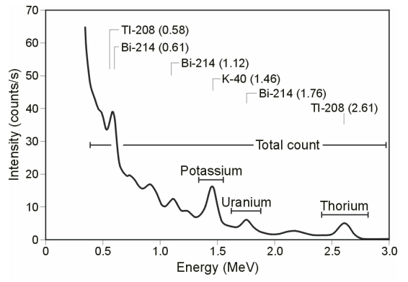
Figure 3: Gamma-ray spectrum with K, Th, U and Total count windows.

Table 2. Specified channel windows for the 1024 RSX-5 systems used in this survey
Gamma-ray spectrum | Cosmic | Total count | K | U | Th
Down | 1022 | 134-934 | 454-521 | 551-617 | 801-934
Up | 1022 |  |  | 551-617
Energy, keV | >3000 | 407-2807 | 1367-1568 | 1658-1856 | 2408-2807
Peak, keV |  |  | 1460 | 1765 | 2614
Peak channel |  |  | 486 | 586 | 872

The RSX-5 is a 1024 channel system with a four downward looking and one upward looking detector, with a total crystal volume of 16 liters downward and 4 liters upward for cosmic corrections. The Gamma-ray spectrum of 0.005 to 3000 keV is divided into 1024 channels, where each channel has a 3.0 keV range. Table 2 shows the channels and energies that were used for the reduction of the spectrum.

Live Time correction
The data were corrected for live time. “Live time” is an expression of the relative period of time the instrument was able to register new pulses per sample interval. On the other hand “dead time” is an expression of the relative period of time the system was unable to register new pulses per sample interval. The relation between “dead” and “live time” is given by the equation (5)
“Live time” = “Real time” – “Dead time” (5)
where the “real time” or “acquisition time” (here 1 second) is the elapsed time over which the spectrum is accumulated.

The live time correction is applied to the total count, Potassium, Uranium, Thorium, upward Uranium and cosmic channels. The formula used to apply the correction is as follows:
(6)
where C_{LT} is the live time corrected channel in counts per second, C_{RAW} is the raw channel data in counts per second and Live Time is in microseconds.

Cosmic and aircraft correction
Background radiation resulting from cosmic rays and aircraft contamination was removed from the Total Count, Potassium, Uranium, Thorium and Upward Uranium channels using the following formula:
(7)
where C_{CA} is the cosmic and aircraft corrected channel, C_{LT} is the live time corrected channel a_{c} is the aircraft background for this channel, b_{c} is the cosmic stripping coefficient for this channel and C_{Cos} is the low pass filtered cosmic channel.

Radon correction
The upward detector method, as discussed in IAEA (1991), was applied to remove the effects of the atmospheric radon in the air below and around the helicopter. Usages of over-water measurements where there is no contribution from the ground, enabled the calculation of the coefficients (a_{C} and b_{C}) of the linear equations that relate the cosmic corrected counts per second of Uranium channel with total count, Potassium, Thorium and Uranium upward channels over water. Data over-land was used in conjunction with data over-water to calculate the a₁ and a₂ coefficients used in equation (8) for the determination of the Radon component in the downward uranium window:

(8)

where Radon_{U} is the radon component in the downward uranium window, Uup_{CA} is the filtered upward uranium, U_{CA} is the filtered Uranium, Th_{CA} is the filtered Thorium, a₁, a₂, a_{U} and a_{Th} are proportional factors and b_{U} an b_{Th} are constants determined experimentally.

The effects of Radon in the downward Uranium are removed by simply subtracting Radon_{U} from U_{CA}. The effects of radon in the other channels are removed using the following formula:
(9)
where C_{RC} is the Radon corrected channel, C_{CA} is the cosmic and aircraft corrected channel, Radon_{U} is the Radon component in the downward uranium window, a_{c} is the proportionality factor and b_{c} is the constant determined experimentally for this channel from over-water data.
The coefficients that were determined from survey data over land and water at Austvågøya-Hinnøya were used for the Radon correction.

Compton Stripping
Potassium-, Uranium- and Thorium- Radon corrected channels are subjected to spectral overlap correction. Compton scattered gamma rays in the radio-nuclides energy windows were corrected by window stripping using Compton stripping coefficients determined from measurements on calibrations pads at the Geological Survey of Norway in Trondheim (for values see Appendix A3).

The stripping corrections are given by the following formulas:

(10)

(11)

(12)

(13)

where U_{RC}, Th_{RC}, K_{RC} are the radon corrected Uranium, Thorium and Potassium, a, b, g, α, β, γ are Compton stripping coefficients.

Reduction to Standard Temperature and Pressure
The radar altimeter data were converted to effective height (H_{STP}) using the acquired temperature and pressure data, according to the expression:

(14)

where H is the smoothed observed radar altitude in meters, T is the measured air temperature in degrees Celsius and P is the measured barometric pressure in millibars.

Height correction
Variations caused by changes in the aircraft altitude relative to the ground corrected to a nominal height of 60 m. Data recorded at the height above 150 m were considered as non-reliable and removed from processing. Total count, Uranium, Thorium and Potassium stripped channels were subjected to height correction according to the equation:

(15)

where C_{ST} is the stripped corrected channel, C_{ht} is the height attenuation factor for that channel and H_{STP} is the effective height.

Conversion to ground concentrations
Finally, corrected count rates were converted to effective ground element concentrations using calibration values derived from calibration pads at the Geological Survey of Norway in Trondheim (for values see Appendix A3). The corrected data provide an estimate of the apparent surface concentrations of Potassium, Uranium and Thorium (K, eU and eTh).

Potassium concentration is expressed as a percentage, equivalent Uranium and Thorium as parts per million (ppm). Uranium and Thorium are described as “equivalent” since their presence is inferred from gamma-ray radiation from daughter elements (²¹⁴Bi for Uranium, ²⁰⁸TI for Thorium). The concentration of the elements is calculated according to the following expressions:

(16)

where C_{60m} is the height corrected channel, C_{SENS_60m} is experimentally determined sensitivity reduced to the nominal height (60m).

Spectrometry data gridding and presentation
Gamma-rays from Potassium, Thorium and Uranium emanate from the uppermost 30 to 40 centimetres of soil and rock in the crust (Minty, 1997). Variations in the concentrations of these radio-elements largely related to changes in the mineralogy and geochemistry of the Earth’s surface.

The calculated ground concentrations of the three main natural radio-elements Potassium, Thorium and Uranium, along with total gamma-ray flux (total count) were microlevelled to remove small line-to-line levelling errors, as in the case of the magnetic data, and then gridded using a minimum curvature method with a grid cell size of 50 meters. This cell size is equal to one quarter of the 200m average line spacing.

The quality of the radiometric data was within standard NGU specifications (Rønning 2013), except for two areas where the radiometric data is missing completely due to system error. Lines 1700 to 1730 and 1860 have no data south of Altevann, data from line 1850 is missing completely. These two areas of missing radiometry data are visible in the maps.

A list of the maps is shown in Table 3. A list of the parameters used in the processing schemes is given in Appendix A3. For further reading regarding standard processing of airborne radiometric data, we recommend the publication from Minty et al. (1997).

PRODUCTS
Processed digital data from the survey are presented as:
- Geosoft XYZ files: Altevann_Mag.xyz, Altevann_Rad.xyz.

- Coloured maps (jpg) at the scale 1:100.000 available from NGU on request.

- Geo-referenced tiff files (Geo-tiff).

Table 3: Maps in scale 1:100.000 available from NGU on request.
Map # | Name | Figure No
2013.046-01 | Total magnetic field | 5
2013.046-02 | Magnetic Vertical Derivative | 6
2013.046-08 | Magnetic Horizontal Derivative | 7
2013.046-03 | Magnetic Tilt Derivative | 8
2013.046-04 | Uranium ground concentration | 9
2013.046-05 | Thorium ground concentration | 10
2013.046-06 | Potassium ground concentration | 11
2013.046-07 | Radiometric Ternary Map | 12

REFERENCES

Geotech 1997: Hummingbird Electromagnetic System. User manual. Geotech Ltd. October 1997

Grasty, R.L., Holman, P.B. & Blanchard 1991: Transportable Calibration pads for ground and airborne Gamma-ray Spectrometers. Geological Survey of Canada. Paper 90-23. 62 pp.

IAEA 2003: Guidelines for radioelement mapping using gamma ray spectrometry data. IAEA-TECDOC-1363, Vienna, Austria. 173 pp.

Minty, B.R.S., Luyendyk, A.P.J. and Brodie, R.C. 1997: Calibration and data processing for gamma-ray spectrometry. AGSO – Journal of Australian Geology & Geophysics. 17(2). 51-62.

Naudy, H. and Dreyer, H. 1968: Non-linear filtering applied to aeromagnetic profiles. Geophysical Prospecting. 16(2). 171-178.

Rønning, J.S. 2013: NGUs helikoptermålinger. Plan for sikring og kontroll av datakvalitet. NGU Intern rapport 2013.001, (38 sider).

Geosoft 2010: Montaj MAGMAP Filtering, 2D-Frequency Domain Processing of Potential Field Data, Extension for Oasis Montaj v 7.1, Geosoft Corporation

P1: Photo by Mari Nymoen, Telen Newspaper, Notodden

Appendix A1: Flow chart of magnetic processing
Meaning of parameters is described in the referenced literature.

Processing flow:

- Quality control.
- Visual inspection of airborne data and manual spike removal
- Import basemag data to Geosoft database
- Inspection of basemag data and removal of spikes
- Special Matlab Gauss-filter for removal of 7.5 sec pendulum noise
- Correction of data for diurnal variation
- Splitting flight data by lines
- Gridding
- Geosoft 2D-Frequency Domain filtering to remove height effect
- Micro-leveling
- 7x7 Convolution filter

Appendix A2: Description of the Special Matlab filtering step
The code is being used to filter the “pendulum effect” periodic noise on the magnetic data. The data are filtered by calling a Matlab built-in convolution routine called “conv” that convolves the input data vector with a vector that has coefficients of Gaussian lowpass filter at a certain frequency (Freq.1).

If the differences between the input and the filtered data are above a predefined threshold, this part of the data is reprocessed be employing a less severe filter (Freq.2) on the input data. Again a threshold is applied on the differences between the input and the filtered data and in this case if the differences are above the threshold then the input data are retained for that part on the final filtered dataset.

These steps enable us to preserve the amplitudes of strong anomalies in the data, which would be lost otherwise by typical convolution or Fourier filtering. The cutoff frequency that were used were Freq.1=0.04Hz and Freq.2=0.09Hz.

Appendix A3: Flow chart of radiometry processing
Underlined processing stages are applied to the K, U, Th and TC windows.
Meaning of parameters is described in the referenced literature.

Processing flow:
- Quality control
- Airborne and cosmic correction (IAEA, 2003)
Used parameters: (determined by high altitude calibration flights at Frosta in May 2013)
Aircraft background counts:
K window 5.36
U window 1.43
Th window 0
Uup window 0.7
Total counts 42.73
Cosmic background counts (normalized to unit counts in the cosmic window):
K window 0.0570
U window 0.0467
Uup window 0.0448
Th window 0.0643
Total counts 1.0317
- Radon correction using upward detector method (IAEA, 2003)
Used parameters (determined from survey data over water and land):
a_{u}: 0.33494 b_{u:} 0
a_{K}: 0.74466 b_{K}: 0.54899
a_{Th}: 0.05134 b_{Th}: 0.76462
aTc: 14.93499 bTc: 0.72081
_{a1}: 0.06766 a₂: 0.02422

- Stripping correction (IAEA, 2003)
Used parameters (determined from measurements on calibrations pads at the NGU in May 2013):
a 0.046856
b 0
g 0
alpha 0.30346
beta 0.47993
gamma 0.82316
- Height correction to a height of 60 m
Used parameters (determined by high altitude calibration flights at Frosta in Jan 2014):
Attenuation factors in 1/m:
K: -0.009523
U: -0.006687
Th: -0.007394
TC: -0.00773

- Converting counts at 60 m heights to element concentration on the ground
Used parameters (determined from measurements on calibrations pads at the NGU in May 2013):
Sensitivity (elements concentrations per count)::
K: 0.007458 %/counts
U: 0.08773 ppm/counts
Th: 0.15666 ppm/counts
Cs: 19.9 kBq/m² /counts

- Microlevelling using Geosoft menu and smoothening by a convolution filtering
Used parameters for microlevelling:
De-corrugation cutoff wavelength: 2000 m
Cell size for gridding: 50 m
Naudy (1968) Filter length: 800 m

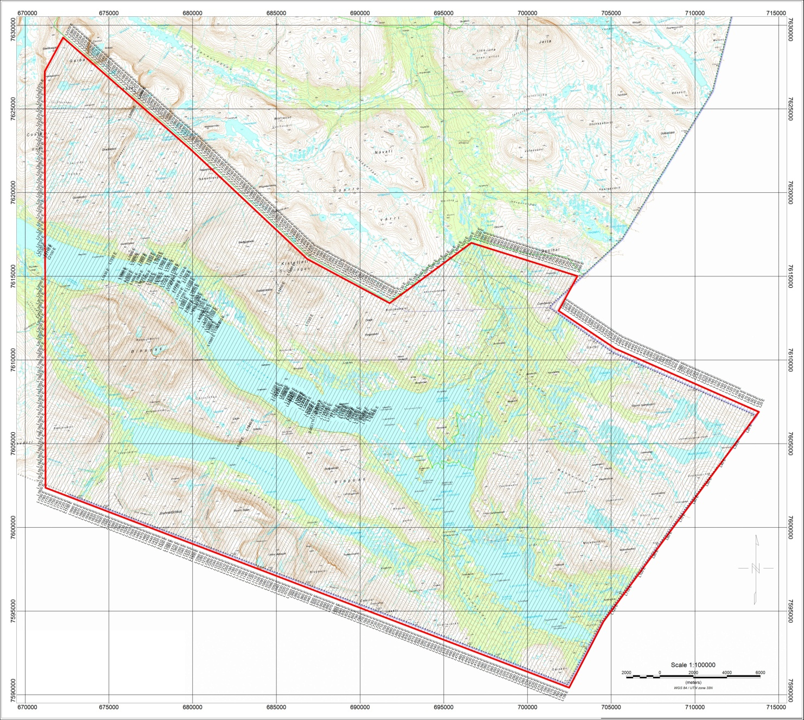
Figure 4: Altevann survey area with flight path
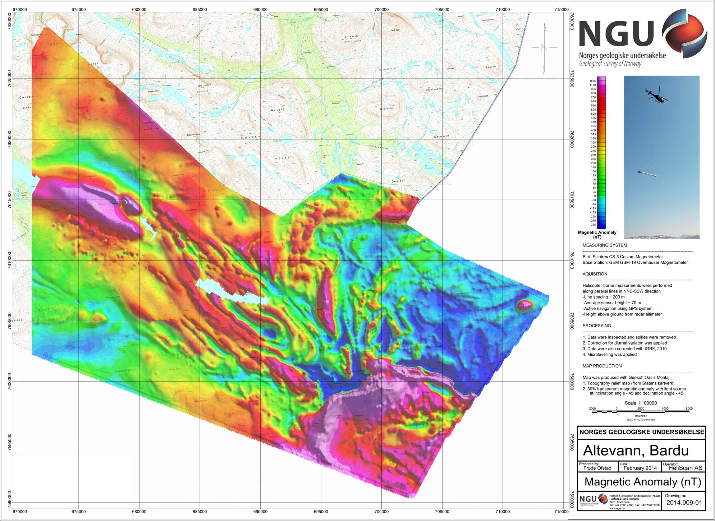
Figure 5: Total Magnetic Field
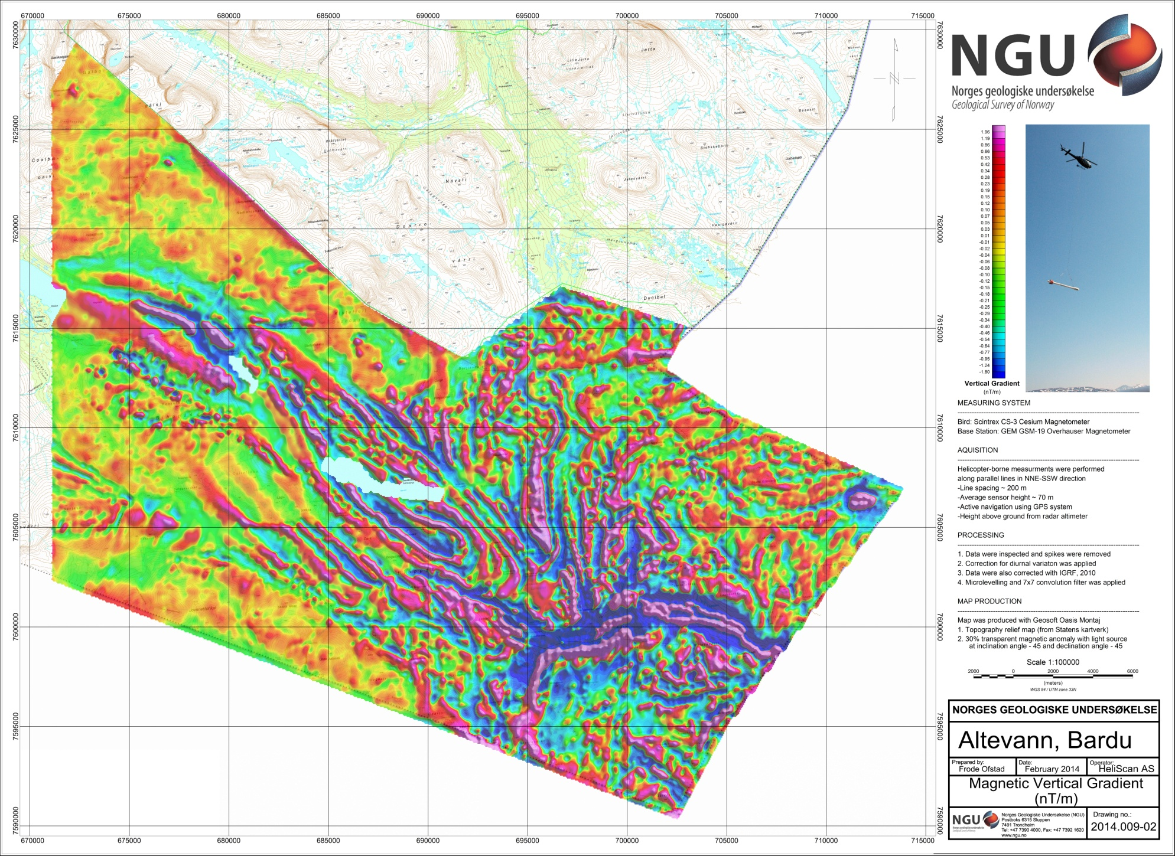
Figure 6: Magnetic Vertical Gradient
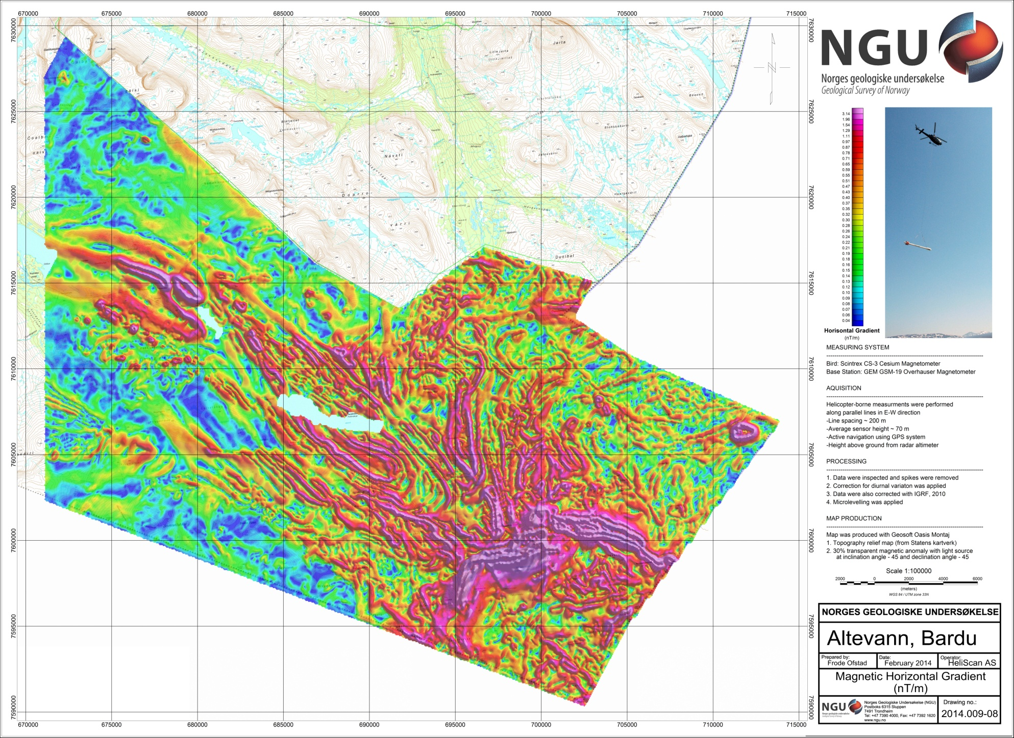
Figure 7: Magnetic Horizontal Gradient
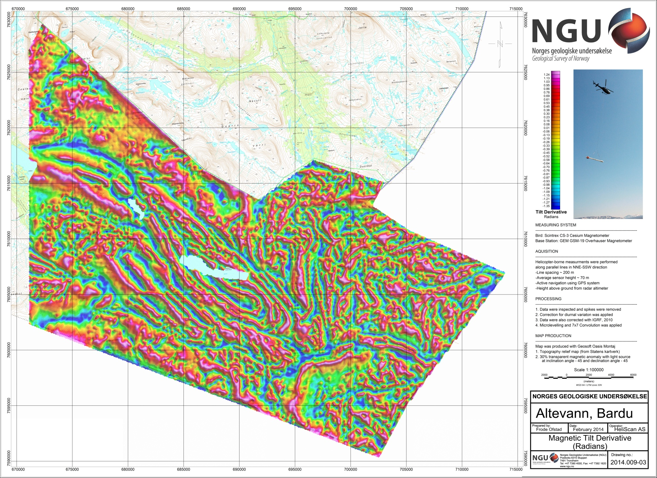
Figure 8: Magnetic Tilt Derivative
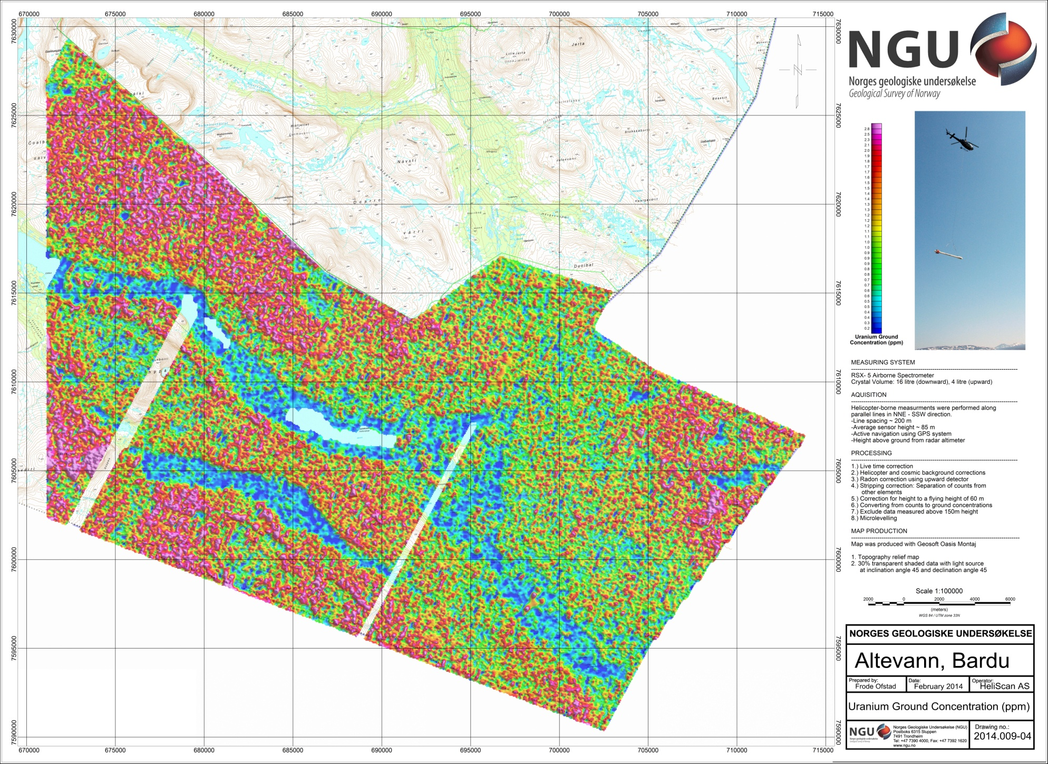
Figure 9: Uranium Ground Concentration
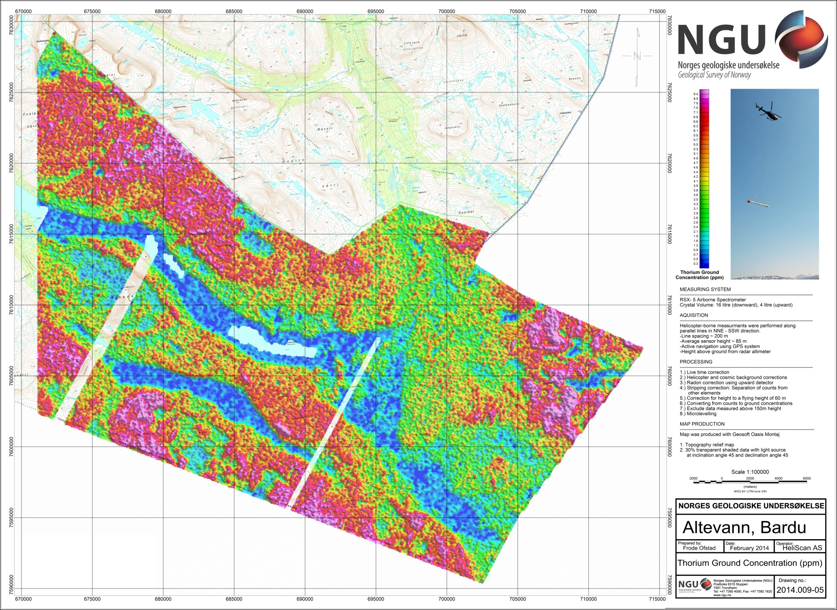
Figure 10: Thorium Ground Concentration
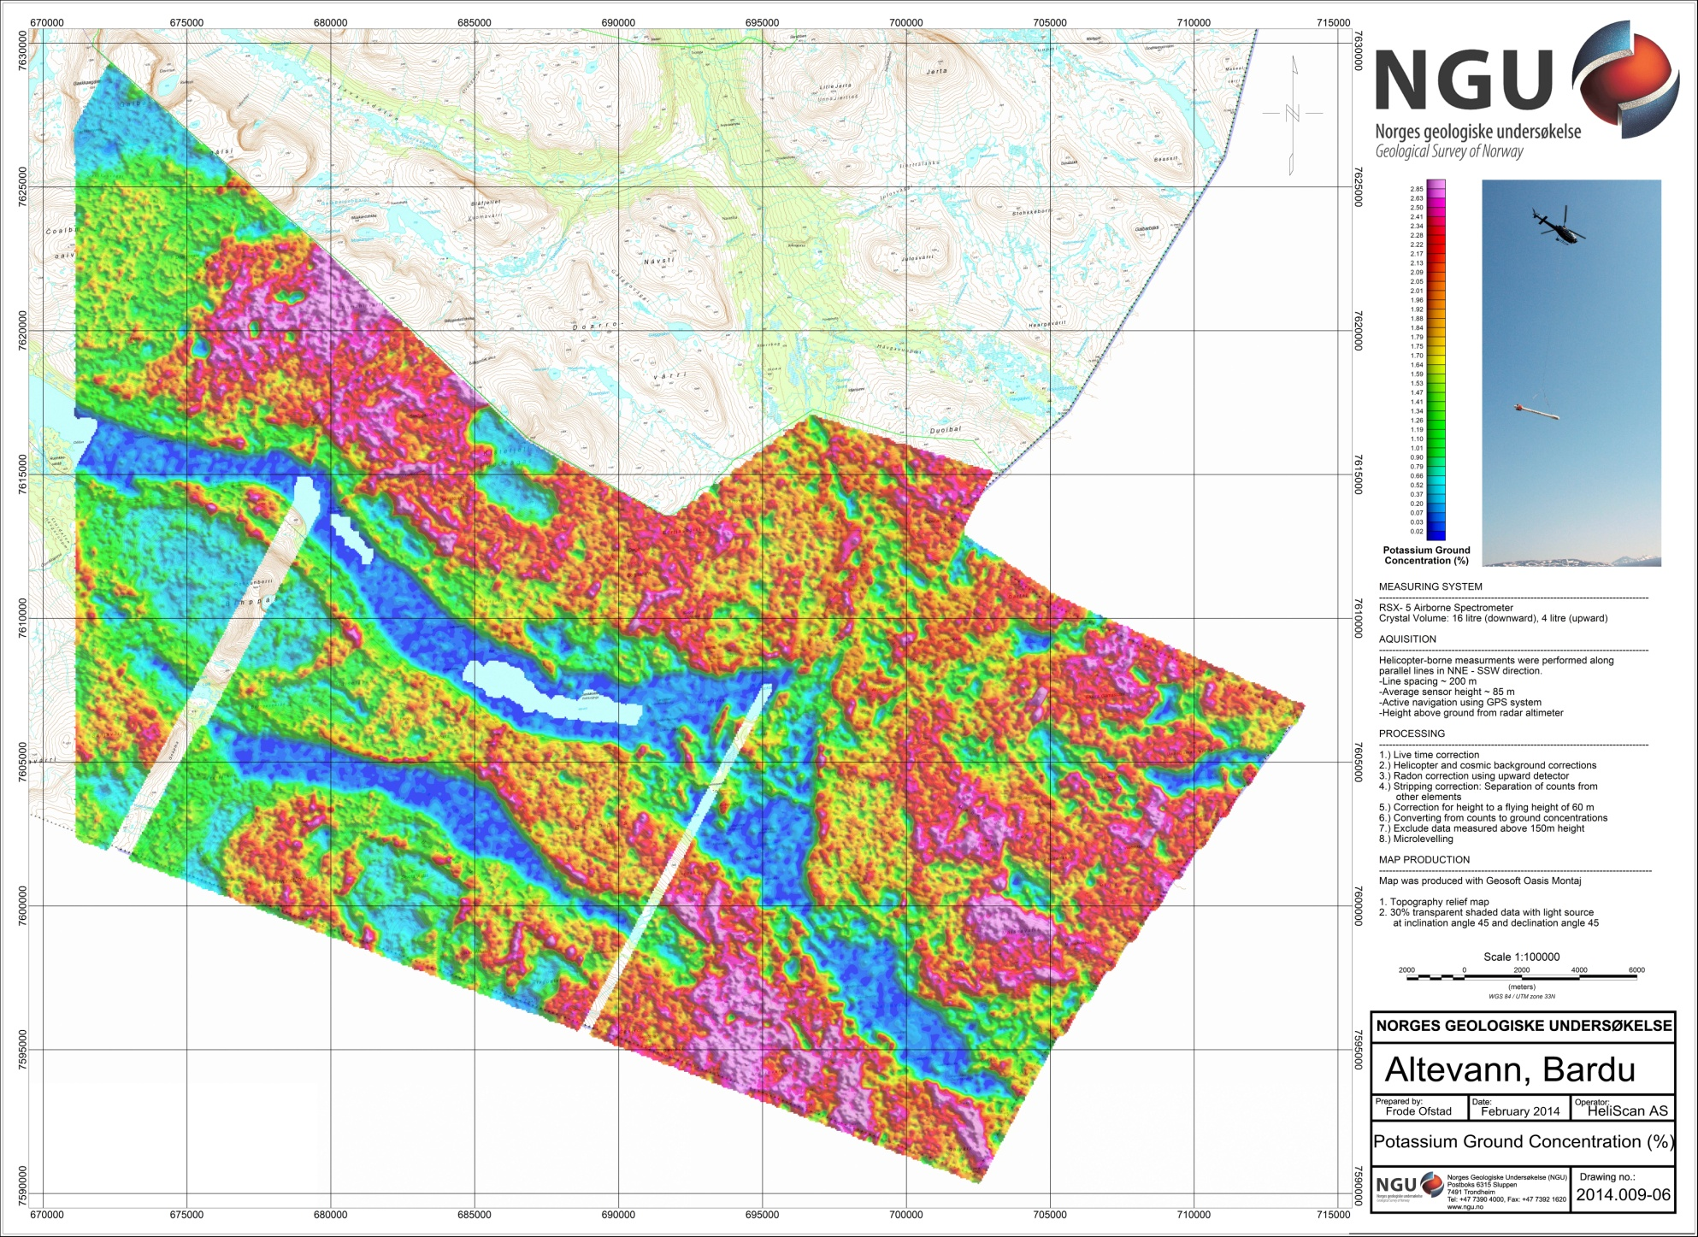
Figure 11: Potassium Ground Concentration
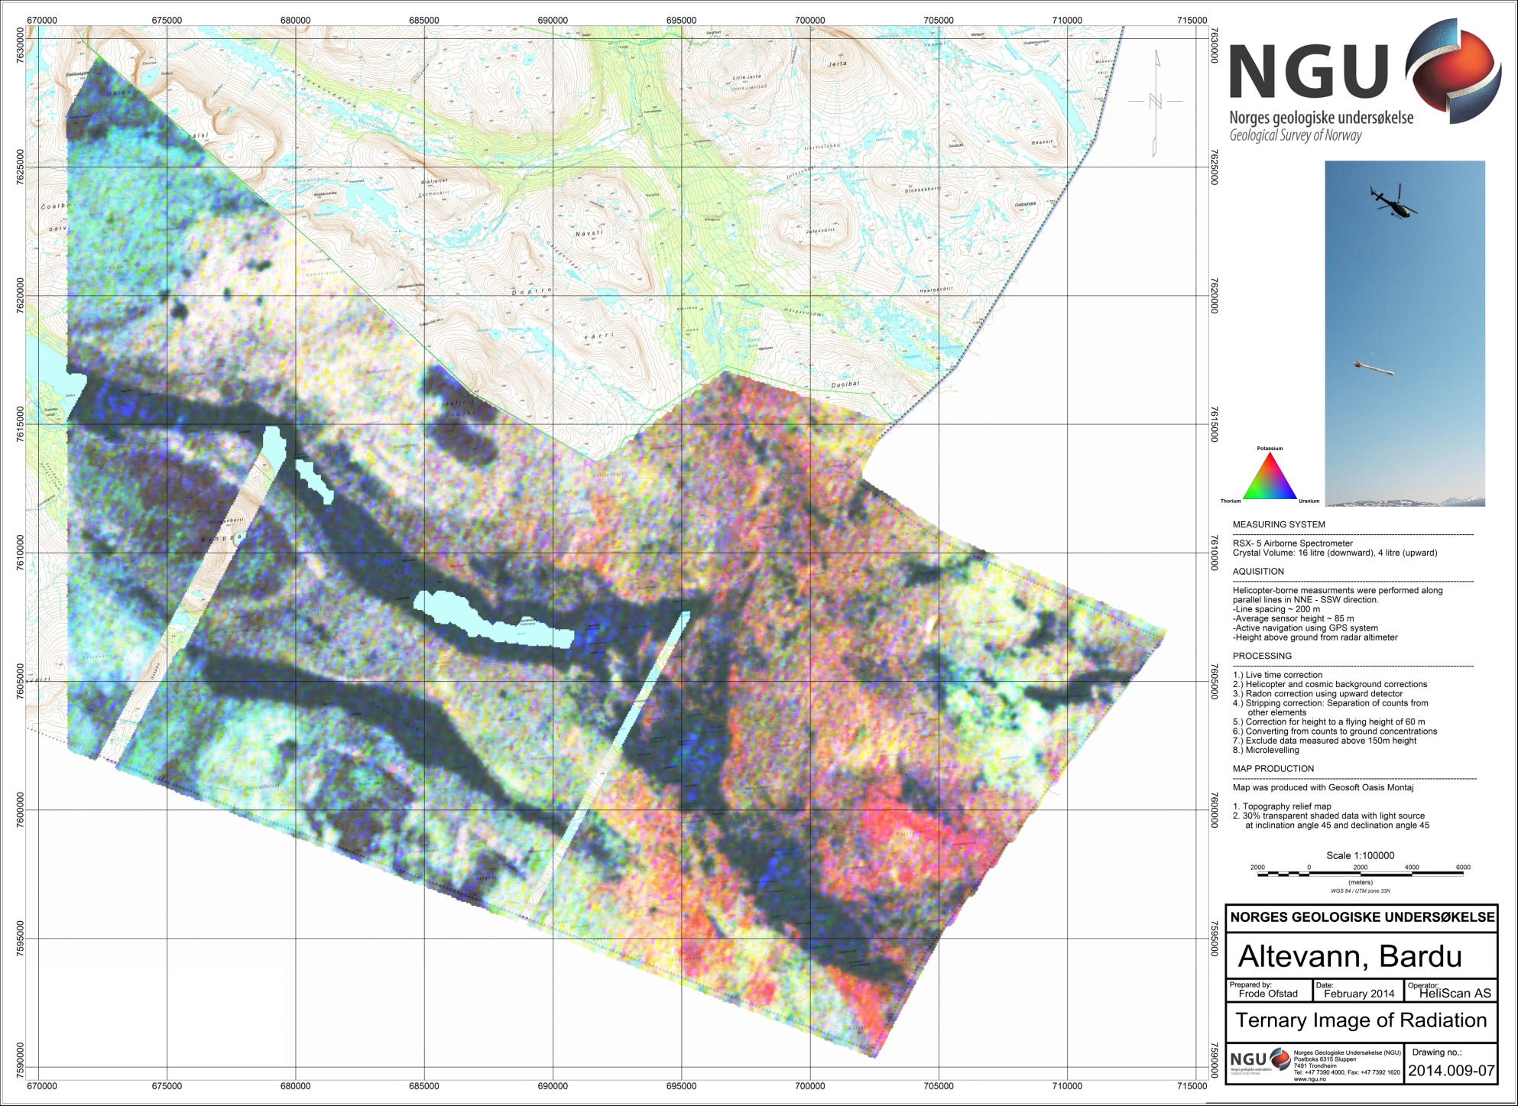
Figure 12: Ternary Image of Radiation Concentrations

